6.3 HONORS CLASS WORKSHEET – HALF-LIVES AND USES OF RADIATION

- Calculating and using half-lives

(a) | Magnesium-28 is radioactive. A sample of magnesium-28 was monitored over several days and its rate of decay is shown in the graph below:  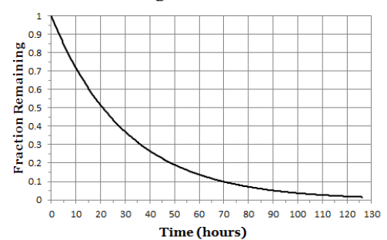
 | (i) | What type of radiation is magnesium-28 likely to emit? Give a reason for your answer and complete the nuclear equation for the decay of magnesium-28.
 |  | ${}_{12}^{28}{Mg}$
 | (ii) | Use the graph above to note the time taken for:
 |  |  | Time
 |  | 50% of the sample to decay
 |  | 75% of the sample to decay
 |  | 87.5% of the sample to decay
 | (iii) | Hence estimate the half-life of magnesium-28

(b) | (i) | Uranium-238 has a half-life of 160,000 years.  Ife has 2000 atoms of uranium-238.
 |  | (α) | How many uranium-238 atoms will she have after 480,000 years?
 |  | (β) | How many uranium-238 atoms will she have after 100,000 years?
 | (ii) | Harry has some radium-224. It is radioactive.  He notices that after 14.5 days his sample is emitting radiation at 6.25% of its original rate.  What is the half-life of radium-224?
 | (iii) | JaNiece has 500 atoms of iodine-131. It is radioactive.  She notices that after 1 day, she only has 459 atoms remaining.  What is the half-life of iodine-131?

- Uses of radiation

(a) | An engineer needs to locate a blockage in an underground pipe.
 | (i) | Describe briefly how she would use a radioactive material to do this.
 | (ii) | State and explain what type of radiation the material should emit.
 | (ii) | State and explain whether the material should have a long or a short half-life.

(b) | Smoke alarms monitor the progress of radiation across 5 mm of air. If the air is smoky the radiation cannot pass through it and this triggers the smoke alarm.
 | (i) | State and explain what type of radiation the material should emit.
 | (ii) | State and explain whether the material should have a long or a short half-life.

