A LEVEL CHEMISTRY
TOPIC 16 – ALDEHYDES, KETONES AND OPTICAL ISOMERISM
TEST
Answer all questions
Max 50 marks

Name ……………………………………………………………..

Mark ……../50 ……....% Grade ………

SECTION A
1. (a) (i) Give a suitable reagent and state the necessary conditions for the conversion of propan-2-ol into propanone. Name the type of reaction.
Reagent ..............................................................................................
Conditions ...........................................................................................
Type of reaction ...................................................................................
(ii) Propanone can be converted back into propan-2-ol. Give a suitable reagent and write an equation for this reaction.
(Use [H] to represent the reagent in your equation.)
Reagent ...............................................................................................
Equation

.............................................................................................................
(5)
(b) Propanal is an isomer of propanone.
(i) Draw the structure of propanal.

(ii) A chemical test can be used to distinguish between separate samples of propanone and propanal. Give a suitable reagent for the test and describe what you would observe with propanone and with propanal.
Test reagent .........................................................................................
Observation with propanone ................................................................
Observation with propanone ................................................................
(4)
(Total 9 marks)

2. Consider the sequence of reactions below.
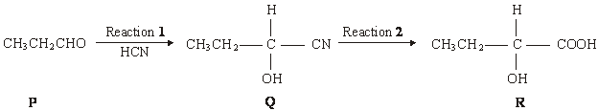
(a) Name and outline a mechanism for Reaction 1.
Name of mechanism ....................................................................................................
Mechanism

(5)
(b) Name compound Q
.............................................................................................................
(1)
(c) Draw the structure of the main organic product formed in each case when R reacts separately with the following substances:
(ii) acidified potassium dichromate(VI);

(iii) concentrated sulphuric acid in an elimination reaction.

(2)
(Total 8 marks)

3. The reducing agent in the following conversion is NaBH₄
(i) Name and outline a mechanism for the reaction.
Name of mechanism ............................................................................
Mechanism

(5)
(ii) By considering the mechanism of this reaction, explain why the product formed is optically inactive.
...............................................................................................................
...............................................................................................................
...............................................................................................................
...............................................................................................................
...............................................................................................................
...............................................................................................................
...............................................................................................................
...............................................................................................................
(3)
(Total 8 marks)

4. (a) P, Q and R have the molecular formula C₆H₁₂
All three are branched-chain molecules and none is cyclic.
P can represent a pair of optical isomers.
Q can represent a pair of geometrical isomers.
R can represent another pair of geometrical isomers different from Q.
Draw one possible structure for one of the isomers of each of P, Q and R.
Structure of P

Structure of Q

Structure of R

(3)
(b) Butanone reacts with reagent S to form compound T which exists as a racemic mixture. Dehydration of T forms U, C₅H₇N, which can represent a pair of geometrical isomers.
(i) State the meaning of the term racemic mixture and suggest why such a mixture is formed in this reaction.
Racemic mixture .................................................................................
.............................................................................................................
Explanation..........................................................................................
.............................................................................................................
.............................................................................................................
(ii) Identify reagent S, and draw a structural formula for each of T and U.
Reagent S ...........................................................................................
Compound T

Compound U

(6)
(Total 9 marks)
5. Compounds C and D, shown below, are isomers of C₅H₁₀O
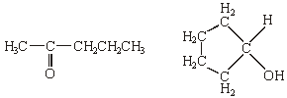
C D
(a) Name compound C.
......................................................................................................................
(1)
(b) Use Table 2 on the Data Sheet to help you to answer this question.
(i) Suggest the wavenumber of an absorption which is present in the infra-red spectrum of C but not in that of D.
.............................................................................................................
(ii) Suggest the wavenumber of an absorption which is present in the infra-red spectrum of D but not in that of C.
.............................................................................................................
(2)
(c) Identify a reagent that you could use to distinguish between C and D. For each of C and D, state what you would observe when the compound is treated with this reagent.
Reagent .......................................................................................................
Observation with C .......................................................................................
Observation with D .......................................................................................
(3)
(d) Compound E, CH₃CH₂CH₂CH₂CHO, is also an isomer of C₅H₁₀O
Identify a reagent which will react with E but not with C or D. State what you would observe when E is treated with this reagent.
Reagent .......................................................................................................
Observation with E .......................................................................................
(2)
(Total 8 marks)

SECTION B
6. Which one of the following reactions involves nucleophilic addition?
A CH₃CH = CH₂ + HBr → CH₃CHBrCH₃
B CH₃CH₂CH₃ + Cl₂ → CH₃CHClCH₃ + HCl
C CH₃CH₂CH₂Br + NaOH → CH₃CH₂CH₂OH + NaBr
D CH₃CH₂CHO + HCN → CH₃CH₂CH(OH)CN
(Total 1 mark)

7. Which one of the following isomers is not oxidised under mild reaction conditions?
A (CH₃)₂CHCH(OH)COCH₃
B (CH₃)₂C(OH)CH₂COCH₃
C (CH₃)₂CHCH(OH)CH₂CHO
D (CH₃)₂C(OH)CH₂CH₂CHO
(Total 1 mark)

8. In which one of the following are the curly arrows not used correctly?
A
B 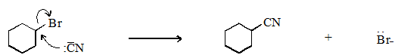
C 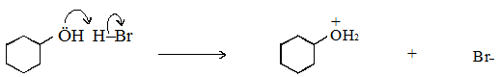
D
(Total 1 mark)

9. Which one of the following is not a suitable method for the preparation of ethanol?
A oxidation of ethane
B hydration of ethene
C reduction of ethanal
D hydrolysis of bromoethane
(Total 1 mark)

10. Which one of the following will undergo nucleophilic addition?
A hex-3-ene
B hexan-3-one
C 3-bromohexane
D hexan-3-ol
(Total 1 mark)

11. How many structural isomers, which are aldehydes, have the molecular formula C₅H₁₀O?
A 2
B 3
C 4
D 5
(Total 1 mark)

12. On reduction, a racemate can be formed by
A CH₃CH₂CH₂CH₂CHO
B CH₃CH₂CH₂COCH₃
C CH₃CH₂COCH₂CH₃
D CH₃CH=CHCH₂CHO
(Total 1 mark)

13. The compound lithium tetrahydridoaluminate(III), LiAlH₄, is a useful reducing agent. It behaves in a similar fashion to NaBH₄. Carbonyl compounds and carboxylic acids are reduced to alcohols. However, LiAlH₄ also reduces water in a violent reaction so that it must be used in an organic solvent.
Which one of the following can be reduced by LiAlH₄ to a primary alcohol?
A 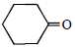
B 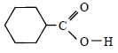
C 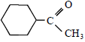
D 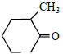
(Total 1 mark)

