TOPIC 16 TEST MS
1. (a) (i) Potassium (OR sodium) dichromate(VI) OR correct formula
OR potassium manganate(VII)
(Oxidation state not needed, but must be correct if included)
(Penalise errors in the formula or oxidation state, but mark conditions)
1
Acidified OR H₂SO₄ / HCl (NOT with KMnO₄) / H₃PO₄ / HNO₃
(Ignore heat or reflux)
(Credit “acidified” as part of reagent)
1
Oxidation or redox
1
(ii) NaBH₄ OR LiAlH₄ OR H₂/Ni
1
CH₃COCH₃ + 2[H] → CH₃CH(OH)CH₃
(Credit H₂ in the equation if H₂ has been chosen as reagent)
1
(b) (i) 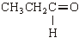
(Structure must show aldehyde structure)
(Credit C₂H₅ as alternative to CH₃CH₂)
(ii) M1 Tollens’  reagent OR  ammoniacal silver  nitrate  OR AgNO₃ + NH₃ | OR Fehling’s  solution | OR acidified  potassium  dichromate | 1
M2 stays colourless stays blue stays orange
1
(Provided reagent is correct, credit “no reaction”, “no change”, “nothing”, “no observation” for M2)

M3 silver mirror /  deposit  OR black / grey  precipitate | red / brown / orange  precipitate / solid | goes green | 1

(Credit other correct reagents and observation)
(For M1, penalise AgNO₃ alone, penalise Ag(NH₃), penalise “potassium dichromate”, etc., but, in each case, mark on and credit correct M2 and M3)
(If totally wrong reagent or no reagent, CE = no marks for M1,M2 or M3)
1
[9]
2. (a) nucleophilic addition
1
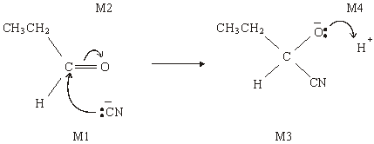
4
(b) (i) 2-hydroxybutanenitrile
1
(c) (i)
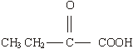
1
(ii) CH₃CH=CHCOOH
1
[8]

3. (c) (i) Nucleophilic addition
1
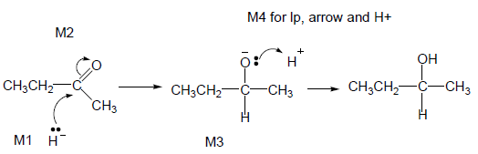
• M2 not allowed independent of M1, but allow M1 for correct attack on C+
• + rather than δ+ on C=O loses M2
• M3 is for correct structure including minus sign but lone pair is part of M4
• Allow C₂H₅
• M1 and M4 include lp and curly arrow
• Allow M4 arrow to H in H₂O (ignore further arrows)
4
(ii) M1 Planar C=O (bond / group)
Not just planar molecule
1
M2 Attack (equally likely) from either side
Not just planar bond without reference to carbonyl
1
M3 (about product): Racemic mixture formed OR 50:50 mixture or
each enantiomer equally likely
1
[8]

4. (a) Structure of P:
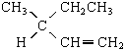 (1)
Structures of Q and R:
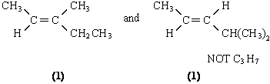
Q and R in any order
3
(b) (i) Racemic mixture: equal mixture of optical isomers / enantiomers
OR in explanation
Explanation: planar (>C=O) (1)
attack from either side is equally likely (1)
(ii) Reagent S: HCN or (KCN / HCl or H₂SO₄) (1)
Compound T: 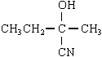 (1)
Compound U: 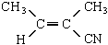 (1)
6
[9]
5. (a) Pentan-2-one
1
(b) (i) 1680 – 1750 (cm^{–1})
1
(ii) 3230 – 3550 or 1000 – 1300 (cm^{–1})
1

(c)

Reagent | K₂Cr₂O₇/H⁺ | KMnO₄ /H⁺ | Na | CH₃COOH/  H₂SO₄ | 1
with C | no reaction | no reaction | no reaction | no reaction | 1
with D | goes green | goes colourless | effervescence | smell | 1

(penalise incomplete reagent e.g. K₂Cr₂O₇ or Cr₂O₇ ^{2–}/H⁺ then mark on)
(d)
Reagent | Tollens | Fehlings or Benedicts | 1
with E | silver  (mirror) | red ppt or goes red  (not red solution) | 1

[8]
6. D
[1]
7. B
[1]
8. D
[1]
9. A
[1]
10. B
[1]
11. C
[1]
12. B
[1]
13. B
[1]

