AS LEVEL CHEMISTRY

TOPIC 1 – ATOMIC STRUCTURE AND THE PERIODIC TABLE
TEST
Answer all questions
Max 50 marks

Name ……………………………………………………………..

Mark ……../50 ……....% Grade ………

SECTION A
1. Table 1 shows some data about fundamental particles in an atom.
 | Table 1
 | Particle | Proton | neutron | electron
 | Mass / g | 1.6725 × 10^{–24} | 1.6748 × 10^{–24} | 0.0009 × 10^{–24}

(i) An atom of hydrogen can be represented as ¹H
Use data from Table 1 to calculate the mass of this hydrogen atom.
...............................................................................................................
(1)

(ii) Which one of the following is a fundamental particle that would not be deflected by an electric field?
A electron
B neutron
C proton
Write the correct letter, A, B or C, in the box.
(1)
(Total 2 marks)

2. (a) Complete the following table.

Particle | Relative charge | Relative mass
Proton
Neutron
Electron

(3)
(b) An atom of element Z has two more protons and two more neutrons than an atom of . Give the symbol, including mass number and atomic number, for this atom of Z.
......................................................................................................................
(2)
(c) Complete the electronic configurations for the sulphur atom, S, and the sulphide ion, S^{2–}.
S 1s² .......................................................................................................
S^{2–} 1s² .......................................................................................................
(2)
(d) State the block in the Periodic Table in which sulphur is placed and explain your answer.
Block ...........................................................................................................
Explanation ..................................................................................................
(2)
(Total 9 narks)

3. (a) One isotope of sodium has a relative mass of 23.
(i) Define, in terms of the fundamental particles present, the meaning of the term isotopes.
.............................................................................................................
.............................................................................................................
(ii) Explain why isotopes of the same element have the same chemical properties.
.............................................................................................................
.............................................................................................................
(3)
(b) Give the electronic configuration, showing all sub-levels, for a sodium atom.
......................................................................................................................
(1)
(c) Explain why chromium is placed in the d block in the Periodic Table.
......................................................................................................................
......................................................................................................................
(1)
(d) An atom has half as many protons as an atom of ²⁸Si and also has six fewer neutrons than an atom of ²⁸Si. Give the symbol, including the mass number and the atomic number, of this atom.
......................................................................................................................
(2)
(Total 7 marks)

4. The mass spectrum of a sample of krypton taken from a meteorite is shown below.
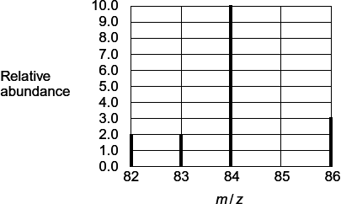
(a) Use this spectrum to calculate the relative atomic mass of this sample of krypton.
Give your answer to one decimal place.
Explain why the value you have calculated is slightly different from the relative atomic mass given in the Periodic Table.
........................................................................................................................
........................................................................................................................
........................................................................................................................
........................................................................................................................
........................................................................................................................
(4)
(b) State how krypton is ionised in the mass spectrometer.
Write an equation, including state symbols, to show the reaction that occurs when the first ionisation energy of Kr is measured.
Sometimes the mass spectrum of Kr has a very small peak with an m/z value of 42.
Explain the occurrence of this peak.
........................................................................................................................
........................................................................................................................
........................................................................................................................
........................................................................................................................
........................................................................................................................
........................................................................................................................
(5)
(Total 9 marks)

5. The diagram below shows the values of the first ionisation energies of some of the elements in Period 3.
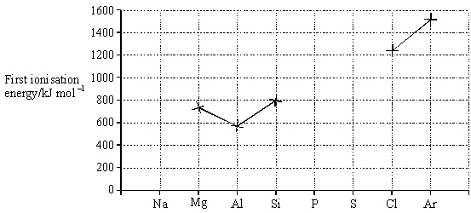
(a) On the above diagram, use crosses to mark the approximate positions of the values of the first ionisation energies for the elements Na, P and S. Complete the diagram by joining the crosses.
(3)

(b) Explain the general increase in the values of the first ionisation energies of the elements Na–Ar.
......................................................................................................................
......................................................................................................................
......................................................................................................................
......................................................................................................................
(3)

(c) In terms of the electron sub-levels involved, explain the position of aluminium and the position of sulphur in the diagram.
Explanation for aluminium ............................................................................
......................................................................................................................
......................................................................................................................
Explanation for sulphur .................................................................................
......................................................................................................................
......................................................................................................................
(4)
(Total 10 marks)

6. This question is about the first ionisation energies of some elements in the Periodic Table.
(a) Write an equation, including state symbols, to show the reaction that occurs when the first ionisation energy of lithium is measured.
.....................................................................................................................
(1)
(b) State and explain the general trend in first ionisation energies for the Period 3 elements aluminium to argon.
Trend ..........................................................................................................
Explanation .................................................................................................
.....................................................................................................................
.....................................................................................................................
(3)
(c) There is a similar general trend in first ionisation energies for the Period 4 elements gallium to krypton.
State how selenium deviates from this general trend and explain your answer.
How selenium deviates from this trend ......................................................
Explanation .................................................................................................
.....................................................................................................................
.....................................................................................................................
(Extra space)................................................................................................
(3)
(d) Suggest why the first ionisation energy of krypton is lower than the first ionisation energy of argon.
.....................................................................................................................
.....................................................................................................................
.....................................................................................................................
(1)
(e) The table below gives the successive ionisation energies of an element.

 | First | Second | Third | Fourth | Fifth
Ionisation energy / kJ mol^{–1} | 590 | 1150 | 4940 | 6480 | 8120
Deduce the group in the Periodic Table that contains this element.
.....................................................................................................................
(1)
(f) Identify the element that has a 5+ ion with an electron configuration of
1s² 2s² 2p⁶ 3s² 3p⁶ 3d¹⁰
.....................................................................................................................
(1)
(Total 10 marks)

SECTION B

7. Which one of the following ionisations requires less energy than the first ionisation energy of oxygen?
A S(g) → S⁺(g) + e⁻
B O⁺(g) → O²⁺(g) + e⁻
C N(g) → N⁺(g) + e⁻
D F(g) → F⁺(g) + e⁻
(Total 1 mark)

8. Which one of the following explains why boron has a lower first ionisation energy than beryllium?
A A boron atom is smaller than a beryllium atom.
B In beryllium all the electrons are paired in full sub-shells.
C A beryllium atom has fewer protons than a boron atom.
D In boron the 2p electron occupies a higher energy level than a 2s electron.
(Total 1 mark)

9. Chlorine has two isotopes, ³⁵Cl and ³⁷Cl. The number of molecular ion peaks in the mass spectrum of a sample of Cl₂ is
A 2
B 3
C 4
D 5
(Total 1 mark)

