AS LEVEL CHEMISTRY

TOPIC 5 – HOW FAR HOW FAST?
TEST
Answer all questions
Max 50 marks

Name ……………………………………………………………..

Mark ……../50 ……....% Grade ………

1. The diagram below shows a Maxwell–Boltzmann distribution for a sample of gas at a fixed temperature. E_{a} is the activation energy for the decomposition of this gas.
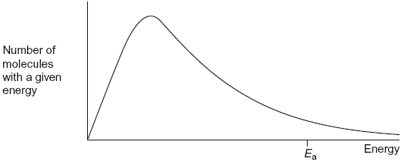
(a) (i) On this diagram, sketch the distribution for the same sample of gas at a higher temperature.
(2)
(ii) With reference to the Maxwell–Boltzmann distribution, explain why an increase in temperature increases the rate of a chemical reaction.
.............................................................................................................
.............................................................................................................
.............................................................................................................
(2)
(b) Dinitrogen oxide (N₂O) is used as a rocket fuel. The data in the table below show how the activation energy for the decomposition of dinitrogen oxide differs with different catalysts.
2N₂O(g) 2N₂(g) + O₂(g)

 | Ea / kJ mol^{–1}
Without a catalyst | 245
With a gold catalyst | 121
With an iron catalyst | 116
With a platinum catalyst | 136

(i) Use the data in the table to deduce which is the most effective catalyst for this decomposition.
.............................................................................................................
(1)

(ii) Explain how a catalyst increases the rate of a reaction.
.............................................................................................................
.............................................................................................................
.............................................................................................................
.............................................................................................................
(2)
(Total 7 marks)

2. The curve below shows how the volume of oxygen evolved varies with time when 50 cm³ of a 2.0 mol dm^{–3} solution of hydrogen peroxide, H₂O₂, decomposes at 298 K.
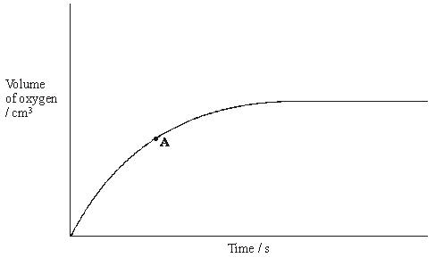
(a) State how you could use the curve to find the rate of reaction at point A.
......................................................................................................................
(1)
(b) Sketch curves, on the above axes, to illustrate how the volume of oxygen evolved would change with time if the experiment was repeated at 298 K using the following.
(i) 100 cm³ of a 1.0 mol dm^{–3} solution of H₂O₂. Label this curve X.
(ii) 25 cm³ of a 2.0 mol dm^{–3} solution of H₂O₂ in the presence of a catalyst.
Label this curve Y.
(4)

(c) Hydrogen peroxide decomposes more rapidly in the presence of aqueous hydrogen bromide. The decomposition proceeds as shown by the following equations.
H₂O₂ + HBr → HBrO + H₂O
HBrO + H₂O₂ → H₂O + O₂ + HBr
(i) Write an equation for the overall reaction.
.............................................................................................................
(ii) Define the term catalyst.
.............................................................................................................
.............................................................................................................
(iii) Give two reasons, other than an increase in the reaction rate, why these equations suggest that hydrogen bromide is behaving as a catalyst.
Reason 1 ............................................................................................
Reason 2 ............................................................................................
(5)
(Total 10 marks)

3. A mixture was prepared using 1.00 mol of propanoic acid, 2.00 mol of ethanol and 5.00 mol of water. At a given temperature, the mixture was left to reach equilibrium according to the following equation.
CH₃CH₂COOH + CH₃CH₂OH CH₃CH₂COOCH₂CH₃ + H₂O ∆H^{ο} = –22 kJ mol^{–1}
The equilibrium mixture contained 0.54 mol of the ester ethyl propanoate.
(a) (i) Calculate the amounts, in moles, of propanoic acid, of ethanol and of water in this equilibrium mixture.
Moles of propanoic acid ......................................................................
Moles of ethanol .................................................................................
Moles of water ....................................................................................
(3)
(ii) Write an expression for the equilibrium constant, K_{c}, for this equilibrium.
.............................................................................................................
.............................................................................................................
(1)

(iii) Calculate a value for K_{c} for this equilibrium at this temperature. Explain why this K_{c} value has no units.
Calculation ..........................................................................................
.............................................................................................................
.............................................................................................................
Explanation .........................................................................................
.............................................................................................................
(3)
(b) For this equilibrium, predict the effect of an increase in temperature on each of the following.
(i) the amount, in moles, of ester at equilibrium
.............................................................................................................
(1)
(ii) the time taken to reach equilibrium
.............................................................................................................
(1)
(iii) the value of K_{c}
.............................................................................................................
(1)
(Total 10 marks)

4. At high temperatures, nitrogen is oxidised by oxygen to form nitrogen monoxide in a reversible reaction as shown in the equation below.
N₂(g) + O₂(g) 2NO(g) ∆H^{ο} = +180 kJ mol^{–1}

(b) State and explain the effect of an increase in pressure, and the effect of an increase in temperature, on the yield of nitrogen monoxide in the above equilibrium.
Effect of an increase in pressure on the yield .............................................
Explanation ..................................................................................................
......................................................................................................................
......................................................................................................................
Effect of an increase in temperature on the yield ........................................
Explanation ..................................................................................................
......................................................................................................................
......................................................................................................................
(Total 6 marks)
5. Sulphur dioxide and oxygen were mixed in a 2:1 mol ratio and sealed in a flask with a catalyst.
The following equilibrium was established at temperature T₁
2SO₂(g) + O₂(g) 2SO₃(g) ΔH = –196 kJ mol^{–1}
(a) When equilibrium was established at a different temperature, T₂, the value of K_{p} was found to have increased. State which of T₁ and T₂ is the lower temperature and explain your answer.
Lower temperature........................................................................................
Explanation ...................................................................................................
......................................................................................................................
(3)
(b) In a further experiment, the amounts of sulphur dioxide and oxygen used, the catalyst and the temperature, T₁, were all unchanged, but a flask of smaller volume was used.
Deduce the effect of this change on the yield of sulphur trioxide and on the value of K_{c}.
Effect on yield of SO₃ ...................................................…............................
Effect on K_{c} ...................................................................................................
......................................................................................................................
(2)
(Total 5 marks)

6. A sealed flask containing gases X and Y in the mole ratio 1:3 was maintained at 600 K until the following equilibrium was established.
X(g) + 3Y(g) 2Z(g)
When this reaction is carried out at 300 K and a high pressure of 100 MPa, rather than at 600 K and 22.0 MPa, a higher equilibrium yield of gas Z is obtained.
Give two reasons why an industrialist is unlikely to choose these reaction conditions.
Reason 1 .....................................................................................................
Reason 2 .....................................................................................................
(Total 2 marks)

7.
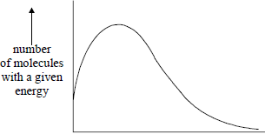
energy
The total area under the distribution curve represents
A total energy.
B activation energy.
C total number of reacting molecules.
D total number of molecules present.
(Total 1 mark)

8. The standard enthalpy of formation, ΔH_{f} for O₃(g) is + 142 kJ mol^{–1}. In which one of the following would both the changes shown increase the amount of O₂ gas in an equilibrium mixture containing only O₂(g) and O₃(g)?
A increasing the temperature and increasing the pressure
B increasing the temperature and decreasing the pressure
C decreasing the temperature and increasing the pressure
D decreasing the temperature and decreasing the pressure
(Total 1 mark)

9. When one mole of ammonia is heated to a high temperature, 50% dissociates according to the following equilibrium.
2NH₃(g) ⇌ N₂(g) + 3H₂(g)
What is the total number of moles of gas present in the equilibrium mixture?
A 1.5
B 2.0
C 2.5
D 3.0
(Total 1 mark)

10. The ester methyl ethanoate is hydrolysed as shown in the following equation.
CH₃COOCH₃(l) + H₂O(l) CH₃COOH(l) + CH₃OH(l) ΔH = +3 kJ mol⁻¹
The equilibrium yield of ethanoic acid could be increased by
A lowering the temperature.
B adding a catalyst.
C adding more water to the reaction mixture.
D adding more methanol to the reaction mixture.
(Total 1 mark)

11. The ester methyl ethanoate is hydrolysed as shown in the following equation.
CH₃COOCH₃(l) + H₂O(l) CH₃COOH(l) + CH₃OH(l) ΔH = +3 kJ mol⁻¹
A 3 mol sample of methyl ethanoate was mixed with 3 mol of water and left to reach equilibrium at 298 K. The equilibrium yield of ethanoic acid was 2 mol. The value of K_{c} for this reaction at 298 K is
A
B
C 2
D 4
(Total 1 mark)

12. The equilibrium constant, K_{c}, for a reaction which leads to ozone (O₃) formation is
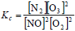
More ozone is formed as the temperature rises. Which one of the following is true at equilibrium?
A When ozone molecules collide with nitrogen they may form nitrogen monoxide.
B The enthalpy change for the reaction has a negative sign.
C Less ozone is formed at high pressure.
D At a fixed temperature, the magnitude of K_{c} increases as the concentration of NO decreases.
(Total 1 mark)

13. Phosphorus(V) chloride decomposes at high temperatures into phosphorus(III) chloride and chlorine according to the equation.
PCl₅(g) ⇌ PCl₃(g) + Cl₂(g)
Which one of the graphs best represents the variation with pressure of the yield of chlorine at equilibrium?
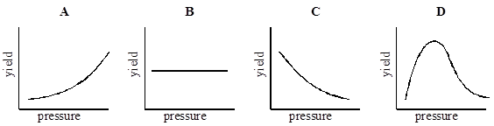
(Total 1 mark)

14. The graph shows the equilibrium percentage of ammonia present during the formation of ammonia by the Haber process:
N₂ + 3H₂ ⇌ 2NH₃ ∆H = −92 kJ mol⁻¹
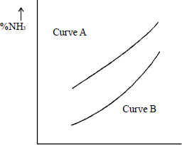
x axis
Which one of the following are correct labels for the graph?

 |  | x axis | Curve A | Curve B
 | A | temperature | high pressure | low pressure
 | B | temperature | low pressure | high pressure
 | C | pressure | high temperature | low temperature
 | D | pressure | low temperature | high temperature

(Total 1 mark)

15. A compound X is formed during a gas phase reaction. The graphs below show how the percentage of a compound X present at equilibrium varies with temperature and pressure.
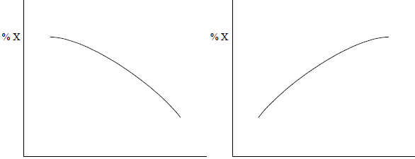

 | Temperature |  | Pressure

Which one of the following statements concerning the formation of X is correct?
A The reaction is exothermic and involves a decrease in the number of moles of gas.
B The reaction is exothermic and involves no change in the number of moles of gas.
C The reaction is exothermic and involves an increase in the number of moles of gas.
D The reaction is endothermic and involves a decrease in the number of moles of gas.
(Total 1 mark)

16. A sample of chlorine gas was sealed in a tube, heated and an equilibrium was established.
Cl₂(g) ⇌ 2Cl(g)
Which one of the following is not true?
A The concentration of chlorine atoms remains the same when a catalyst is added to the tube.
B Increase in temperature causes an increase in the concentration of chlorine atoms.
C Increase in pressure causes an increase in the concentration of chlorine atoms relative to chlorine molecules.
D Addition of more chlorine gas to the tube causes an increase in the concentration of chlorine atoms.
(Total 1 mark)

