AS LEVEL CHEMISTRY

TOPIC 8 – REACTIONS OF ORGANIC COMPOUNDS
ASSESSED HOMEWORK
Answer all questions
Max 80 marks

Name ……………………………………………………………..

Mark ……../80 ……....% Grade ………

1. Chlorination of ethane follows a free-radical substitution mechanism. This mechanism is similar to that which occurs when methane is chlorinated. The overall equation for the reaction of ethane to form chloroethane is given below.
C₂H₆ + Cl₂ C₂H₅Cl + HCl
State the conditions and outline a mechanism for this reaction. Show how butane can be formed in this reaction.
....................................................................................................................................................
....................................................................................................................................................
....................................................................................................................................................
....................................................................................................................................................
....................................................................................................................................................
....................................................................................................................................................
(Total 5 marks)

2. Halogens are used to make halogenated organic compounds.
(a) The refrigerant used in air conditioners is a mixture of fluorinated alkanes. These compounds are made by fluorination reactions.
The mechanism for the reaction of fluorine with an alkane or with a fluoroalkane is a free-radical substitution similar to the reaction of chlorine with methane.
(i) Write the overall equation for the reaction of fluorine with methane to form trifluoromethane (CHF₃).
.............................................................................................................
(1)
(ii) Write equations for the following steps in the mechanism for the reaction of fluorine with trifluoromethane (CHF₃) to form tetrafluoromethane (CF₄).
Initiation step
.............................................................................................................
First propagation step
.............................................................................................................
Second propagation step
.............................................................................................................
A termination step leading to the formation of hexafluoroethane.
.............................................................................................................
(4)

(b) Chlorofluorocarbons (CFCs) were used as refrigerants.
In the upper atmosphere, ultra-violet radiation breaks bonds in the CFCs to produce a reactive intermediate that catalyses the decomposition of ozone.
(i) An example of a CFC is 1,1,1-trichloro-2,2-difluoroethane.
Draw the displayed formula of this CFC.

(1)
(ii) Identify a bond in a CFC that is broken by ultra-violet radiation to produce a reactive intermediate.
Give the name of this reactive intermediate that catalyses the decomposition of ozone.
Write an overall equation for this decomposition of ozone.
Bond broken ......................................................................................
Name of the reactive intermediate .....................................................
Overall equation
.............................................................................................................
(3)
(Total 9 marks)

3. Sulfuric acid is manufactured by the Contact Process.

Concentrated sulfuric acid is used in a two-stage process to convert 2-methylpropene into 2-methylpropan-2-ol.
Stage 1 (CH₃)₂C=CH₂ + H₂SO₄ (CH₃)₂C(OSO₂OH)CH₃
Stage 2 (CH₃)₂C(OSO₂OH)CH₃ + H₂O (CH₃)₂C(OH)CH₃ + H₂SO₄
(a) Name and outline a mechanism for Stage 1 of this conversion.
Name of mechanism .........................................................................
Mechanism

(5)
(b) Deduce the type of reaction in Stage 2 of this conversion.
...............................................................................................................
(1)
(iii) State the overall role of sulfuric acid in this conversion.
...............................................................................................................
(1)
(Total 7 marks)

4. The following table gives the names and structures of some structural isomers with the molecular formula C₅H₁₀.

 |  | Name of isomer | Structure
 | Isomer 1 | pent-2-ene | CH₃CH = CHCH₂CH₃
 | Isomer 2 | cyclopentane | 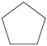
 | Isomer 3 | 3-methylbut-1-ene | (CH₃)₂CHCH = CH₂
 | Isomer 4 | 2-methylbut-2-ene | (CH₃)₂C = CHCH₃
 | Isomer 5 | 2-methylbut-1-ene | H₂C = C(CH₃)CH₂CH₃

(a) A chemical test can be used to distinguish between separate samples of Isomer 1 and Isomer 2.
Identify a suitable reagent for the test.
State what you would observe with Isomer 1 and with Isomer 2.
Reagent..........................................................................................................
Observation with Isomer 1..............................................................................
........................................................................................................................
Observation with Isomer 2..............................................................................
........................................................................................................................
(3)

(b) Two alcohols are formed by the hydration of Isomer 4.
Draw the displayed formula for the alcohol formed that is oxidised readily by acidified potassium dichromate(VI).

(1)
(c) Isomer 4 reacts with hydrogen bromide to give two structurally isomeric bromoalkanes.
(i) Name and outline a mechanism for the reaction of Isomer 4 with hydrogen bromide to give 2-bromo-2-methylbutane as the major product.
(CH₃)₂C = CHCH₃ + HBr (CH₃)₂CBrCH₂CH₃
Name of mechanism..............................................................................
Mechanism

(5)
(ii) The minor product in this reaction mixture is 2-bromo-3-methylbutane.
Explain why this bromoalkane is formed as a minor product.
...............................................................................................................
...............................................................................................................
...............................................................................................................
...............................................................................................................
...............................................................................................................
(2)
(Total 11 marks)

5. A student carried out an experiment to study the rates of hydrolysis of some haloalkanes.
(a) In the experiment, two different haloalkanes were placed in separate test tubes containing silver nitrate solution. The haloalkanes reacted with the water in the silver nitrate solution. The student timed how long it took for the first appearance of the silver halide precipitate in each tube at a constant temperature. This time was used to provide a measure of the initial rate of reaction.
The student obtained the following results.

 | 1-bromobutane | 1-iodobutane
Time to form a precipitate / s | 480 | 15
(i) State the meaning of the term hydrolysis.
.............................................................................................................
.............................................................................................................
(1)
(ii) State the colour of the precipitate formed when iodide ions react with silver nitrate and write the simplest ionic equation for this reaction.
Colour of precipitate ...........................................................................
Simplest ionic equation
.............................................................................................................
(2)
(iii) Use your knowledge of the reactions of halide ions with silver nitrate to suggest why the student did not include 1-fluorobutane in this experiment.
.............................................................................................................
.............................................................................................................
(2)
(b) The student used the following enthalpy data to try to account for the different initial rates of hydrolysis of the haloalkanes used in part (a). The student deduced that the rate of hydrolysis of a haloalkane is influenced by the strength of the carbon–halogen bond in the haloalkane.

 | C–Br | C–I
Bond enthalpy / kJ mol^{–1} | 276 | 238
State how the experimental evidence enabled the student to make this deduction.
......................................................................................................................
......................................................................................................................
(1)
(Total 6 marks)

6. (a) Consider the following reaction.
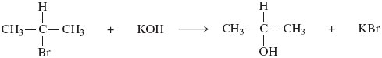
(i) Name and outline a mechanism for this reaction.
Name of mechanism ..........................................................................
Mechanism

(3)
(ii) Name the haloalkane in this reaction.
.............................................................................................................
(1)
(iii) Identify the characteristic of the haloalkane molecule that enables it to undergo this type of reaction.
.............................................................................................................
(1)
(b) An alternative reaction can occur between this haloalkane and potassium hydroxide as shown by the following equation.
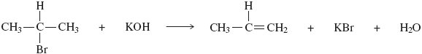
Name and outline a mechanism for this reaction.
Name of mechanism ....................................................................................
Mechanism

(4)
(c) Give one condition needed to favour the reaction shown in part (b) rather than that shown in part (a).
......................................................................................................................
(1)
(d) Alkenes can be polymerised to produce poly(alkenes).
(i) State the type of polymerisation that alkenes undergo.
.............................................................................................................
(1)
(ii) Name the alkene that gives a polymer with the repeating unit shown below.
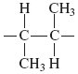
Name of alkene ...................................................................................
(1)
(Total 12 marks)

7. Ethanol is an important fuel.
A dilute aqueous solution of ethanol can be produced by the fermentation of an aqueous solution of glucose.
It is claimed that the ethanol obtained from this solution is a carbon-neutral biofuel.
Write an equation for this fermentation reaction.
Give two other essential conditions for this reaction to produce a good yield of ethanol.
Name a process used to produce a much more concentrated solution of ethanol from a dilute aqueous solution.
State the meaning of the term carbon-neutral in the context of this biofuel.
........................................................................................................................
........................................................................................................................
........................................................................................................................
........................................................................................................................
........................................................................................................................
........................................................................................................................
........................................................................................................................
(5)
(Total 5 marks)

8. There are seven isomeric carbonyl compounds with the molecular formula C₅H₁₀O.
The structures and names of some of these isomers are given below.

Structure | Name
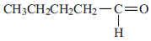 | pentanal
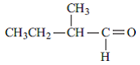 | 2-methybutanal
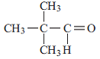 | 2, 2-dimethypropanal
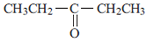
 | pentan-2-one

(i) Complete the table.

(ii) Two other isomeric carbonyl compounds with the molecular formula C₅H₁₀O are not shown in the table. One is an aldehyde and one is a ketone. Draw the structure of each.
isomeric aldehyde isomeric ketone

(4)
(Total 4 marks)

9. Some alcohols can be oxidised to form aldehydes, which can then be oxidised further to form carboxylic acids.
Some alcohols can be oxidised to form ketones, which resist further oxidation.
Other alcohols are resistant to oxidation.
(a) Draw the structures of the two straight-chain isomeric alcohols with molecular formula, C₄H₁₀O

(2)
(b) Draw the structures of the oxidation products obtained when the two alcohols from part (a) are oxidised separately by acidified potassium dichromate(VI). Write equations for any reactions which occur, using [O] to represent the oxidising agent.

(6)
(c) Draw the structure and give the name of the alcohol with molecular formula C₄H₁₀O which is resistant to oxidation by acidified potassium dichromate(VI).

(2)
(Total 10 marks)

10. The following instructions are from an experimental procedure for the preparation of cyclohexene from cyclohexanol and concentrated phosphoric acid.
Read these instructions and answer the questions that follow.
1 Place 25 cm³ of cyclohexanol into a round-bottomed flask with some porous pot to act as anti-bumping granules. Add 10 cm³ of concentrated phosphoric acid carefully while shaking the flask. Cool the flask under the tap if it gets too hot.
Make sure the reagents are thoroughly mixed.
2 Set up an apparatus for simple distillation using this flask.
3 Warm the flask, gently at first, for about 15 minutes. Then increase the heating so that cyclohexene begins to distil over. Collect the fraction that distils below 95 °C.
(a) State the purpose of the anti-bumping granules.
........................................................................................................................
........................................................................................................................
(1)
(b) Name the part of the distillation apparatus where cyclohexene vapour is changed back into a liquid.
Draw a simple diagram of this part of the apparatus.
Name .............................................................................................................
Diagram

(2)
(Total 3 marks)

11. Ethanal is prepared by heating ethanol with potassium dichromate(VI) in the presence of sulfuric acid. Figures 1 and 2 show two possible ways of heating this reaction mixture.
Figure 1 Figure 2
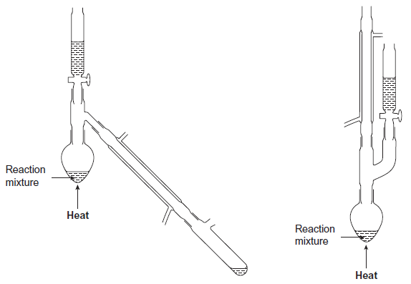
State which arrangement would not be suitable for the preparation of ethanal. Explain your answer.
Arrangement ...........................................................................................................
Explanation .............................................................................................................
.................................................................................................................................
(Total 2 marks)

12. Which one of the following is least likely to occur in the reaction between methane and chlorine?
A CH₄ + Cl• → CH₃• + HCl
B CH₃• + HCl → CH₃Cl + H•
C CH₃• + Cl₂ → CH₃Cl + Cl•
D CH₃Cl + Cl• → CH₂Cl• + HCl
(Total 1 mark)
13. For this question refer to the reaction scheme below.
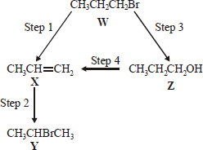
Which one of the following reagents would not bring about the reaction indicated?
A Step 1 : alcoholic KOH
B Step 2 : aqueous Br₂
C Step 3 : aqueous NaOH
C Step 4 : concentrated H₂SO₄
(Total 1 mark)

14. Which one of the following does not represent an oxidation?
A propene → propane
B propan-l-ol → propanal
C propan-l-ol → propanoic acid
D propanal → propanoic acid
(Total 1 mark)

15. The structure of the molecule of methyl 2-methylpropenoate is shown below.
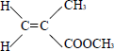
Which one of the following statements concerning this compound is not true?
A It displays geometrical isomerism.
B It forms an addition polymer.
C It undergoes reduction.
D It decolourises bromine.
(Total 1 mark)

16. How many different alkenes are formed when 2-bromo-2-methylbutane reacts with ethanolic potassium hydroxide?
A 2
B 3
C 4
D 5
(Total 1 mark)

17. This question is about the reaction between propanone and an excess of ethane-1,2-diol, the equation for which is given below.
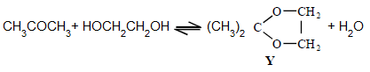
In a typical procedure, a mixture of 1.00 g of propanone, 5.00 g of ethane-1,2-diol and 0.100 g of benzenesulphonic acid, C₆H₅SO₃H, is heated under reflux in an inert solvent. Benzenesulphonic acid is a strong acid.
Which one of the following statements is not true?
A Ethane-1,2-diol and water can form hydrogen bonds.
B Ethane-1,2-diol is soluble in water.
C Propane has a higher boiling point than ethane-1,2-diol.
D Y and water are polar molecules.
(Total 1 mark)

