Topic 8

ORGANIC REACTIONS

Reactions of alkanes
Reactions of alkenes
Reactions of haloalkanes
Role of chloroalkanes in ozone layer depletion
Production of ethanol
Reactions of alcohols

- REACTIONS OF ALKANES

- Free radical substitution reactions – making haloalkanes

Chloroalkanes can be made from alkanes in a reaction known as a free radical substitution reaction.

Eg CH₄ + Cl₂ → CH₃Cl + HCl

A substitution reaction is one in which one atom or group of atoms on the organic molecule is directly replaced by another. In this reaction the H atom on the alkane is replaced by a Cl atom.
Since all the carbon atoms in alkanes are attached to four other atoms, it is not possible to add another species to an alkane unless another species leaves. Thus addition reactions are not possible and alkanes can undergo substitution reactions only.

A free radical is a species which contains an unpaired electron. Free radicals are very reactive species and will bond with almost anything they come into contact with.

In this reaction the free radical which starts the reaction is a chlorine atom, formed when a chlorine molecule breaks up in the presence of ultra-violet light:

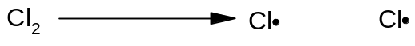

Free radicals are represented by a dot next to the atom containing an unpaired electron. They are caused by homolytic fission of covalent bonds.

Homolytic fission is the breaking of a covalent bond in such a way that one electron goes to each atom.

Mechanism 1: free radical substitution

Free radical substitution reactions proceed in three stages: initiation, propagation and then termination.

- Initiation

Initiation is the production of free radicals by homolytic fission of a covalent bond.

Most bonds do not undergo homolytic fission under normal conditions. Generally, UV light is required.

UV

- Propagation

Propagation is the reaction of a free radical with a molecule to produce another free radical.
The reaction involves two propagation steps:

- Termination

Termination is the combination of two free radicals to form a single molecule.

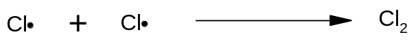
Note that the Cl radicals are recycled during the propagation steps, so the reaction only requires a very small number of Cl-Cl bonds to undergo fission for the reaction to proceed.

By-products in free radical substitution:

Chloromethane is not generally the only organic product of this reaction. Free radical reactions tend to result in a variety of different products.

- Different propagation steps

The propagation steps can continue beyond the formation of methane, and can result in the formation of dichloromethane, trichloromethane or tetrachloromethane:

These further propagation steps are likely if excess chlorine is used. If excess methane is used, then chloromethane is likely to be the major product.

- Different termination steps

It also possible to get other products from alternative termination steps:

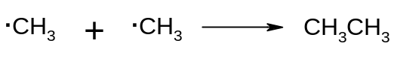

Thus when methane reacts with chlorine, a variety of products are formed including chloromethane, dichloromethane and ethane.

In order to ensure that chloromethane is the major product, it is important to use excess methane. In excesss chlorine, it is likely that multiple substitution will take place.

- REACTIONS OF ALKENES

Alkenes are hydrocarbons containing a carbon-carbon double bond. The atoms around the carbon-carbon double bond adopt a planar arrangement and the bond angle is 120º.

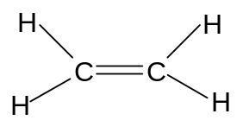

The presence of the C=C bond gives alkenes a number of chemical properties that are not seen in alkanes.

- Since the alkene contains π-bonds, it is possible to break the π-bond and form σ-bonds with other species without forcing any atoms on the molecule to break off. As a result alkenes (unlike alkanes) are capable of undergoing addition reactions. Molecules which contain π-bonds and which can hence undergo addition are said to be unsaturated. Molecules which do not contain π-bonds and which hence cannot undergo addition are said to be saturated.
Alkenes are unsaturated and can hence undergo addition. Addition is the combination of two or more molecules to form a single molecule. Addition reactions are generally faster than substitution reactions since only weak π-bonds are broken, rather than stronger σ-bonds.

- The π-bond in an alkene is an area of high electron density. It can thus attract electrophiles and undergo heterolytic fission. Heterolytic fission is the breaking of a covalent bond which results in both electrons going to the same atom. This is in contrast to alkanes which can only react with free radicals and undergo homolytic fission. An electrophile is a species which can accept a pair of electrons from a species with a high electron density.

The fact that alkenes can react by heterolytic mechanisms, however, does not mean that the π-bond will not undergo homolytic fission as well. On the contrary - since the bond is non-polar it is very likely to undergo homolytic fission.

Alkenes can thus react in two ways:
- by free radical addition
- by electrophilic addition

The ability of alkenes to undergo addition, and their ability to react with electrophiles as well as free radicals, means that they are much more reactive than alkanes.

- Electrophilic addition reactions of alkenes – making halogenoalkanes, dihalogenoalkanes and alcohols

In the presence of electrophiles, the C=C π-bond tends to undergo electrophilic addition.

Possible electrophiles are hydrogen halides (H-Cl, H-Br and H-I) and halogens (Br-Br, Cl-Cl and I-I). Alkenes also undergo an electrophilic addition reaction with H₂SO₄.

Mechanism 2 – Electrophilic Addition

i) with hydrogen halides

Eg CH₂=CH₂ + H-Br → CH₃CH₂Br

The H in the H-X bond has a positive dipole and is attacked by the pair of electrons on the C=C bond, which undergoes heterolytic fission:
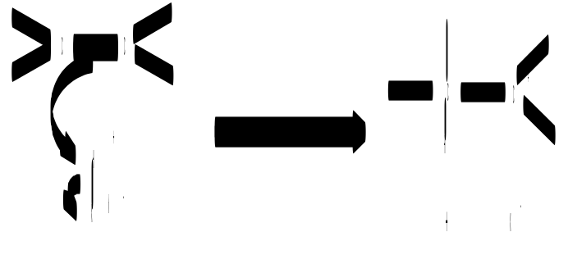

Note that the curly arrow indicates the movement of a pair of electrons.

The halide ion then attacks the carbocation to form a haloalkane:
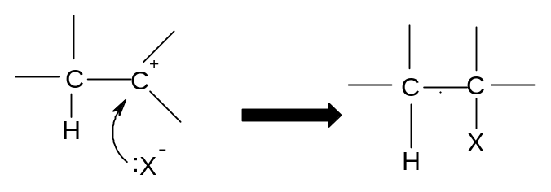

This reaction is fairly quick and takes place readily at room temperature.

ii) with halogens

Eg CH₂=CH₂ + Br₂ → CH₂BrCH₂Br

The Br-Br molecule is non-polar but in the presence of alkenes the electrons move to one side of the molecule and it acquires a temporary dipole (in other words a dipole is induced by the alkene). The δ+ve Br is then attacked by the alkene:
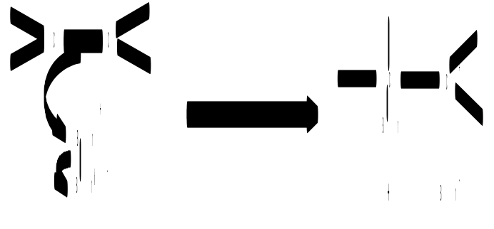
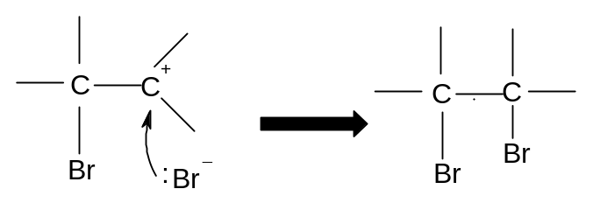

A dibromoalkane is formed. The Br₂ should be dissolved in water or an organic solvent, and is decolorised during the reaction. (orange → colourless).

The reaction is fairly quick and takes place readily at room temperature.

If bromine solution is added to an alkene and the mixture shaken, it will thus decolorise and this is a good test for an alkene.

iii) with H₂SO₄

eg CH₂=CH₂ + H₂SO₄ → CH₃CH₂HSO₄

Alkenes will undergo an electrophilic addition reaction with cold concentrated sulphuric acid:
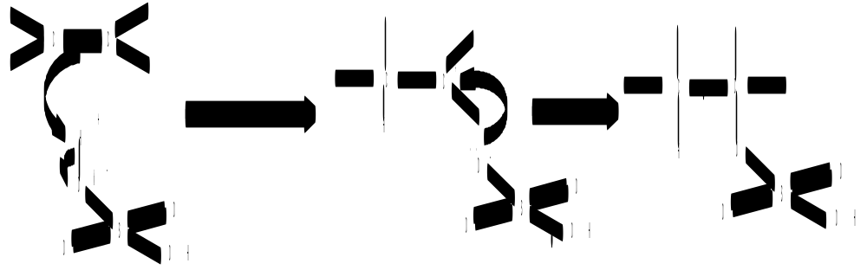

If the mixture is then warmed and water added, the H₂SO₄ group will be replaced by an OH group and an alcohol will be formed:
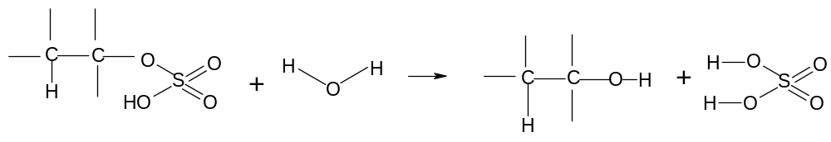

This is known as a hydrolysis reaction. Hydrolysis means using water to break covalent bonds.

The overall reaction is thus:
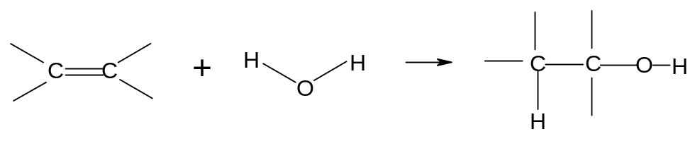

This is a two step reaction:
Step 1: cold concentrated H₂SO₄
Step 2: warm and add H₂O

It is a useful way of converting alkenes into alcohols in the laboratory.

UNSYMMETRICAL ALKENES

Unsymmetrical alkenes are those in which the two carbon atoms in the double bond are not attached to the same groups.

Eg propene Eg but-1-ene
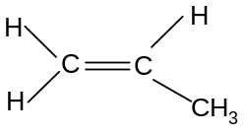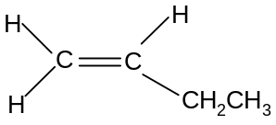

Eg 2-methylpropene Eg 2-methylbut-1-ene
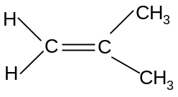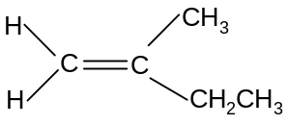

Alkenes in which both carbon atoms are attached to the same groups are known as symmetrical alkenes.

Eg ethene Eg but-2-ene
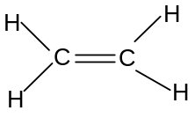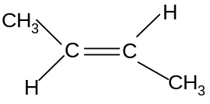

If unsymmetrical alkenes react with unsymmetrical eletrophiles such as H-X or H₂SO₄, there are two possible products:

Eg propene with hydrogen bromide

Route 1:

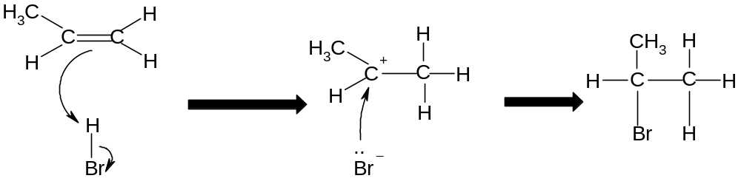
Propene → 2-bromopropane

Route 2:

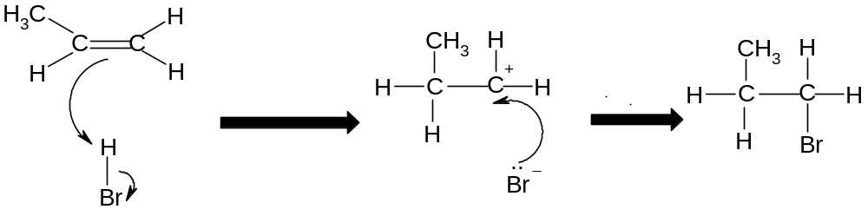

Propene → 1-bromopropane

The two products are not formed in equal quantities. The likelihood of one product being formed over the other depends on the stability of the carbocation intermediate.

In route 1, the intermediate is a secondary carbocation, as the carbon holding the positive charged is attached to two other carbon atoms:

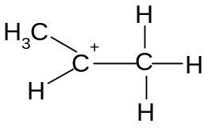

In route 2, the intermediate is a primary carbocation, as the carbon holding the positive charge is attached to one other carbon atom:

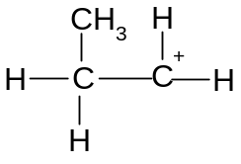

Secondary carbocations are more stable than primary carbocations. Tertiary carbocations are even more stable than secondary cations. Therefore the product of route 1 (2-bromopropane) is a more likely product than the product of route 2 (1-bromopropane).
Thus 2-bromopropane will be the major product and 1-bromopropane will be the minor product.

In general, the more stable carbocation will be the one which is more highly substituted. The more electronegative part of the electrophile will thus always attach itself to the more highly substituted carbon atom.

This is known as Markownikoff's rule: "The more electronegative part of the electrophile will usually attach itself to the more highly substituted carbon atom".

The major product of the addition reaction is known as the Markownikoff product.
The minor product of the addition reaction is known as the anti-Markownikoff product.

Eg but-1-ene + HBr

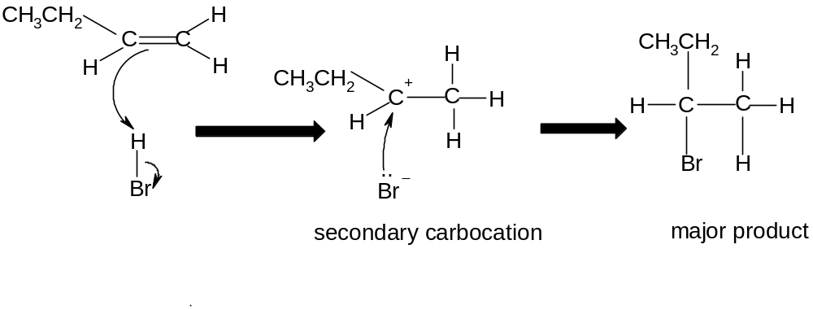

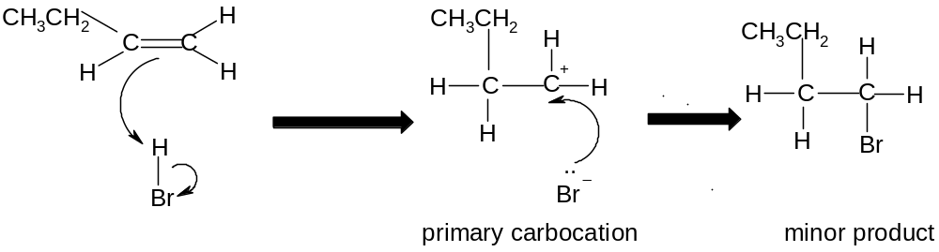

The major product is 2-bromobutane.

The minor product is 1-bromobutane.

Eg 2-methylbut-2-ene + H₂SO₄, then warm and dilute

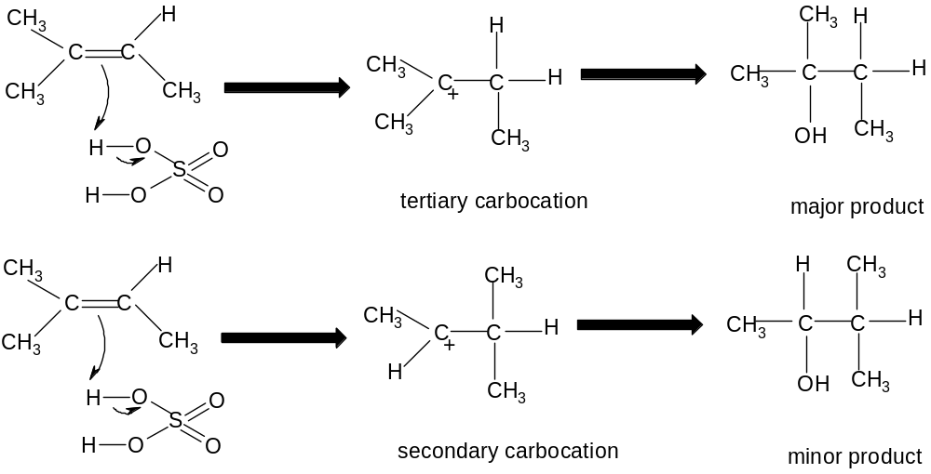

The major product is 2-methylbutan-2-ol

The minor product is 3-methylbutan-2-ol

Symmetrical alkenes only give one product when elecrophiles are added. Unsymmetrical alkenes only give one product if the electrophile is symmetrical
(Eg propene Br₂).

Thus two products are only obtained when both the alkene and the electrophile are unsymmetrical. In such cases the identity of the major and minor products can be predicted by Markownikoff's rule.

- Other addition reactions of alkenes

i) addition of steam to make alcohols (hydration)

When alkenes are treated with steam at 300 ºC, a pressure of 60 atmospheres and a phosphoric acid (H₃PO₄) catalyst, the H₂O is added across the double bond and an alcohol is formed in a reaction known as hydration:
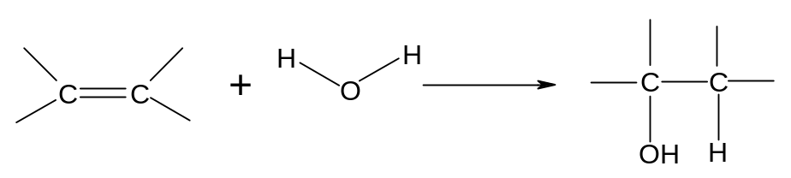
Eg CH₂=CH₂ + H₂O → CH₃CH₂OH

This is a common industrial method for the production of pure ethanol.

ii) addition polymerisation to make polyalkenes

Alkenes can be made to join together in the presence of high pressure and a suitable catalyst. This is known as addition polmerisation.
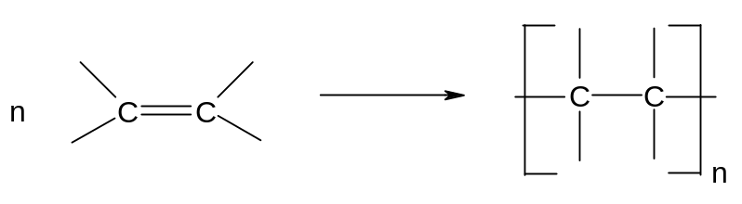

The product of this addition process is a very long hydrocarbon chain. This is known as a polymer. Since it is a product of an addition reaction (unlike some other polymers) it is known as an addition polymer. Since it is made from an alkene it is known as a polyalkene.

Polyalkenes are saturated, like alkanes. They are therefore unreactive.

Addition polymers can be made from any alkene:
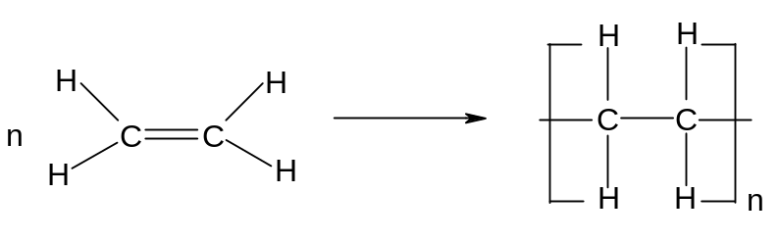
Eg ethene poly(ethene)

Polyethene is most widely used in plastic shopping bags.

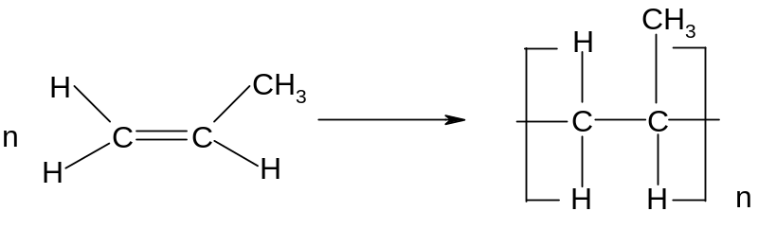
Eg propene poly(propene)

Polypropene is used in biros, straws and plastic food containers. It can be recycled commercially.
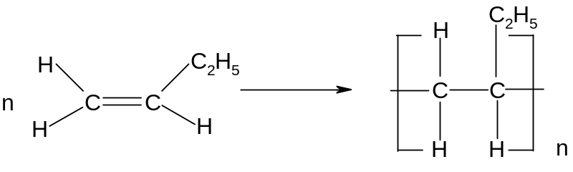
Eg but-1-ene poly(but-1-ene)

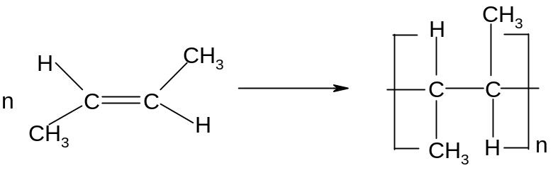
Eg but-2-ene poly(but-2-ene)

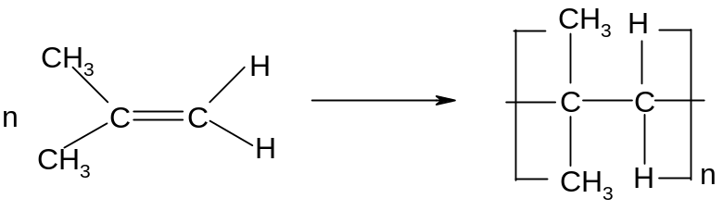
Eg 2-methylpropene poly(2-methylpropene)

- REACTIONS OF HALOALKANES

The C-X bond is polar, and the carbon is δ+ve. Therefore haloalkanes can react with nucleophiles.

A nucleophile is a species with a lone pair of electrons which it can use to bond with an electropositive carbon atom on an organic molecule.

The nucleophile generally replaces the halogen atom on the molecule. Thus haloalkanes can undergo nucleophilic substitution reactions.

Haloalkanes can also undergo elimination reactions.

An elimination reaction is one in which the organic molecule loses two species from adjacent carbon atoms without replacement, resulting in the formation of a double bond between the two carbon atoms.

- Nucleophilic substitution to make alcohols, nitriles and ammonia

Mechanism 3: Nucleophilic Substitution

The three nucleophiles most commonly used in nucleophilic substitution of haloalkanes are hydroxide ions, OH⁻, cyanide ions, CN⁻ and ammonia, NH₃.

i) Reaction with hydroxide ions

Haloalkanes react with hydroxide ions when boiled under reflux with aqueous NaOH or aqueous KOH:

R-X + OH⁻ → R-OH + X⁻

The nucleophile (ie the hydroxide ion) attacks the δ+ve carbon atom from behind, forcing the X atom to leave as the halide ion. It is a one-step mechanism:

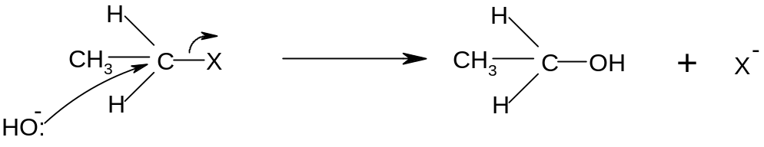

Note that the hydroxide ion is behaving as a nucleophile in this reaction.
Eg bromoethane → ethanol

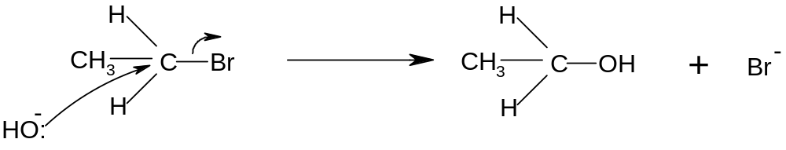

Eg 2-chloropropane → propan-2-ol

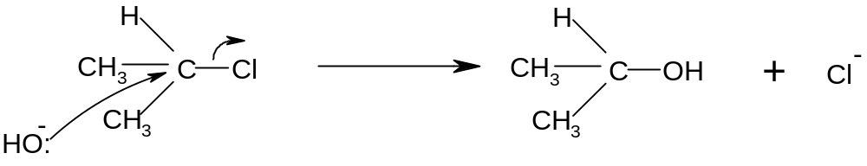

ii) Reaction with cyanide ions

Cyanide ions are nucleophiles and react with haloalkanes by nucleophilic substitution to give nitriles. The haloalkane should be boiled under reflux with KCN in aqueous ethanol.

R-X + CN⁻ → R-CN + X⁻

The mechanism is exactly the same as with the hydroxide ion.

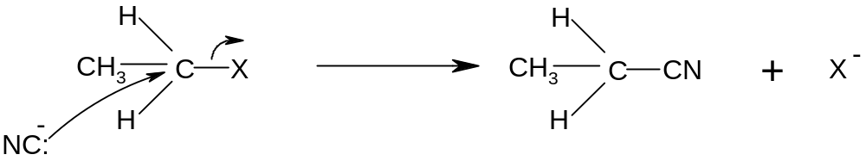

Note that the CN⁻ ion has the following structure:
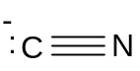

Thus the lone pair of electrons is on the carbon, not the nitrogen. It is thus the carbon which attaches itself to the organic molecule.

Eg bromoethane → propanenitrile

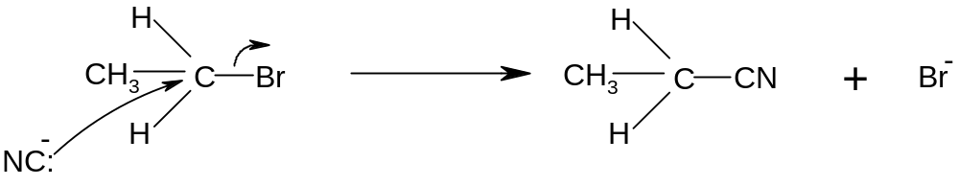
Eg 2-chloropropane → 2-methylpropanenitrile

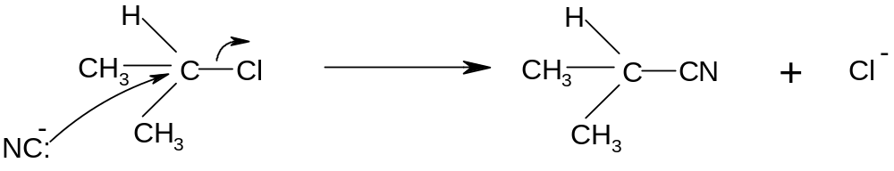

The reaction with cyanide ions is significant because it increases the number of carbon atoms on the chain, so it provides a way of ascending the homologous series. It is thus very useful in organic synthesis.

iii) Reaction with ammonia

If a haloalkane is heated with ethanolic ammonia in a sealed tube, a primary amine is formed:

R-X + 2NH₃ → R-NH₂ + NH₄X

The mechanism is again nucleophilic substitution:

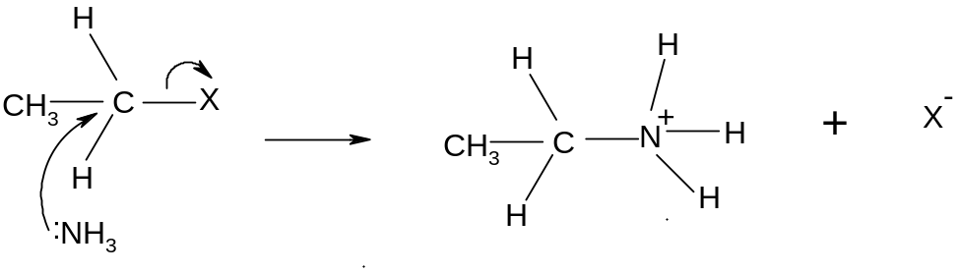

The initial substitution step forms the intermediate R-NH₃⁺ ion. The H is removed by another ammonia molecule to form the amine:

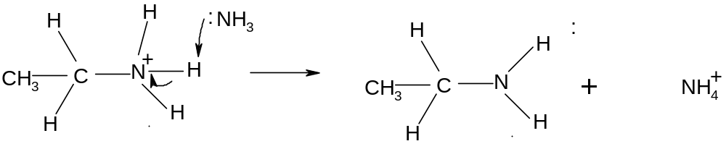

Eg bromoethane → aminoethane

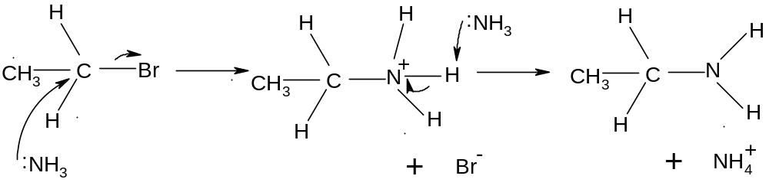

Eg 2-chloropropane → 2-aminopropane

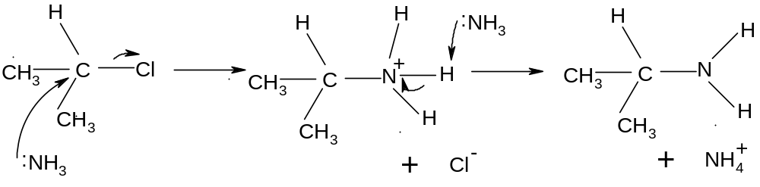

It is possible for the amine product to attack the haloalkane in the same way as ammonia does. This would make a series of alternative products called secondary amines. To avoid this, it is necessary to use excess ammonia.

- Elimination of hydrogen halides to make alkenes

If haloalkanes are boiled with an ethanolic solution of KOH instead of with an aqueous solution, they will undergo elimination of an HX molecule to give an alkene:

R₁R₂CHR₃R₄CBr + OH⁻ → R₁R₂C=CR₃R₄ + Br⁻ + H₂O

NaOH is not used since it is only sparingly soluble in ethanol. This reaction works best if distillation apparatus is used since the alkene product is volatile.

The hydrogen is always lost from a carbon atom adjacent to the carbon atom attached to the halogen (all the hydrogen atoms which could be removed have been circled). Sometimes this can result in more than one possible product:

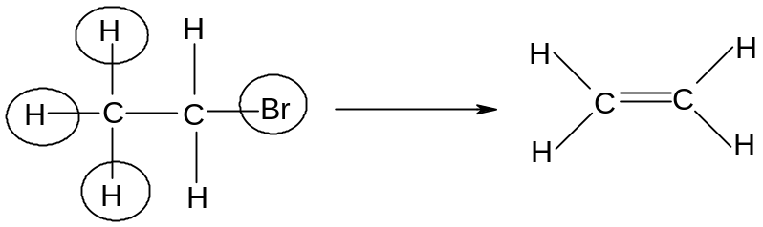
bromoethane ethene

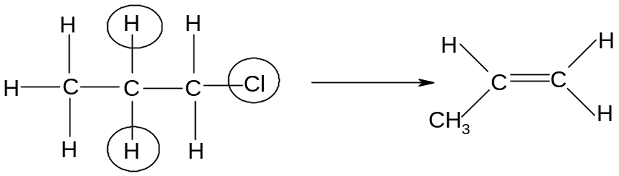
1-chloropropane propene

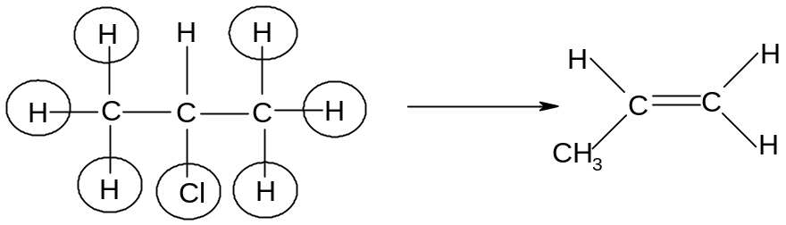
2-chloropropane propene

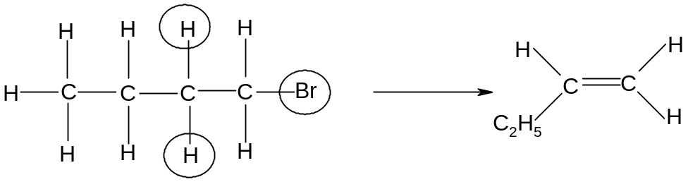
1-bromobutane but-1-ene

During the above elimination reactions there is only one possible product.

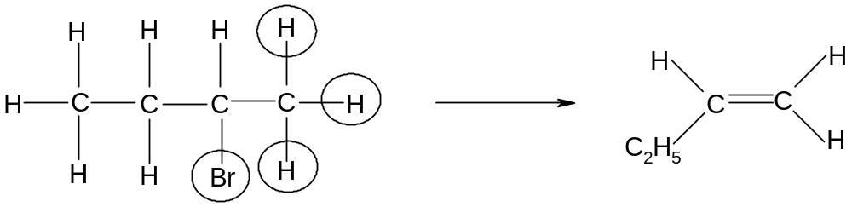

2-bromobutane but-1-ene

In this reaction, losing an H atom on the other side of the Br atom results in two different products:

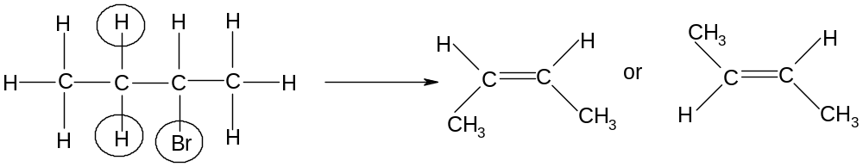

2-bromobutane cis but-2-ene or trans but-2-ene

Mechanism 4: elimination of hydrogen halides from haloalkanes

The mechanism of this reaction involves the hydroxide ion attacking a hydrogen atom on the haloalkane:

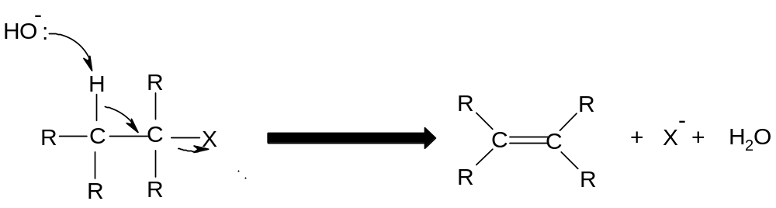

Note that the hydroxide ion is behaving as a base, not a nucleophile

Eg 1-chloropropane → propene
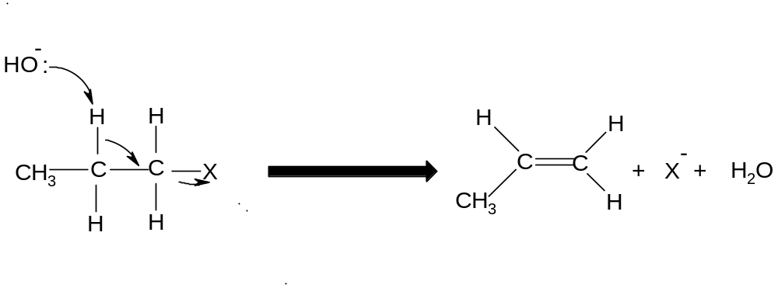

RATES OF REACTION OF HALOGENOALKANES

The rate of substitution or elimination of haloalkanes depends on the ease with which the C-X bond can be broken. This depends on the strength of the C-X bond, which in turn depends on the length of the bond.

Since the C-F bond is very short, it is very strong and difficult to break. Thus fluoroalkanes react very slowly.

The C-Cl bond is longer and weaker than the C-F bond, and the C-X bonds become progressively longer and weaker on descending the group. Thus the C-I bond is the longest, weakest and easiest to break and thus iodoalkanes react the most quickly.

Thus rates of reactions decrease in the order:
Iodoalkanes > bromoalkanes > chloroalkanes > fluoroalkanes
As the halogen atom becomes larger, the C-X bond becomes longer, weaker and easier to break and the corresponding halogenoalkanes react more quickly.

- ROLE OF CHLOROALKANES IN OZONE LAYER DEPLETION

Chloroalkanes and chlorofluoroalkanes can be used as solvents. One type in particular, known as chlorofluorocarbons (CFCs), are widely used in aerosols and fridges. Chlorofluorocarbons are haloalkanes containing chlorine and fluorine atoms but not hydrogen atoms, eg CCl₂F₂ or CClF₃. The small chlorofluorocarbons are gases and can escape into the atmosphere.

Usually chlorofluorocarbons are very unreactive. However in the upper atmosphere the C-Cl bonds can undergo homolytic fission if exposed to ultra-violet light:
Eg CF₂Cl₂ → CF₂Cl. + Cl.

Ozone (O₃) is a naturally occurring substance found in the upper atmosphere. It plays an important role in absorbing ultra-violet radiation from the sun and preventing it from getting to the earth’s surface.

However if CFCs find their way into the upper atmosphere and the ultra-violet light breaks them down into Cl. radicals, these Cl. radicals act as catalysts in the destruction of the ozone layer as follows:
Cl. + O₃ → ClO. + O₂
ClO. + O₃ → 2O₂ + Cl.
This process can repeat itself indefinitely, meaning that even small quantities of chlorine radicals can significantly destroy the ozone layer.

This process has resulted in the formation of a hole in the ozone layer.

As a result of this, chemists supported legislation to ban CFCs completely and they have been replaced in fridges and aerosols by alternative chlorine-free compounds.

The hole in the ozone layer is slowly mending itself.
- THE MANUFACTURE OF ETHANOL

Ethanol can be manufactured industrially in two ways – fermentation of sugars and hydration of ethene. The method used depends on the desired purity of the ethanol and the availability of the different raw materials in the country where it is manufactured.

- fermentation of sugars

At 35 – 55 ºC, sugars such as glucose can be fermented by yeast and turned into ethanol and carbon dioxide. This process must be carried out in the absence of air:
C₆H₁₂O₆ → 2C₂H₅OH + 2CO₂

This process has a number of advantages:
- it is a low-technology process, which means it can be used anywhere
- it does not use much energy
- it uses sugar cane as a raw material, which is a renewable resource
There are, however, a few disadvantages associated with this process:
- it is a batch process, which means that once the reaction has finished the vessel needs to emptied before the reaction can be started again
- it is a relatively slow process
- it produces fairly impure ethanol

Ethanol for human consumption is manufactured during this process. Some ethanol made in this way is also used as fuels in countries such as Brazil, which have an abundant supply of sugar cane.

- hydration of ethene

At 300 ºC and 60 atmospheres with a concentrated H₃PO₄ catalyst, H₂O can be added to ethene to make ethanol:
C₂H₄ + H₂O → C₂H₅OH

This process has a number of advantages:
- it is a relatively fast process
- it is a continuous flow process, which means that ethene can be entered into the vessel continuously and the reaction never has to be stopped
- it produces pure ethanol
There are also a number of disadvantages associated with this process:
- it requires fairly high technology
- it uses a lot of energy
- the ethene comes from crude oil, which is a non-renewable resource

Ethanol for use in industry is manufactured during this process.

- REACTIONS OF ALCOHOLS

Alcohols are saturated molecules containing an –OH group. The H atom in the
O-H bond can hydrogen bond with other alcohol molecules and with water, which is why alcohols have relatively high boiling points and many are soluble in water.

Ethanol, C₂H₅OH, is the most commercially important of the alcohols. In pure form it is used as a fuel and as a solvent, and in impure form is present in alcoholic drinks.

Alcohol molecules are saturated and polar, containing a δ+ve carbon. Thus alcohols tend to undergo nucleophilic substitution reactions.

The OH can combine with an adjacent H atom to form a stable H₂O molecule. Thus alcohols can also undergo elimination reactions.

Alcohols can lose hydrogen and undergo a variety of oxidation and combustion reactions.

Primary, secondary and tertiary alcohols

Alcohols can be divided into three classes: primary, secondary and tertiary.

Primary alcohols are those in which the carbon attached to the OH is attached to 0 or 1 other carbon atom. In other words, they are molecules in which the functional group is at the end of the chain.

Eg propan-1-ol
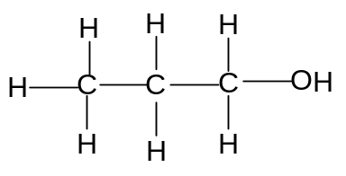

Secondary alcohols are those in which the carbon attached to the OH is attached to 2 other carbon atoms. In other words, they are molecules in which the functional group is not at the end of the chain.

Eg propan-2-ol
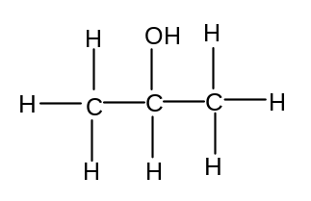
Tertiary alcohols are those in which the carbon atom attached to the OH is attached to 3 other carbon atoms. In other words, they are molecules in which the functional group is attached to a carbon which also has a branch attached to it.

Eg 2-methypropan-2-ol
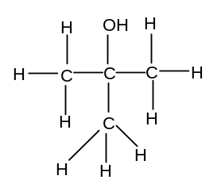

- Combustion of Alcohols

Ethanol is a useful fuel; it burns with a clean flame and is increasingly used in cars:

C₂H₆O(l) + 3O₂(g) → 3CO₂(g) + 3H₂O(g)

If the ethanol used has been produced by fermentation, then it can be classified as a renewable fuel. A fuel derived or produced from renewable biological sources is known as a biofuel.

Biofuels are carbon-neutral. Although they release carbon dioxide when they are burned, they come from plant sources which absorb carbon dioxide from the atmosphere during photosynthesis while they are growing. Thus there are no net emissions of carbon dioxide during the process from growing to combustion.

b) elimination reactions

Like halogenoalkanes, alcohols can undergo elimination to give alkenes. Since alcohols lose water when they undergo elimination, the reaction is also called dehydration.

The ethanol should be heated and passed over a catalyst (pumice can be used).It can also be refluxed at 180ºC with concentrated sulphuric acid.

Alkenes produced in this way can be polymerised. This method therefore allows polymers to be produced without using crude oil (assuming that the original ethanol was produced by fermentation).

The dehydration of alcohols is favoured by acidic conditions, as the -OH group becomes protonated by H⁺ ions which produces a water molecule which then leaves. The acid acts as a catalyst. The detailed mechanism is not required.

The H which is lost comes from a carbon atom which is adjacent to the carbon atom attached to the OH group. In some cases, this can lead to more than one product.

Eg butan-2-ol:

When butan-2-ol undergoes elimination, two different products can be formed depending on which H atom is lost:

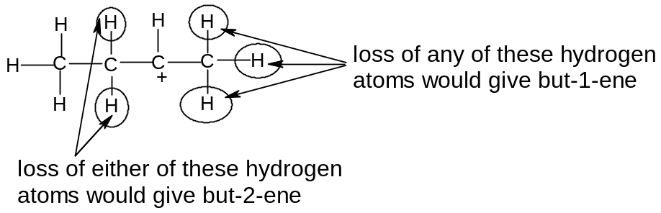

Mechanism 5 – Dehydration of Alcohols

The OH group on the alcohol accepts a proton, and water is then lost to form a carbocation:

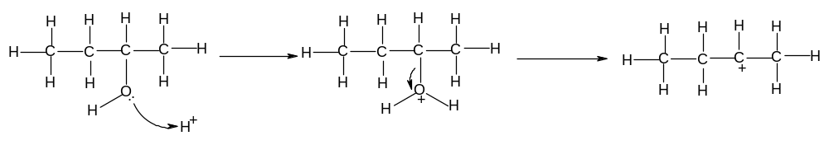
One of the C atoms next to the C+ loses its hydrogen, with the electron pair from the C-H bond being used to form the C=C bond:

Butan-2-ol → but-2-ene:
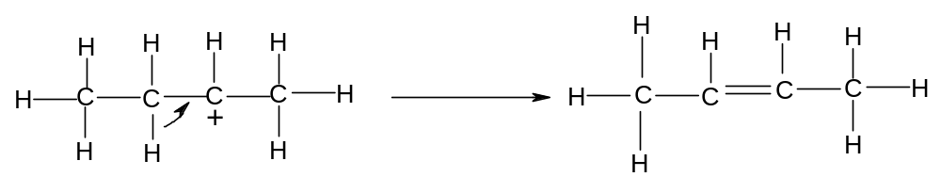
Butan-2-ol → but-1-ene

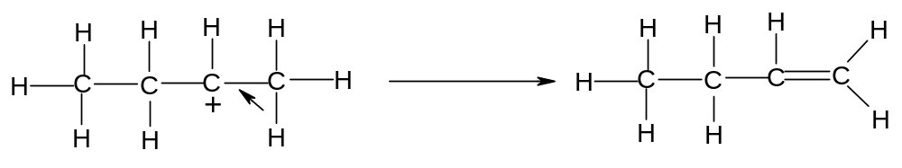

NB Alcohols which have no H atoms on the C atom adjacent to the OH group cannot undergo elimination:

Eg dimethylpropanol: 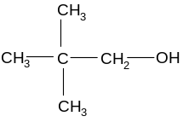

c) oxidation reactions to make aldehydes, ketones and carboxylic acids

Oxidation in organic chemistry can be regarded as the addition of oxygen or the removal of hydrogen. As the full equations are quite complex, the oxidising agent is represented by the symbol [O].

i) mild oxidation of primary and secondary alcohols

If a primary alcohol is mixed with an oxidising agent, two hydrogen atoms can be removed and an aldehyde will be formed:

Eg CH₃CH₂OH + [O] → CH₃CHO + H₂O

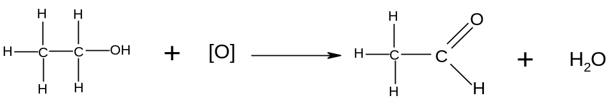
Ethanol Ethanal

An aldehyde is a molecule containing the following group:
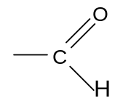

If a secondary alcohol is mixed with an oxidising agent, two hydrogen atoms can be removed and a ketone will be formed:

Eg CH₃CH(OH)CH₃ + [O] → CH₃COCH₃ + H₂O

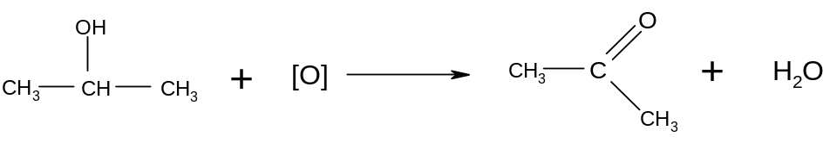
Propan-2-ol propanone

A ketone is a molecule containing the following group:
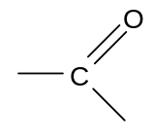

Tertiary alcohols are not readily oxidised since they do not have available H atoms to give up.

Aldehydes and ketones are collectively known as carbonyls and can be represented by the general formula C_{n}H_{2n}O
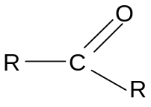

In aldehydes, one of the R groups is a H atom. In ketones, neither of the R groups is a H atom.

b) further oxidation of aldehydes

If an aldehyde is mixed with an oxidising agent, an oxygen atom can be added to the group and a carboxylic acid will be formed:

Eg CH₃CHO + [O] → CH₃COOH

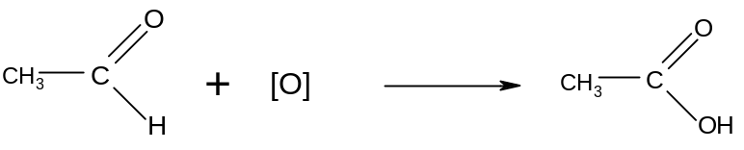
Ethanal Ethanoic acid

A carboxylic acid is a molecule containing the following group:
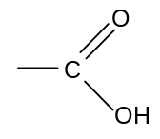

Ketones cannot be oxidised into carboxylic acids since there is no C-H bond into which an oxygen atom can be inserted.

Reagents and conditions for oxidation

The oxidising agent most widely used in organic chemistry is potassium dichromate (K₂Cr₂O₇) in dilute sulphuric acid (H₂SO₄).
Cr₂O₇²⁻(aq) + 14H⁺(aq) + 6e → 2Cr³⁺(aq) + 7H₂O(l)
The Cr₂O₇²⁻(aq) ion is orange and the Cr³⁺ ion is green. Thus this reduction process is accompanied by a colour change from orange to green.

If primary alcohols are oxidised, it is possible to form both aldehydes and carboxylic acids. The major product will depend on the conditions used.

Carbonyls are more volatile than alcohols and carboxylic acids, since there is no hydrogen bonding between aldehyde molecules. Thus if a distillation apparatus is used, the volatile aldehyde can be distilled off as it is formed. If reflux apparatus is used, the aldehyde remains in the reaction vessel and is converted into the carboxylic acid.
Thus distillation apparatus should be used to make carbonyls and reflux apparatus should be used to make carboxylic acids. Heat and an excess of the oxidising agent also improve the yield of carboxylic acid.

Secondary alcohols are oxidised to make ketones only. The distillation apparatus is still favoured since the ketone is volatile so can be distilled off as it is formed.

Thus the oxidation reactions of alcohols and aldehydes can be summarised as follows:

R-CH₂OH + [O] → R-CHO + H₂O (primary alcohol → aldehyde)
K₂Cr₂O₇, H₂SO₄, mild conditions, distillation.

R-CH₂OH + 2[O] → R-COOH + H₂O (primary alcohol → carboxylic acid)
Excess K₂Cr₂O₇, H₂SO₄, heat, reflux

R-CHO + [O] → R-COOH (aldehyde → carboxylic acid)
Excess K₂Cr₂O₇, H₂SO₄, heat, reflux

R₁-CH(OH)-R₂ + [O] → R₁-CO-R₂ + H₂O (secondary alcohol → ketone)
K₂Cr₂O₇, H₂SO₄, heat, distillation

Summary of oxidation reactions of alcohols and carbonyls

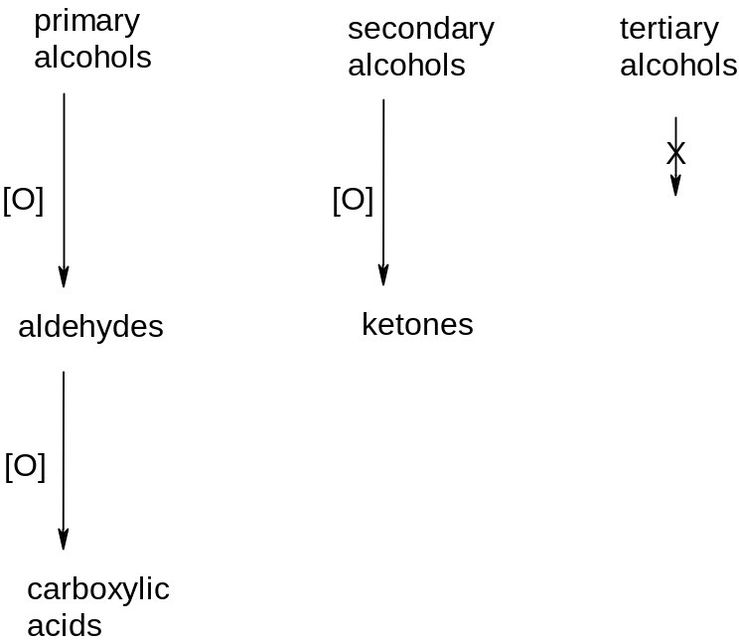
SUMMARY OF REACTIONS IN ORGANIC CHEMISTRY

- Alkane → haloalkane

Conditions: UV light

Equation: RCH₃ + X₂ → RCH₂Cl + HCl

Mechanism: free radical substitution

- Alkene → polyalkene

Conditions: high p.

Equation:
Type of reaction: addition polymerisation

- Alkene → halogenoalkane

Reagent: HX(g)
Conditions: room T

Equation:
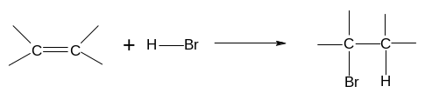
Mechanism: electrophilic addition

- Alkene → dihalogenoalkane

Reagent: X₂ in water or in an organic solvent
Conditions: room T

Equation:
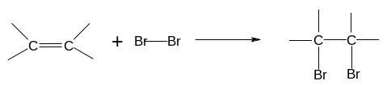
Mechanism: electrophilic addition

- Alkene → alkylhydrogensulphate

Reagent: concentrated sulphuric acid
Conditions: cold

Equation:
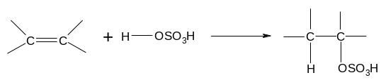
Mechanism: electrophilic addition

- Alkene → alcohol

Reagent: steam
Conditions: 300 ºC, 60 atm, H₃PO₄ catalyst

Equation:
Type of reaction: hydration

- Haloalkane → alcohol

Reagent: NaOH(aq) or KOH(aq)
Conditions: warm under reflux

Equation: R-X + OH⁻ → R-OH + X⁻

Mechanism: nucleophilic substitution

Role of hydroxide ion: nucleophile

- Haloalkane → nitrile

Reagent: KCN in aqueous ethanol
Conditions: boil under reflux

Equation: R-X + CN⁻ → R-CN + X⁻

Mechanism: nucleophilic substitution

- Haloalkane → Amine

Reagent: ammonia in ethanol in a sealed tube
Conditions: heat

Equation: R-X + 2NH₃ → R-NH₂ + NH₄X

Mechanism: nucleophilic substitution

- Haloalkane → alkene

Reagent: KOH in ethanol
Conditions: heat

Equation:
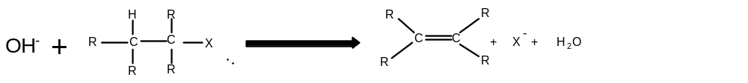
Mechanism: elimination

Role of hydroxide ion: base

- Primary alcohol → aldehyde

Reagent: potassium dichromate and dilute sulphuric acid
Conditions: warm, distillation

Equation: RCH₂OH + [O] → RCHO + H₂O

Type of reaction: oxidation

- Secondary alcohol → ketone

Reagent: potassium dichromate and dilute sulphuric acid
Conditions: heat, distillation

Equation: R₁CH(OH)R₂ + [O] → R₁COR₂ + H₂O

Type of reaction: oxidation

- aldehyde → carboxylic acid

Reagent: potassium dichromate and dilute sulphuric acid
Conditions: heat, reflux

Equation: R-CHO + [O] → R-COOH

Type of reaction: oxidation

- Alcohols → alkenes

Reagent: concentrated sulphuric acid

Conditions: heat

Equation: R₁R₂CHC(OH)R₃R₄ → R₁R₂C=CR₃R₄ + H₂O

Type of reaction: elimination

