AS LEVEL CHEMISTRY

TOPIC 8 – REACTIONS OF ORGANIC COMPOUNDS
TEST
Answer all questions
Max 50 marks

Name ……………………………………………………………..

Mark ……../50 ……....% Grade ………

1. Trifluoromethane (CHF₃) can be used to make the refrigerant chlorotrifluoromethane(CClF₃).
(a) Chlorotrifluoromethane is formed when trifluoromethane reacts with chlorine.
CHF₃ + Cl₂ CClF₃ + HCl
The reaction is a free-radical substitution reaction similar to the reaction of methane with chlorine.
(i) Write an equation for each of the following steps in the mechanism for the reaction of CHF₃ with Cl₂
Initiation step
...............................................................................................................
First propagation step
...............................................................................................................
Second propagation step
...............................................................................................................
Termination step to form hexafluoroethane
...............................................................................................................
(4)
(ii) Give one essential condition for this reaction.
...............................................................................................................
(1)
(b) In some refrigeration systems, CHF₃ has replaced CClF₃ because of concerns about ozone depletion.
(i) Identify the species formed from CClF₃ that is responsible for the catalytic decomposition of ozone in the upper atmosphere.
...............................................................................................................
(1)
(ii) Write an overall equation to represent the decomposition of ozone into oxygen.
...............................................................................................................
(1)
(Total 7 marks)

2. Consider the following reactions.
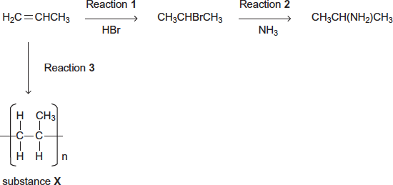
(a) Name and outline a mechanism for Reaction 1.
Name of mechanism .........................................................................................................
Mechanism

(5)
(b) Name and outline a mechanism for Reaction 2.
Name of mechanism .........................................................................................................
Mechanism

(5)

(c) State the type of reaction in Reaction 3.
Give the name of substance X.
........................................................................................................................
........................................................................................................................
........................................................................................................................
(2)
(d) The haloalkane produced in Reaction 1 can be converted back into propene in an elimination reaction using ethanolic potassium hydroxide.
CH₃CHBrCH₃ 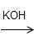 H₂C=CHCH₃
Outline a mechanism for this conversion.

(3)
(Total 15 marks)

3. Glucose can be used as a source of ethanol. Ethanol can be burned as a fuel or can be converted into ethene.
C₆H₁₂O₆ → CH₃CH₂OH → H₂C=CH₂
glucose ethanol ethene
(a) Name the types of reaction illustrated by the two reactions above.
Glucose to ethanol .......................................................................................
Ethanol to ethene .........................................................................................
(2)
(b) (i) State what must be added to an aqueous solution of glucose so that ethanol is formed.
.............................................................................................................
(ii) Identify a suitable catalyst for the conversion of ethanol into ethene.
.............................................................................................................
(2)
(c) (i) State the class of alcohols to which ethanol belongs.
.............................................................................................................
(ii) Give one advantage of using ethanol as a fuel compared with using a petroleum fraction.
.............................................................................................................
(2)
(d) Most of the ethene used by industry is produced when ethane is heated to 900°C in the absence of air. Write an equation for this reaction.
......................................................................................................................
(1)
(e) Name the type of polymerisation which occurs when ethene is converted into poly(ethene).
......................................................................................................................
(1)
(Total 8 marks)

4. In an investigation of the chemical properties of alcohols, a mixture of ethanol and acidified potassium dichromate(VI) is heated in a conical flask in a water bath.
(a) Explain why a water bath is used to heat the mixture.
........................................................................................................................
........................................................................................................................
(1)
(b) Describe the colour change which would be observed.
........................................................................................................................
........................................................................................................................
(1)
(Total 2 marks)

5. (a) Ethanol can be manufactured by the direct hydration of ethene and by the fermentation of sugars.
(i) State what is meant by the term hydration.
.............................................................................................................
(ii) Give one advantage and one disadvantage of manufacturing ethanol by fermentation rather than by hydration.
Do not include energy consumption or cost.
Advantage ...........................................................................................
.............................................................................................................
Disadvantage ......................................................................................
.............................................................................................................
(3)

(b) Ethanol can be oxidised to an aldehyde and to a carboxylic acid.
(i) Draw the structure of this aldehyde and of this carboxylic acid.
Structure of aldehyde Structure of carboxylic acid

(ii) Give a suitable reagent and reaction conditions for the oxidation of ethanol to form the carboxylic acid as the major product.
Reagent ..............................................................................................
Conditions ...........................................................................................
.............................................................................................................
(5)
(c) (i) Draw the structure of an alcohol containing four carbon atoms which is resistant to oxidation.

(ii) Draw the structure of an alcohol containing four carbon atoms which can be oxidised to a ketone.

(2)
(Total 10 marks)

6. Which one of the following mechanisms is not involved in the reaction sequence below?
CH₃CH₃ → CH₃CH₂Cl → CH₃CH₂OH → CH₂=CH₂ → CH₃CH₂Br
A electrophilic addition
B electrophilic substitution
C nucleophilic substitution
D free-radical substitution
(Total 1 mark)

7. In which of the following is a curly arrow used incorrectly?
A 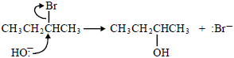
B 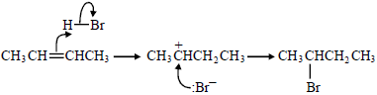
C 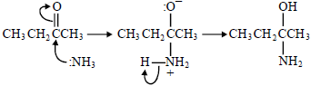
D 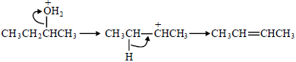
(Total 1 mark)

8. Which one of the following statements explains best why fluoroalkanes are the least reactive haloalkanes?
A Fluorine is much more electronegative than carbon.
B The F⁻ ion is the most stable halide ion.
C The C–F bond is the most polar carbon–halogen bond.
D The C–F bond is the strongest carbon–halogen bond.
(Total 1 mark)

9. Which one of the following conversions does not represent a reduction?
A propene → propane
B propanal → propan-l-ol
C propanal → propanoic acid
D propanone → propane
(Total 1 mark)

10. Which one of the following isomers is not oxidised under mild reaction conditions?
A (CH₃)₂CHCH(OH)COCH₃
B (CH₃)₂C(OH)CH₂COCH₃
C (CH₃)₂CHCH(OH)CH₂CHO
D (CH₃)₂C(OH)CH₂CH₂CHO
(Total 1 mark)

11. Which one of the following alcohols forms a mixture of alkenes when dehydrated?
A propan-1-ol
B propan-2-ol
C pentan-1-ol
D pentan-2-ol
(Total 1 mark)

12. Which one of the following cannot be produced by oxidation of propan-l-ol?
A carbon dioxide
B propanone
C propanal
D propanoic acid
(Total 1 mark)

13. 25.0 cm³ of ethanedioic acid required 22.5 cm³ of 0.100 mol dm⁻³ potassium hydroxide solution for complete neutralisation.
The concentration of ethanedioic acid is
A 0.0225 mol dm⁻³
B 0.0450 mol dm⁻³
C 0.0560 mol dm⁻³
D 0.0900 mol dm⁻³
(Total 1 mark)

