2.2.3 Exercise 3 - MASS SPECTRA OF ORGANIC COMPOUNDS
In a mass spectrum, molecules are ionised and the ions are then detected according to their relative mass (their mass/charge ratio, m/z).
Some of the molecule remains intact – the intact molecule always gives you the peak with the largest m/z ratio (ie the peak furthest to the right). This peak is called the molecular ion peak and tells you the rmm of the molecule.
Some of the molecule breaks up (fragments). The fragments give rise to peaks with smaller m/z ratios and these are known as fragment ion peaks. These fragments give you clues about the structure of the molecule.

Mass Spectrum 1 – an unknown organic molecule
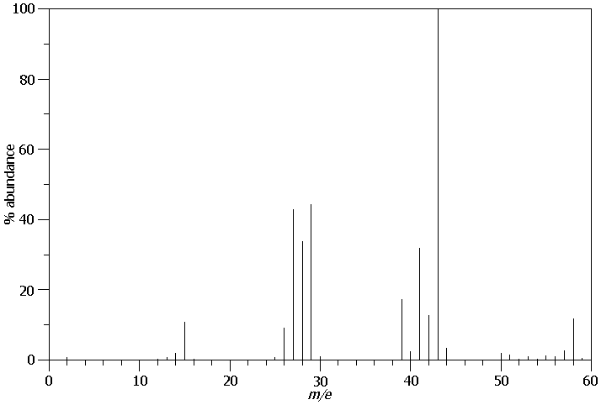
- Circle the peak with the largest m/z ratio and hence deduce the rmm of the molecule.

- How many molecules can you think of with this rmm?

- What are the m/z values of the two most abundant fragment ions?

- Can you think of possible fragments that could be responsible for these peaks?

- Hence can you deduce the most likely structure of this molecule?

Mass Spectrum 2 – a known organic molecule
- Can you name this molecule?

- Can you account for the peaks at 43, 55, 83 and 98?

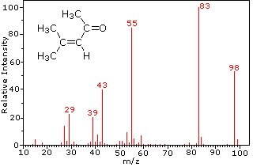

Mass Spectrum 3 – an unknown organic molecule
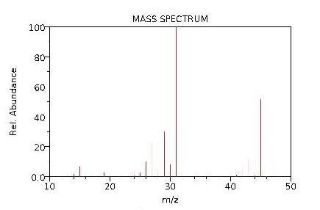
- Identify the molecular ion peak and the two most abundant fragment ion peaks.

- Account for the two fragment ion peaks and hence identify the molecule.

Mass Spectrum 4 – a known organic molecule
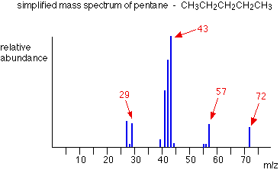
- Identify the species responsible for the peaks at 29, 43, 57 and 72

Mass Spectrum 5 – a known organic molecule
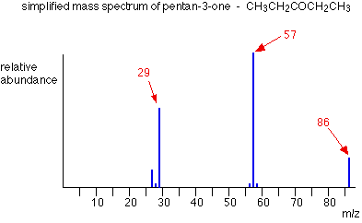
- Identify the species responsible for the peaks at 29, 57 and 86

IDENTIFYING ORGANIC MOLECULES FROM THEIR MASS SPECTRA

The mass spectrum of hydrocarbon A is found to give peaks at:
m/z = 15, m/z = 29, m/z = 43, m/z = 57, m/z = 72

The mass spectrum of hydrocarbon B is found to give peaks at:
m/z = 15, m/z = 57, m/z = 72

The mass spectrum of hydrocarbon C is found to give peaks at:
m/z = 15, m/z = 27, m/z = 29, m/z = 41, m/z = 56

The mass spectrum of hydrocarbon D is found to give peaks at:
m/z = 15, m/z = 41, m/z = 56

The mass spectrum of alcohol E is found to give peaks at;
m/z = 15, m/z = 29, m/z = 45, m/z = 59, m/z = 74

The mass spectrum of alcohol F is found to give peaks at;
m/z = 15, m/z = 59, m/z = 74

The mass spectrum of alcohol G is found to give peaks at;
m/z = 15, m/z = 29, m/z = 31, m/z = 43, m/z = 45, m/z = 59, m/z = 74

The mass spectrum of alcohol H is found to give peaks at;
m/z = 15, m/z = 31, m/z = 43, m/z = 59, m/z = 74

Identify B, C, E, F, G and H. Deduce two possible structures of A and D.
Identify at least one of the fragment ions responsible for a peak in each spectrum.

FINGERPRINTING
The mass spectrum of a molecule is sometimes described as its “fingerprint”.
Explain why.

