A-LEVEL CHEMISTRY

PAPER 1
PRACTICE PAPER 1

Answer all questions
Max 105 marks
2 hours

Name ……………………………………………………………..

Mark ……../105 ……....% Grade ………

1. | 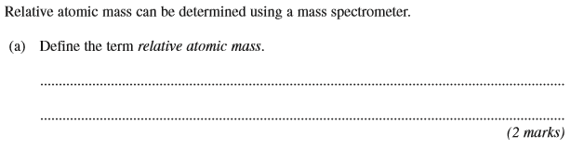
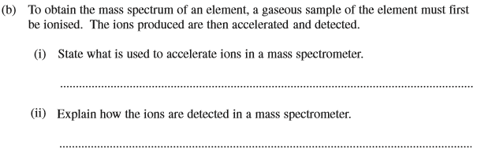
(2 marks)
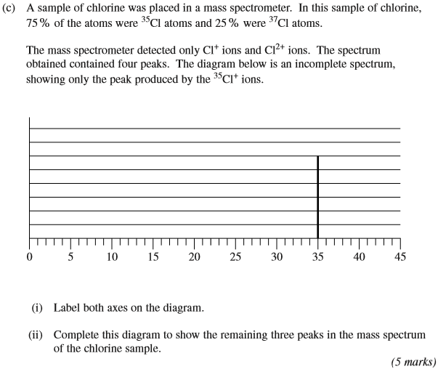
(Total 9 marks)
2. | 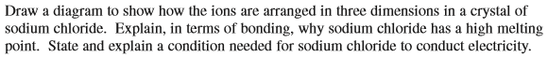  ………………………………………………………………………………………………………………………………………………………………………………...  ………………………………………………………………………………………………………………………………………………………………………………...  ………………………………………………………………………………………………………………………………………………………………………………...  (Total 6 marks)
3. | 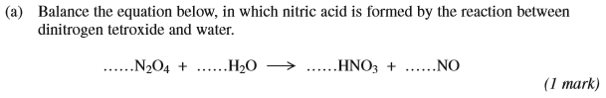  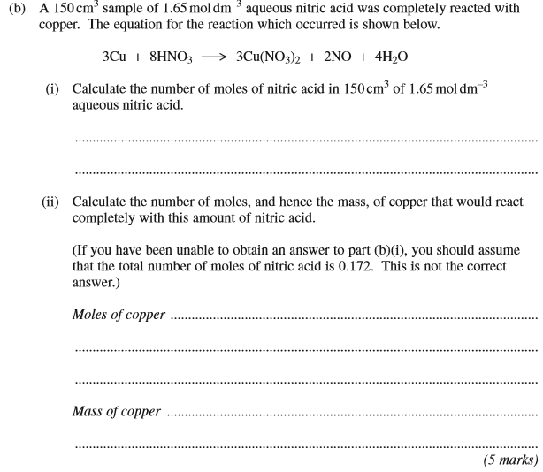  (Total 6 marks)
4. The oxides nitrogen monoxide (NO) and nitrogen dioxide (NO₂) both contribute to atmospheric pollution.
The table gives some data for these oxides and for oxygen.

 | S^{ϴ} / JK^{–1} mol^{–1} | ∆H_{f}^{ϴ} / kJ mol^{–1}
O₂(g) | 211 | 0
NO(g) | 205 | +90
NO₂(g) | 240 | +34

Nitrogen monoxide is formed in internal combustion engines. When nitrogen monoxide comes into contact with air, it reacts with oxygen to form nitrogen dioxide.
NO(g) + O₂(g) NO₂(g)
(a) Calculate the enthalpy change for this reaction.
........................................................................................................................
........................................................................................................................
........................................................................................................................
........................................................................................................................
(2)
(b) Calculate the entropy change for this reaction.
........................................................................................................................
........................................................................................................................
........................................................................................................................
........................................................................................................................
(2)
(c) Calculate the temperature below which this reaction is spontaneous.
........................................................................................................................
........................................................................................................................
........................................................................................................................
........................................................................................................................
........................................................................................................................
(2)

(d) Suggest one reason why nitrogen dioxide is not formed by this reaction in an internal combustion engine.
........................................................................................................................
........................................................................................................................
(1)
(e) Write an equation to show how nitrogen monoxide is formed in an internal combustion engine.
........................................................................................................................
(1)
(f) Use your equation from part (e) to explain why the free-energy change for the reaction to form nitrogen monoxide stays approximately constant at different temperatures.
........................................................................................................................
........................................................................................................................
........................................................................................................................
........................................................................................................................
(2)
(Total 10 marks)

5. (a) By reference to the forces between molecules, explain why ammonia is very soluble in water.
......................................................................................................................
......................................................................................................................
(2)
(b) Aqueous solutions of ammonia have a pH greater than 7.
(i) Write an equation for the reaction of ammonia with water.
.............................................................................................................
(ii) Explain why the pH of a solution containing 1.0 mol dm^{–3} of ammonia is less than
14 at 298 K.
.............................................................................................................
.............................................................................................................
(3)
(c) An ammonium ion in aqueous solution can behave as a Brønsted–Lowry acid. State what is meant by the term Brønsted–Lowry acid.
.....................................................................................................................................
(1)

(d) State what is meant by the term buffer solution. Identify a reagent which could be added to a solution of ammonia in order to form a buffer solution.
Buffer solution ..............................................................................................
......................................................................................................................
Reagent ........................................................................................................
(3)
(e) An acidic buffer solution is obtained when sodium ethanoate is dissolved in aqueous ethanoic acid.
(i) Calculate the pH of the buffer solution formed at 298 K when 0.125 mol of sodium ethanoate is dissolved in 250 cm³ of a 1.00 mol dm^{–3} solution of ethanoic acid.
The acid dissociation constant, K_{a}, for ethanoic acid is 1.70 × 10^{–5} mol dm^{–3} at 298 K.
.............................................................................................................
.............................................................................................................
.............................................................................................................
.............................................................................................................
.............................................................................................................
.............................................................................................................
(ii) Write an ionic equation for the reaction which occurs when a small volume of dilute hydrochloric acid is added to this buffer solution.
.............................................................................................................
(5)
(Total 14 marks)

6. In order to obtain a pH curve, you are provided with a conical flask containing 25.0 cm³ of a 0.100 mol dm^{–3} carboxylic acid solution and a burette filled with 0.100 mol dm^{–3} sodium hydroxide solution. You are also provided with a calibrated pH meter.
(a) State why calibrating a pH meter just before it is used improves the accuracy of the pH measurement.
........................................................................................................................
........................................................................................................................
(1)

(b) Describe how you would obtain the pH curve for the titration.
........................................................................................................................
........................................................................................................................
........................................................................................................................
........................................................................................................................
........................................................................................................................
........................................................................................................................
........................................................................................................................
........................................................................................................................
........................................................................................................................
........................................................................................................................
(5)
(Total 6 marks)

7. One cell that has been used to provide electrical energy is the Daniell cell. This cell uses copper and zinc.
(a) The conventional representation for the Daniell cell is
Zn(s) | Zn²⁺(aq) | | Cu²⁺(aq) | Cu(s)
The e.m.f. of this cell under standard conditions is +1.10 V.
Deduce the half-equations for the reactions occurring at the electrodes.
At Zn electrode ..............................................................................................
At Cu electrode ..............................................................................................
(2)
(b) A Daniell cell was set up using 100 cm³ of a 1.0 mol dm^{–3} copper(II) sulfate solution. The cell was allowed to produce electricity until the concentration of the copper(II) ions had decreased to 0.50 mol dm^{–3}.
Calculate the decrease in mass of the zinc electrode. Show your working.
........................................................................................................................
........................................................................................................................
........................................................................................................................
........................................................................................................................
........................................................................................................................
(3)
(c) You are provided with the Daniell cell referred to in part (b), including a zinc electrode of known mass.
Briefly outline how you would carry out an experiment to confirm your answer to part (b).
........................................................................................................................
........................................................................................................................
........................................................................................................................
........................................................................................................................
........................................................................................................................
........................................................................................................................
(3)
(Total 8 marks)

8. The data in the table below show the melting points of oxides of some Period 3 elements.

 | Na₂O | P₄O₁₀ | SO₂
T_{m}/K | 1548 | 573 | 200

(a) In terms of structure and bonding, explain why
(i) sodium oxide has a high melting point
...............................................................................................................
...............................................................................................................
...............................................................................................................
(2)
(ii) sulfur dioxide has a low melting point.
...............................................................................................................
...............................................................................................................
...............................................................................................................
...............................................................................................................
(2)
(b) Explain why the melting point of P₄O₁₀ is higher than the melting point of SO₂
........................................................................................................................
........................................................................................................................
........................................................................................................................
(2)
(c) Write equations for the reactions of Na₂O and P₄O₁₀ with water. In each case give the approximate pH of the resulting solution.
Equation for Na₂O..........................................................................................
pH ....................................
Equation for P₄O₁₀.........................................................................................
pH ....................................
(4)
(d) Write an equation for the acid–base reaction that occurs when Na₂O reacts with P₄O₁₀ in the absence of water.
........................................................................................................................
(1)
(Total 11 marks)

9. Transition metals and their complexes have characteristic properties.
(a) Give the electron configuration of the Zn²⁺ ion.
Use your answer to explain why the Zn²⁺ ion is not classified as a transition metal ion.
Electron configuration ..................................................................................
Explanation ..................................................................................................
......................................................................................................................
(2)
(b) In terms of bonding, explain the meaning of the term complex.
......................................................................................................................
......................................................................................................................
......................................................................................................................
......................................................................................................................
(2)
(c) Identify one species from the following list that does not act as a ligand. Explain your answer.
H₂ O^{2–} O₂ CO
Not a ligand..................................................................................................
Explanation ...................................................................................................
(2)

(d) The element palladium is in the d block of the Periodic Table. Consider the following palladium compound which contains the sulfate ion.
[Pd(NH₃)₄]SO₄
(i) Give the oxidation state of palladium in this compound.
.............................................................................................................
(1)

(ii) Give the names of two possible shapes for the complex palladium ion in this compound.
Shape 1 ..............................................................................................
Shape 2 ..............................................................................................
(2)
(Total 9 marks)

10. Consider the following reaction scheme that starts from aqueous [Cu(H₂O)6]²⁺ ions.
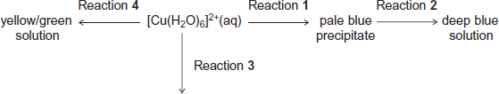
green-blue precipitate
For each of the reactions 1 to 4, identify a suitable reagent, give the formula of the copper-containing species formed and write an equation for the reaction.
(a) Reaction 1
Reagent ........................................................................................................
Copper-containing species ...........................................................................
Equation ........................................................................................................
(3)
(b) Reaction 2
Reagent ........................................................................................................
Copper-containing species ...........................................................................
Equation ........................................................................................................
(3)

(c) Reaction 3
Reagent ........................................................................................................
Copper-containing species ...........................................................................
Equation ........................................................................................................
(3)
(d) Reaction 4
Reagent ........................................................................................................
Copper-containing species ...........................................................................
Equation ........................................................................................................
(3)
(Total 12 marks)

11.
 | (a)
 | (b)
 | (c)
 | (d)
 | (e)
 | (f)
 | (g)
 | (h)
 | (i)
 | (j) | (Total 14 marks)

