A-LEVEL CHEMISTRY

PAPER 1
PRACTICE PAPER 13

Answer all questions
Max 105 marks
2 hours

Name ……………………………………………………………..

Mark ……../105 ……....% Grade ………

1. | 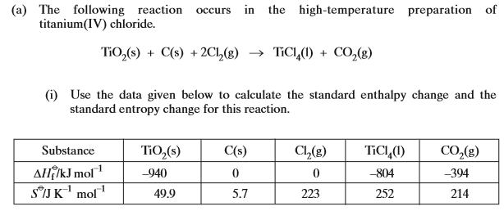  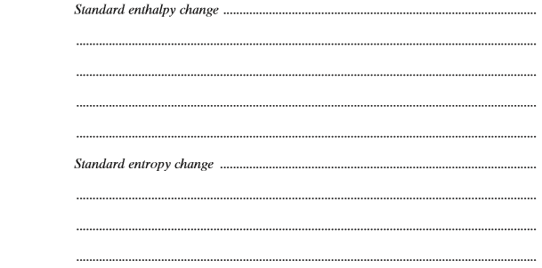  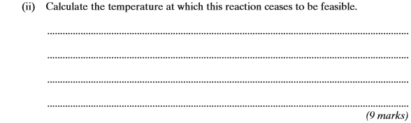
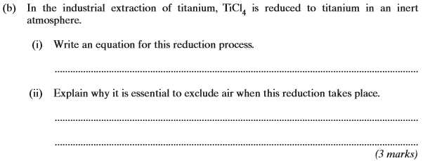
(Total 12 marks)

2. | 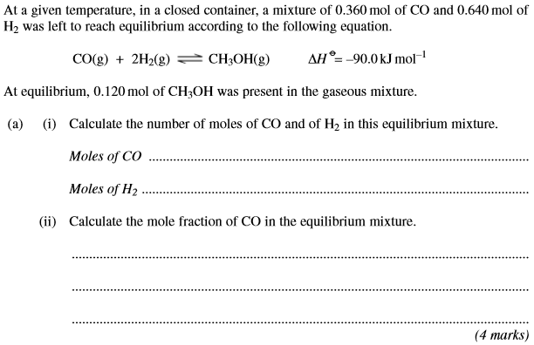
 | 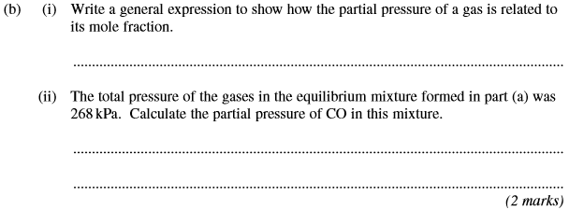
 | 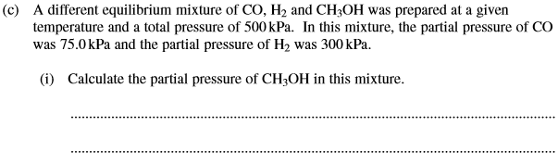
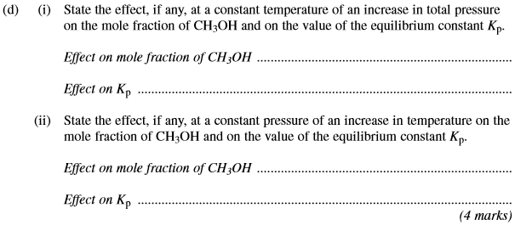
(Total 15 marks)

3. | ……………………………………………………………………………………………………………………………………………………………………………  ……………………………………………………………………………………………………………………………………………………………………………  ……………………………………………………………………………………………………………………………………………………………………………  ……………………………………………………………………………………………………………………………………………………………………………  ……………………………………………………………………………………………………………………………………………………………………………  ……………………………………………………………………………………………………………………………………………………………………………  ……………………………………………………………………………………………………………………………………………………………………………  ……………………………………………………………………………………………………………………………………………………………………………  ……………………………………………………………………………………………………………………………………………………………………………  (Total 7 marks)
4. | 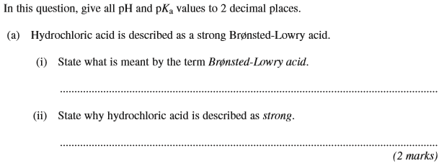
 | 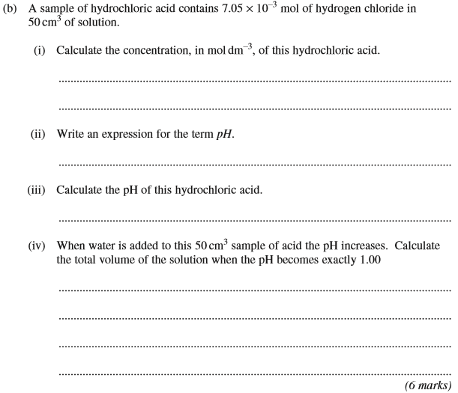
 | 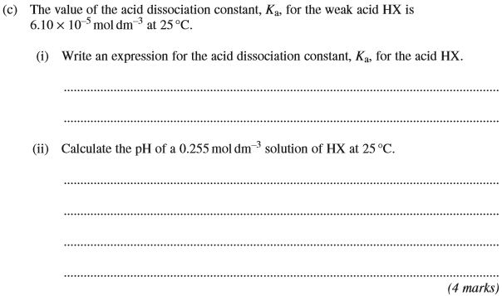
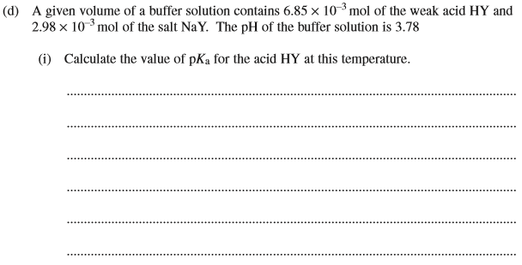
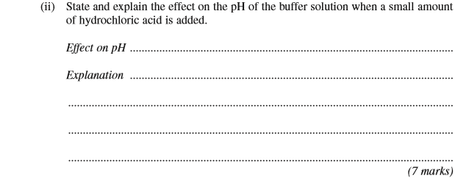
(Total 19 marks)

5. | 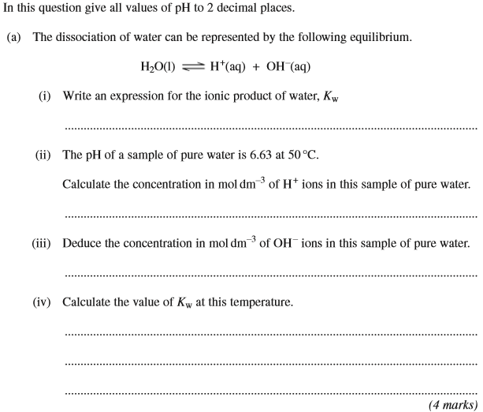
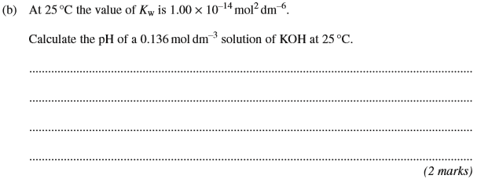
(Total 6 marks)

6. | ……………………………………………………………………………………………………………………………………………………………………………  ……………………………………………………………………………………………………………………………………………………………………………  ……………………………………………………………………………………………………………………………………………………………………………  ……………………………………………………………………………………………………………………………………………………………………………  ……………………………………………………………………………………………………………………………………………………………………………  ……………………………………………………………………………………………………………………………………………………………………………  ……………………………………………………………………………………………………………………………………………………………………………  (6 marks)
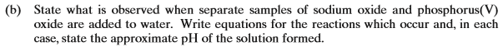
……………………………………………………………………………………………………………………………………………………………………………

……………………………………………………………………………………………………………………………………………………………………………

……………………………………………………………………………………………………………………………………………………………………………

……………………………………………………………………………………………………………………………………………………………………………

……………………………………………………………………………………………………………………………………………………………………………

……………………………………………………………………………………………………………………………………………………………………………

……………………………………………………………………………………………………………………………………………………………………………
(6 marks)
(Total 12 marks)

7. | 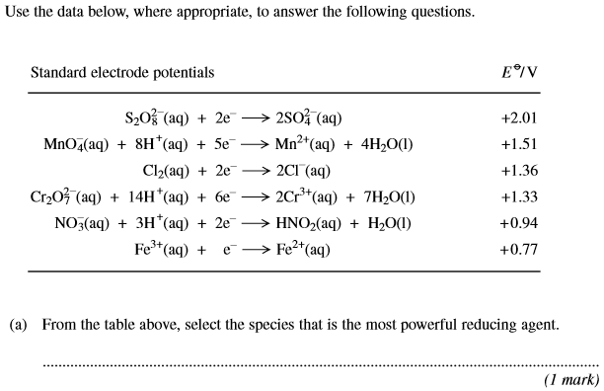
 | 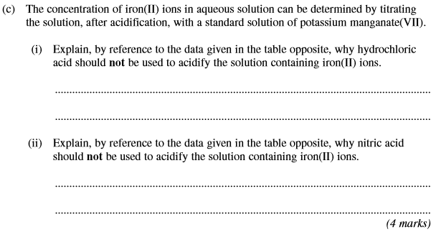
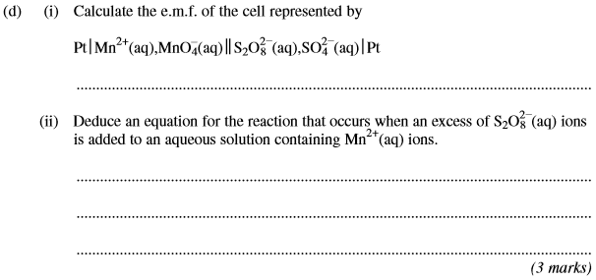
(Total 10 marks)

8. | 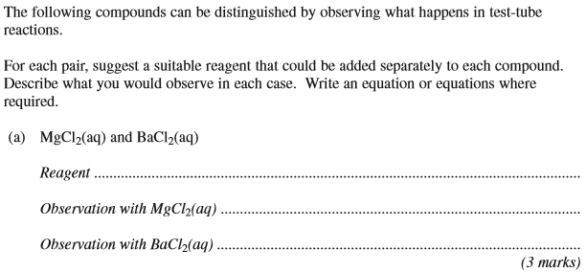
 | (Total 10 marks)
9. | 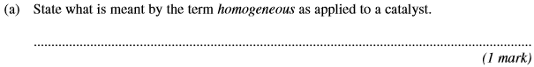
 | 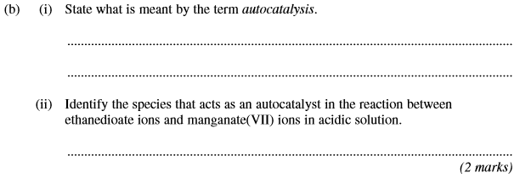
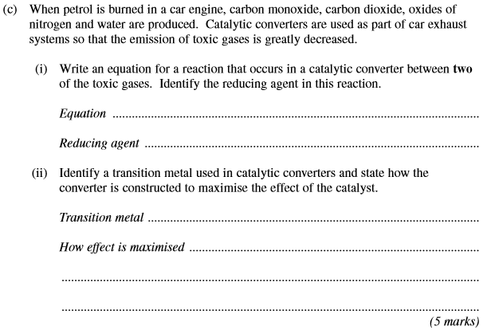
(Total 8 marks)

10. | 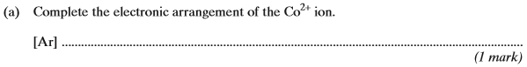
 | 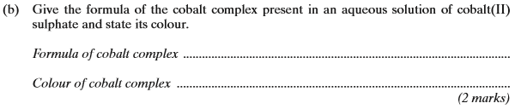
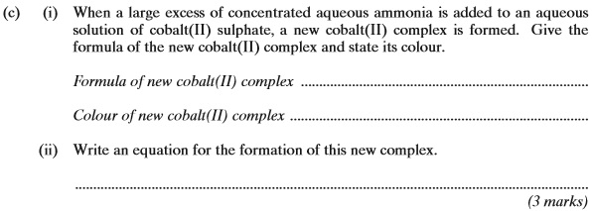
(Total 6 marks)

