A-LEVEL CHEMISTRY

PAPER 1
PRACTICE PAPER 14

Answer all questions
Max 105 marks
2 hours

Name ……………………………………………………………..

Mark ……../105 ……....% Grade ………

1. | 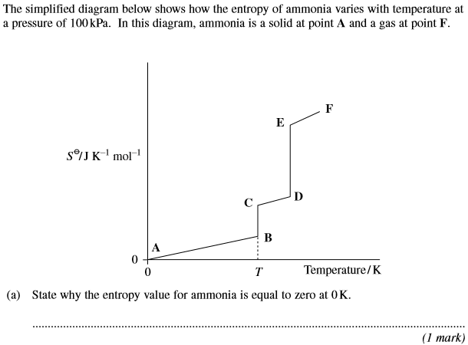
 | 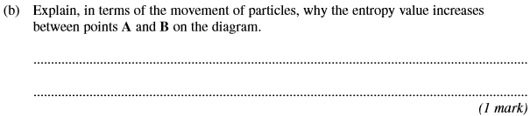
 | 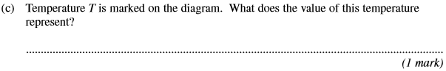
 | 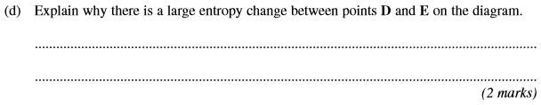
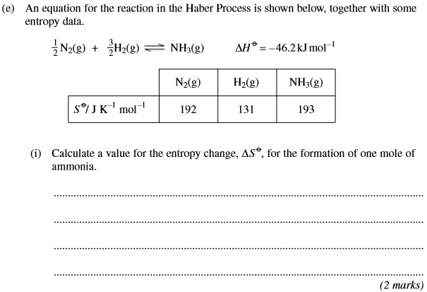
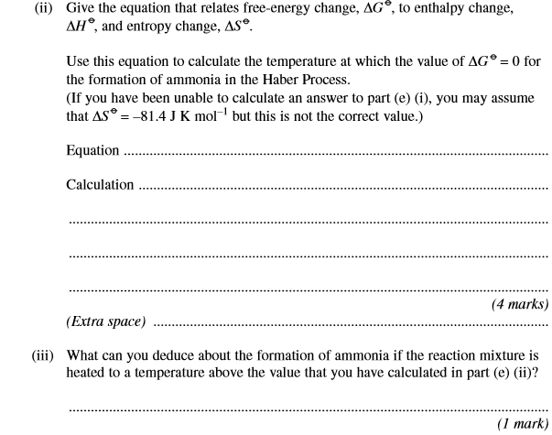
(Total 12 marks)

2. | 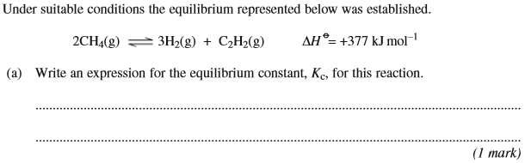
 | 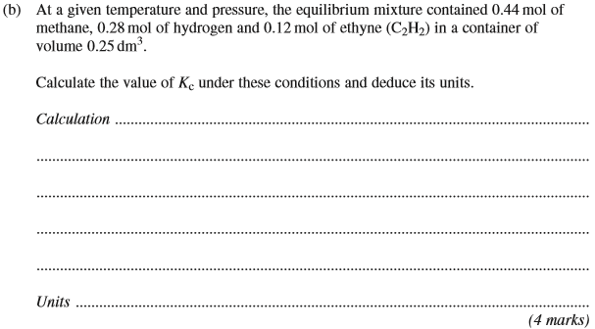
 | 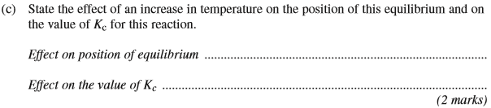
 | 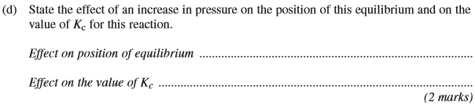
 | 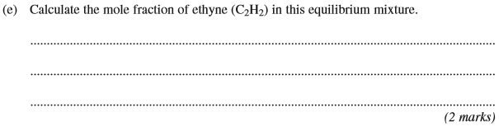
 | 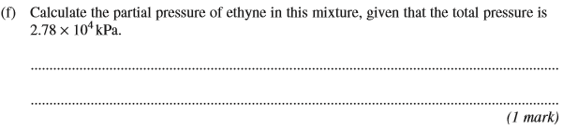
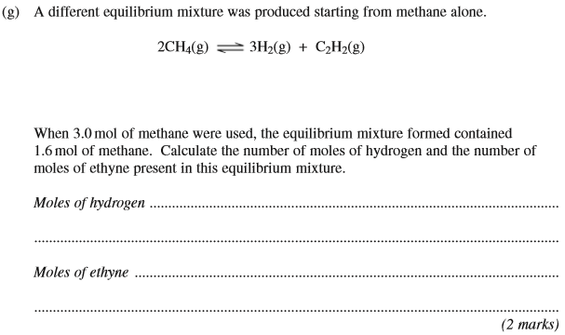
(Total 14 marks)

3. | ……………………………………………………………………………………………………………………………………………………………………………  ……………………………………………………………………………………………………………………………………………………………………………  ……………………………………………………………………………………………………………………………………………………………………………  (5 marks)

……………………………………………………………………………………………………………………………………………………………………………

……………………………………………………………………………………………………………………………………………………………………………

……………………………………………………………………………………………………………………………………………………………………………
(2 marks)
(Total 7 marks)

4.
 | (Total 7 marks)
5. | 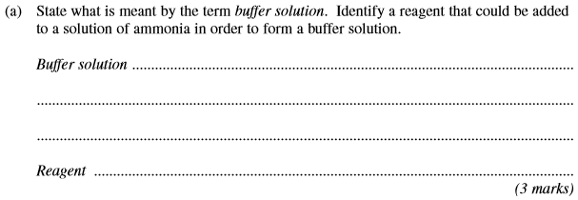
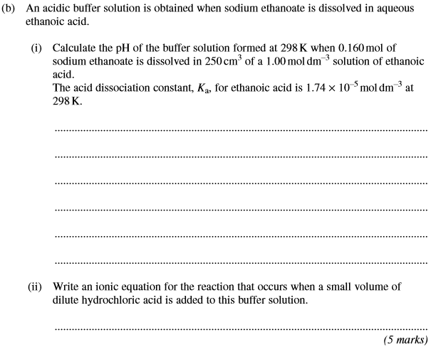
(Total 8 marks)

6. | 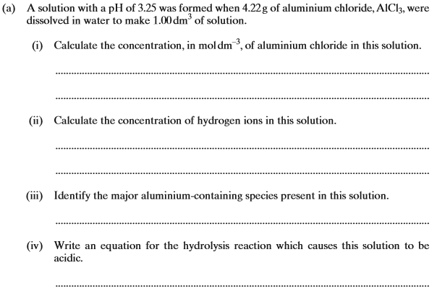
 | 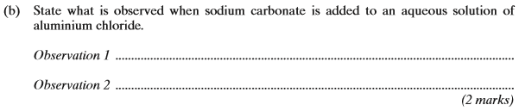
 | 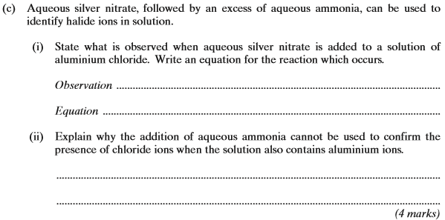
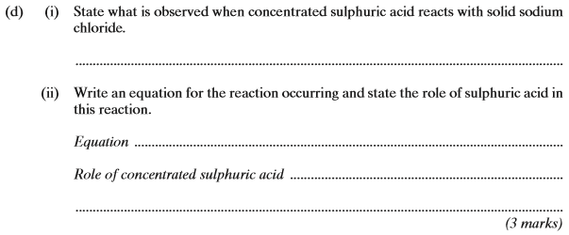
(Total 17 marks)

7. | 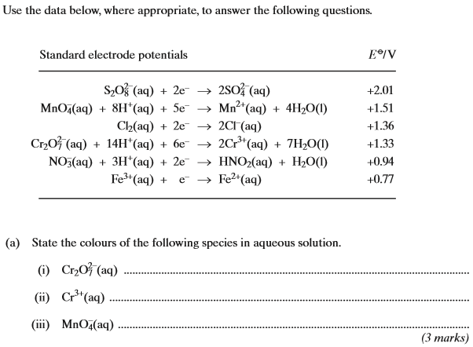
 | 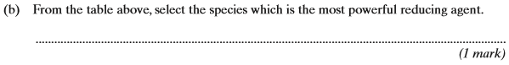
 | 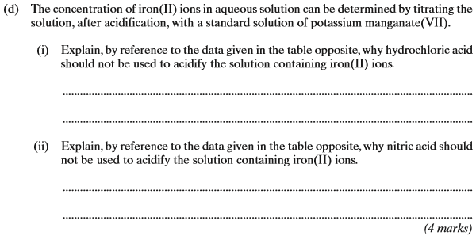
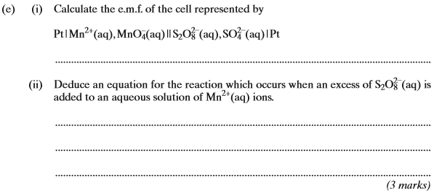
(Total 13 marks)

8. | (a) | …………………………………………………………………………………………………………………………………………………………………  …………………………………………………………………………………………………………………………………………………………………  …………………………………………………………………………………………………………………………………………………………………  …………………………………………………………………………………………………………………………………………………………………  …………………………………………………………………………………………………………………………………………………………………  (5 marks)
 | (b) | …………………………………………………………………………………………………………………………………………………………………  …………………………………………………………………………………………………………………………………………………………………  …………………………………………………………………………………………………………………………………………………………………  (2 marks)

 | (c) | 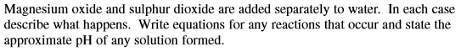  …………………………………………………………………………………………………………………………………………………………………  …………………………………………………………………………………………………………………………………………………………………  …………………………………………………………………………………………………………………………………………………………………  …………………………………………………………………………………………………………………………………………………………………  …………………………………………………………………………………………………………………………………………………………………  …………………………………………………………………………………………………………………………………………………………………  …………………………………………………………………………………………………………………………………………………………………  (6 marks)
 | (d) | …………………………………………………………………………………………………………………………………………………………………  …………………………………………………………………………………………………………………………………………………………………  …………………………………………………………………………………………………………………………………………………………………  (4 marks)  (Total 17 marks)
9. | …………………………………………………………………………………………………………………………………………………………………  …………………………………………………………………………………………………………………………………………………………………  …………………………………………………………………………………………………………………………………………………………………  …………………………………………………………………………………………………………………………………………………………………  …………………………………………………………………………………………………………………………………………………………………  …………………………………………………………………………………………………………………………………………………………………  …………………………………………………………………………………………………………………………………………………………………  …………………………………………………………………………………………………………………………………………………………………  …………………………………………………………………………………………………………………………………………………………………  (6 marks)
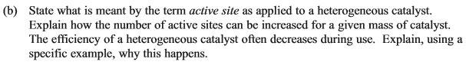

…………………………………………………………………………………………………………………………………………………………………

…………………………………………………………………………………………………………………………………………………………………

…………………………………………………………………………………………………………………………………………………………………

…………………………………………………………………………………………………………………………………………………………………

…………………………………………………………………………………………………………………………………………………………………

…………………………………………………………………………………………………………………………………………………………………
(4 marks)
(Total 10 marks)

