A-LEVEL CHEMISTRY

PAPER 1
PRACTICE PAPER 17

Answer all questions
Max 105 marks
2 hours

Name ……………………………………………………………..

Mark ……../105 ……....% Grade ………

1. | 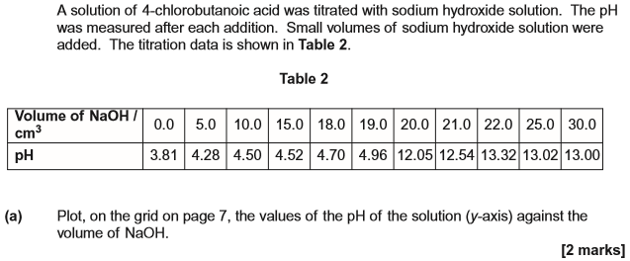  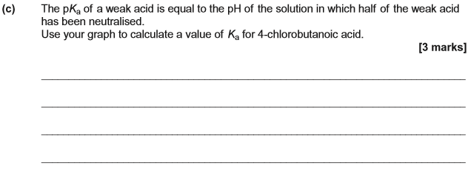  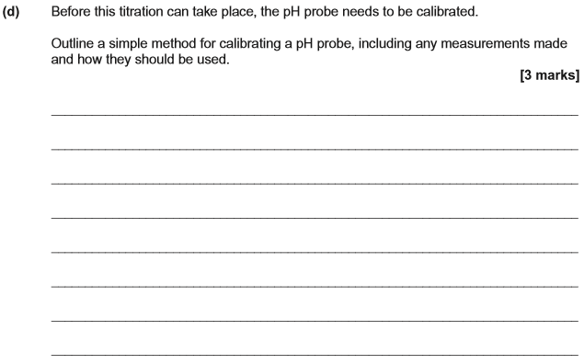  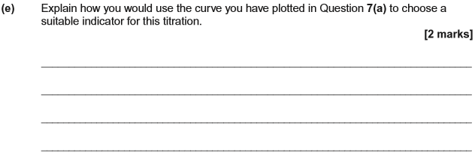  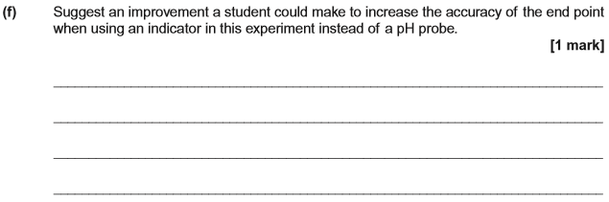  (Total 13 marks)
2.
 | (Total 12 marks)
3.
 | (Total 8 marks)
4.
 | (Total 6 marks)
5.
 | (Total 11 marks)
6.
 | (Total 9 marks)
7.

(Total 14 marks)

8.
(Total 4 marks)

9.

(Total 12 marks)
10.
(Total 16 marks)

