A-LEVEL CHEMISTRY

PAPER 1
PRACTICE PAPER 2

Answer all questions
Max 105 marks
2 hours

Name ……………………………………………………………..

Mark ……../105 ……....% Grade ………

1. | 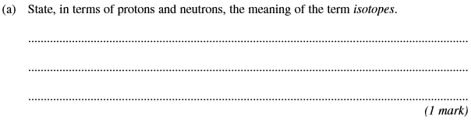
 | 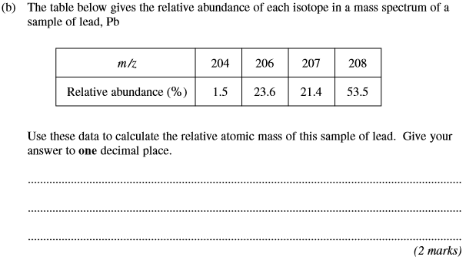
 | 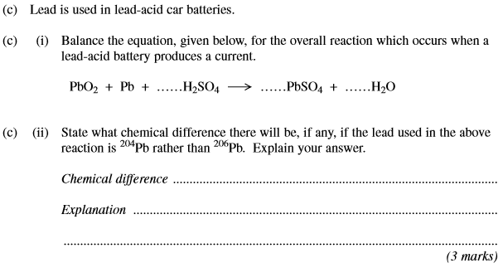
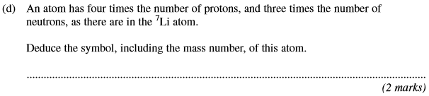
(Total 8 marks)
2. | 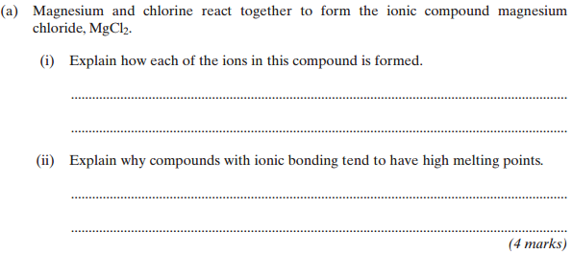
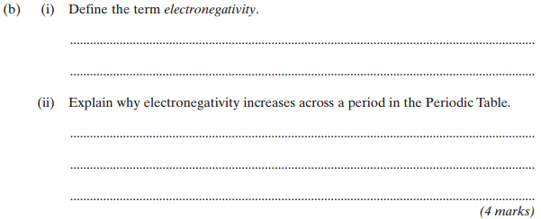
(Total 8 marks)

3.
 | (Total 6 marks)
4. This question is about magnesium oxide. Use data from the table below, where appropriate, to answer the following questions.
 | ∆H^{ϴ} / kJ mol^{–1}
First electron affinity of oxygen (formation of O–(g) from O(g)) | –142
Second electron affinity of oxygen (formation of O^{2–}(g) from O–(g)) | +844
Atomisation enthalpy of oxygen | +248
(a) Define the term enthalpy of lattice dissociation.
........................................................................................................................
........................................................................................................................
........................................................................................................................
........................................................................................................................
........................................................................................................................
........................................................................................................................
(3)
(b) In terms of the forces acting on particles, suggest one reason why the first electron affinity of oxygen is an exothermic process.
........................................................................................................................
........................................................................................................................
(1)

(c) Complete the Born–Haber cycle for magnesium oxide by drawing the missing energy levels, symbols and arrows.
The standard enthalpy change values are given in kJ mol^{–1}.

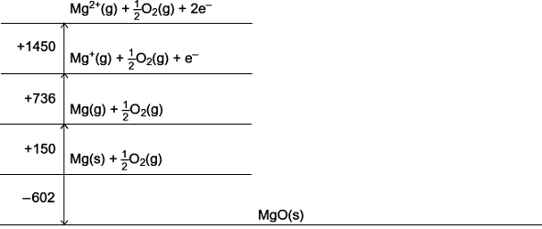
(4)
(d) Use your Born–Haber cycle from part (c) to calculate a value for the enthalpy of lattice dissociation for magnesium oxide.
........................................................................................................................
........................................................................................................................
........................................................................................................................
........................................................................................................................
(2)
(e) The standard free-energy change for the formation of magnesium oxide from magnesium and oxygen, ∆G_{f}^{ϴ} = –570 kJ mol^{–1}.
Suggest one reason why a sample of magnesium appears to be stable in air at room temperature, despite this negative value for ∆G_{f}^{ϴ} .
........................................................................................................................
........................................................................................................................
(1)

(f) Use the value of ∆G_{f}^{ϴ} given in part (e) and the value of ∆H_{f}^{ϴ} from part (c) to calculate a value for the entropy change ∆S^{ϴ} when one mole of magnesium oxide is formed from magnesium and oxygen at 298 K. Give the units of ∆S^{ϴ} .
........................................................................................................................
........................................................................................................................
........................................................................................................................
........................................................................................................................
........................................................................................................................
(3)
(g) In terms of the reactants and products and their physical states, account for the sign of the entropy change that you calculated in part (f).
........................................................................................................................
........................................................................................................................
........................................................................................................................
........................................................................................................................
(2)
(Total 16 marks)

5. The value of the acid dissociation constant, K_{a}, for ethanoic acid is 1.74 × 10^{–5} mol dm^{–3} at 298 K.
(a) (i) Write an expression for K_{a} for ethanoic acid.
.............................................................................................................
(ii) Calculate the pH at 298 K of a 0.220 mol dm^{–3} solution of ethanoic acid.
.............................................................................................................
.............................................................................................................
.............................................................................................................
.............................................................................................................
.............................................................................................................
.............................................................................................................
(5)

(b) A sample of the 0.220 mol dm^{–3} solution of ethanoic acid was titrated against sodium hydroxide solution.
(i) Calculate the volume of a 0.150 mol dm^{–3} solution of sodium hydroxide required to neutralise 25.0 cm³ of the ethanoic acid solution.
.............................................................................................................
.............................................................................................................
.............................................................................................................
.............................................................................................................
(ii) From the list below, select the best indicator for this titration and explain your choice.
Name of indicator pH range
bromophenol blue 3.0 – 4.6
methyl red 4.2 – 6.3
bromothymol blue 6.0 – 7.6
thymol blue 8.0 – 9.6
Indicator ..............................................................................................
Explanation .........................................................................................
.............................................................................................................
.............................................................................................................
(5)
(c) A buffer solution is formed when 2.00 g of sodium hydroxide are added to 1.00 dm³ of a 0.220 mol dm^{–3} solution of ethanoic acid.
Calculate the pH at 298 K of this buffer solution.
......................................................................................................................
......................................................................................................................
......................................................................................................................
......................................................................................................................
......................................................................................................................
......................................................................................................................
......................................................................................................................
(6)
(Total 16 marks)

6. (a) The term oxidation was used originally to describe a reaction in which a substance gained oxygen. The oxygen was provided by the oxidising agent. Later the definition of oxidation was revised when the importance of electron transfer was recognised.
An aqueous solution of sulfur dioxide was reacted in separate experiments as follows.
Reaction 1 with HgO
H₂O + SO₂ + HgO → H₂SO₄ + Hg
Reaction 2 with chlorine
2H₂O + SO₂ + Cl₂ → H₂SO₄ + 2HCl
(i) In Reaction 1, identify the substance that donates oxygen and therefore is the oxidising agent.
.............................................................................................................
(ii) Show, by writing a half-equation, that this oxidising agent in reaction 1 is an electron acceptor.
.............................................................................................................
(iii) Write a half-equation for the oxidation process occurring in reaction 2.
.............................................................................................................
(iv) Write a half-equation for the reduction process occurring in reaction 2.
.............................................................................................................
(4)

(b) Use the standard electrode potential data given in the able below to answer the questions which follow.
E / V
V³⁺(aq) + e– → V²⁺(aq) –0.26
SO₄^{2–}(aq) + 4H⁺(aq) + 2e– → H₂SO₃(aq) + H₂O(l) +0.17
VO²⁺(aq) + 2H⁺(aq) + e– → V³⁺(aq) + H₂O(l) +0.34
Fe³⁺(aq) + e– → Fe²⁺(aq) +0.77
VO₂⁺(aq) + 2H⁺(aq) + e– → VO²⁺(aq) + H₂O(l) +1.00
MnO₄–(aq) + 8H⁺(aq) + 5e– → Mn²⁺(aq) + 4H₂O(l) +1.52
Each of the above can be reversed under suitable conditions
(i) An excess of potassium manganate(VII) was added to a solution containing V²⁺(aq) ions. Determine the vanadium species present in the solution at the end of this reaction. State the oxidation state of vanadium in this species and write a half-equation for its formation from V²⁺(aq).
Vanadium species present at the end of the reaction .......................................
.............................................................................................................
Oxidation state of vanadium in the final species ................................
.............................................................................................................
Half-equation .......................................................................................
(ii) The cell represented below was set up under standard conditions.
Pt|H₂SO₃(aq),SO₄^{2–}(aq),H⁺(aq)||Fe³⁺(aq),Fe²⁺(aq)|Pt
Calculate the e.m.f. of this cell and state, with an explanation, how this e.m.f. will change if the concentration of Fe³⁺(aq) ions is increased.
Cell e.m.f. ...........................................................................................
Change in cell e.m.f. ..........................................................................
Explanation .........................................................................................
.............................................................................................................
(7)

(c) Consider the cell below
– +
Pt|H₂(g)|H⁺(aq)||O₂(g)|OH–(aq)|Pt
(i) Using half-equations, deduce an overall equation for the cell reaction.
.............................................................................................................
.............................................................................................................
.............................................................................................................
(ii) State how, if at all, the e.m.f. of this cell will change if the surface area of each platinum electrode is doubled.
.............................................................................................................
(3)
(d) Currently, almost all hydrogen is produced by the high-temperature reaction between methane, from North Sea gas, and steam. Give one economic and one environmental disadvantage of this method of producing hydrogen.
Economic disadvantage ..............................................................................
Environmental disadvantage .......................................................................
(2)
(e) Hydrogen can also be produced by the electrolysis of acidified water using electricity produced using solar cells. Give one reason why this method is not used on a large scale.
......................................................................................................................
(1)
(Total 17 marks)

7. Three characteristic properties of transition metals are complex formation, coloured ions and catalytic activity.
(a) State the feature of transition metals that gives rise to these characteristic properties.
......................................................................................................................
(1)
(b) State a fourth characteristic property of transition metals.
......................................................................................................................
(1)

(c) For each of the following shapes of complex, identify an appropriate example by drawing its structure.
(i) a linear complex

(1)
(ii) a square planar complex

(1)
(iii) a tetrahedral complex

(1)
(d) The chemical industry makes use of the catalytic activity of transition metal compounds. For example, vanadium(V) oxide is used as a heterogeneous catalyst in the Contact Process.
(i) Write an equation for the overall reaction in the Contact Process.
.............................................................................................................
(1)
(ii) Explain the meaning of the term heterogeneous as applied to a catalyst.
.............................................................................................................
(1)
(iii) Write two equations to illustrate how vanadium(V) oxide acts as a catalyst in the Contact Process.
Equation 1 ...........................................................................................
Equation 2 ...........................................................................................
(2)
(iv) Suggest what is done to a heterogeneous catalyst such as vanadium(V) oxide to maximise its efficiency and how this is achieved.
.............................................................................................................
.............................................................................................................
.............................................................................................................
(2)

(e) The porphyrin ring is a multidentate ligand that is found in living systems complexed with iron(II) ions in haemoglobin and with cobalt(II) ions in vitamin B₁₂
(i) Give the meaning of the term multidentate.
.............................................................................................................
.............................................................................................................
(1)
(ii) A porphyrin ring can be represented by the symbol PR. It reacts with aqueous iron(II) ions as shown in the equation below.
The enthalpy change for this reaction is approximately zero.
PR(aq) + [Fe(H₂O)₆]²⁺(aq) → [FePR(H₂O)₂]²⁺(aq) + 4H₂O(l)
Explain why the free-energy change for this reaction is negative.
.............................................................................................................
.............................................................................................................
.............................................................................................................
.............................................................................................................
(2)
(iii) In vitamin B₁₂ the cobalt(II) ion is co-ordinated to a porphyrin ring, a cyanide
(CN–) ion and an additional unidentate ligand. The cyanide ion is very toxic.
Predict the co-ordination number of the cobalt ion in vitamin B₁₂
Suggest why vitamin B₁₂ is not toxic.
Co-ordination number .....................................................................................
Reason why vitamin B₁₂ is not toxic
.............................................................................................................
.............................................................................................................
(2)
(Total 16 marks)

8. (a) State the origin of the colour of transition-metal complexes.
......................................................................................................................
......................................................................................................................
(2)

(b) Give three changes to a transition-metal complex which result in a change in colour.
Change 1 ......................................................................................................
Change 2 ......................................................................................................
Change 3 …..................................................................................................
......................................................................................................................
(3)
(c) You are provided with a 1.00 mol dm^{–3} solution of iron(III) ions and a visible-light spectrophotometer (colorimeter). Outline a plan for experiments using this solution and this apparatus which would enable you to determine the concentration of iron(III) ions in a solution of unknown concentration.
......................................................................................................................
......................................................................................................................
......................................................................................................................
......................................................................................................................
......................................................................................................................
......................................................................................................................
......................................................................................................................
......................................................................................................................
(5)
(Total 10 marks)

9.
 | (a) | ……………………………………………………………………………………………………………………………………………………………………
 | (b) | ……………………………………………………………………………………………………………………………………………………………………  ……………………………………………………………………………………………………………………………………………………………………
 | (c) | ……………………………………………………………………………………………………………………………………………………………………  ……………………………………………………………………………………………………………………………………………………………………  ……………………………………………………………………………………………………………………………………………………………………  ……………………………………………………………………………………………………………………………………………………………………

 | (d) | ……………………………………………………………………………………………………………………………………………………………………  ……………………………………………………………………………………………………………………………………………………………………  ……………………………………………………………………………………………………………………………………………………………………  ……………………………………………………………………………………………………………………………………………………………………  ……………………………………………………………………………………………………………………………………………………………………  ……………………………………………………………………………………………………………………………………………………………………  ……………………………………………………………………………………………………………………………………………………………………  ……………………………………………………………………………………………………………………………………………………………………  ……………………………………………………………………………………………………………………………………………………………………  ……………………………………………………………………………………………………………………………………………………………………  ……………………………………………………………………………………………………………………………………………………………………
 | (e) | ……………………………………………………………………………………………………………………………………………………………………  ……………………………………………………………………………………………………………………………………………………………………  ……………………………………………………………………………………………………………………………………………………………………  ……………………………………………………………………………………………………………………………………………………………………
 | (f) | ……………………………………………………………………………………………………………………………………………………………………  ……………………………………………………………………………………………………………………………………………………………………  ……………………………………………………………………………………………………………………………………………………………………  (Total 8 marks)

