A-LEVEL CHEMISTRY

PAPER 1
PRACTICE PAPER 6

Answer all questions
Max 105 marks
2 hours

Name ……………………………………………………………..

Mark ……../105 ……....% Grade ………

1. (a) A Born–Haber cycle for the formation of magnesium(II) chloride is shown below.
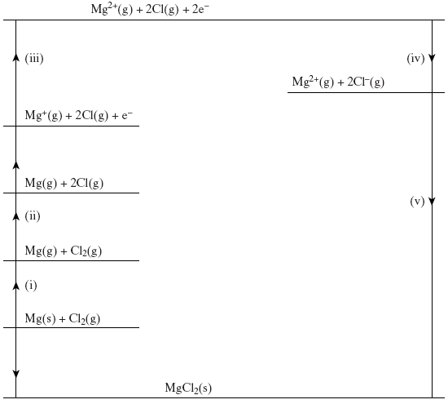
Taking care to note the direction of the indicated enthalpy change and the number of moles of species involved, give each of the enthalpy changes (i) to (v) above.
Enthalpy change (i) ....................................................................................
Enthalpy change (ii) ...............................................................................….
Enthalpy change (iii) ...................................................................................
Enthalpy change (iv) ...................................................................................
Enthalpy change (v) ….................................................................................
(5)

(b) Write an equation for the decomposition of MgCl(s) into MgCl₂(s) and Mg(s) and use the following data to calculate a value for the enthalpy change of this reaction.
∆H_{f}MgCl(s) = –113 kJ mol^{–1}
∆H_{f}MgCl₂(s) = –653 kJ mol^{–1}
Equation ......................................................................................................
Calculation ...................................................................................................
......................................................................................................................
......................................................................................................................
......................................................................................................................
(4)
(c) Use the data below to calculate a value for the molar enthalpy of a solution of MgCl₂(s).
Lattice formation enthalpy of MgCl₂(s) = –2502 kJ mol^{–1}
of Mg²⁺(g) = –1920 kJ mol^{–1}
of Cl–(g) = –364 kJ mol^{–1}
......................................................................................................................
......................................................................................................................
......................................................................................................................
......................................................................................................................
......................................................................................................................
......................................................................................................................
(3)
(Total 12 marks)

2. The enthalpy of hydration for the chloride ion is −364 kJ mol⁻¹ and that for the bromide ion is −335 kJ mol⁻¹.
(a) By describing the nature of the attractive forces involved, explain why the value for the enthalpy of hydration for the chloride ion is more negative than that for the bromide ion.
........................................................................................................................
........................................................................................................................
........................................................................................................................
........................................................................................................................
........................................................................................................................
........................................................................................................................
........................................................................................................................
........................................................................................................................
(3)
(b) The enthalpy of hydration for the potassium ion is −322 kJ mol⁻¹. The lattice enthalpy of dissociation for potassium bromide is +670 kJ mol⁻¹.
Calculate the enthalpy of solution for potassium bromide.
........................................................................................................................
........................................................................................................................
........................................................................................................................
........................................................................................................................
........................................................................................................................
........................................................................................................................
(2)

(c) The enthalpy of solution for potassium chloride is +17.2 kJ mol⁻¹.
(i) Explain why the free-energy change for the dissolving of potassium chloride in water is negative, even though the enthalpy change is positive.
...............................................................................................................
...............................................................................................................
...............................................................................................................
...............................................................................................................
...............................................................................................................
(3)
(ii) A solution is formed when 5.00 g of potassium chloride are dissolved in 20.0 g of water. The initial temperature of the water is 298 K.
Calculate the final temperature of the solution.
In your calculation, assume that only the 20.0 g of water changes in temperature and that the specific heat capacity of water is 4.18 J K⁻¹ g⁻¹.
...............................................................................................................
...............................................................................................................
...............................................................................................................
...............................................................................................................
...............................................................................................................
...............................................................................................................
...............................................................................................................
...............................................................................................................
...............................................................................................................
...............................................................................................................
...............................................................................................................
(5)
(Total 13 marks)

3.(a) Figure 1 shows how the entropy of a molecular substance X varies with temperature.
Figure 1
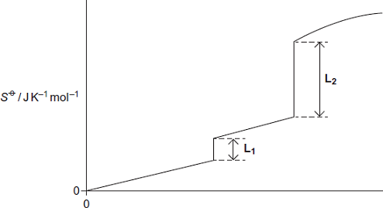
T / K
(i) Explain, in terms of molecules, why the entropy is zero when the temperature is zero Kelvin.
...............................................................................................................
...............................................................................................................
...............................................................................................................
(2)
(ii) Explain, in terms of molecules, why the first part of the graph in Figure 1 is a line that slopes up from the origin.
...............................................................................................................
...............................................................................................................
...............................................................................................................
...............................................................................................................
(2)
(iii) On Figure 1, mark on the appropriate axis the boiling point (T_{b}) of substance X.
(1)
(iv) In terms of the behaviour of molecules, explain why L₂ is longer than L₁ in Figure 1.
...............................................................................................................
...............................................................................................................
...............................................................................................................
...............................................................................................................
(2)
(b) Figure 2 shows how the free-energy change for a particular gas-phase reaction varies with temperature.
Figure 2
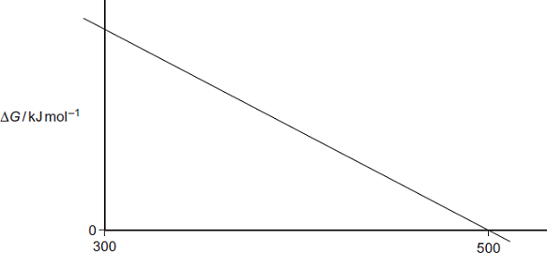
T / K
(i) Explain, with the aid of a thermodynamic equation, why this line obeys the mathematical equation for a straight line, y = mx + c.
...............................................................................................................
...............................................................................................................
...............................................................................................................
...............................................................................................................
...............................................................................................................
...............................................................................................................
(2)
(ii) Explain why the magnitude of ΔG decreases as T increases in this reaction.
...............................................................................................................
...............................................................................................................
(1)
(iii) State what you can deduce about the feasibility of this reaction at temperatures lower than 500 K.
...............................................................................................................
...............................................................................................................
(1)

(c) The following reaction becomes feasible at temperatures above 5440 K.
H₂O(g) H₂(g) + O₂(g)
The entropies of the species involved are shown in the following table.

 |  | H₂O(g) | H₂(g) | O₂(g)
 | S / J K⁻¹ mol⁻¹ | 189 | 131 | 205

(i) Calculate the entropy change ΔS for this reaction.
...............................................................................................................
...............................................................................................................
(1)
(ii) Calculate a value, with units, for the enthalpy change for this reaction at 5440 K.
(If you have been unable to answer part (c)(i), you may assume that the value of the entropy change is +98 J K⁻¹ mol⁻¹. This is not the correct value.)
...............................................................................................................
...............................................................................................................
...............................................................................................................
...............................................................................................................
...............................................................................................................
...............................................................................................................
(3)
(Total 15 marks)

4. This question is about the pH of some solutions containing potassium hydroxide and ethanoic acid.
Give all values of pH to 2 decimal places.
(a) (i) Write an expression for pH.
.............................................................................................................
(1)
(ii) Write an expression for the ionic product of water, K_{w}
.............................................................................................................
(1)
(iii) At 10 °C, a 0.154 mol dm^{–3} solution of potassium hydroxide has a pH of 13.72. Calculate the value of K_{w} at 10 °C.
.............................................................................................................
.............................................................................................................
.............................................................................................................
.............................................................................................................
(2)
(b) At 25 °C, the acid dissociation constant K_{a} for ethanoic acid has the value
1.75 × 10^{–5} mol dm^{–3}.
(i) Write an expression for K_{a} for ethanoic acid.
.............................................................................................................
.............................................................................................................
(1)
(ii) Calculate the pH of a 0.154 mol dm^{–3} solution of ethanoic acid at 25 °C.
.............................................................................................................
.............................................................................................................
.............................................................................................................
.............................................................................................................
.............................................................................................................
.............................................................................................................
(3)

(c) At 25 °C, the acid dissociation constant K_{a} for ethanoic acid has the value
1.75 × 10^{–5} mol dm^{–3}.
(i) Calculate the pH of the solution formed when 10.0 cm³ of 0.154 mol dm^{–3} potassium hydroxide are added to 20.0 cm³ of 0.154 mol dm^{–3} ethanoic
acid at 25 °C.
.............................................................................................................
.............................................................................................................
.............................................................................................................
.............................................................................................................
.............................................................................................................
.............................................................................................................
.............................................................................................................
(4)
(ii) Calculate the pH of the solution formed when 40.0 cm³ of 0.154 mol dm^{–3} potassium hydroxide are added to 20.0 cm³ of 0.154 mol dm^{–3} ethanoic acid at 25 °C.
At 25 °C, K_{w} has the value 1.00 × 10^{–14} mol² dm^{–6}.
.............................................................................................................
.............................................................................................................
.............................................................................................................
.............................................................................................................
.............................................................................................................
.............................................................................................................
.............................................................................................................
.............................................................................................................
.............................................................................................................
(4)
(Total 16 marks)

5. This table shows some standard electrode potential data.

 | Electrode half-equation | E^{ϴ} / V
 | Au⁺(aq) + e⁻ Au(s) | +1.68
 | O₂(g) + 2H⁺(aq) + 2e⁻ H₂O(l) | +1.23
 | Ag⁺(aq) + e⁻ Ag(s) | +0.80
 | Fe³⁺(aq) + e⁻ Fe²⁺(aq) | +0.77
 | Cu²⁺(aq) + 2e⁻ Cu(s) | +0.34
 | Fe²⁺(aq) + 2e⁻ Fe(s) | −0.44

(a) Draw a labelled diagram of the apparatus that could be connected to a standard hydrogen electrode in order to measure the standard electrode potential of the Fe³⁺ / Fe²⁺ electrode.
In your diagram, show how this electrode is connected to the standard hydrogen electrode and to a voltmeter. Do not draw the standard hydrogen electrode.
State the conditions under which this cell should be operated in order to measure the standard electrode potential.

Conditions .....................................................................................................
........................................................................................................................
........................................................................................................................
(5)
(b) Use data from the table to deduce the equation for the overall cell reaction of a cell that has an e.m.f. of 0.78 V.
Give the conventional cell representation for this cell.
Identify the positive electrode.
........................................................................................................................
........................................................................................................................
........................................................................................................................
........................................................................................................................
(4)

(c) Use data from the table to explain why Au⁺ ions are not normally found in aqueous solution.
Write an equation to show how Au⁺ ions would react with water.
........................................................................................................................
........................................................................................................................
........................................................................................................................
........................................................................................................................
........................................................................................................................
........................................................................................................................
(3)
(d) Use data from the table to predict and explain the redox reactions that occur when iron powder is added to an excess of aqueous silver nitrate.
........................................................................................................................
........................................................................................................................
........................................................................................................................
........................................................................................................................
........................................................................................................................
........................................................................................................................
(3)
(Total 15 marks)

6. The characteristic properties of transition metals include complex formation and the formation of coloured ions.
(a) Some complex ions can undergo a ligand substitution reaction in which both the coordination number of the metal and the colour of complex ions change in the reaction.
Write an equation for one such reaction and state the colours of the complex ions involved.
Equation ......................................................................................................
......................................................................................................................
Colours of complex ions ...............................................................................
......................................................................................................................
(4)

(b) The frequency, v, of light absorbed by a transition–metal complex ion can be determined using the relationship ΔE = hv.
(i) State what is meant by the symbols ΔE and h.
Meaning of symbol ΔE ......................................................................
Meaning of symbol h ..........................................................................
(ii) Give three factors which may cause the frequency of light absorbed to change when a complex ion reacts.
Factor 1 .............................................................................................
Factor 2 ..............................................................................................
Factor 3 ..............................................................................................
(5)
(Total 9 marks)

7. This question explores some reactions and some uses of cobalt compounds.
(a) Ethanal is oxidised to ethanoic acid by oxygen. The equation for this reaction is
2CH₃CHO + O₂ 2CH₃COOH
This redox reaction is slow at room temperature but speeds up in the presence of cobalt compounds.
Explain why a cobalt compound is able to act as a catalyst for this process.
Illustrate your explanation with two equations to suggest how, in the presence of water and hydrogen ions, Co³⁺ and then Co²⁺ ions could be involved in catalysing this reaction.
........................................................................................................................
........................................................................................................................
........................................................................................................................
........................................................................................................................
........................................................................................................................
........................................................................................................................
........................................................................................................................
........................................................................................................................
(4)

(b) In aqueous solution, the [Co(H₂O)₆]²⁺ ion reacts with an excess of ethane-1,2-diamine to form the complex ion Y.
(i) Write an equation for this reaction.
Explain, in terms of the chelate effect, why the complex ion Y is formed in preference to the [Co(H₂O)₆]²⁺ complex ion.
...............................................................................................................
...............................................................................................................
...............................................................................................................
...............................................................................................................
...............................................................................................................
...............................................................................................................
...............................................................................................................
(3)
(ii) Draw a diagram that shows the shape of the complex ion Y and shows the type of bond between the ethane-1,2-diamine molecules and the cobalt.

(3)

(c) Compound Z is a complex that contains only cobalt, nitrogen, hydrogen and chlorine.
A solid sample of Z was prepared by reaction of 50 cm³ of 0.203 mol dm⁻³ aqueous cobalt(II) chloride with ammonia and an oxidising agent followed by hydrochloric acid.
When this sample of Z was reacted with an excess of silver nitrate, 4.22 g of silver chloride were obtained.
Use this information to calculate the mole ratio of chloride ions to cobalt ions in Z.
Give the formula of the complex cobalt compound Z that you would expect to be formed in the preparation described above.
Suggest one reason why the mole ratio of chloride ions to cobalt ions that you have calculated is different from the expected value.
........................................................................................................................
........................................................................................................................
........................................................................................................................
........................................................................................................................
........................................................................................................................
........................................................................................................................
........................................................................................................................
........................................................................................................................
........................................................................................................................
........................................................................................................................
........................................................................................................................
(5)
(Total 15 marks)

8. The table below shows some standard electrode potentials.

 |  |  |  | E / V
 | MnO₄– + 8H⁺ + 5e– |  | Mn²⁺ + 4H₂O | +1.51
 | Cl₂(g) + 2e– |  | 2Cl–(aq) | +1.36
 | Cr₂O₇^{2–} + 14H⁺ + 6e– |  | 2Cr³⁺ + 7H₂O | +1.33
A student determined the concentration of iron(II) ions in a solution of iron(II) chloride by titration with acidified potassium dichromate(VI) solution. A second student titrated the same solution of iron(II) chloride with acidified potassium manganate(VII) solution.
By reference to the table, explain why the second student obtained a greater value for the concentration of iron(II) ions.
.................................................................................................................................
.................................................................................................................................
.................................................................................................................................
.................................................................................................................................
(Total 2 marks)

9.
 | (a) | ……………………………………………………………………………………………………………………………………………………………...  ……………………………………………………………………………………………………………………………………………………………...  ……………………………………………………………………………………………………………………………………………………………...
 | (b) | ……………………………………………………………………………………………………………………………………………………………...  ……………………………………………………………………………………………………………………………………………………………...  ……………………………………………………………………………………………………………………………………………………………...
 | (c) | ……………………………………………………………………………………………………………………………………………………………...  ……………………………………………………………………………………………………………………………………………………………...  ……………………………………………………………………………………………………………………………………………………………...
 | (d) | ……………………………………………………………………………………………………………………………………………………………...  ……………………………………………………………………………………………………………………………………………………………...  ……………………………………………………………………………………………………………………………………………………………...  ……………………………………………………………………………………………………………………………………………………………...  ……………………………………………………………………………………………………………………………………………………………...  ……………………………………………………………………………………………………………………………………………………………...  ……………………………………………………………………………………………………………………………………………………………...  ……………………………………………………………………………………………………………………………………………………………...  ……………………………………………………………………………………………………………………………………………………………...
 | (e) | ……………………………………………………………………………………………………………………………………………………………...  ……………………………………………………………………………………………………………………………………………………………...  ……………………………………………………………………………………………………………………………………………………………...  ……………………………………………………………………………………………………………………………………………………………...  ……………………………………………………………………………………………………………………………………………………………...
 | (f) | ……………………………………………………………………………………………………………………………………………………………...  ……………………………………………………………………………………………………………………………………………………………...  ……………………………………………………………………………………………………………………………………………………………...  (Total 8 marks)

