A-LEVEL CHEMISTRY

PAPER 2
PRACTICE PAPER 1

Answer all questions
Max 105 marks
2 hours

Name ……………………………………………………………..

Mark ……../105 ……....% Grade ………

1. | 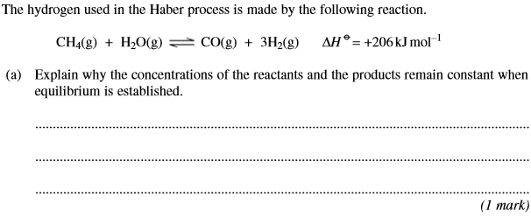
 | 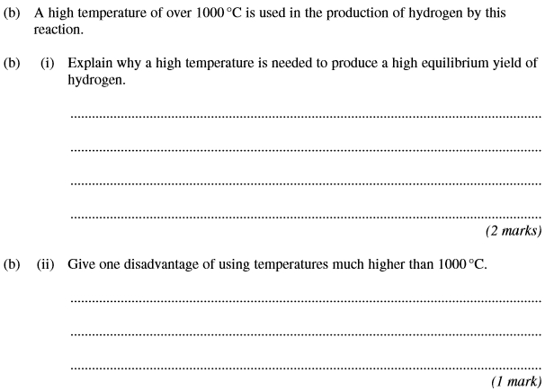
 | 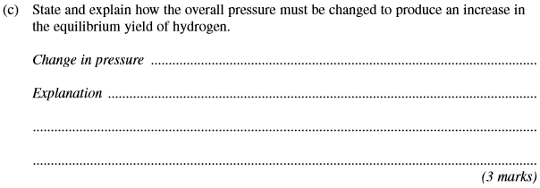
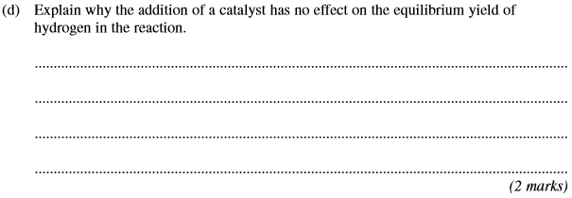
(Total 9 marks)

2. | 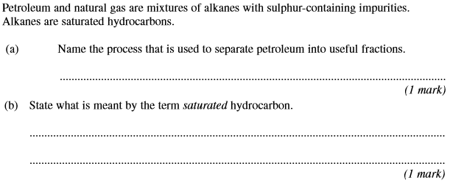
 | 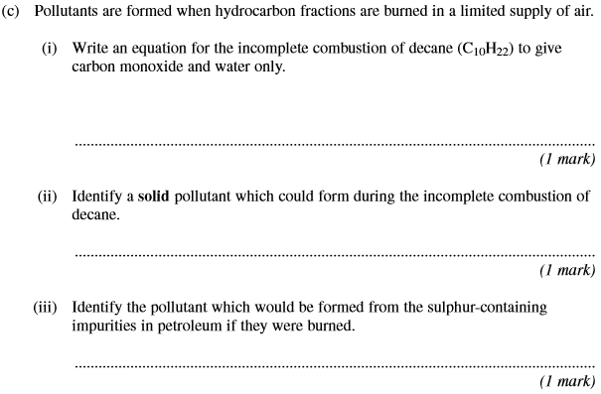
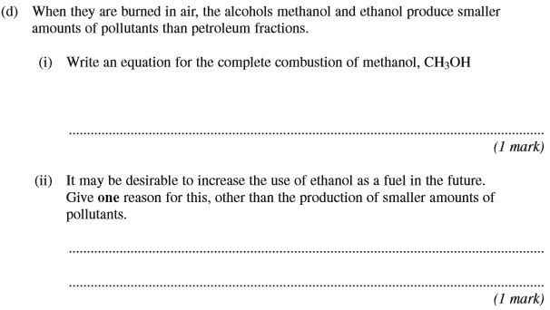
(Total 7 marks)

3. | 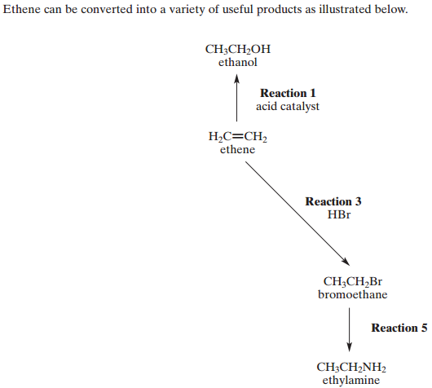
 | (a) | Reaction 1: …………………………………………………………………………………………………………………………………………………  Reaction 5: …………………………………………………………………………………………………………………………………………………  (2)

 | (b) | (4)
 | (c) | 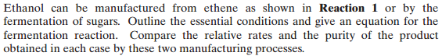  ……………………………………………………………………………………………………………………………………………………………………  ……………………………………………………………………………………………………………………………………………………………………  ……………………………………………………………………………………………………………………………………………………………………  ……………………………………………………………………………………………………………………………………………………………………  ……………………………………………………………………………………………………………………………………………………………………  ……………………………………………………………………………………………………………………………………………………………………  (5)  (Total 11 marks)

4. Benzene reacts with propanoyl chloride in the presence of aluminium chloride. Write equations to show the role of aluminium chloride as a catalyst in this reaction. Outline a mechanism for this reaction of benzene.

(5)
(Total 5 marks)

5. A reaction mechanism is a series of steps by which an overall reaction may proceed.
The reactions occurring in these steps may be deduced from a study of reaction rates.
Experimental evidence about initial rates leads to a rate equation. A mechanism is then proposed which agrees with this rate equation.
Ethanal dimerises in dilute alkaline solution to form compound X as shown in the following equation.
2CH₃CHO → CH₃CH(OH)CH₂CHO
X
A chemist studied the kinetics of the reaction at 298 K and then proposed the following rate equation.
Rate = k [CH₃CHO][OH–]
(a) Give the IUPAC name of compound X.
......................................................................................................................
(1)
(b) The initial rate of the reaction at 298K was found to be 2.2 × 10^{–3} mol dm^{–3} s^{–1} when the initial concentration of ethanal was 0.10 mol dm^{–3} and the initial concentration of sodium hydroxide was 0.020 mol dm^{–3}.
Calculate a value for the rate constant at this temperature and give its units.
Calculation ...................................................................................................
......................................................................................................................
......................................................................................................................
Units .............................................................................................................
(3)
(c) The sample of X produced consists of a racemic mixture (racemate). Explain how this racemic mixture is formed.
......................................................................................................................
......................................................................................................................
......................................................................................................................
(2)

(d) A three-step mechanism has been proposed for this reaction according to the following equations.

Step 1 | 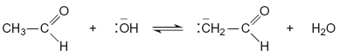
Step 2 | 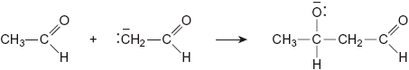
Step 3 | 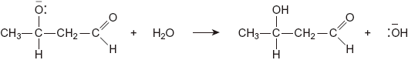

(i) Using the rate equation, predict which of the three steps is the rate-determining step. Explain your answer.
Rate-determining step ........................................................................
Explanation .........................................................................................
.............................................................................................................
(2)
(ii) Deduce the role of ethanal in Step 1.
.............................................................................................................
(1)
(iii) Use your knowledge of reaction mechanisms to deduce the type of reaction occurring in Step 2.
.............................................................................................................
(1)
(iv) In the space below draw out the mechanism of Step 2 showing the relevant curly arrows.

(2)

(e) In a similar three-step mechanism, one molecule of X reacts further with one molecule of ethanal. The product is a trimer containing six carbon atoms.
Deduce the structure of this trimer.

(1)
(Total 13 marks)

6. Esters are produced by the reaction of alcohols with other esters and by the reaction of alcohols with carboxylic acids.
(a) The esters which make up biodiesel are produced industrially from the esters in vegetable oils.
(i) Complete the equation for this formation of biodiesel.
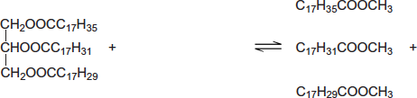
............................................................................
(2)
(ii) Write an equation for the complete combustion of C₁₇H₃₅COOCH₃.
...............................................................................................................
(2)

(b) The ester commonly known as diethyl malonate (DEM) occurs in strawberries and grapes. It can be prepared from acid A according to the following equilibrium.
(i) A mixture of 2.50 mol of A and 10.0 mol of ethanol was left to reach equilibrium in an inert solvent in the presence of a small amount of concentrated sulfuric acid.
The equilibrium mixture formed contained 1.80 mol of DEM in a total volume, V dm³, of solution.
Calculate the amount (in moles) of A, of ethanol and of water in this equilibrium mixture.
Moles of A .............................................................................................
Moles of ethanol ....................................................................................
Moles of water........................................................................................
(3)
(ii) The total volume of the mixture in part (b)(i) was doubled by the addition of more of the inert solvent.
State and explain the effect of this addition on the equilibrium yield of DEM.
Effect ....................................................................................................
Explanation ...........................................................................................
...............................................................................................................
(2)
(iii) Using A to represent the acid and DEM to represent the ester, write an expression for the equilibrium constant K_{c} for the reaction.
...............................................................................................................
...............................................................................................................
(1)
(iv) In a second experiment, the equilibrium mixture was found to contain 0.85 mol of A, 7.2 mol of ethanol, 2.1 mol of DEM and 3.4 mol of water.
Calculate a value of K_{c} for the reaction and deduce its units.
Calculation.............................................................................................
...............................................................................................................
...............................................................................................................
Units.......................................................................................................
(3)
(Total 13 marks)
7. The reactions of molecules containing the chlorine atom are often affected by other functional groups in the molecule.
Consider the reaction of CH₃CH₂COCl and of CH₃CH₂CH₂Cl with ammonia.
(a) For the reaction of CH₃CH₂COCl with ammonia, name and outline the mechanism and name the organic product.
........................................................................................................................
........................................................................................................................
........................................................................................................................
........................................................................................................................
........................................................................................................................
........................................................................................................................
........................................................................................................................
(6)
(b) For the reaction of CH₃CH₂CH₂Cl with an excess of ammonia, name and outline the mechanism and name the organic product.
........................................................................................................................
........................................................................................................................
........................................................................................................................
........................................................................................................................
........................................................................................................................
........................................................................................................................
........................................................................................................................
........................................................................................................................
........................................................................................................................
(6)
(c) Suggest one reason why chlorobenzene (C₆H₅Cl) does not react with ammonia under normal conditions.
........................................................................................................................
........................................................................................................................
........................................................................................................................
........................................................................................................................
(1)
(Total 13 marks)

8. (a) Ester 1 and Ester 2 were studied by ¹H n.m.r. spectroscopy.

 | 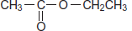 |  | 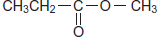
 | Ester 1 |  | Ester 2

One of the two esters produced this spectrum.
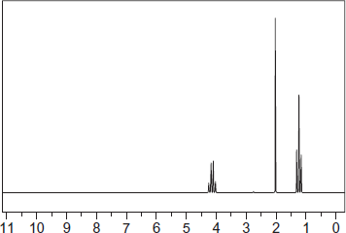
ppm
Deduce which of the two esters produced the spectrum shown. In your answer, explain the position and splitting of the quartet peak at δ = 4.1 ppm in the spectrum.
Predict the δ value of the quartet peak in the spectrum of the other ester.
Use Table B on the Data Sheet.
........................................................................................................................
........................................................................................................................
........................................................................................................................
........................................................................................................................
........................................................................................................................
........................................................................................................................
........................................................................................................................
........................................................................................................................
(4)

(b) Cetrimide is used as an antiseptic.
[CH₃(CH₂)₁₅N(CH₃)₃]⁺ Br–
cetrimide
Name this type of compound.
Give the reagent that must be added to CH₃(CH₂)15NH₂ to make cetrimide and state the reaction conditions.
Name the type of mechanism involved in this reaction.
........................................................................................................................
........................................................................................................................
........................................................................................................................
........................................................................................................................
........................................................................................................................
........................................................................................................................
........................................................................................................................
........................................................................................................................
(4)
(Total 8 marks)

9. The following five isomers, P, Q, R, S and T, were investigated using test-tube reactions and also using n.m.r. spectroscopy.
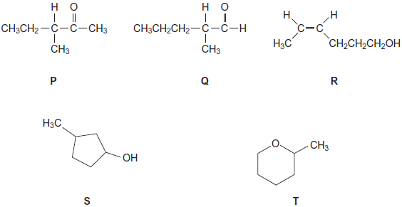
(a) A simple test-tube reaction can be used to distinguish between isomers P and S.
Identify a reagent (or combination of reagents) you could use.
State what you would observe when both isomers are tested separately with this reagent or combination of reagents.
........................................................................................................................
........................................................................................................................
........................................................................................................................
........................................................................................................................
........................................................................................................................
(3)
(b) A simple test-tube reaction can be used to distinguish between isomer Q and all the other isomers.
Identify a reagent (or combination of reagents) you could use.
State what you would observe when Q is tested with this reagent or combination of reagents.
........................................................................................................................
........................................................................................................................
........................................................................................................................
........................................................................................................................
(2)

(c) State which one of the isomers, P, Q, R, S and T, has the least number of peaks in its ¹H n.m.r. spectrum.
Give the number of peaks for this isomer.
........................................................................................................................
........................................................................................................................
........................................................................................................................
(2)
(d) Write the molecular formula of the standard used in ¹³C n.m.r. spectroscopy.
Give two reasons why this compound is used.
........................................................................................................................
........................................................................................................................
........................................................................................................................
........................................................................................................................
........................................................................................................................
(3)

(e) Figure 1 and Figure 2 show the ¹³C n.m.r. spectra of two of the five isomers.
Figure 1 Figure 2
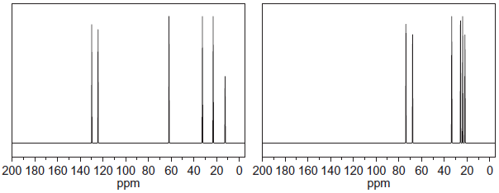
State which isomer produces the spectrum in Figure 1 and which isomer produces the spectrum in Figure 2.
Explain your answer.
You do not need to identify every peak in each spectrum.
Use Table C on the Data Sheet to answer the question.
........................................................................................................................
........................................................................................................................
........................................................................................................................
........................................................................................................................
........................................................................................................................
........................................................................................................................
........................................................................................................................
(5)
(f) U and V are other isomers of P, Q, R, S and T.
The ¹H n.m.r. spectrum of U consists of two singlets.
V is a cyclic alcohol that exists as optical isomers.
Draw the structure of U and the structure of V.
U V

(2)
(Total 17 marks)

10. The structure of N-phenylethanamide is
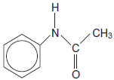
Use this structure to determine the number of peaks in the ¹³C n.m.r. spectrum of N−phenylethanamide.
.................................................................................................................................
.................................................................................................................................
.................................................................................................................................
(Total 1 mark)

11.
 | (a) | (i)
 |  | (ii)
 |  | (iii)
 |  | (iv)
 | (b) | ………………………………………………………………………………………………………………………………………………………………………  ………………………………………………………………………………………………………………………………………………………………………  ………………………………………………………………………………………………………………………………………………………………………  ………………………………………………………………………………………………………………………………………………………………………  ………………………………………………………………………………………………………………………………………………………………………  ………………………………………………………………………………………………………………………………………………………………………  ………………………………………………………………………………………………………………………………………………………………………  ………………………………………………………………………………………………………………………………………………………………………  ………………………………………………………………………………………………………………………………………………………………………  ………………………………………………………………………………………………………………………………………………………………………  ………………………………………………………………………………………………………………………………………………………………………
 | (c) | ………………………………………………………………………………………………………………………………………………………………………  ………………………………………………………………………………………………………………………………………………………………………  ………………………………………………………………………………………………………………………………………………………………………  ………………………………………………………………………………………………………………………………………………………………………
 | (d) | ………………………………………………………………………………………………………………………………………………………………………  ………………………………………………………………………………………………………………………………………………………………………  ………………………………………………………………………………………………………………………………………………………………………  ………………………………………………………………………………………………………………………………………………………………………  (Total 8 marks)

