A-LEVEL CHEMISTRY

PAPER 2
PRACTICE PAPER 13

Answer all questions
Max 105 marks
2 hours

Name ……………………………………………………………..

Mark ……../105 ……....% Grade ………

1. | 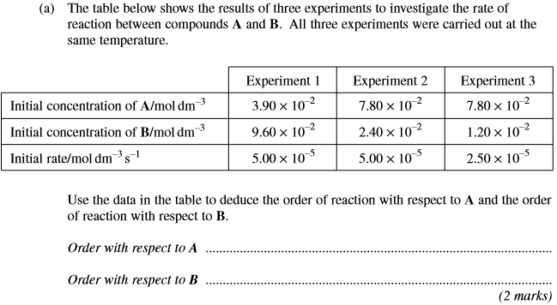
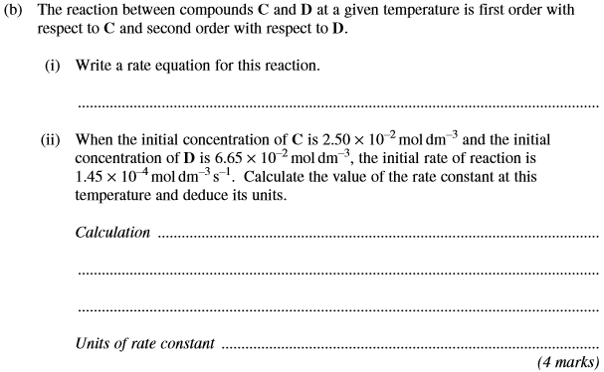
(Total 6 marks)

2. | 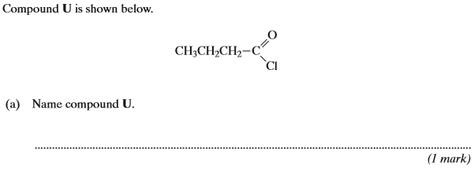
 | 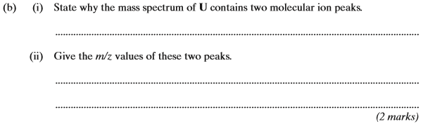
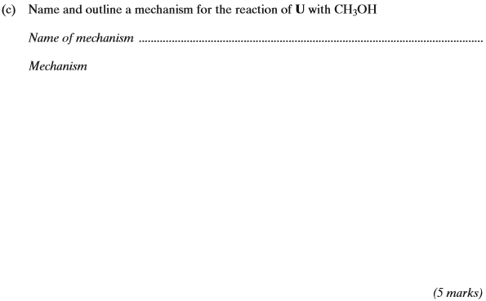
(Total 8 marks)

3. | 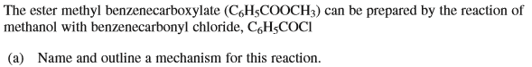  Name of mechanism: ……………………………………………………………………………………  Mechanism:  (5 marks)

……………………………………………………………………………………………………………………………………………………………………………

……………………………………………………………………………………………………………………………………………………………………………

……………………………………………………………………………………………………………………………………………………………………………
(2 marks)
(Total 7 marks)

4. | Rate of reaction …………………………………………………………………………………………………………………………………………………  ……………………………………………………………………………………………………………………………………………………………………………  Catalyst ..……………………………………………………………………………………………………………………………………………………………  ……………………………………………………………………………………………………………………………………………………………………………  (2 marks)

Catalyst: …………………………………………………………………………………………………………………………………………………………….

Equation: ……………………………………………………………………………………………………………………………………………………………

Catalyst: …………………………………………………………………………………………………………………………………………………………….

Equation: ……………………………………………………………………………………………………………………………………………………………

Catalyst: …………………………………………………………………………………………………………………………………………………………….

Equation: ……………………………………………………………………………………………………………………………………………………………
(7 marks)
(Total 9 marks)

5. | ……………………………………………………………………………………………………………………………………………………………………………  ……………………………………………………………………………………………………………………………………………………………………………  ……………………………………………………………………………………………………………………………………………………………………………  ……………………………………………………………………………………………………………………………………………………………………………  ……………………………………………………………………………………………………………………………………………………………………………  ……………………………………………………………………………………………………………………………………………………………………………  (6 marks)

Reagents:………………………………………………………………………………………………………………………………………………

Equation:………………………………………………………………………………………………………………………………………………

Type of mechanism:………………………………………………………………………………………………………………………………………

Structure of product:

(5 marks)
(Total 11 marks)

6. | 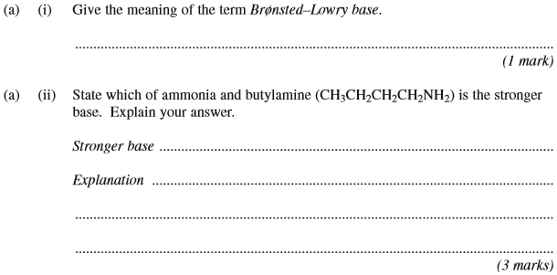
 | 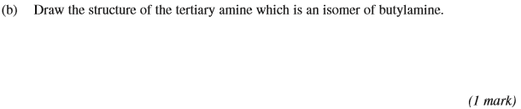
 | 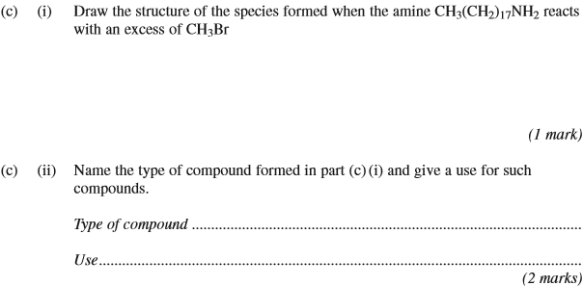
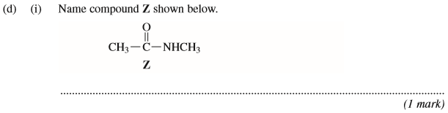
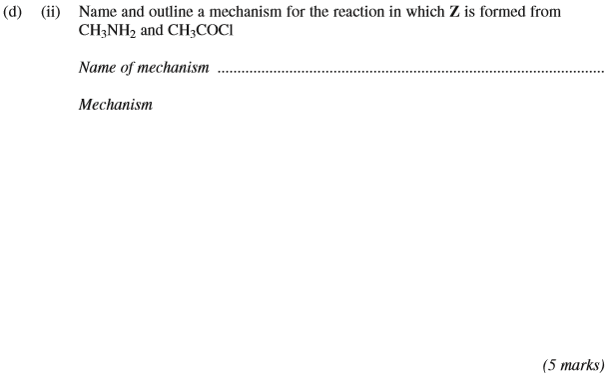
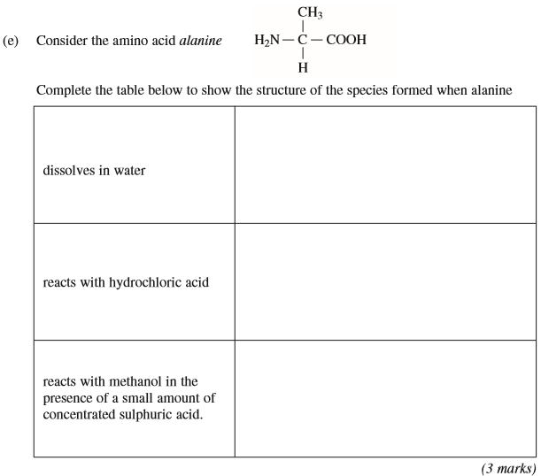
(Total 17 marks)

7. | 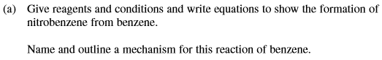  …………………………………………………………………………………………………………………………………………………………………………  ……………………………………………………………………………………………………………………………………………………………………………  ……………………………………………………………………………………………………………………………………………………………………………  ……………………………………………………………………………………………………………………………………………………………………………  (8 marks)
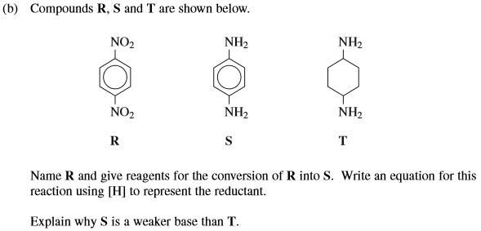

……………………………………………………………………………………………………………………………………………………………………………

……………………………………………………………………………………………………………………………………………………………………………

……………………………………………………………………………………………………………………………………………………………………………

……………………………………………………………………………………………………………………………………………………………………………

……………………………………………………………………………………………………………………………………………………………………………

……………………………………………………………………………………………………………………………………………………………………………
(6 marks)

(1 mark)
(Total 15 marks)

8. | 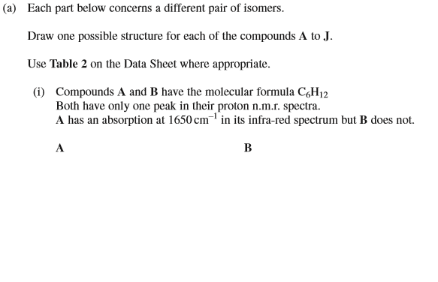  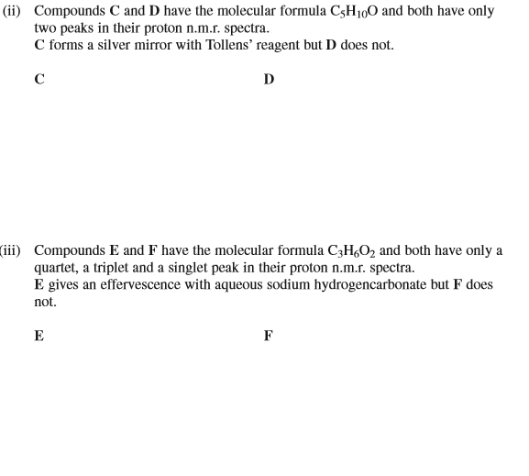
 | 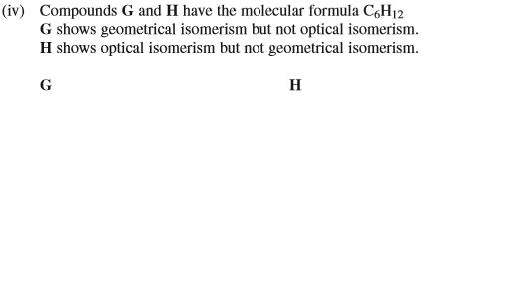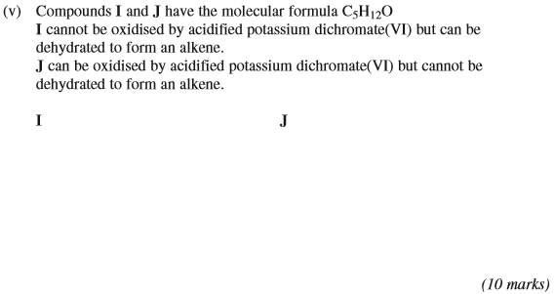
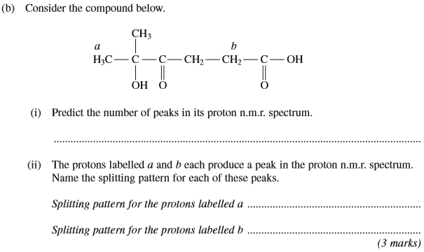
(Total 13 marks)
9. | 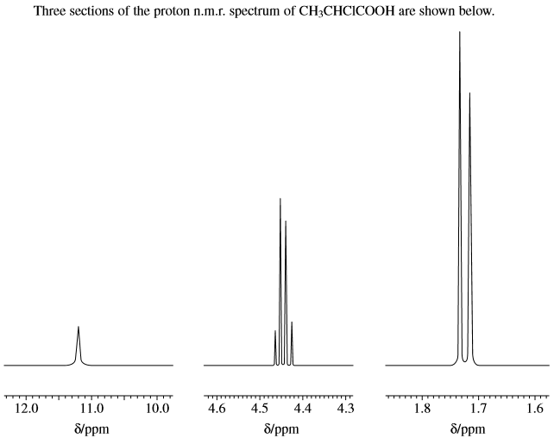  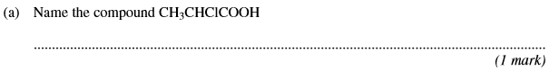
 | 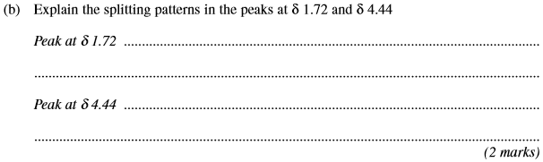
 | 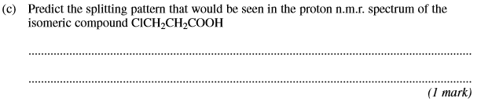
 | 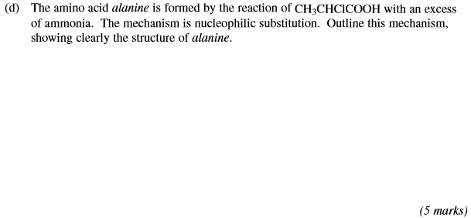
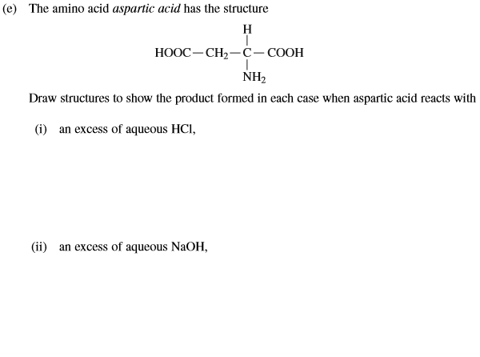
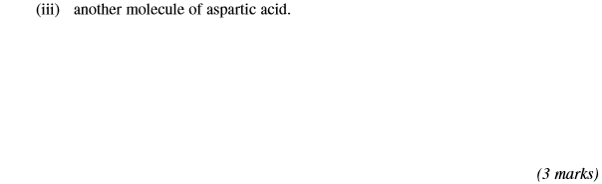
(Total 12 marks)

10. | 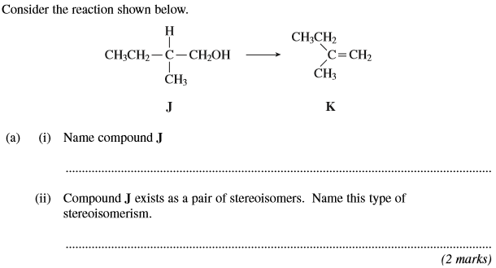
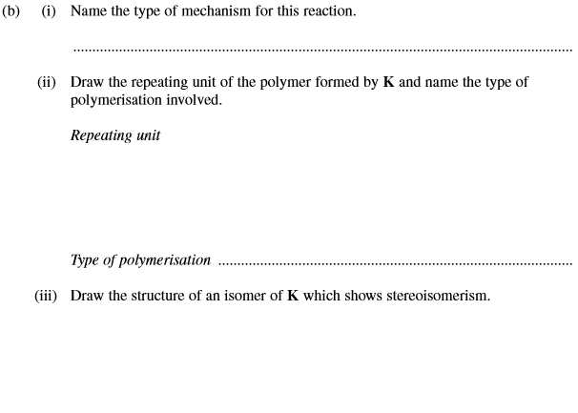
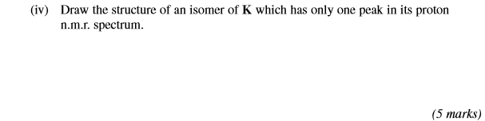
(Total 7 marks)

