A-LEVEL CHEMISTRY

PAPER 2
PRACTICE PAPER 14

Answer all questions
Max 105 marks
2 hours

Name ……………………………………………………………..

Mark ……../105 ……....% Grade ………

1. | 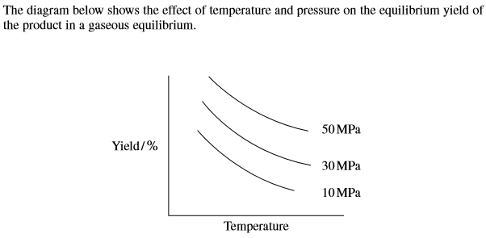  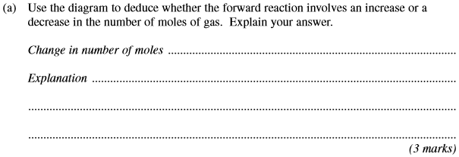
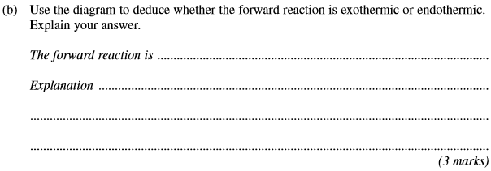
(Total 6 marks)

2. | 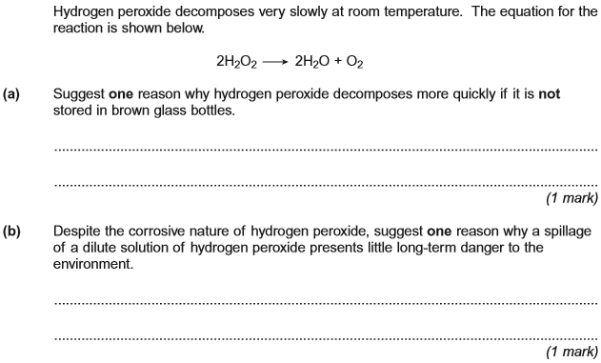  (Total 2 marks)

3.
(Total 12 marks)

4.
(Total 15 marks)

5.
(Total 13 marks)

6.
(Total 7 marks)

7.
(Total 5 marks)

8.
(Total 5 marks)

9.
(Total 8 marks)

10.
(Total 12 marks)

11.

(Total 14 marks)

12.
(Total 6 marks)

