A-LEVEL PAPER 2 PP1 MS
1. | 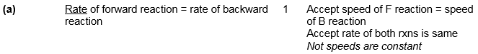
 | [9]
2.
 | [8]
3. | (a)
 | (b)

 | (c) | [11]

4. CH₃CH₂COCl + AlCl₃ → [CH₃CH₂CO]⁺ + AlCl₄–;
(penalise wrong alkyl group once at first error)
(position of + on electrophile can be on O or C or outside [ ]) (penalise wrong curly arrow in the equation or lone pair on AlCl₃)
1

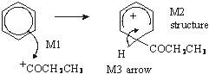  (M1 arrow from within hexagon to C or to + on C)  (don’t penalise position of + on C of RCO+) | (horseshoe must not extend beyond C2 to C6 but can be smaller)  (+ not too close to C1)  (penalise M2 if CH₃ chain wrong again but allow M1 and M3)  (M3 arrow into hexagon unless Kekule)  (allow M3 arrow independent of M2 structure)
3
(or can be gained in mechanism);
1
[5]

5. (a) 3-hydroxybutanal
ignore number 1 i.e. allow 3-hydroxybutan-1-al
not hydroxyl
1
(b) 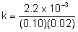
1
= 1.1
1
mol^{–1} dm³ s^{–1}
1
(c) planar or flat C=O or molecule
allow planar molecule
1
equal probability of attack from above or below
must be equal; not attack of OH–
1
(d) (i) Step 1 if wrong – no mark for explanation.
1
involves ethanal and OH– or species/ “molecules”
in rate equation
1
(ii) (B-L) acid or proton donor
not Lewis acid
1
(iii) nucleophilic addition
QOL
1
(iv)
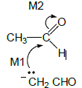
not allow M2 before M1, but allow M1 attack on C+ after non-scoring carbonyl arrow
ignore error in product
2

(e)
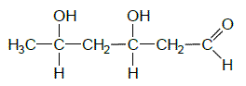
1
[13]

6. (a) (i) 3CH₃OH
Not molecular formula
1
HOCH₂CH(OH)CH₂OH
1
(ii) → 19CO₂ + 19H₂O
Or doubled
1
C₁₇H₃₅COOCH₃ + 27½ or 55/2 O₂
Consequential on correct right-hand side
1
(b) (i) A 0.7
1
Ethanol 6.4
1
Water 3.6
1
(ii) No effect
If wrong, CE= 0
1
Equal moles on each side of equation OR V cancels
Ignore moles of gas
1
(iii) M1 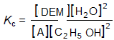

Must have all brackets but allow ( )
1
(iv) M2 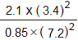

If K_{c} wrong can only score M4 for units consequential to their K_{c} working in (b)(iv)
1
M3 0.55 (min 2dp)
1
M4 No units
1
[13]
7. (a) (Nucleophilic) addition-elimination
• Minus sign on NH₃ loses M1(but not M4 also)
• M2 not allowed independent of M1, but
1
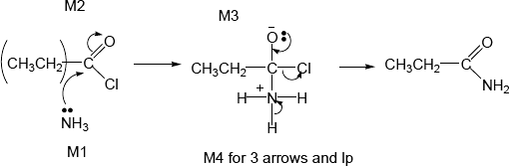

• allow M1 for correct attack on C+
• + rather than δ+ on C=O loses M2
• If Cl lost with C=O breaking, max1 for M1
• M3 for correct structure with charges but lp on O is part of M4
• only allow M4 after correct/very close M3
• For M4, ignore NH₃ removing H⁺ but lose M4 for Cl– removing H⁺ in mechanism,
• but ignore HCl shown as a product
4
propanamide (Ignore -1- )
penalise other numbers
penalise propaneamide and N-propanamide
1

(b) Nucleophilic substitution
• Minus sign on NH₃ loses M1 (not M4 also)
• + rather than δ+ on C=O loses M2
1
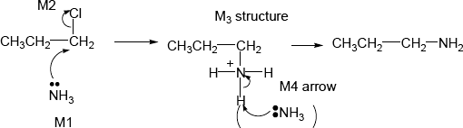
• ALLOW SN1 so allow M2 for loss of Cl– before attack of NH₃ on C+ for M1
• only allow M4 after correct/very close M3
• For M4, ignore NH₃ removing H⁺ but lose M4 for Cl– removing H⁺ in mechanism,
Propylamine (ignore number 1)
• but ignore HCl shown as a product
4
or propan-1-amine or 1-aminopropane (number 1 needed)
penalise other numbers
allow 1-propanamine
1
(c) electron rich ring or benzene or pi cloud repels nucleophile/ammonia
Allow
• C–Cl bond is short/stronger than in haloalkane
• C–Cl is less polar than in haloalkane
• resonance stabilisation between ring and Cl
1
[13]

6. (a) M1 Ester 1
If Ester 2, can score M3 only.
1
M2 peak at δ = 4.1 due to 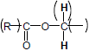
When marking M2 and M3, check any annotation of structures in the stem at the top of the page.
1
M3 (δ = 4.1 peak is) quartet as adjacent / next to / attached to CH₃
1
M4 Other spectrum quartet at δ = 2.1-2.6 (or value in this range)
1

(b) M1 Quaternary (alkyl) ammonium salt / bromide
1
M2 CH₃Br or bromomethane
Penalise contradictory formula and name.
1
M3 Excess ( CH₃Br or bromomethane)
Mention of acid eg H₂SO₄ OR alkali eg NaOH loses both M2 and M3.
1
M4 Nucleophilic substitution
Can only score M3 if reagent correct.
Ignore alcohol or ethanol (conditions) or Temp.
1
[8]

9. (a)
Reagent (1) | P (ketone) | S (2° alcohol)
Acidified K₂Cr₂O₇ | no reaction | (orange to) green
Acidified KMnO₄ | no reaction | (purple to) colourless
I₂ / NaOH | Yellow ppt | no reaction
Named RCOOH with HCl or H₂SO₄ | no reaction | fruity or sweet smell
Named RCOCl | no reaction | Misty fumes
Allow names including potassium permanganate  Wrong or no reagent CE = 0  Penalise incorrect formulae or incomplete reagent, such as K₂Cr₂O₇ or acidified dichromate, but mark on. | Allow no change or nvc but penalise nothing or no observation  If 2 reagents added sequentially or 2 different reagents used for P and S then CE = 0
1 | 1 | 1

(b) Tollens’ (1) and silver mirror / solid (1)
or
Fehling’s / Benedicts (1) and red ppt (1)
1
(c) G
P
If not P then no marks for clip
1
5 OR five
1
(d) C₄H₁₂Si
Must be molecular formula
Wrong substance CE = 0 for clip
1
Any two from
• One or single peak OR all (four) carbon atoms are equivalent or one environment
1
• upfield from others or far away from others or far to right
• non toxic OR inert
• low boiling point or volatile or easy removed from sample
Ignore and don’t credit single peak linked to 12 equivalent H or has a peak at δ = 0
but use list principle for wrong statements
1
1
(e) Figure 1 is R
If not R cannot score M2
M1
1
90−150 (ppm) or value in range is (two peaks for) C = C / alkene
M2
1
Figure 2 is T
If not T cannot score M4 or M5
M3
1
50-90 (ppm) or value in range is C—O or alcohol or ether
M4
1
two peaks (so not S which would have only one)
M5
1
(f)
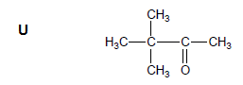
1
V Answers include
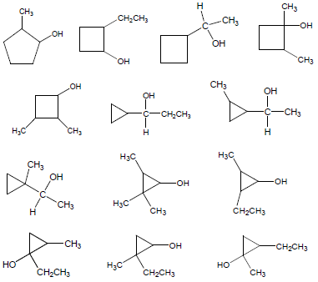
Not allow S
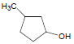
because V must be an isomer of S
[17]

10. 6 / six
[1]

11.

