A-LEVEL CHEMISTRY

PAPER 2
PRACTICE PAPER 2

Answer all questions
Max 105 marks
2 hours

Name ……………………………………………………………..

Mark ……../105 ……....% Grade ………

1. | (Total 5 marks)
2. | 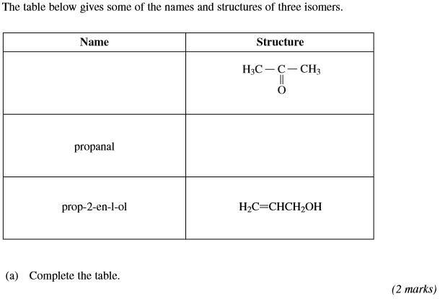
 | 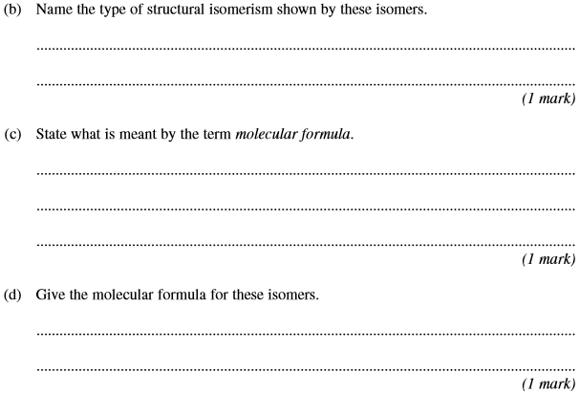
 | 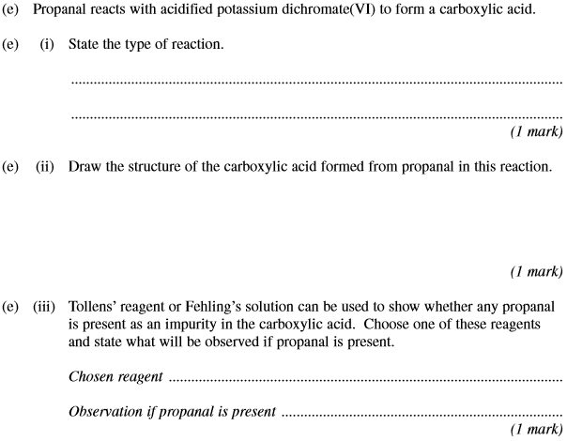
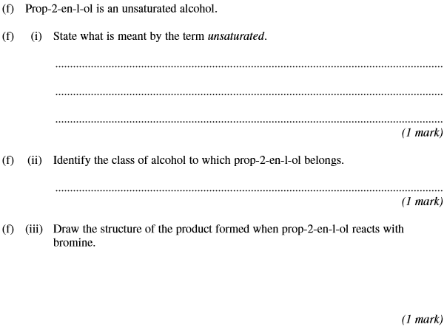
(Total 12 marks)

3.
 | (Total 11 marks)

4. (a) Name and outline a mechanism for the reaction of CH₃CH₂NH₂ with CH₃CH₂COCl
Name the amide formed.

(6)
(b) Haloalkanes such as CH₃Cl are used in organic synthesis.
Outline a three-step synthesis of CH₃CH₂NH₂ starting from methane. Your first step should involve the formation of CH₃Cl
In your answer, identify the product of the second step and give the reagents and conditions for each step.
Equations and mechanisms are not required.
......................................................................................................................
......................................................................................................................
......................................................................................................................
......................................................................................................................
......................................................................................................................
......................................................................................................................
......................................................................................................................
......................................................................................................................
......................................................................................................................
......................................................................................................................
......................................................................................................................
......................................................................................................................
(6)
(Total 12 marks)

5. Each of the following conversions involves reduction of the starting material.
(a) Consider the following conversion.
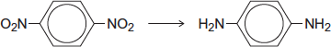
Identify a reducing agent for this conversion.
Write a balanced equation for the reaction using molecular formulae for the nitrogen-containing compounds and [H] for the reducing agent.
Draw the repeating unit of the polymer formed by the product of this reaction with benzene-1,4-dicarboxylic acid.
........................................................................................................................
........................................................................................................................
........................................................................................................................
........................................................................................................................
........................................................................................................................
........................................................................................................................
........................................................................................................................
(5)
(b) Consider the following conversion.
State the empirical formula of the product.
State the bond angle between the carbon atoms in the starting material and the bond angle between the carbon atoms in the product.
........................................................................................................................
........................................................................................................................
........................................................................................................................
........................................................................................................................
........................................................................................................................
........................................................................................................................
(3)
(Total 8 marks)

6. (a) Consider the following amino acid.
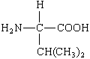
(i) Draw the structure of the amino acid species present in a solution at pH 12.

(ii) Draw the structure of the dipeptide formed from two molecules of this amino acid.

(iii) Protein chains are often arranged in the shape of a helix. Name the type of interaction that is responsible for holding the protein chain in this shape.
.............................................................................................................
(3)

(b) Consider the hydrocarbon G, (CH₃)₂C=CHCH₃, which can be polymerised.
(i) Name the type of polymerisation involved and draw the repeating unit of the polymer.
Type of polymerisation ........................................................................
Repeating unit

(ii) Draw the structure of an isomer of G which shows geometrical isomerism.

(iii) Draw the structure of an isomer of G which does not react with bromine water.

(4)
(Total 7 marks)

7. Benzene reacts with ethanoyl chloride in a substitution reaction to form C₆H₅COCH₃.
This reaction is catalysed by aluminium chloride.
(a) Write equations to show the role of aluminium chloride as a catalyst in this reaction.
Outline a mechanism for the reaction of benzene.
Name the product, C₆H₅COCH₃.
........................................................................................................................
........................................................................................................................
........................................................................................................................

(6)

(b) When methylbenzene reacts with ethanoyl chloride and aluminium chloride, a similar substitution reaction occurs but the reaction is faster than the reaction of benzene.
Suggest why the reaction of methylbenzene is faster.
........................................................................................................................
........................................................................................................................
........................................................................................................................
........................................................................................................................
........................................................................................................................
........................................................................................................................
(2)
(Total 8 marks)

8. Items softened with plasticisers have become an essential part of our modern society.
Compound S, shown below, is commonly known as phthalic acid.
Esters of phthalic acid are called phthalates and are used as plasticisers to soften polymers such as PVC, poly(chloroethene).
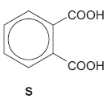
(a) Give the IUPAC name for phthalic acid.
......................................................................................................................
(1)
(b) Draw the displayed formula of the repeating unit of poly(chloroethene).

(1)

(c) The ester diethyl phthalate (DEP) is used in food packaging and in cosmetics.
(i) Complete the following equation showing the formation of DEP from phthalic anhydride.
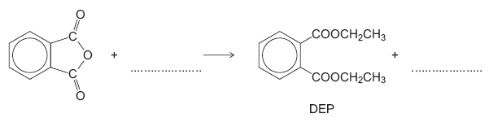
(2)
(ii) Deduce the number of peaks in the ¹³C n.m.r. spectrum of DEP.
.............................................................................................................
(1)
(iii) One of the peaks in the ¹³C n.m.r. spectrum of DEP is at δ = 62 ppm.
Table 3 on the Data Sheet can be used to identify a type of carbon atom responsible for this peak.
Draw a circle around one carbon atom of this type in the structure below.
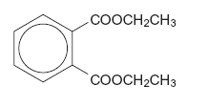
(1)

(e) Because of their many uses, phthalates have been tested for possible adverse effects to humans and to the environment.
An organisation that represents the manufacturers of plasticisers asserts that experimental evidence and research findings show that phthalates do not pose a risk to human health because they biodegrade in a short time scale.
According to the organization’s research, phthalates do not represent a risk for humans or for the environment and they are biodegradable.
(i) Hydrolysis of DEP in an excess of water was found to follow first order kinetics.
Write a rate equation for this hydrolysis reaction using DEP to represent the ester.
.............................................................................................................
(1)
(ii) Suggest what needs to be done so that the public could feel confident that the research discussed above is reliable.
.............................................................................................................
.............................................................................................................
.............................................................................................................
.............................................................................................................
.............................................................................................................
(2)
(Total 9 marks)

10. Use the data given on the back of the Periodic Table (PT) to help you answer this question.
Compounds A to G are all isomers with the molecular formula C₆H₁₂O₂
(a) Isomer A, C₆H₁₂O₂, is a neutral compound and is formed by the reaction between compounds X and Y in the presence of a small amount of concentrated sulphuric acid.
X and Y can both be formed from propanal by different redox reactions.
X has an absorption in its infra-red spectrum at 1750 cm^{–1}.
Deduce the structural formulae of A, X and Y. Give suitable reagents, in each case, for the formation of X and Y from propanal and state the role of concentrated sulphuric acid in the formation of A.

(7)
(b) Isomers B, C, D and E all react with aqueous sodium carbonate to produce carbon dioxide.
Deduce the structural formulae of the three isomers that contain an asymmetric carbon atom.
The fourth isomer has only three singlet peaks in its proton n.m.r. spectrum. Deduce the structural formula of this isomer and label it E.

(4)
(c) Isomer F, C₆H₁₂O₂, has the structural formula shown below, on which some of the protons have been labelled.
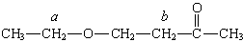
A proton n.m.r. spectrum is obtained for F. Using Table 1 at the back of the Periodic Table (PT), predict a value of δ for the protons labelled a and also for those labelled b. State and account for the splitting patterns of the peaks assigned to the protons a and b.
……………………………………………………………………………………………………………
…………………………………………………………………………………………………………....
……………………………………………………………………………………………………………
…………………………………………………………………………………………………………....
……………………………………………………………………………………………………………
…………………………………………………………………………………………………………....
……………………………………………………………………………………………………………
…………………………………………………………………………………………………………....
(6)
(d) Isomer G, C₆H₁₂O₂, contains six carbon atoms in a ring. It has an absorption in its infra-red spectrum at 3270 cm^{–1} and shows only three different proton environments in its proton n.m.r. spectrum. Deduce a structural formula for G.

(2)
(Total 19 marks)

10.

 | (a)
 | (b)
 | (c)
 | (d)
 | (e)
 | (f)
 | (g)
 | (h) | (i)
 |  | (ii)
 | (i)
 | (j) | (Total 14 marks)

