A-LEVEL CHEMISTRY

PAPER 2
PRACTICE PAPER 8

Answer all questions
Max 105 marks
2 hours

Name ……………………………………………………………..

Mark ……../105 ……....% Grade ………

1. | 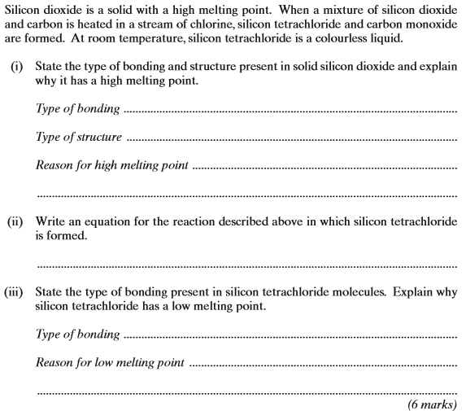  (Total 6 marks)
2.
 | (Total 10 marks)

3. | 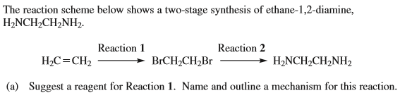  Reagent:…………………………………………………………………………………………………………………  Name of mechanism:……………………………………………………………………………………………..  Mechanism:

Reagent:…………………………………………………………………………………………………………………

Name of mechanism:……………………………………………………………………………………………..

Equation:

[8]

4.

5. Gases P and Q react as shown in the following equation.

2P(g) | + | 2Q(g) |  | R(g) | + | S(g)

The initial rate of the reaction was measured in a series of experiments at a constant temperature. The following rate equation was determined.
rate = k[P]²[Q]
(a) Complete the table of data for the reaction between P and Q.

Experiment | Initial [P] / mol dm^{–3} | Initial [Q] / mol dm^{–3} | Initial rate / mol dm^{–3} s^{–1}
1 | 2.5 × 10^{–2} | 1.8 × 10^{–2} | 5.0 × 10^{–5}
2 | 7.5 × 10^{–2} | 1.8 × 10^{–2}
3 | 5.0 × 10^{–2} |  | 5.0 × 10^{–5}
4 |  | 5.4 × 10^{–2} | 4.5 × 10^{–4}

(Space for working) .......................................................................................
........................................................................................................................
........................................................................................................................
........................................................................................................................
(3)
(b) Use the data from Experiment 1 to calculate a value for the rate constant (k) at this temperature. Deduce the units of k.
Calculation .....................................................................................................
........................................................................................................................
........................................................................................................................
........................................................................................................................
Units ...............................................................................................................
........................................................................................................................
(3)
(Total 6 marks)

6. | 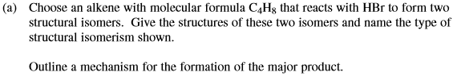  (7 marks)
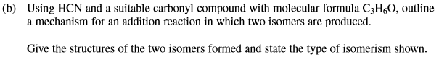

(7 marks)
(Total 14 marks)

7. Esters are used as raw materials in the production of soaps and biodiesel.
(a) A student prepared an ester by two different methods.
Method 1 alcohol + acid anhydride
Method 2 alcohol + acyl chloride
(i) An ester was prepared using method 1, by reacting (CH₃)₂CHOH with (CH₃CO)₂O
Write an equation for this reaction and give the IUPAC name of the ester formed.
Equation
...............................................................................................................
IUPAC name of the ester .....................................................................
(2)
(ii) The same ester was prepared using method 2 by reacting (CH₃)₂CHOH with CH₃COCl
Outline a mechanism for this reaction.

(4)
(b) The ester shown occurs in vegetable oils.
It can be hydrolysed to make soap and can also be used to produce biodiesel.
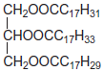
(i) Write an equation for the reaction of this ester with sodium hydroxide to form soap.
...............................................................................................................
(2)
(ii) Give the formula of the biodiesel molecule with the highest M_{r} that can be produced by reaction of this ester with methanol.
...............................................................................................................
(1)
(Total 9 marks)

8. | 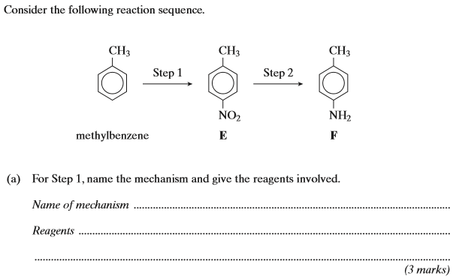
 | 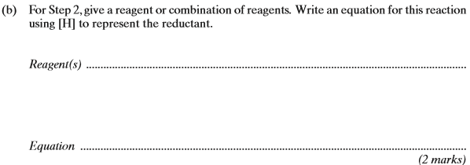
 | (c) | 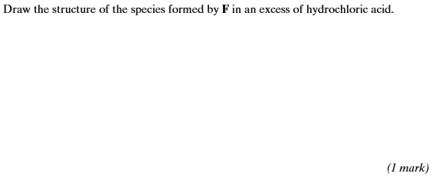
 | (d) | 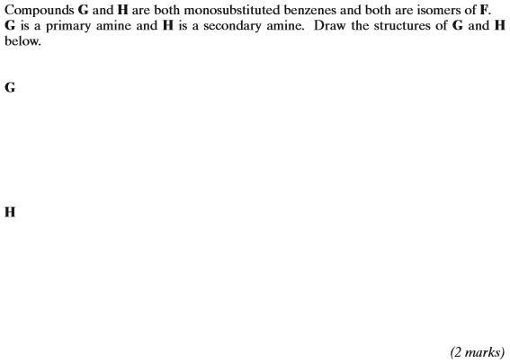  (Total 8 marks)

9.
 | (a) | (i) | ………………………………………………………………………………………………………………………………………………………….
 |  | (ii) | ………………………………………………………………………………………………………………………………………………………….  ………………………………………………………………………………………………………………………………………………………….  ………………………………………………………………………………………………………………………………………………………….
 |  | (iii) | ………………………………………………………………………………………………………………………………………………………….  ………………………………………………………………………………………………………………………………………………………….  ………………………………………………………………………………………………………………………………………………………….
 |  | (iv) | ………………………………………………………………………………………………………………………………………………………….  ………………………………………………………………………………………………………………………………………………………….

 | (b) | ………………………………………………………………………………………………………………………………………………………….  ………………………………………………………………………………………………………………………………………………………….  ………………………………………………………………………………………………………………………………………………………….  ………………………………………………………………………………………………………………………………………………………….  ………………………………………………………………………………………………………………………………………………………….  ………………………………………………………………………………………………………………………………………………………….  ………………………………………………………………………………………………………………………………………………………….  ………………………………………………………………………………………………………………………………………………………….  ………………………………………………………………………………………………………………………………………………………….
 | (c) | ………………………………………………………………………………………………………………………………………………………….  ………………………………………………………………………………………………………………………………………………………….  ………………………………………………………………………………………………………………………………………………………….  ………………………………………………………………………………………………………………………………………………………….  (Total 8 marks)

10. | 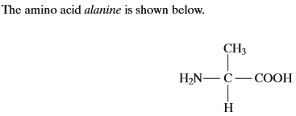  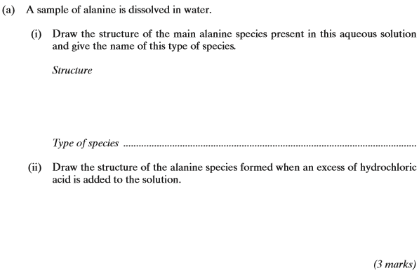
 | 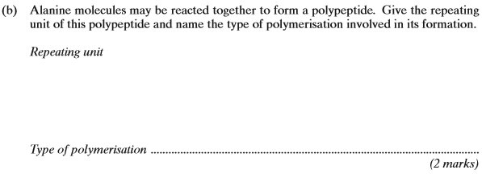
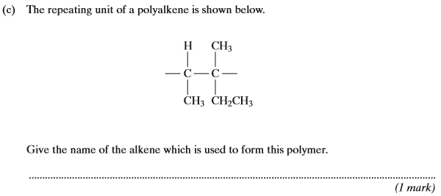
(Total 6 marks)

11. Aspirin can be made by reacting salicylic acid with ethanoic anhydride as outlined below.
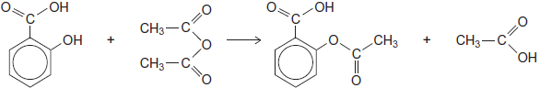
(a) In an experiment, after purification by recrystallisation, 1.76 g of aspirin (M_{r} = 180.0) were produced from 2.00 g of salicylic acid.
Calculate the percentage yield for this experiment.
........................................................................................................................
........................................................................................................................
........................................................................................................................
........................................................................................................................
(2)
(b) Suggest one practical reason why the yield of purified aspirin is less than 100%.
........................................................................................................................
........................................................................................................................
(1)
(Total 3 marks)

12. | (a)
 | (b) | 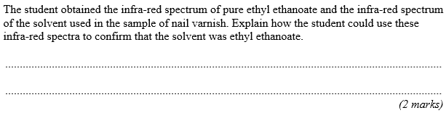

 | (c) | 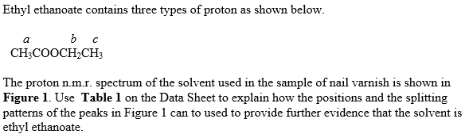  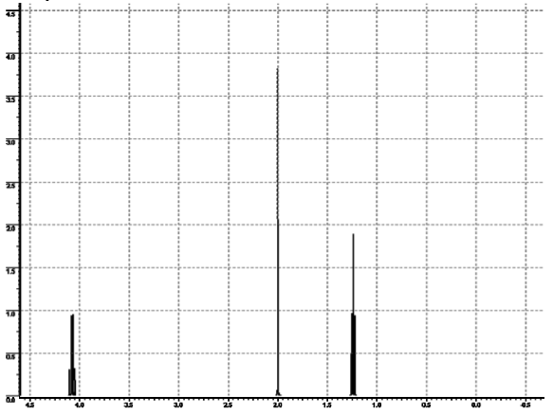
 | (d)
 | (e) | 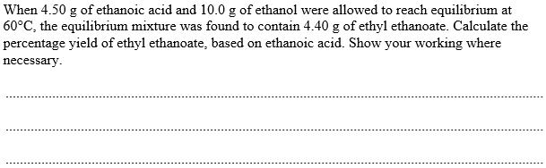
 | (f) | 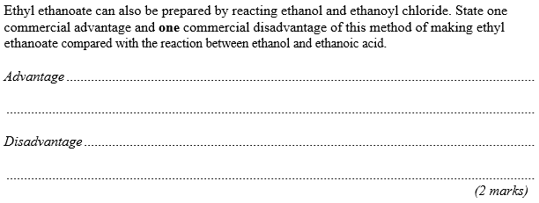
 | (g) | 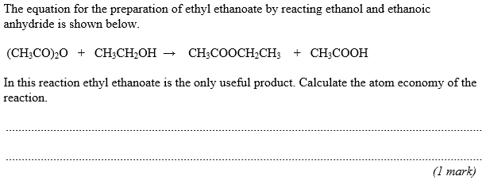
 | (h) | (Total 19 marks)
13. | ……………………………………………………………………………………………………………………………………………………………………………...  ……………………………………………………………………………………………………………………………………………………………………………...  ……………………………………………………………………………………………………………………………………………………………………………...  ……………………………………………………………………………………………………………………………………………………………………………...  ……………………………………………………………………………………………………………………………………………………………………………...  ……………………………………………………………………………………………………………………………………………………………………………...  (Total 6 marks)

