A-LEVEL CHEMISTRY

PAPER 2
PRACTICE PAPER 9

Answer all questions
Max 105 marks
2 hours

Name ……………………………………………………………..

Mark ……../105 ……....% Grade ………

1. | (a) | 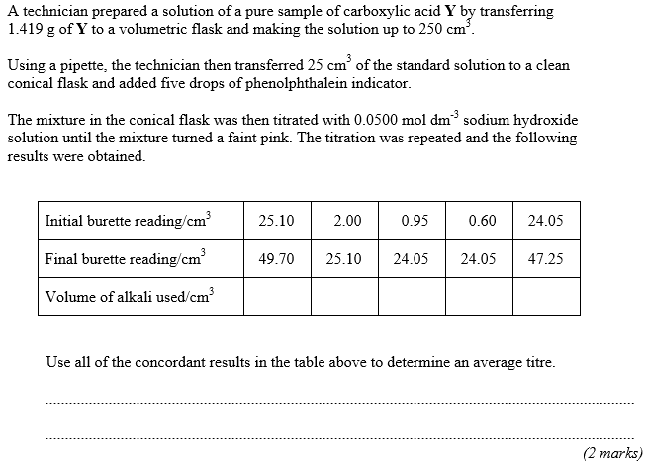
 | (b) | 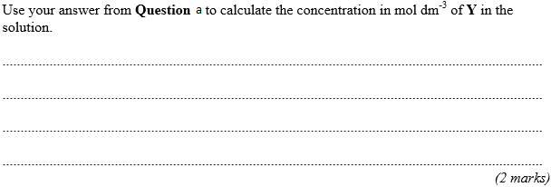
 | (c) | 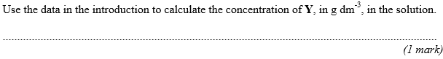
 | (d) | 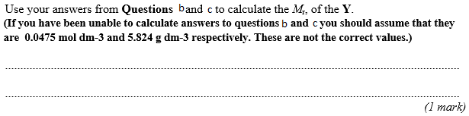
 | (e) | 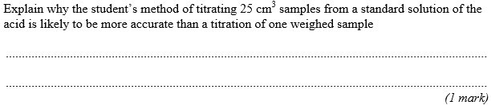  (Total 7 marks)
2. | 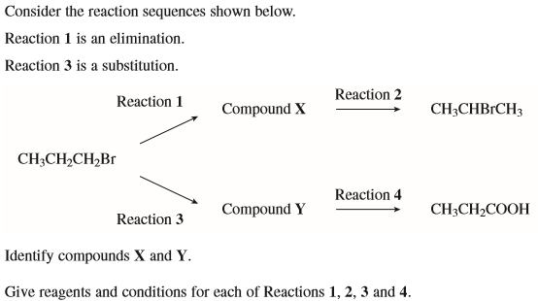  ……………………………………………………………………………………………………………………………………………………………………………...  ……………………………………………………………………………………………………………………………………………………………………………...  ……………………………………………………………………………………………………………………………………………………………………………...  ……………………………………………………………………………………………………………………………………………………………………………...  ……………………………………………………………………………………………………………………………………………………………………………...  ……………………………………………………………………………………………………………………………………………………………………………...  ……………………………………………………………………………………………………………………………………………………………………………...  ……………………………………………………………………………………………………………………………………………………………………………...  (Total 9 marks)
3. | 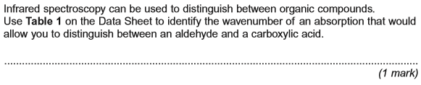  (Total 1 mark)
4.
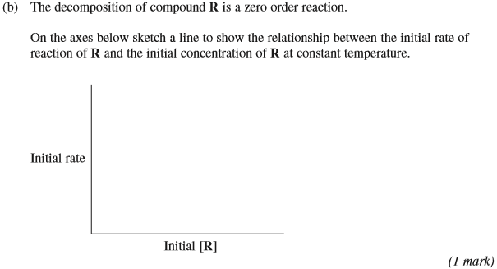
(Total 7 marks)
5. | 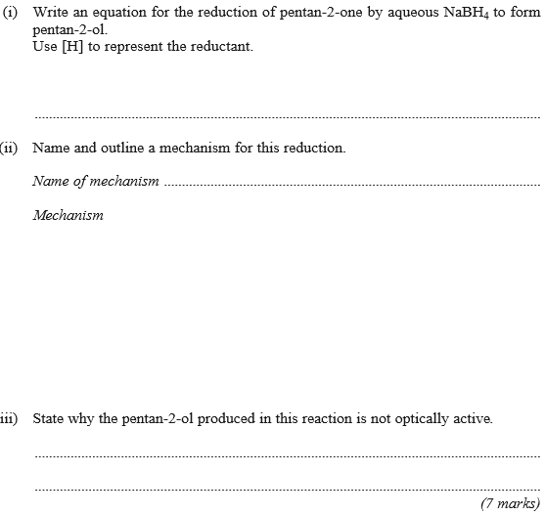  (Total 7 marks)
6. | 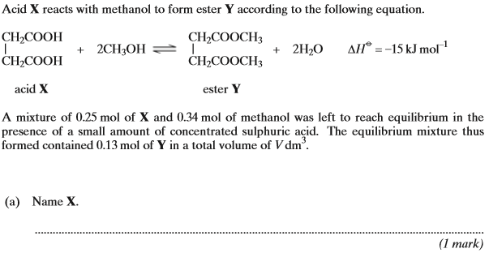
 | 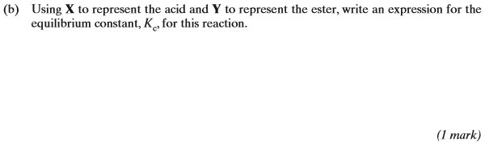
 | 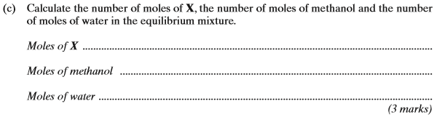
 | 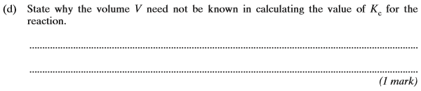
 | 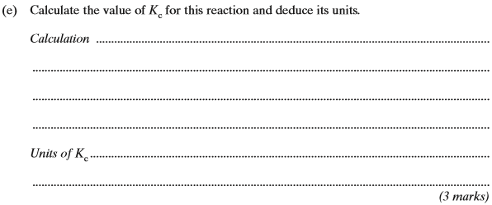
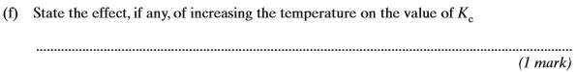
(Total 10 marks)

7.

 | (a) | ………………………………………………………………………………………………………………………………………………………….
 |  | (i) | ………………………………………………………………………………………………………………………………………………………….  ………………………………………………………………………………………………………………………………………………………….
 |  | (ii) | ………………………………………………………………………………………………………………………………………………………….  ………………………………………………………………………………………………………………………………………………………….
 |  | (iii) | ………………………………………………………………………………………………………………………………………………………….  ………………………………………………………………………………………………………………………………………………………….

 | (b) | ………………………………………………………………………………………………………………………………………………………….  ………………………………………………………………………………………………………………………………………………………….  ………………………………………………………………………………………………………………………………………………………….  ………………………………………………………………………………………………………………………………………………………….  ………………………………………………………………………………………………………………………………………………………….  ………………………………………………………………………………………………………………………………………………………….  ………………………………………………………………………………………………………………………………………………………….  ………………………………………………………………………………………………………………………………………………………….  ………………………………………………………………………………………………………………………………………………………….  ………………………………………………………………………………………………………………………………………………………….  ………………………………………………………………………………………………………………………………………………………….  ………………………………………………………………………………………………………………………………………………………….  ………………………………………………………………………………………………………………………………………………………….  ………………………………………………………………………………………………………………………………………………………….  ………………………………………………………………………………………………………………………………………………………….  ………………………………………………………………………………………………………………………………………………………….
 | (c) | ………………………………………………………………………………………………………………………………………………………….  ………………………………………………………………………………………………………………………………………………………….  ………………………………………………………………………………………………………………………………………………………….  (Total 8 marks)

8. | 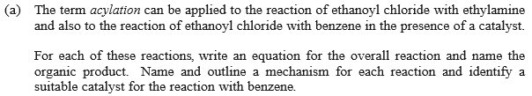  ……………………………………………………………………………………………………………………………………………………………………………...  ……………………………………………………………………………………………………………………………………………………………………………...  ……………………………………………………………………………………………………………………………………………………………………………...  ……………………………………………………………………………………………………………………………………………………………………………...  ……………………………………………………………………………………………………………………………………………………………………………...  ……………………………………………………………………………………………………………………………………………………………………………...  ……………………………………………………………………………………………………………………………………………………………………………...  ……………………………………………………………………………………………………………………………………………………………………………...  ……………………………………………………………………………………………………………………………………………………………………………...  ……………………………………………………………………………………………………………………………………………………………………………...  ……………………………………………………………………………………………………………………………………………………………………………...  ……………………………………………………………………………………………………………………………………………………………………………...  ……………………………………………………………………………………………………………………………………………………………………………...  ……………………………………………………………………………………………………………………………………………………………………………...  ……………………………………………………………………………………………………………………………………………………………………………...  ……………………………………………………………………………………………………………………………………………………………………………...  ……………………………………………………………………………………………………………………………………………………………………………...  ……………………………………………………………………………………………………………………………………………………………………………...  ……………………………………………………………………………………………………………………………………………………………………………...  ……………………………………………………………………………………………………………………………………………………………………………...  ……………………………………………………………………………………………………………………………………………………………………………...  ……………………………………………………………………………………………………………………………………………………………………………...
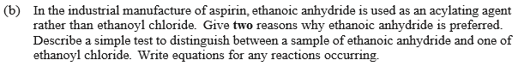

……………………………………………………………………………………………………………………………………………………………………………...

……………………………………………………………………………………………………………………………………………………………………………...

……………………………………………………………………………………………………………………………………………………………………………...

……………………………………………………………………………………………………………………………………………………………………………...

……………………………………………………………………………………………………………………………………………………………………………...

……………………………………………………………………………………………………………………………………………………………………………...

……………………………………………………………………………………………………………………………………………………………………………...

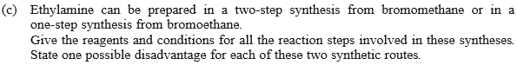

……………………………………………………………………………………………………………………………………………………………………………...

……………………………………………………………………………………………………………………………………………………………………………...

……………………………………………………………………………………………………………………………………………………………………………...

……………………………………………………………………………………………………………………………………………………………………………...

……………………………………………………………………………………………………………………………………………………………………………...

……………………………………………………………………………………………………………………………………………………………………………...

……………………………………………………………………………………………………………………………………………………………………………...
(Total 30 marks)

9. | 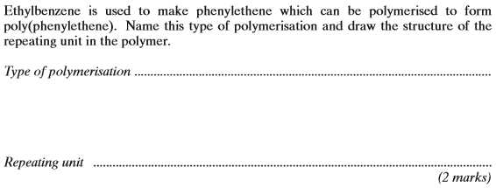  (Total 2 marks)
10. | 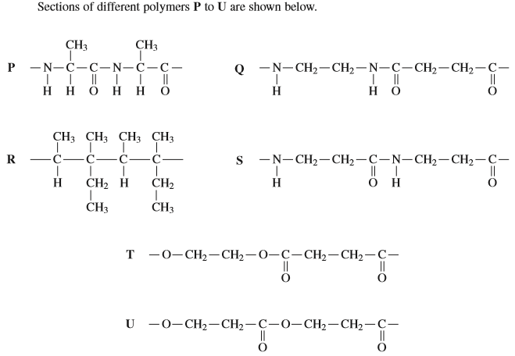  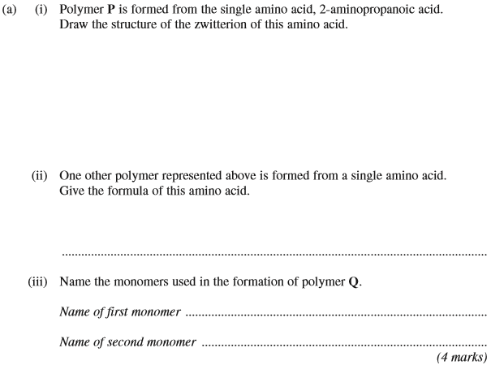
 | 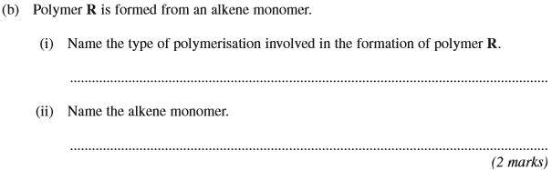
 | 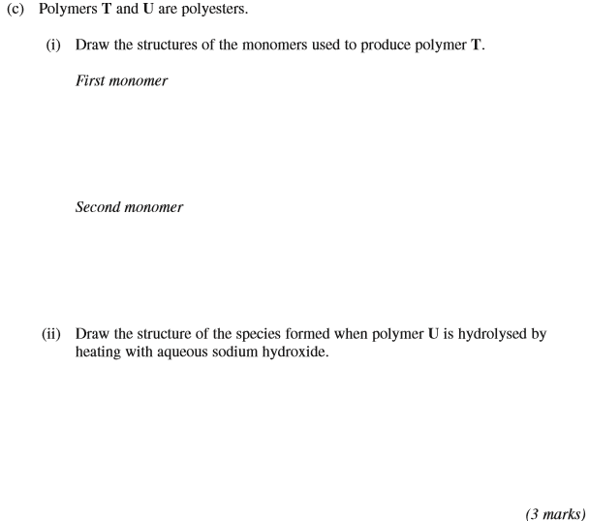
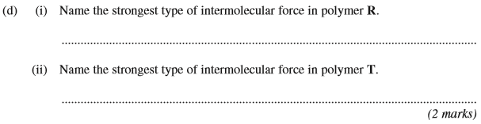
(Total 11 marks)

11. | …………………………………………………………………………………………………………………………………………………………………………….  …………………………………………………………………………………………………………………………………………………………………………….  …………………………………………………………………………………………………………………………………………………………………………….  …………………………………………………………………………………………………………………………………………………………………………….  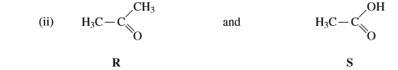  …………………………………………………………………………………………………………………………………………………………………………….  …………………………………………………………………………………………………………………………………………………………………………….  …………………………………………………………………………………………………………………………………………………………………………….  …………………………………………………………………………………………………………………………………………………………………………….  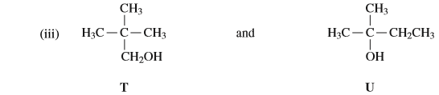  …………………………………………………………………………………………………………………………………………………………………………….  …………………………………………………………………………………………………………………………………………………………………………….  …………………………………………………………………………………………………………………………………………………………………………….  …………………………………………………………………………………………………………………………………………………………………………….  (9)
 | (b) | 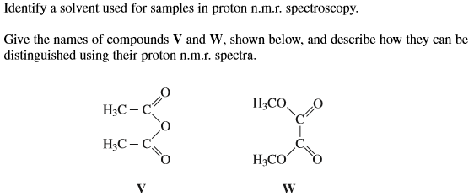  ………………………………………………………………………………………………………………………………………………………………………  ………………………………………………………………………………………………………………………………………………………………………  ………………………………………………………………………………………………………………………………………………………………………  ………………………………………………………………………………………………………………………………………………………………………  (4)  (Total 13 marks)

