A-LEVEL PAPER 3 PP13 MS
1.
 | 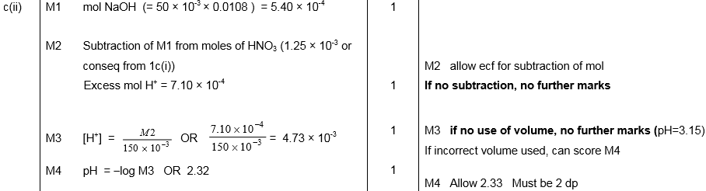
 | 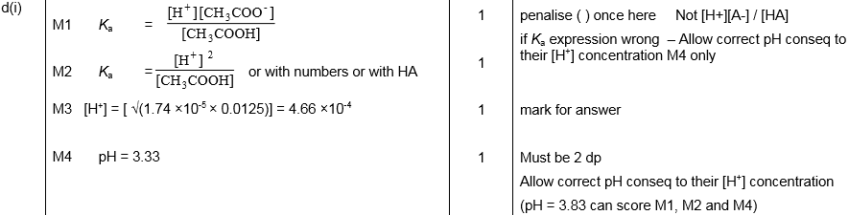
 | 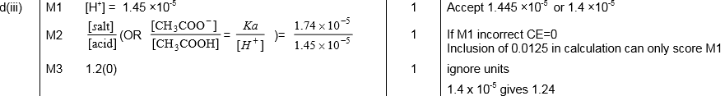
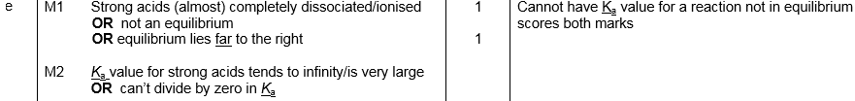
[18]

2.
 | 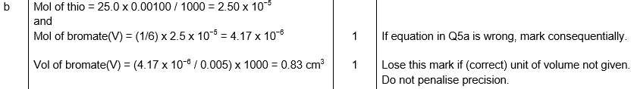
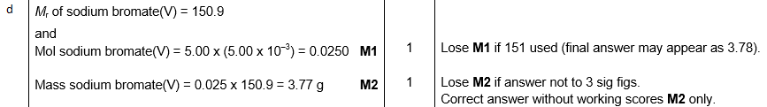
[6]

3.
 | 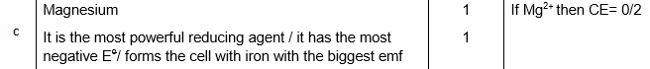
 | 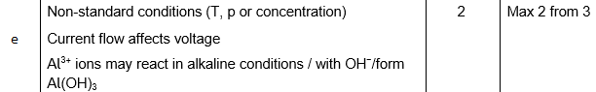
 | [13]
4. | 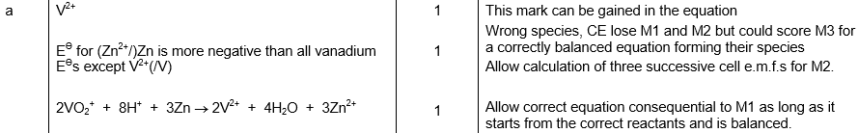
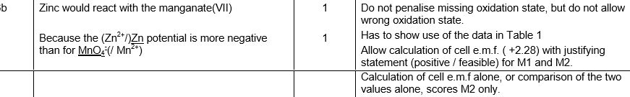
[5]

5. | 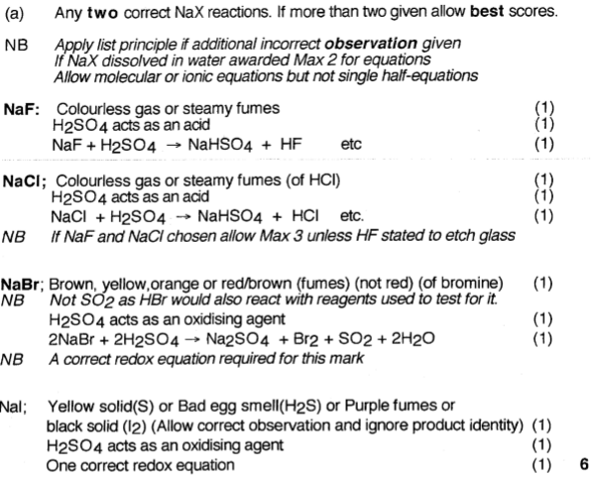
 | 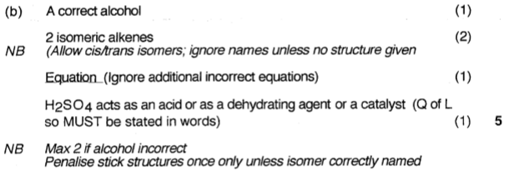
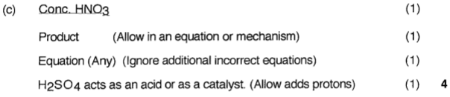
[15]

6. (a) (i) EDTA⁴⁻ + [Cu(H₂O)₆]²⁺ → [Cu(EDTA)]²⁻ + 6H₂O
1
(ii) (Mol EDTA = (6.45/1000) ×0.015 = )9.68 ×10⁻⁵ mol Cu(II)
1
Conc. Cu(II) = ((9.68 ×10⁻⁵) / 0.025 =) 0.00387 mol dm⁻³
Correct answer without working gains M2 only.
1
(b) Samples may not be consistent throughout the river
OR
Concentration may vary over time
Ignore comments on technique.
1
(c) [Ag(NH₃)₂]⁺
Accept name eg diamminesilver(I) ion.
1
aldehyde
Allow CHO.
1
[6]

7. C
1
8. D
1
9. A
1
10. D
1
11. D
1
12. C
1
13. D
1
14. C
1
15. D
1
16. D
1
17. D
1
18. D
1
19. A
1
20. B
1
21. C
1
22. D
1
23. C
1
24. D
1
25. D
1
26. D
1
27. C
1
28. C
1
29. D
1
30. D
1
31. A
1
32. A
1
33. C
1

