A-LEVEL CHEMISTRY

PAPER 3
PRACTICE PAPER 15

Answer all questions
Max 83 marks
1 hour 35 minutes

Name ……………………………………………………………..

Mark ……../83 ……....% Grade ………

This paper contains structured questions only
This paper is slightly shorter than a typical Paper 3

1. | 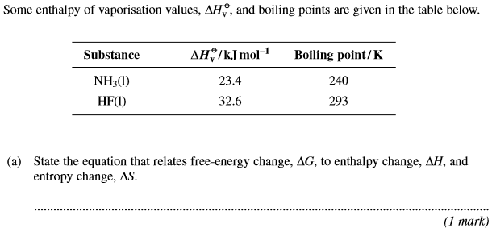
 | 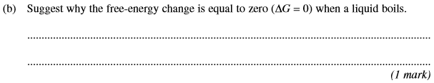
 | 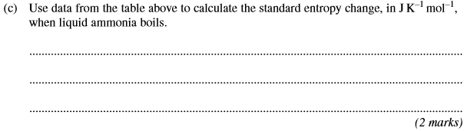
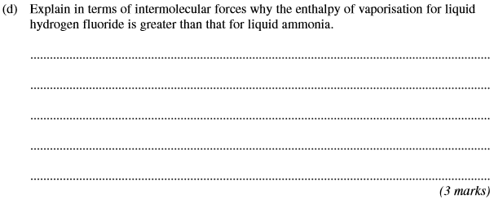
(Total 7 marks)

2. | 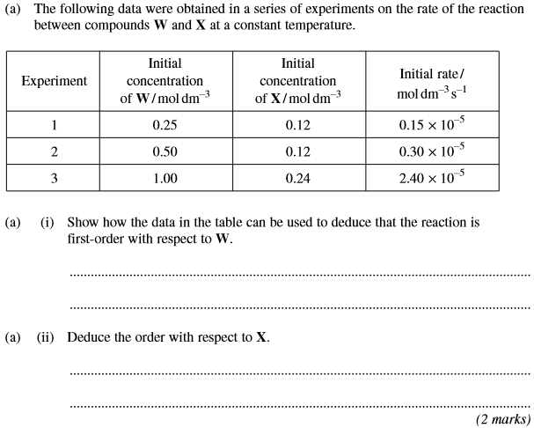

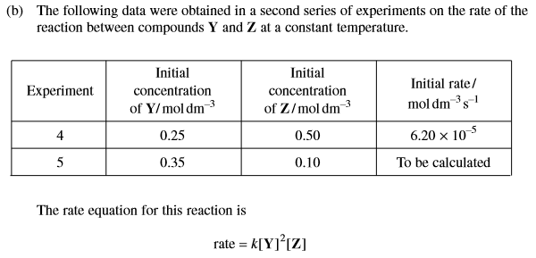
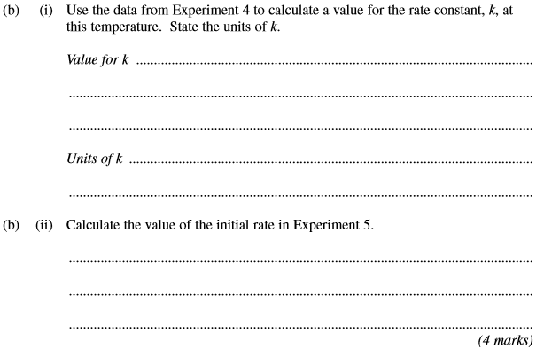
(Total 6 marks)

3.
 | (Total 19 marks)
4. | 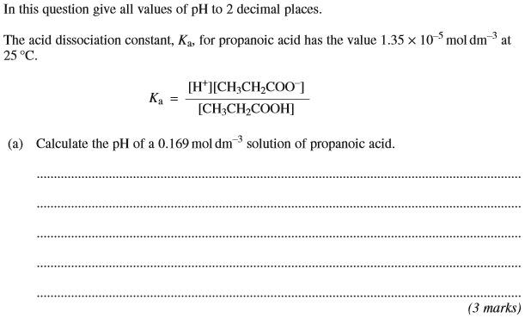
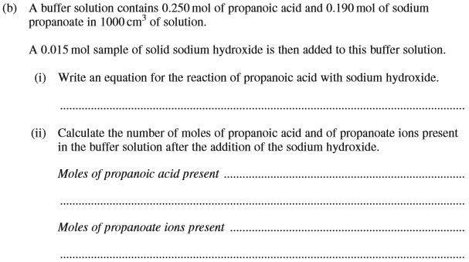
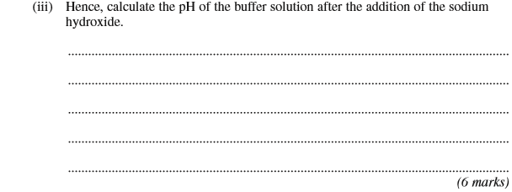
(Total 9 marks)

5. | 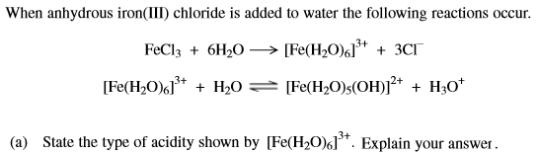  ……………………………………………………………………………………………………………………………………………………………………………  ……………………………………………………………………………………………………………………………………………………………………………  ……………………………………………………………………………………………………………………………………………………………………………  (2 marks)
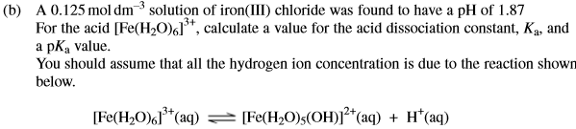

……………………………………………………………………………………………………………………………………………………………………………

……………………………………………………………………………………………………………………………………………………………………………

……………………………………………………………………………………………………………………………………………………………………………

……………………………………………………………………………………………………………………………………………………………………………

……………………………………………………………………………………………………………………………………………………………………………

……………………………………………………………………………………………………………………………………………………………………………
(6 marks)

……………………………………………………………………………………………………………………………………………………………………………

……………………………………………………………………………………………………………………………………………………………………………

……………………………………………………………………………………………………………………………………………………………………………
(2 marks)
(Total 10 marks)

6. | 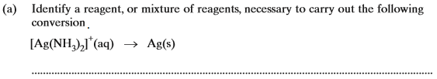
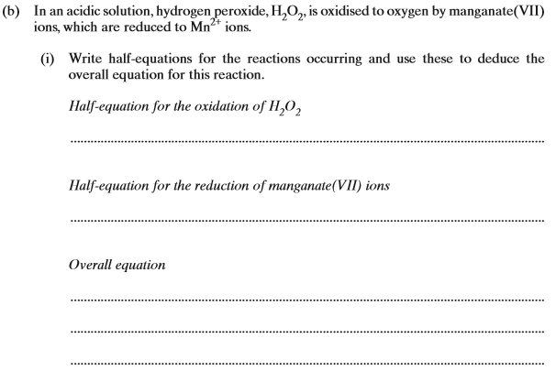
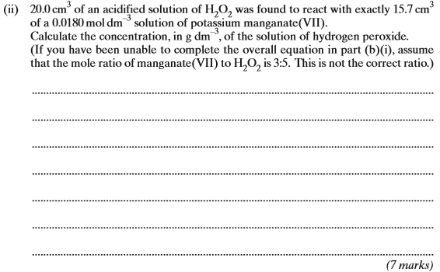
(Total 8 marks)

7. | (Total 4 marks)
8. | 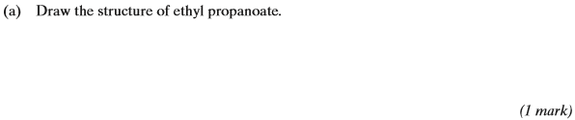
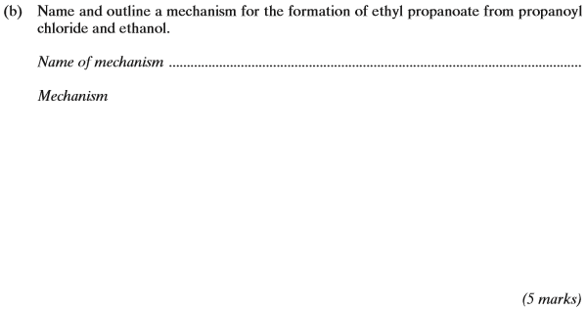
(Total 6 marks)

9. | A reaction scheme starting with benzene is shown below:  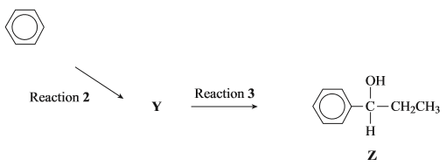  ……………………………………………………………………………………………………………………………………………………………………………  ……………………………………………………………………………………………………………………………………………………………………………  ……………………………………………………………………………………………………………………………………………………………………………  ……………………………………………………………………………………………………………………………………………………………………………  (Total 3 marks)

10. | 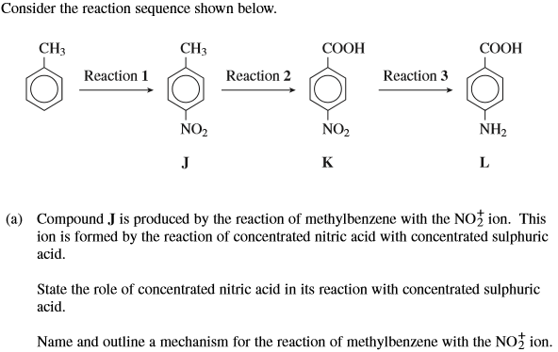  ……………………………………………………………………………………………………………………………………………………………………………  ……………………………………………………………………………………………………………………………………………………………………………  ……………………………………………………………………………………………………………………………………………………………………………  (5 marks)
 | (1 mark)

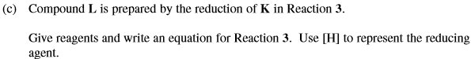

……………………………………………………………………………………………………………………………………………………………………………

……………………………………………………………………………………………………………………………………………………………………………

……………………………………………………………………………………………………………………………………………………………………………
(2 marks)
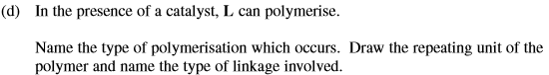
(3 marks)
(Total 11 marks)

