A-LEVEL CHEMISTRY

PAPER 3
PRACTICE PAPER 4

Answer all questions
Max 90 marks
1 hour 45 minutes

Name ……………………………………………………………..

Mark ……../90 ……....% Grade ………

The first 10 multiple choice questions have already been used for AS-level resources

1. (a) Some scientists thought that the waste water from a waste disposal factory contained two sodium halides.
They tested a sample of the waste water.
They added three reagents, one after the other, to the same test tube containing the waste water.
The table below shows their results.

Reagent added | Observations
1. Silver nitrate solution (acidified  with dilute nitric acid) | A cream precipitate formed
2. Dilute ammonia solution | A yellow precipitate remained
3. Concentrated ammonia solution | The yellow precipitate did not dissolve

(i) Identify the yellow precipitate that did not dissolve in concentrated ammonia solution.
Write the simplest ionic equation for the formation of this precipitate from silver ions and the correct halide ion.
Identify the other sodium halide that must be present in this mixture of two sodium halides.
.............................................................................................................
.............................................................................................................
.............................................................................................................
(3)
(ii) Give one reason why the silver nitrate solution was acidified before it was used in this test.
.............................................................................................................
.............................................................................................................
.............................................................................................................
(1)
(iii) The method that the scientists used could not detect one type of halide ion. Identify this halide ion.
Give one reason for your answer.
.............................................................................................................
.............................................................................................................
.............................................................................................................
.............................................................................................................
(2)
(b) The scientists thought that the waste water also contained dissolved barium ions. An aqueous solution of sodium sulfate can be used to test for the presence of dissolved barium ions.
Write the simplest ionic equation for the reaction between barium ions and sulfate ions to form barium sulfate.
State what is observed in this reaction.
Give a use for barium sulfate in medicine and explain why this use is possible, given that solutions containing barium ions are poisonous.
......................................................................................................................
......................................................................................................................
......................................................................................................................
......................................................................................................................
......................................................................................................................
......................................................................................................................
......................................................................................................................
......................................................................................................................
(4)

(c) The scientists also analysed the exhaust gases from an incinerator used to destroy waste poly(ethene).
Mass spectrometry showed that there was a trace gas with a precise M_{r} = 28.03176 in the exhaust gases from the incinerator.
The table below contains some precise relative atomic mass data.

Atom | Precise relative atomic mass
¹²C | 12.00000
¹H | 1.00794
¹⁶O | 15.99491

Use the data to show that the trace gas is ethene. Show your working.
Suggest why both ethene and carbon monoxide might have been identified as the trace gas if the scientists had used relative atomic masses to a precision of only one decimal place.
Write an equation for the incomplete combustion of ethene to form carbon monoxide and water only.
Ethene is used to make poly(ethene).
Draw the displayed formula for the repeating unit of poly(ethene).
Name this type of polymer.
......................................................................................................................
......................................................................................................................
......................................................................................................................
......................................................................................................................
......................................................................................................................
......................................................................................................................
......................................................................................................................
......................................................................................................................
......................................................................................................................
......................................................................................................................
(5)
(Total 15 marks)

2. The sketch below shows the change in pH when a 0.200 mol dm^{–3} solution of sodium hydroxide is added from a burette to 25.0 cm³ of a 0.150 mol dm⁻³ solution of the weak acid HA at 25 °C.
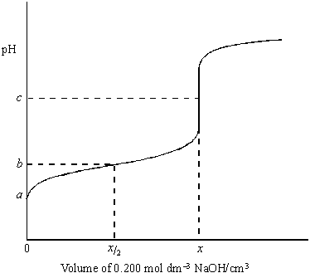
(a) The volume of sodium hydroxide solution added at the equivalence point is x cm³.
Calculate the value of x.
......................................................................................................................
......................................................................................................................
......................................................................................................................
(2)
(b) (i) Define the term pH.
.............................................................................................................
(ii) The pH at the equivalence point is c. Suggest a value for c.
.............................................................................................................
(iii) Identify a suitable indicator for detecting the equivalence point of the titration.
.............................................................................................................
(3)

(c) The value of K_{c} for the weak acid HA at 25 °C is 2.75 × 10^{–5} mol dm^{–3}.
(i) Explain the term weak as applied to the acid HA.
.............................................................................................................
(ii) Write an expression for K_{a} for the acid HA.
.............................................................................................................
(iii) Calculate the pH of the 0.150 mol dm^{–3} solution of acid HA before any sodium hydroxide is added, i.e. the pH at point a.
.............................................................................................................
.............................................................................................................
.............................................................................................................
.............................................................................................................
.............................................................................................................
(5)
(d) Calculate the pH of the solution formed when cm³ of the 0.200 mol dm^{–3} solution of sodium hydroxide are added to 25.0 cm³ of the 0.150 mol dm^{–3} solution of HA, i.e. the pH at point b.
......................................................................................................................
......................................................................................................................
......................................................................................................................
(3)
(Total 13 marks)

3. Ammonia and ethylamine are examples of weak Brønsted–Lowry bases.
(a) State the meaning of the term Brønsted–Lowry base.
........................................................................................................................
........................................................................................................................
(1)

(b) (i) Write an equation for the reaction of ethylamine (CH₃CH₂NH₂) with water to form a weakly alkaline solution.
...............................................................................................................
...............................................................................................................
(1)
(ii) In terms of this reaction, state why the solution formed is weakly alkaline.
...............................................................................................................
...............................................................................................................
(1)
(c) State which is the stronger base, ammonia or ethylamine. Explain your answer.
Stronger base ................................................................................................
Explanation ....................................................................................................
........................................................................................................................
........................................................................................................................
........................................................................................................................
(3)
(d) Give the formula of an organic compound that forms an alkaline buffer solution when added to a solution of ethylamine.
........................................................................................................................
(1)
(e) Explain qualitatively how the buffer solution in part (d) maintains an almost constant pH when a small amount of hydrochloric acid is added to it.
........................................................................................................................
........................................................................................................................
........................................................................................................................
........................................................................................................................
(2)
(Total 9 marks)

4. Aqueous solutions of copper(II) sulfate and cobalt(II) sulfate undergo ligand substitution reactions when treated separately with an excess of dilute aqueous ammonia.
Write equations for these reactions. Include the formulae for any complex ions.
Describe the changes that you would observe in each reaction.
........................................................................................................................
........................................................................................................................
........................................................................................................................
........................................................................................................................
........................................................................................................................
........................................................................................................................
........................................................................................................................
........................................................................................................................
........................................................................................................................
........................................................................................................................
(6)
(Total 6 marks)

5. (a) When a solution containing iron(II) ions is treated with a slight excess of a solution containing ethanedioate ions a bright yellow precipitate of hydrated iron(II) ethanedioate, FeC₂O₄.2H₂O, is formed. The precipitate is filtered off, washed with propanone and then allowed to dry. A typical yield of the solid is 95%.
(i) Propanone boils at 56 °C and is miscible with water in all proportions. Suggest two reasons why washing with propanone is an effective method for producing a pure, dry precipitate.
Reason 1 ..............................................................................................
...............................................................................................................
Reason 2 ..............................................................................................
...............................................................................................................
(2)
(ii) By suggesting a simple test tube reaction, state how the filtrate could be tested to show that all of the iron(II) ions have been removed from the solution. State what you would observe.
Test ......................................................................................................
Observation ..........................................................................................
(2)
(iii) Suggest one reason why the typical yield of iron(II) ethanedioate is less than 100%.
...............................................................................................................
...............................................................................................................
(1)
(iv) Calculate the mass of hydrated iron(II) ethanedioate, FeC₂O₄.2H₂O that can be formed from 50.0 cm³ of a 0.50 mol dm^{–3} solution of iron(II) sulfate when the yield of the reaction is 95%. Show your working.
...............................................................................................................
...............................................................................................................
...............................................................................................................
...............................................................................................................
(3)
(v) The identity of the precipitate can be confirmed by dissolving it in sulfuric acid and titrating the mixture with potassium manganate(VII).
Deduce the number of moles of iron(II) ethanedioate that would react with one mole of potassium manganate(VII) in acidic solution.
...............................................................................................................
...............................................................................................................
(1)
(b) Ethanedioate ions can be used to remove calcium ions from blood plasma.
A precipitate of calcium ethanedioate is formed. Write an ionic equation for the reaction of ethanedioate ions with calcium ions.
........................................................................................................................
........................................................................................................................
(1)
(c) Ethanedioic acid is used to clean marble, a form of calcium carbonate. Suggest one reason why the reaction between ethanedioic acid and marble stops after a short time.
........................................................................................................................
........................................................................................................................
(1)
(d) Tea leaves contain ethanedioic acid. Suggest one reason why tea drinkers do not suffer from ethanedioic acid poisoning.
........................................................................................................................
(1)
(e) Ethanedioic acid is produced by the oxidation of carbon monoxide in a multi-step process. The equation which summarises the reactions taking place is shown below.
4CO + 4NaOH + O₂ + 4HCl → 2H₂C₂O₄ + 4NaCl + 2H₂O
Calculate the percentage atom economy for the formation of ethanedioic acid in this reaction. Show your working.
........................................................................................................................
........................................................................................................................
........................................................................................................................
(2)
(Total 14 marks)

6. Calcium fluoride crystals absorb ultra-violet light. Some of the energy gained is given out as visible light. The name of this process, fluorescence, comes from the name of the mineral, fluorite.
Use your knowledge of the equation ΔE = hν to suggest what happens to the electrons in fluorite when ultra-violet light is absorbed and when visible light is given out.
......................................................................................................................
......................................................................................................................
......................................................................................................................
......................................................................................................................
(2)
(Total 2 marks)

7. In which one of the following pairs is the first ionisation energy of element Y greater than that of element X?

 |  | electronic configuration  of element X | electronic configuration  of element Y
 | A | 1s¹ | ls²
 | B | 1s² 2s² | ls²2s² 2p¹
 | C | 1s² 2s²2p³ | ls²2s²2p⁴
 | D | 1s² 2s²2p⁶ | ls²2s²2p⁶ 3s¹

(Total 1 mark)

8. Which one of the following contains the smallest number of moles of carbon dioxide gas?
A 2.65 g
B 0.0150 m³ at 1000 K and 33.0 kPa
C 1.50 dm³ at 327 °C and 200 kPa
D 1500 cm³ at 300 K and 100 kPa
(Total 1 mark)

9. Which one of the following bond polarities is not correct?
A in ethane
B in bromoethane
C in ethanol
D in ethanal
(Total 1 mark)

10. The data below refer to the industrial production of nitric acid from ammonia.
Reaction 1 4NH₃(g) + 5O₂(g) 4NO(g) + 6H₂O(g) ∆H = −909 kJ mol⁻¹
Reaction 2 2NO(g) + O₂(g) 2NO₂(g) ∆H = −115 kJ mol⁻¹
Reaction 3 3NO₂(g) + H₂O(l) 2HNO₃(aq) + NO(g) ∆H = −117 kJ mol⁻¹
The direct oxidation of ammonia to nitrogen dioxide can be represented by the equation
4NH₃(g) + 7O₂(g) → 4NO₂(g) + 6H₂O(g)
for which the standard enthalpy change, in kJ mol⁻¹, is
A −1139
B −1024
C −794
D −679
(Total 1 mark)

11. The apparatus in the figure below was set up to measure the time taken for 20.0 cm³ of sodium thiosulfate solution to react with 5.0 cm³ of hydrochloric acid in a 100 cm³ conical flask at 20 °C. The timer was started when the sodium thiosulfate solution was added to the acid in the flask. The timer was stopped when it was no longer possible to see the cross on the paper.
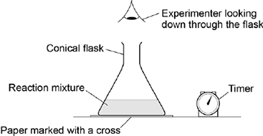
What is likely to decrease the accuracy of the experiment?

 | A | Rinsing the flask with acid before each new experiment.
 | B | Stirring the solution throughout each experiment.
 | C | Using the same piece of paper for each experiment.
 | D | Using different measuring cylinders to measure the volumes of acid and sodium thiosulfate.

(Total 1 mark)

12. The experiment was repeated at 20 °C using a 250 cm³ conical flask.
Which statement is correct about the time taken for the cross to disappear when using the larger conical flask?

 | A | The time taken will not be affected by using the larger conical flask.
 | B | The time taken will be decreased by using the larger conical flask.
 | C | The time taken will be increased by using the larger conical flask.
 | D | It is impossible to predict how the time taken will be affected by using the larger conical flask.

(Total 1 mark)

13. The reaction between sodium iodide and concentrated phosphoric acid produces hydrogen iodide but no iodine. The reaction of sodium iodide with concentrated sulphuric acid produces mainly iodine. The difference in product occurs because, in comparison with sulphuric acid, phosphoric acid is
A the weaker acid.
B the stronger oxidising agent.
C the weaker oxidising agent.
D the stronger reducing agent.
(Total 1 mark)

14. Phosphorus(V) chloride decomposes at high temperatures into phosphorus(III) chloride and chlorine according to the equation.
PCl₅(g) ⇌ PCl₃(g) + Cl₂(g)
Which one of the graphs best represents the variation with pressure of the yield of chlorine at equilibrium?
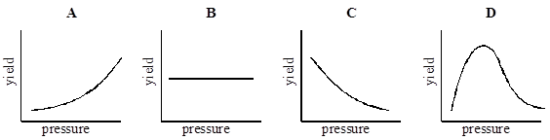
(Total 1 mark)

15. The compound cis-retinal is shown below.
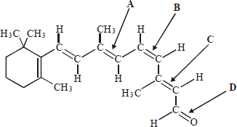
Which one of the labelled bonds leads to the prefix in the name?
(Total 1 mark)
16. For this question refer to the reaction scheme below.
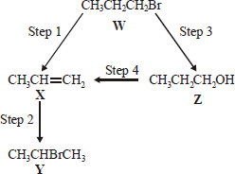
Which one of the following reagents would not bring about the reaction indicated?
A Step 1 : alcoholic KOH
B Step 2 : aqueous Br₂
C Step 3 : aqueous NaOH
C Step 4 : concentrated H₂SO₄
(Total 1 mark)

17. When an excess of methane is reacted with chlorine in the presence of ultra-violet light, which of the following statements is not true about the organic product of the reaction?
A it has permanent dipole-dipole forces between molecules.
B it has van der Waal’s forces between molecules.
C it has covalent bonds between atoms.
D it has hydrogen bonds between molecules.
(Total 1 mark)

18. | 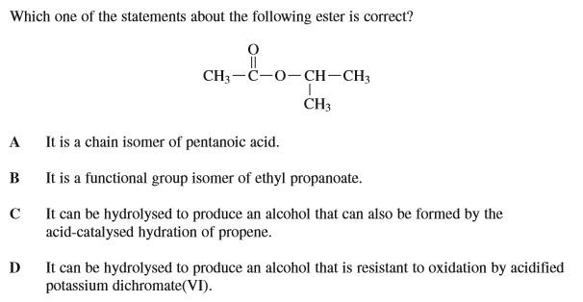  (Total 1 mark)
19. | A The product of the reaction of 1, 2-dichloroethane with excess aqueous NaOH  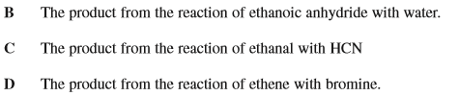  (Total 1 mark)
20. | 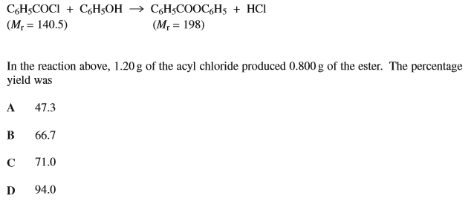  (Total 1 mark)
21. | 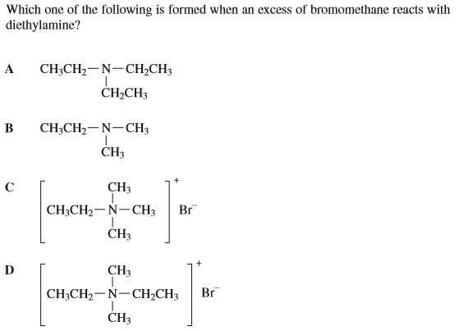  (Total 1 mark)

22. | 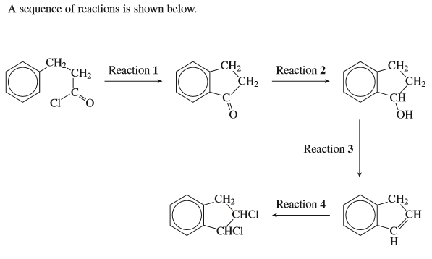  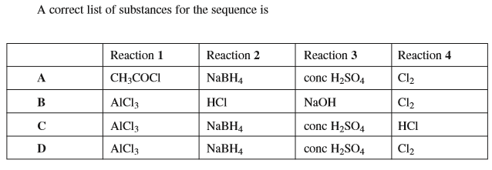  (Total 1 mark)
23. | 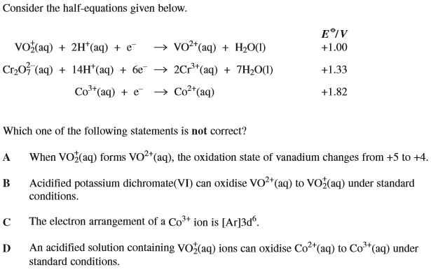  (Total 1 mark)
24.  25. | 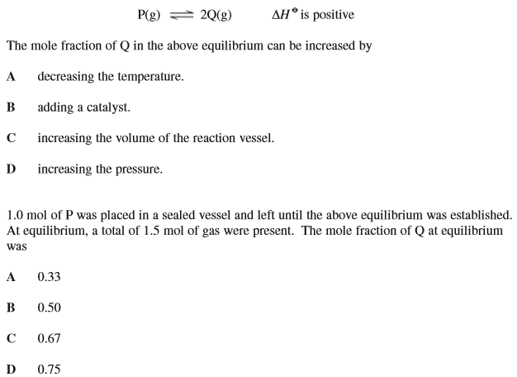  (Total 2 marks)
26. | 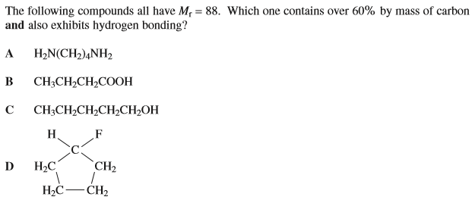  (Total 1 mark)
27. | 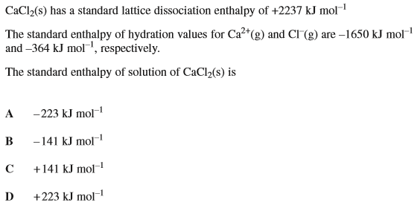  (Total 1 mark)

28.  29. | 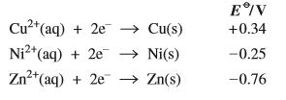  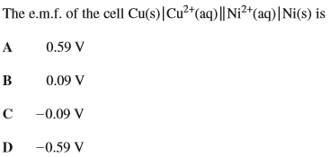  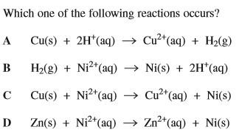  (Total 2 marks)
30. | 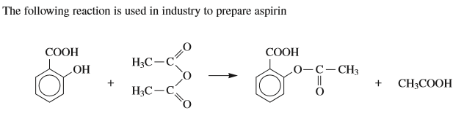  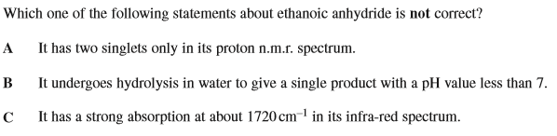  D It has a molecular ion peak at m/z = 102  (Total 1 mark)
31. | 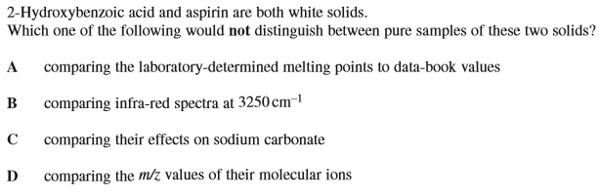  (Total 1 mark)
32. | 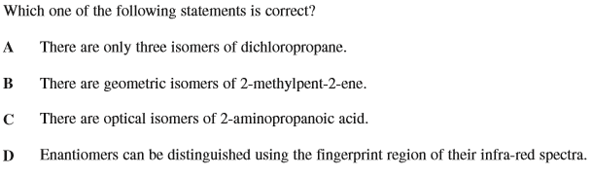  (Total 1 mark)
33. | 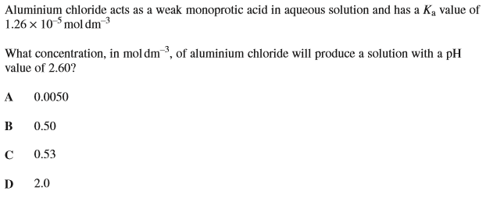  (Total 1 mark)
34. | 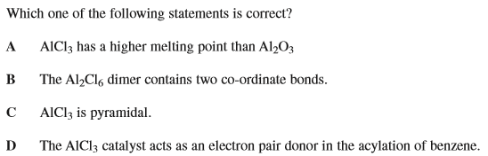  (Total 1 mark)
35.  36. | (Total 2 marks)

