A-LEVEL CHEMISTRY

PAPER 3
PRACTICE PAPER 7

Answer all questions
Max 90 marks
1 hour 45 minutes

Name ……………………………………………………………..

Mark ……../90 ……....% Grade ………

The first 10 multiple choice questions have already been used for AS-level resources

1. (a) Give the formula of a Group 2 metal hydroxide used in agriculture.
.....................................................................................................................
(1)
(b) Identify a sodium halide that does not undergo a redox reaction when added as a solid to concentrated sulfuric acid.
.....................................................................................................................
(1)
(c) Chlorine gas reacts with cold dilute sodium hydroxide solution to form sodium chloride and another chlorine-containing compound, X.
Give the formula of X.
.....................................................................................................................
(1)
(d) Give the formula of the substance responsible for the orange colour when chlorine gas is bubbled through an aqueous solution of sodium bromide.
.....................................................................................................................
(1)
(e) Solid sodium iodide undergoes a redox reaction with concentrated sulfuric acid.
Give the formula for each of the following in this reaction.
Formula of the solid reduction product ......................................................
Formula of the oxidation product ................................................................
(2)

(f) Draw the structure of each of the following organic compounds.
(i) The hydrocarbon that is a chain isomer of methylpropene, but does not exhibit E–Z stereoisomerism.

(1)
(ii) The alcohol that is a position isomer of butan-2-ol.

(1)
(iii) The hydrocarbon that has a peak, due to its molecular ion, at m/z = 44 in its mass spectrum.

(1)
(iv) The bromoalkane that reacts with sodium cyanide to produce propanenitrile.

(1)
(Total 10 marks)

2. The following pairs of compounds can be distinguished by simple test−tube reactions.
For each pair of compounds, give a reagent (or combination of reagents) that, when added separately to each compound, could be used to distinguish between them.
State what is observed in each case.
(a) Butan−2−ol and 2−methylpropan−2−ol
Reagent .........................................................................................................
Observation with butan−2−ol
........................................................................................................................
........................................................................................................................
Observation with 2−methylpropan−2−ol
........................................................................................................................
........................................................................................................................
(3)

(b) Propane and propene
Reagent .........................................................................................................
Observation with propane
........................................................................................................................
........................................................................................................................
Observation with propene
........................................................................................................................
........................................................................................................................
(3)
(c) Aqueous silver nitrate and aqueous sodium nitrate
Reagent .........................................................................................................
Observation with aqueous silver nitrate
........................................................................................................................
........................................................................................................................
Observation with aqueous sodium nitrate
........................................................................................................................
........................................................................................................................
(3)
(d) Aqueous magnesium chloride and aqueous barium chloride
Reagent .........................................................................................................
Observation with aqueous magnesium chloride
........................................................................................................................
........................................................................................................................
Observation with aqueous barium chloride
........................................................................................................................
........................................................................................................................
(3)
(Total 12 marks)

3. The characteristic properties of transition metals include coloured ions, complex formation and catalytic activity.
(a) Consider the chromium complexes P and Q.

 | [Cr(H₂O)₆]³⁺(aq)  red-violet  P |  | [Cr(H₂O)₅Cl]²⁺(aq)  green  Q
Explain, with reference to oxidation states and electron configurations, why the chromium ions in complexes P and Q contain the same number of d electrons.
You should not consider the electrons donated by the ligands.
Explain, in terms of electrons, why the complexes are different colours.
(You are not required to explain why the observed colours are red-violet and green.)
........................................................................................................................
........................................................................................................................
........................................................................................................................
........................................................................................................................
........................................................................................................................
........................................................................................................................
........................................................................................................................
........................................................................................................................
........................................................................................................................
........................................................................................................................
........................................................................................................................
(6)
(b) Write an equation to show how the [Co(NH₃)₆]²⁺(aq) ion reacts with 1,2-diaminoethane.
Explain the thermodynamic reasons why this reaction occurs.
........................................................................................................................
........................................................................................................................
........................................................................................................................
........................................................................................................................
........................................................................................................................
........................................................................................................................
........................................................................................................................
(5)
(c) The toxic complex cisplatin is an effective anti-cancer drug because it reacts with the DNA in cancer cells, preventing cell division.
(i) Draw the displayed structure of cisplatin.
On your structure, show the value of one of the bond angles at platinum.
State the charge, if any, on the complex.

(3)
(ii) When cisplatin is ingested, an initial reaction involves one of the chloride ligands being replaced by water.
Write an equation for this reaction.
...............................................................................................................
(1)
(iii) Suggest how the risk associated with the use of this drug can be minimised.
...............................................................................................................
...............................................................................................................
...............................................................................................................
(1)
(d) Explain, with the aid of equations, how and why vanadium(V) oxide is used in the Contact Process.
........................................................................................................................
........................................................................................................................
........................................................................................................................
........................................................................................................................
........................................................................................................................
........................................................................................................................
........................................................................................................................
........................................................................................................................
........................................................................................................................
(4)
(Total 20 marks)

4. Chlorine can be found in water. One method for the determination of chlorine in water is to use colorimetry.
A colourless sample of water from a vase of flowers was analysed after the addition of compound Z as the addition of Z resulted in a purple solution.
Compound W
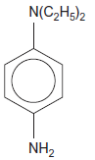
(a) Calculate the M_{r} of Compound W.
........................................................................................................................
........................................................................................................................
........................................................................................................................
(1)
(b) Determine the percentage, by mass, of nitrogen in this compound.
........................................................................................................................
........................................................................................................................
........................................................................................................................
(1)

(c) A simplified diagram of a colorimeter is shown below.
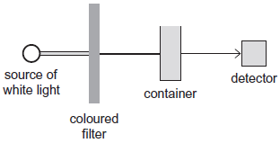
(i) Suggest why it is important that the container for each sample has the same dimensions.
...............................................................................................................
...............................................................................................................
(1)
(ii) Suggest why the coloured filter is used.
...............................................................................................................
...............................................................................................................
(1)
(iii) Suggest one reason why a colorimetric method might be chosen in preference to titration.
...............................................................................................................
(1)
(Total 5 marks)
﻿
5. An excess of a given reagent is added to each of the following pairs of aqueous metal ions.
For each metal ion, state the initial colour of the solution and the final observation that you would make.
In each case, write an overall equation for the formation of the final product from the initial aqueous metal ion.
(a) An excess of aqueous sodium carbonate is added to separate aqueous solutions containing [Fe(H₂O)₆]²⁺ and [Fe(H₂O)₆]³⁺.
........................................................................................................................
........................................................................................................................
........................................................................................................................
........................................................................................................................
........................................................................................................................
(5)
(b) An excess of concentrated hydrochloric acid is added to separate aqueous solutions containing [Cu(H₂O)₆]²⁺ and [Co(H₂O)₆]²⁺.
........................................................................................................................
........................................................................................................................
........................................................................................................................
........................................................................................................................
........................................................................................................................
(4)
(c) An excess of dilute aqueous ammonia is added to separate aqueous solutions containing [Al(H₂O)₆]³⁺ and [Ag(H₂O)₂]⁺
........................................................................................................................
........................................................................................................................
........................................................................................................................
........................................................................................................................
........................................................................................................................
........................................................................................................................
........................................................................................................................
(4)
(Total 13 marks)

6. Which one of the following atoms has only two unpaired electrons in its ground (lowest energy) state?
A helium
B beryllium
C nitrogen
D oxygen
(Total 1 mark)

7. What is the volume occupied by 10.8 g of the freon CCl₂F₂ at 100 kPa and 273 K?
A 2.02 dm³
B 2.05 dm³
C 2.02 cm³
D 2.05 cm³
(Total 1 mark)

8. What will you see when a solution of silver nitrate is added to a solution containing bromide ions, and concentrated aqueous ammonia is added to the resulting mixture?
A a white precipitate soluble in concentrated aqueous ammonia
B a white precipitate insoluble in concentrated aqueous ammonia
C a cream precipitate soluble in concentrated aqueous ammonia
D a yellow precipitate insoluble in concentrated aqueous ammonia
(Total 1 mark)

9. Assuming that chlorine exists as two isotopes, and that hydrogen and carbon exist as one isotope each, how many molecular ion peaks will be shown in the mass spectrum of C₄H₆Cl₄?
A 2
B 3
C 4
D 5
(Total 1 mark)

10. How many structural isomers, which are aldehydes, have the molecular formula C₅H₁₀O?
A 2
B 3
C 4
D 5
(Total 1 mark)

11. The boiling points of the halogens increase down Group VII because
A covalent bond strengths increase.
B bond polarities increase.
C the surface areas of the molecules increase.
D electronegativities increase.
(Total 1 mark)

12. The data below refer to the industrial production of nitric acid from ammonia.
Reaction 1 4NH₃(g) + 5O₂(g) 4NO(g) + 6H₂O(g) ∆H = −909 kJ mol⁻¹
Reaction 2 2NO(g) + O₂(g) 2NO₂(g) ∆H = −115 kJ mol⁻¹
Reaction 3 3NO₂(g) + H₂O(l) 2HNO₃(aq) + NO(g) ∆H = −117 kJ mol⁻¹
The equilibrium yield in all three reactions is increased when
A the pressure is increased.
B the pressure is decreased.
C the temperature is increased.
D the temperature is decreased.
(Total 1 mark)

13. Using the data below, which is the correct value for the standard enthalpy of formation for TiCl₄(l)?
C(s) + TiO₂(s) + 2Cl₂(g) → TiCl₄(l) + CO₂(g) ∆H = −232 kJ mol⁻¹
Ti(s) + O₂(g) → TiO₂(s) = −912 kJ mol⁻¹
C(s) + O₂(g) → CO₂(g) = −394 kJ mol⁻¹
A −1538 kJ mol⁻¹
B −1094 kJ mol⁻¹
C −750 kJ mol⁻¹
D +286 kJ mol⁻¹
(Total 1 mark)

14. Which one of the following explains why boron has a lower first ionisation energy than beryllium?
A A boron atom is smaller than a beryllium atom.
B In beryllium all the electrons are paired in full sub-shells.
C A beryllium atom has fewer protons than a boron atom.
D In boron the 2p electron occupies a higher energy level than a 2s electron.
(Total 1 mark)

15. Predict which one of the following has the highest boiling temperature.
A CH₃COOCH₂CH₃
B CH₃CH₂CH₂CH₂OH
C CH₃CH₂CH₂CH₂CH₃
D CH₃CH₂CH₂CHO
(Total 1 mark)

16. |  | 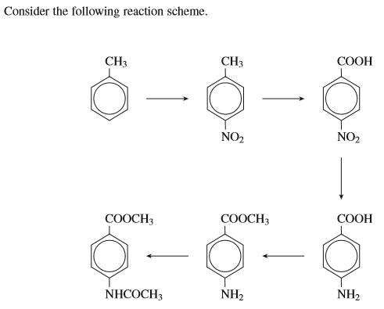  Which of the following types of mechanism is involved in this sequence?
 |  | A | electrophilic addition
 |  | B | electrophilic substitution
 |  | C | nucleophilic addition
 |  | D | nucleophilic substitution  (Total 1 mark)
17. |  | On melting, covalent bonds must break in:
 |  | A | poly(ethene)
 |  | B | Bromine
 |  | C | sulphur dioxide
 |  | D | silicon dioxide  (Total 1 mark)
18. | 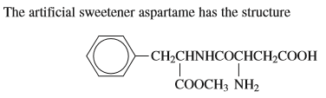  Which of the following statements about aspartame is incorrect?
 | A |  | it can form a zwitterion
 | B |  | it can undergo alkaline hydrolysis
 | C |  | it contains an amide link
 | D |  | it has three chiral carbon atoms  (Total 1 mark)
19. | Which of the following statements is incorrect?
 | A |  | A substitution reaction occurs when ammonia reacts with
 | B |  | 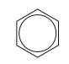is a hydrocarbon which contains 85.7% by mass of carbon
 | C |  | has at least one bond angle of 90º
 | D |  | CH₃CHO can act as both an oxidising agent and a reducing agent  (Total 1 mark)
20. | Which of the following statements is correct?
 | A |  | has at least one bond angle of 90º
 | B |  | Fe can act as both an oxidising agent and a reducing agent
 | C |  | Fe²⁺ can act as both an oxidising agent and a reducing agent
 | D |  | Fe³⁺ can act as both an oxidising agent and a reducing agent  (Total 1 mark)

21. | Which of the following pairs of reactants cannot form an organic product which has an asymmetric carbon atom?
 | A | but-2-ene and HBr
 | B | butanone and NaBH₄
 | C | propanal and HCN
 | D | propene and H₂O  (Total 1 mark)
22. | 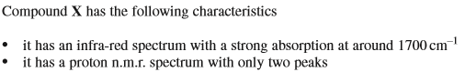  - It does not give a silver mirror with Tollen’s reagent  X could be:
 | A | Butanone
 | B | pentan-3-one
 | C | Propanone
 | D | 2,2-dimethylpropanal  (Total 1 mark)
23. | 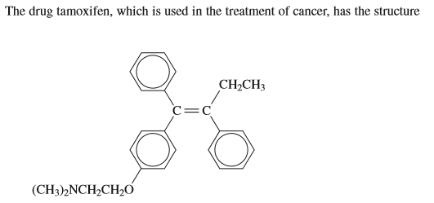  Which of the following statements about tamoxifen is incorrect?
 | A | it can undergo electrophilic addition with bromine
 | B | it has a stereoisomer
 | C | it can undergo electrophilic substitution with ethanoyl chloride
 | D | it is insoluble in hydrochloric acid  (Total 1 mark)
24. | 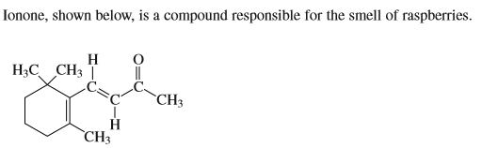  Which of the following is not a correct statement about ionone?
 | A | it can undergo electrophilic addition
 | B | it can undergo electrophilic substitution
 | C | it can undergo nucleophilic addition
 | D | it does not have a chiral centre  (Total 1 mark)
25. | 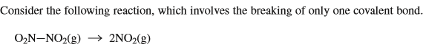  Which of the following statements is correct?
 | A | ΔH is positive
 | B | ΔG is always positive
 | C | ΔS is negative
 | D | the reaction is feasible at any temperature  (Total 1 mark)
26. | Which of the following statements is incorrect?
 | A | and are functional group isomers
 | B | and are functional group isomers
 | C
 | D | Some covalent oxides of Period 3 elements react with water to give solutions with a pH value less than 5  (Total 1 mark)
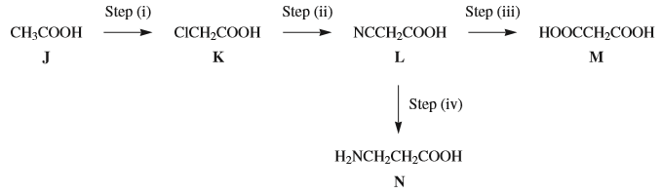

27. | Which of the following statements about the reaction scheme is incorrect?
 | A
 | B
 | C
 | D
28. | Which of the following statements is incorrect?
 | A | M can form a condensation polymer with 1,6-diaminohexane
 | B
 | C | M can act as a bidentate ligand
 | D | N undergoes self-polymerisation
29. | Which of the following statements is correct?
 | A | The systematic name of M is ethanedioic acid
 | B | N exists as the ion in a solution at pH 2
 | C | N reacts with methanol to form a tetraalkylammonium salt
 | D | N reacts with ethanoyl chloride to form an ester  (Total 3 marks)

30. | Which of the following species does not contain four or more atoms in the same plane?
 | A | Cisplatin
 | B | but-2-ene
 | C | Benzene
 | D | an ammonium ion  (Total 1 mark)
31. | Which of the following statements is not correct?
 | A
 | B
 | C | the complex ions and are both octahedral
 | D | Concentrated sulphuric acid can protonate concentrated nitric acid  (Total 1 mark)
32. | Which of the following statements is correct?
 | A | Some ionic oxides of Period 3 elements react with water to give solutions with a pH value less than 5
 | B | Optical isomerism is shown by 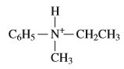
 | C | Optical isomerism is shown by 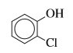
 | D | Optical isomerism is shown by 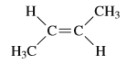  (Total 1 mark)

33. | 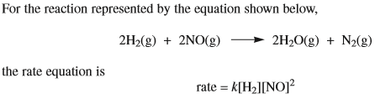  Assuming that a 10 K temperature rise doubles the rate, which of the following would not increase the rate by a factor of four?
 | A
 | B
 | C
 | D | (Total 1 mark)
34. | Which of the following increases down Group VII?
 | A | the electronegativity of the halogen
 | B | the lattice dissociation enthalpy of the sodium halide
 | C | the oxidising ability of the halogen
 | D | the strength of the halide ion as a reducing agent  (Total 1 mark)
35. | Which of the following statements is correct?
 | A
 | B
 | C
 | D | the [Al(H₂O₆)]³⁺  (Total 1 mark)

