A-LEVEL CHEMISTRY

PAPER 3
PRACTICE PAPER 8

Answer all questions
Max 90 marks
1 hour 45 minutes

Name ……………………………………………………………..

Mark ……../90 ……....% Grade ………

The first 10 multiple choice questions have already been used for AS-level resources

- Consider the following scheme of reactions.
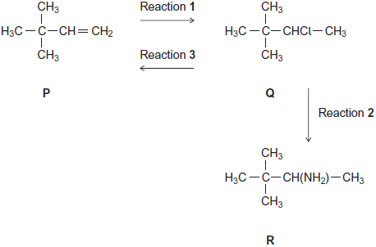
(a) Give the IUPAC name for compound P and that for compound Q.
P .....................................................................................................................
Q ....................................................................................................................
(2)
(b) The conversion of P into Q in Reaction 1 uses HCl
Name and outline a mechanism for this reaction.
........................................................................................................................
(5)
(c) The conversion of Q into R in Reaction 2 uses NH₃
Name and outline a mechanism for this reaction.
........................................................................................................................
(5)
(d) State the type of reaction shown by Reaction 3.
Identify a reagent for this reaction.
Give one condition necessary for a high yield of product when Q is converted into P.
........................................................................................................................
........................................................................................................................
........................................................................................................................
........................................................................................................................
(3)

(e) Hydrogen bromide (HBr) could be used in the overall conversion of P into R, instead of using HCl
Hydrogen bromide is made by the reaction of NaBr with concentrated phosphoric acid.
Concentrated sulfuric acid is not used to make HBr from NaBr
Write an equation for the reaction of NaBr with H₃PO₄ to produce HBr and Na₃PO₄ only.
Identify two toxic gases that are formed, together with HBr, when NaBr reacts with concentrated H₂SO₄
State the role of H₂SO₄ in the formation of these two toxic gases.
........................................................................................................................
........................................................................................................................
........................................................................................................................
........................................................................................................................
........................................................................................................................
........................................................................................................................
........................................................................................................................
(4)
(Total 19 marks)

2. (a) Figure 1 shows the volume of hydrogen gas collected when a sample of magnesium reacted with an excess of dilute hydrochloric acid.
The rate of this reaction can be studied by measuring the time it takes for a given volume of hydrogen to be collected.
Figure 1
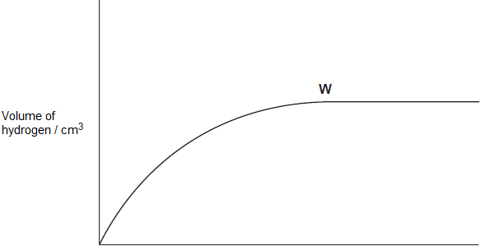
Time / s
(i) State the meaning of the term rate of reaction.
...............................................................................................................
...............................................................................................................
...............................................................................................................
(1)
(ii) State and explain what has happened to the rate of this reaction at point W in Figure 1.
...............................................................................................................
...............................................................................................................
...............................................................................................................
(2)
(iii) In terms of collision theory explain why, at a fixed temperature, the rate of this reaction doubles when the concentration of the hydrochloric acid doubles.
...............................................................................................................
...............................................................................................................
...............................................................................................................
...............................................................................................................
...............................................................................................................
...............................................................................................................
(2)
(b) In a study of the reaction in part (a), a student referred to activation energy.
(i) State the meaning of the term activation energy.
...............................................................................................................
...............................................................................................................
(1)
(ii) Complete Figure 2 by drawing the shape of the reaction profile from reactants to products for an exothermic reaction.
Show the position of the products. Show and label the activation energy.
Figure 2
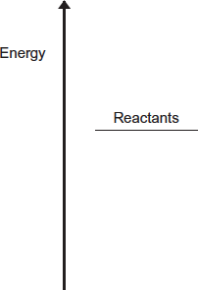
(2)

(c) Barium metal reacts very quickly with dilute hydrochloric acid, but it reacts more slowly with water.
(i) Write an equation for the reaction of barium with water.
...............................................................................................................
(1)
(ii) A solution containing barium ions can be used to show the presence of sulfate ions in an aqueous solution of sodium sulfate.
Write the simplest ionic equation for the reaction that occurs and state what is observed.
Simplest ionic equation
...............................................................................................................
Observation
...............................................................................................................
(2)

(iii) State one use of barium sulfate in medicine.
Explain why this use is possible, given that solutions containing barium ions are poisonous.
Use .......................................................................................................
...............................................................................................................
Explanation ............................................................................................
...............................................................................................................
...............................................................................................................
(2)
(Total 13 marks)

3. This question is about some reactions of cobalt compounds.
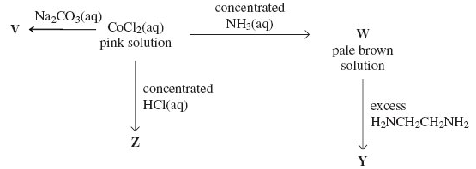
(a) Give the formula of the complex responsible for the pink colour in aqueous CoCl₂ and name its shape.
Formula .......................................................................................................
Name of shape ............................................................................................
(2)
(b) Give the formula of the cobalt-containing compound V and describe its appearance.
Formula .......................................................................................................
Appearance .................................................................................................
(2)
(c) Write an equation for the reaction that occurs when the pink solution is converted into W.
......................................................................................................................
(2)
(d) Give the formula of the cobalt-containing complex in Y and explain why this complex is more stable than the cobalt-containing complex in W.
Formula .......................................................................................................
Explanation ..................................................................................................
......................................................................................................................
......................................................................................................................
(3)
(e) Identify the cobalt-containing complex in solution Z and explain why its co-ordination number is different from that in the pink solution of CoCl₂
Complex ......................................................................................................
Explanation ..................................................................................................
......................................................................................................................
(2)
(Total 11 marks)
4. (a) State and explain the effect of a catalyst on the rate and on the equilibrium yield in a reversible reaction.
…………………………………………………………………………………………………………….
…………………………………………………………………………………………………………….
…………………………………………………………………………………………………………….
…………………………………………………………………………………………………………….
…………………………………………………………………………………………………………….
…………………………………………………………………………………………………………….
(5)
(b) Explain the terms heterogeneous and active sites as applied to a catalyst. Give two reasons why a ceramic support is used for the catalyst in catalytic converters in cars. Explain how lead poisons this catalyst.
…………………………………………………………………………………………………………….
…………………………………………………………………………………………………………….
…………………………………………………………………………………………………………….
…………………………………………………………………………………………………………….
…………………………………………………………………………………………………………….
…………………………………………………………………………………………………………….
…………………………………………………………………………………………………………….
…………………………………………………………………………………………………………….
(7)
(c) In aqueous solution, Fe²⁺ ions act as a homogeneous catalyst in the reaction between
I– and ions. Give one reason why the reaction is slow in the absence of a catalyst. Write equations to show how Fe²⁺ ions act as a catalyst for this reaction.
…………………………………………………………………………………………………………….
…………………………………………………………………………………………………………….
…………………………………………………………………………………………………………….
…………………………………………………………………………………………………………….
…………………………………………………………………………………………………………….
…………………………………………………………………………………………………………….
…………………………………………………………………………………………………………….
(5)
(Total 17 marks)
5. Which of these atoms has the largest atomic radius?

 | A | Ar
 | B | Cl
 | C | Mg
 | D | Na

(Total 1 mark)

6. Which one of the following samples of gas, when sealed into a vessel of volume 0.10 m³, is at the highest pressure?
A 1.6 g of helium (He) at 100 K
B 1.6 g of methane (CH₄) at 100 K
C 1.6 g of oxygen (O₂) at 600 K
D 1.6 g of sulphur dioxide (SO₂) at 1200 K
(Total 1 mark)

7. Which one of the following is not a suitable method for the preparation of ethanol?
A oxidation of ethane
B hydration of ethene
C reduction of ethanal
D hydrolysis of bromoethane
(Total 1 mark)

8. Certain chemical tests were performed on the pain-relief drug ibuprofen. The results of these tests are given in the table below.

 | Test | Result
 | Aqueous sodium carbonate | Effervescence
 | Bromine water | Remained orange
 | Acidified potassium dichromate(VI) and heat | Remained orange
 | Fehling’s solution and heat | Remained blue

Which one of the following functional groups do these results suggest that ibuprofen contains?
A 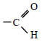
B 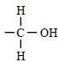
C 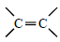
D 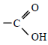
(Total 1 mark)

9. On complete combustion, 0.0150 mol of an organic acid produced 735 cm³ of carbon dioxide (measured at 101 kPa and 298 K). The same amount of acid required 15.0 cm³ of 2.00 M sodium hydroxide solution for neutralisation. Which one of the following could be the formula of the acid?
A HCOOH
B CH₃COOH
C HOOCCOH
D HOOCCH₂CH₂COOH
(Total 1 mark)

10. Which one of the following has the most covalent character?
A MgF₂
B MgBr₂
C AlF₃
D AlBr₃
(Total 1 mark)

11. Which one of the following statements concerning halogen chemistry is true?
A Sodium chloride produces chlorine when treated with concentrated sulphuric acid.
B Sodium chloride produces chlorine when treated with bromine.
C Sodium bromide produces bromine when treated with concentrated sulphuric acid.
D Sodium bromide produces bromine when treated with iodine in aqueous potassium iodide.
(Total 1 mark)

12. Use the information about the following solutions to answer the question below.
Solution F: This is a mixture of 1 mol of propanoic acid, 1 mol of methanol and 2 mol of water.
Solution G: This was originally the same mixture as solution F but it has been left to reach equilibrium.
Solution G was found to contain 0.5 mol of propanoic acid. Which one of the following is the value of the equilibrium constant (K_{c}) for the following equilibrium?
propanoic acid + methanol methyl propanoate + water
A 0.2
B 1
C 5
D 10
(Total 1 mark)

13. This question is about the reaction between propanone and an excess of ethane-1,2-diol, the equation for which is given below.
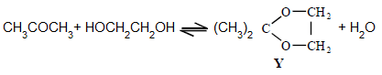
In a typical procedure, a mixture of 1.00 g of propanone, 5.00 g of ethane-1,2-diol and 0.100 g of benzenesulphonic acid, C₆H₅SO₃H, is heated under reflux in an inert solvent. Benzenesulphonic acid is a strong acid.
Which one of the following statements is not true?
A Ethane-1,2-diol and water can form hydrogen bonds.
B Ethane-1,2-diol is soluble in water.
C Propane has a higher boiling point than ethane-1,2-diol.
D Y and water are polar molecules.
(Total 1 mark)

14. The removal of silicon dioxide with limestone in the Blast Furnace can be represented by the following equation.
CaCO₃(s) + SiO₂(s) → CaSiO₃(l) + CO₂(g)
The volume of carbon dioxide, measured at 298 K and 1.01 × 10⁵ Pa, formed in this reaction during the removal of 1.00 tonne (1000 kg) of silicon dioxide is
A 24.5 dm³
B 408 dm³
C 24.5 m³
D 408 m³
(Total 1 mark)

15. | Which of the following statements is incorrect?
 | A
 | B
 | C | the carbon to carbon bond enthalpy decreases from ethene to benzene to ethane
 | D | (Total 1 mark)

16. | Which of the following solids has a macromolecular structure?
 | A | MgO
 | B | C₁₇H₃₅COONa
 | C | P₄O₁₀
 | D | Si  (Total 1 mark)
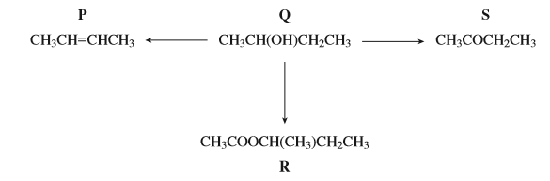
17. | Which of the compounds in the reaction scheme above does not have stereoisomers?
 | A | P
 | B | Q
 | C | R
 | D | S  (Total 1 mark)
18. | Which of the following types of reaction is not in the reaction scheme above?
 | A | Dehydration
 | B | Alkylation
 | C | Esterification
 | D | Oxidation  (Total 1 mark)

19. | Which of the following conversions does not require four moles of hydrogen gas per mole of starting material?
 | A
 | B
 | C | 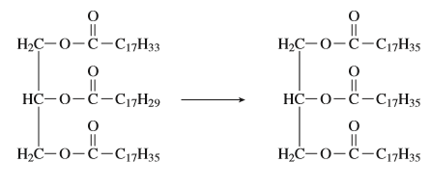
 | D | (Total 1 mark)
20. | Which of the following is a correct statement about chloroethanoic acid?
 | A | it gives an immediate white precipitate with silver nitrate solution
 | B | it gives a silver mirror with Tollen’s reagent
 | C | it gives colourless fumes on addition of water
 | D | a mixture of acidified potassium dichromate (VI) and the acid remains orange on warming  (Total 1 mark)
21. | Which of the following is not a correct statement about phenylamine, methylamine and ammonia?
 | A | the order of base strength is phenylamine < methylamine < ammonia
 | B | they all form amides with ethanoyl chloride
 | C | they all form basic buffers with a suitable amount of hydrochloric acid
 | D | they all act as nucleophiles and ligands using the lone pair on the nitrogen atom  (Total 1 mark)

22. | 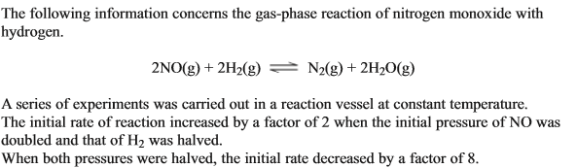  Which of these statements is correct?
 | A | the overall order of reaction is 2
 | B | the reaction is second order with respect to hydrogen
 | C | the reaction is first order with respect to nitrogen monoxide
 | D | the overall order of reaction is 3  (Total 1 mark)
23. | Which of the following statements is correct?
 | A | oxidation occurs at the copper electrode
 | B | electrons pass from copper to zinc
 | C | the concentration of Zn²⁺ ions decreases over time
 | D | the e.m.f of the cell decreases over time  (Total 1 mark)
24. | 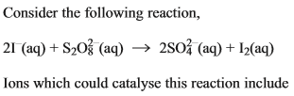
 | A | Fe²⁺
 | B | Zn²⁺
 | C | Al³⁺
 | D | Sc³⁺  (Total 1 mark)

25. | 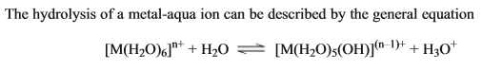  Which of the following statements is incorrect?
 | A | the solvent H₂O is acting as a base by accepting a proton
 | B | the pH of the solution will be lower if the value of n is 3 rather than 2
 | C | the equilibrium position lies more to the right if the value of n is 3 rather than 2
 | D | the oxidation state of the central metal cation has decreased from n to n-1  (Total 1 mark)
26. | Which of the following statements is correct?
 | A | NH₃ leaves a precipitate after an excess has been added to aqueous copper (II) sulphate
 | B | Na₂CO₃ leaves a precipitate after an excess has been added to aqueous copper (II) sulphate
 | C | HCl leaves a precipitate after an excess has been added to aqueous copper (II) sulphate
 | D | NaOH does not leave a precipitate after an excess has been added to aqueous copper (II) sulphate  (Total 1 mark)
27. | Which of the following reactions involves a free radical intermediate?
 | A | the nitration of benzene
 | B | the acylation of methylamine with ethanoyl chloride
 | C | the reduction of butanal with NaBH₄
 | D | the thermal cracking of octane  o(Total 1 mark)
28. | Which of the following statements about X is correct?
 | A | it has the systematic name hex-4-en-1-ol
 | B | it has the empirical formula C₃H₆O
 | C | it has optical isomers
 | D | it has geometrical isomers  (Total 1 mark)
29. | 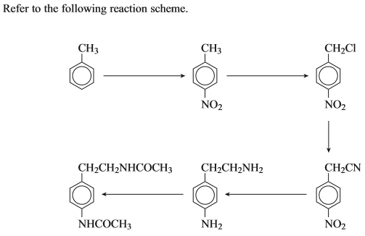  Which type of reaction is not involved in this scheme?
 | A | Chlorination
 | B | Oxidation
 | C | Acylation
 | D | Reduction  (Total 1 mark)
30. | Which of the following statements is incorrect?
 | A | polymer Z has a repeating unit with empirical formula C₅H₉NO
 | B | acid Y has the systematic name dibutanoic acid
 | C | amine Z has the systematic name pentane-1,5-diamine
 | D | polymer Z is a condensation polymer  (Total 1 mark)

31. | 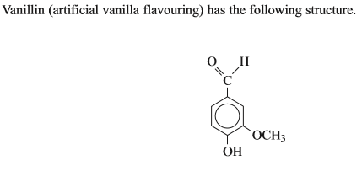  Which of the following is a not a correct statement about vanillin?
 | A | it contains an ester functional group
 | B | it will produce a silver precipitate with Tollen’s reagent
 | C | it will undergo nucleophilic addition
 | D | it is able to undergo hydrogen bonding  (Total 1 mark)
32. | 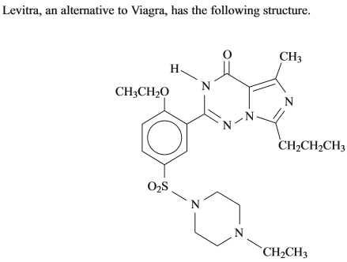  Which of the following is not a correct statement about Levitra?
 | A | it reacts with dilute hydrochloric acid
 | B | it exhibits geometrical isomerism
 | C | it can be nitrated
 | D | it can undergo addition polymerisation  (Total 1 mark)

33. | Which of the following statements is correct?
 | A | Optical isomerism is shown by 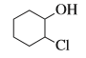
 | B | is a redox reaction
 | C | contains an element with an oxidation state of +5
 | D | (Total 1 mark)
34. | 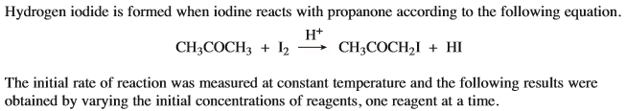  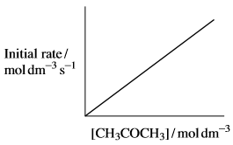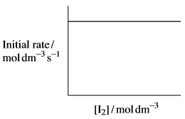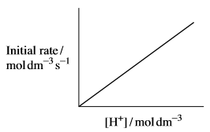  Which of the following statements is incorrect?
 | A
 | B
 | C | The rate constant for the reaction has units mol⁻¹dm³s⁻¹
 | D | (Total 1 mark)

