A-LEVEL CHEMISTRY

PAPER 3
PRACTICE PAPER 9

Answer all questions
Max 90 marks
1 hour 45 minutes

Name ……………………………………………………………..

Mark ……../90 ……....% Grade ………

The first 10 multiple choice questions have already been used for AS-level resources

1. Sulfuric acid is an important chemical in many industrial and laboratory reactions.
Consider the following three reactions involving sulfuric acid.
Reaction 1 Mg(OH)₂ + H₂SO₄ → MgSO₄ + 2H₂O
Reaction 2 The reaction of solid sodium bromide with concentrated
sulfuric acid
Reaction 3 H₂C=CH₂ + H₂O CH₃CH₂OH
(a) Give a use for magnesium hydroxide in medicine.
......................................................................................................................
(1)
(b) Sulfuric acid behaves as an oxidising agent in Reaction 2.
(i) In terms of electrons, state the meaning of the term oxidising agent.
.............................................................................................................
(1)
(ii) Give the formula of the oxidation product that is formed from sodium bromide in Reaction 2.
.............................................................................................................
(1)
(iii) Deduce the half-equation for the reduction of H₂SO₄ to SO₂ in Reaction 2.
.............................................................................................................
(1)

(c) The formation of ethanol in Reaction 3 uses concentrated sulfuric acid and proceeds in two stages according to the following equations.
Stage 1 H₂C=CH₂ + H₂SO₄ → CH₃CH₂OSO₂OH
Stage 2 CH₃CH₂OSO₂OH + H₂O → CH₃CH₂OH + H₂SO₄
(i) State the overall role of sulfuric acid in Reaction 3.
.............................................................................................................
(1)
(ii) Outline a mechanism for Stage 1 of this reaction.

(4)
(iii) State the class of alcohols to which ethanol belongs.
.............................................................................................................
(1)
(iv) Draw the displayed formula of the carboxylic acid formed when ethanol is oxidised by an excess of acidified potassium dichromate(VI) solution.

(1)
(Total 11 marks)

2. The three compounds CH₃CH₂CH₂CH₂OH, (CH₃)₃COH and CH₃CH₂CH₂CHO can be distinguished by use of the following three reagents
1. potassium dichromate(VI) acidified with dilute sulphuric acid
2. Tollens’ reagent
3. ethanoic acid, together with a small amount of concentrated sulphuric acid.
- Identify which of these three organic compounds would reduce acidified potassium dichromate(VI). Give the structures of the organic products formed. Write a half-equation for the reduction of dichromate(VI) ions in acidic solution.

………………………………………………………………………………………………………...............
………………………………………………………………………………………………………...............
………………………………………………………………………………………………………...............
………………………………………………………………………………………………………...............
(6)
(b) Identify which one of these three organic compounds would reduce Tollens’ reagent. Give the structure of the organic product formed. Write a half-equation for the reduction of Tollens’ reagent.

………………………………………………………………………………………………………...............
………………………………………………………………………………………………………...............
(3)
(c) Identify which of these three organic compounds would react with ethanoic acid in the presence of concentrated sulphuric acid. In each case, give the structure of the organic product formed.

(4)
(d) State the number of peaks in the proton n.m.r. spectra of CH₃CH₂CH₂CH₂OH and of (CH₃)₃COH. (Analysis of peak splitting is not required.)
………………………………………………………………………………………………………...............
………………………………………………………………………………………………………...............
(2)
(Total 15 marks)
3. The complex cisplatin acts as an anticancer drug by changing the properties of DNA when it reacts with guanine, a component of DNA.
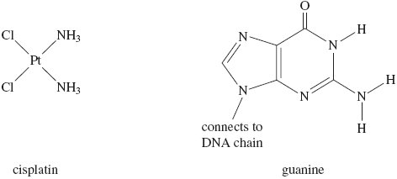
When cisplatin is absorbed into the human body, it undergoes a ligand substitution reaction and one chloride ligand is replaced by a water molecule forming a complex ion Q.
(a) Write an equation for this substitution reaction to form the complex ion Q.
......................................................................................................................
(2)
(b) The complex ion Q can bond to guanine in two different ways.
(i) The first way involves a hydrogen atom, from one of the ammonia ligands on Q, bonding to an atom in a guanine molecule. State the type of bond formed to guanine and identify an atom in guanine that could form a bond to this hydrogen atom.
Type of bond .......................................................................................
Atom in guanine ..................................................................................
(2)
(ii) The second way involves a ligand substitution reaction in which an atom in a guanine molecule bonds to platinum by displacing the water molecule from Q.
State the type of bond formed between guanine and platinum when a water molecule is displaced and identify an atom in guanine that could bond to platinum in this way.
Type of bond .......................................................................................
Atom in guanine ..................................................................................
(2)
(c) State and explain one risk associated with the use of cisplatin as an anticancer drug.
Risk .............................................................................................................
Explanation ..................................................................................................
(2)
(Total 8 marks)

4. Iron is an important element in living systems. It is involved in redox and in acid–base reactions.
(a) Explain how and why iron ions catalyse the reaction between iodide ions and S₂O₈^{2–} ions. Write equations for the reactions that occur.
......................................................................................................................
......................................................................................................................
......................................................................................................................
......................................................................................................................
......................................................................................................................
......................................................................................................................
......................................................................................................................
......................................................................................................................
......................................................................................................................
......................................................................................................................
(5)
(b) Iron(II) compounds are used as moss killers because iron(II) ions are oxidised in air to form iron(III) ions that lower the pH of soil.
Explain, with the aid of an equation, why iron(III) ions are more acidic than iron(II) ions in
aqueous solution.
.............................................................................................................
.............................................................................................................
.............................................................................................................
.............................................................................................................
.............................................................................................................
(3)
(c) Some sodium carbonate solution was added to a solution containing iron(III) ions.
Describe what you would observe and write an equation for the reaction that occurs.
......................................................................................................................
......................................................................................................................
......................................................................................................................
......................................................................................................................
......................................................................................................................
(3)
(Total 11 marks)
5. Complexes containing transition elements have a wide variety of uses including acting as dyestuffs like Prussian Blue.
Cisplatin is a platinum-based chemotherapy drug used to treat various types of cancers. It was the first member of a class of anti-cancer drugs that react with DNA in tumour cells.
Cisplatin is prepared from K₂PtCl₄ according to the following scheme.
All the reactions shown are reversible.
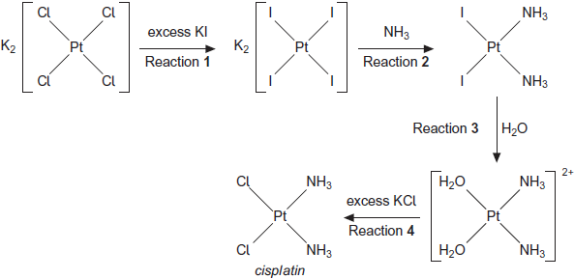
(a) Name the type of reaction occurring in all four steps of the scheme.
........................................................................................................................
(1)
(b) Explain why an excess of potassium iodide is used in Reaction 1.
........................................................................................................................
........................................................................................................................
........................................................................................................................
(2)
(c) (i) Write an equation for Reaction 1.
...............................................................................................................
...............................................................................................................
(1)
(ii) Calculate the percentage atom economy for the formation of K₂PtI₄ in Reaction 1.
Show your working.
...............................................................................................................
...............................................................................................................
...............................................................................................................
(2)

(d) In Reaction 3, silver nitrate solution is added to improve the yield of product.
(i) Write the simplest ionic equation for the reaction of iodide ions with silver nitrate.
...............................................................................................................
(1)
(ii) Suggest why addition of silver nitrate improves the yield of product from Reaction 3.
...............................................................................................................
...............................................................................................................
(1)
(e) Suggest two reasons, other than poor practical technique, why the overall yield of cisplatin in this synthesis may be low.
Reason 1 .......................................................................................................
........................................................................................................................
Reason 2 .......................................................................................................
........................................................................................................................
(2)
(f) The cisplatin formed in Reaction 4 is impure. Outline how the impure solid is purified by recrystallisation.
........................................................................................................................
........................................................................................................................
........................................................................................................................
........................................................................................................................
........................................................................................................................
(3)
(g) Platinum compounds are highly toxic.
(i) State why cisplatin is used in cancer treatment despite its toxicity.
...............................................................................................................
...............................................................................................................
(1)
(ii) Suggest a suitable precaution that should be taken by medical staff when using cisplatin.
...............................................................................................................
(1)
(Total 15 marks)

6. Photochromic glass contains silver ions and copper ions. A simplified version of a redox equilibrium is shown below. In bright sunlight the high energy u.v. light causes silver atoms to form and the glass darkens. When the intensity of the light is reduced the reaction is reversed and the glass lightens.
Cu⁺(s) + Ag⁺(s) Cu²⁺(s) + Ag(s)
clear glass dark glass
Which one of the following is a correct electron arrangement?
A Cu⁺ is [Ar]3d⁹4s¹
B Cu is [Ar]3d¹⁰4s²
C Cu²⁺ is [Ar]3d⁸4s¹
D Cu⁺ is [Ar]3d¹⁰
(Total 1 mark)

7. A particular sample of iron ore contains 85% by mass of Fe₂O₃ (M_{r}= 159.6) and no other iron compound. The maximum mass of iron that could be extracted from 1.0 tonne of this ore is
A 0.59 tonne
B 0.66 tonne
C 0.75 tonne
C 0.85 tonne
(Total 1 mark)

8. Which one of the following compounds contains the smallest percentage, by mass, of oxygen?
A CH₃OCH₂CH₃
B CH₃OCH₂NH₂
C COS
D C₄H₉Al(OH)₂
(Total 1 mark)

9. Which one of the following contains the greatest number of moles of methanol? (The Avogadro number (L) is 6.02 × 10²³, the relative molecular mass (M_{r}) of methanol is 32.)
A 6.6 × 10²² molecules
B 3.3 g of methanol
C 2.5 × 10⁻³ m³ of methanol vapour at 300 K and 100 kPa
D 70 cm³ of 1.5 M aqueous methanol
(Total 1 mark)

10. How many different alkenes are formed when 2-bromo-3-methylbutane reacts with ethanolic potassium hydroxide?
A 2
B 3
C 4
D 5
(Total 1 mark)

11. Use the information below to answer this question.
C(s) + O₂(g) → CO₂(g) ΔH = −394 kJ mol⁻¹
H₂(g) + O₂(g) → H₂O(l) ΔH = −286 kJ mol⁻¹
4C(s) + 5H₂(g) → C₄H₁₀(g) ΔH = −126 kJ mol⁻¹
The standard enthalpy of combustion of butane, in kJ mol⁻¹, is
A −2880
B −2590
C −806
D −554
(Total 1 mark)

12. Which one of the following does not represent an oxidation?
A propene → propane
B propan-l-ol → propanal
C propan-l-ol → propanoic acid
D propanal → propanoic acid
(Total 1 mark)

13. The ester methyl ethanoate is hydrolysed as shown in the following equation.
CH₃COOCH₃(l) + H₂O(l) CH₃COOH(l) + CH₃OH(l) ΔH = +3 kJ mol⁻¹
The equilibrium yield of ethanoic acid could be increased by
A lowering the temperature.
B adding a catalyst.
C adding more water to the reaction mixture.
D adding more methanol to the reaction mixture.
(Total 1 mark)

14. Which of these species has a trigonal planar structure?

 | A | PH₃
 | B | BCl₃
 | C | H₃O⁺
 | D | CH₃⁻

(Total 1 mark)

15. Which of these atoms has the highest electronegativity?

 | A | Na
 | B | Mg
 | C | Cl
 | D | Ar

(Total 1 mark)

16. | Which of the following statements is correct?
 | A | There is an increase in entropy during the reaction CaCO₃(s) + SiO₂(s) CaSiO₃(l) + CO₂(g)
 | B | Silicon dioxide is a basic oxide
 | C
 | D | (Total 1 mark)
17. | 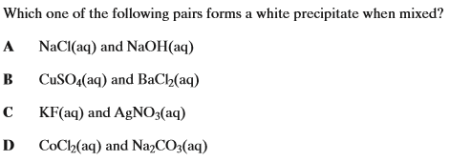  (Total 1 mark)
18. | 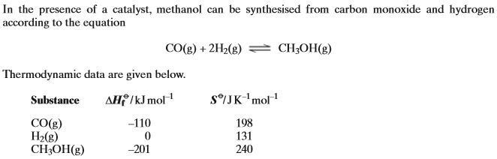  Which of the following statements is incorrect?
 | A
 | B
 | C
 | D | (Total 1 mark)

19. | Which of the following processes will be accompanied by a decrease in entropy?
 | A | the formation of ammonia from nitrogen and hydrogen
 | B | the melting of ice
 | C | the formation of NO₂ has from N₂O₄ gas
 | D | the reaction of ethanedioate ions with Cu²⁺(aq) ions  (Total 1 mark)
20. | 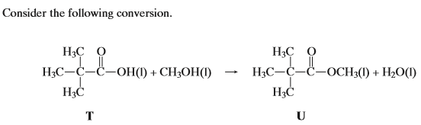  Which of the following statements about this conversion is incorrect?
 | A | the entropy change in this reaction is likely to be small
 | B | the enthalpy change in this reaction is likely to be small
 | C | if 1 g of T gives 1 g of U the yield for the conversion is 100%
 | D | the reaction is catalysed by acids  (Total 1 mark)
21. | Which of the following structures does not have a central atom having a co-ordination number of 6 and an oxidation state of +2?
 | A
 | B
 | C
 | D | (Total 1 mark)

22. | Which type of bonding is not present in methylammonium chloride?
 | A | ionic
 | B | co-ordinate
 | C | covalent
 | D | Hydrogen  (Total 1 mark)
23. | Which of the following is not a possible product when methylamine reacts with aquous cobalt (II) chloride?
 | A
 | B
 | C
 | D | Co(OH)₂  (Total 1 mark)
24. | 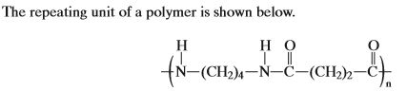  Which of the following does this polymer not have?
 | A | van der Waal’s forces
 | B | hydrogen bonding
 | C | dipole-dipole interactions
 | D | ionic bonding  (Total 1 mark)

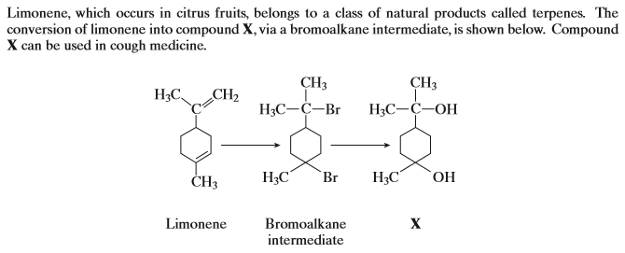
25. |  | Which types of mechanism are shown in the reactions above?
 | A | electrophilic addition and electrophilic substitution
 | B | nucleophilic addition and nucleophilic substitution
 | C | electrophilic addition and nucleophilic substitution
 | D | nucleophilic addition and electrophilic substitution
26. | Which of the following is not a correct statement about compound X?
 | A | it exhibits hydrogen bonding between its molecules
 | B | it is dehydrated by hot concentrated sulphuric acid
 | C | it reacts with ethanoyl chloride to produce an ester
 | D | it is oxidised by acidified potassium dichromate (VI)  (Total 2 marks)
27. | Which of the following statements is incorrect?
 | A |  | in the reduction of iron (III) oxide during carbon, there is a greater positive entropy change than in the reduction using carbon monoxide.
 | B |  | The reactioncan take place
 | C |  | The reaction can take place
 | D |  | can form an alkaline solution in water  (Total 1 mark)

28. | Which of the following statements is incorrect?
 | A |  | can form an alkaline solution in water
 | B |  | can form an alkaline solution in water
 | C |  | can form an alkaline solution in water
 | D |  | methylamine reacts with ethanoyl chloride  (Total 1 mark)
29. | Which of the following statements is correct?
 | A |  | methylamine reacts with ethene
 | B |  | methylamine reacts with benzene
 | C |  | methylamine reacts with bromoethane
 | D |  | ethane has two singlets in the proton n.m.r. spectrum  (Total 1 mark)
30. | Which of the following statements is incorrect?
 | A |  | show an increase from left to right
 | B |  | the n.m.r. δ values of the underlined protons in and show an increase from left to right
 | C |  | ethanoic acid has two singlets in the proton n.m.r. spectrum
 | D |  | ethanol has two singlets in the proton n.m.r. spectrum  (Total 1 mark)
31. | Which of the following statements is incorrect?
 | A | ethane-1,2-diol has two singlets in the proton n.m.r. spectrum
 | B
 | C
 | D | The fermentation of glucose has a positive value for ΔS  (Total 1 mark)

32. | Which of the following statements is incorrect?
 | A | The hydration of ethene has a positive value for ΔS
 | B | The hydrolysis of ethanoyl chloride has a positive value for ΔS
 | C
 | D | ethanedioic acid produces bubbles of gas when treated with aqueous sodium hydrogencarbonate  (Total 1 mark)
33. | Which of the following is not a redox reaction?
 | A
 | B
 | C
 | D | (Total 1 mark)
34. | 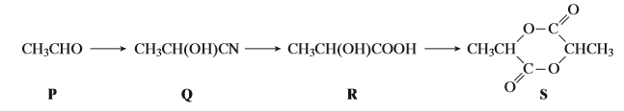  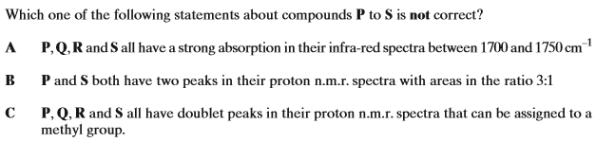
 | D | S has a molecular ion peak in the mass spectrum at m/z = 144  (Total 1 mark)

35. | 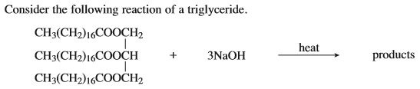  Which of the following statements is incorrect?
 | A
 | B | One of the products of the reaction is used to make soaps
 | C
 | D | (Total 1 mark)

