AS LEVEL CHEMISTRY

PAPER 1
PRACTICE PAPER 2
Answer all questions
Max 80 marks

Name ……………………………………………………………..

Mark ……../80 ……....% Grade ………

1. Mass spectrometry can be used to identify isotopes of elements.
(a) (i) In terms of fundamental particles, state the difference between isotopes of an element.
.............................................................................................................
.............................................................................................................
(1)
(ii) State why isotopes of an element have the same chemical properties.
.............................................................................................................
.............................................................................................................
(1)
(b) Give the meaning of the term relative atomic mass.
......................................................................................................................
......................................................................................................................
......................................................................................................................
(2)
(c) The mass spectrum of element X has four peaks. The table below gives the relative abundance of each isotope in a sample of element X.

m/z | 64 | 66 | 67 | 68
Relative abundance | 12 | 8 | 1 | 6

(i) Calculate the relative atomic mass of element X.
Give your answer to one decimal place.
.............................................................................................................
.............................................................................................................
.............................................................................................................
.............................................................................................................
.............................................................................................................
(3)
(ii) Use the Periodic Table to identify the species responsible for the peak at m/z = 64
.............................................................................................................
(2)

(d) Suggest one reason why particles with the same mass and velocity can drift at different speeds in a TOF mass spectrometer.
......................................................................................................................
......................................................................................................................
(1)
(e) Explain how the detector in a mass spectrometer enables the abundance of an isotope to be measured.
......................................................................................................................
......................................................................................................................
......................................................................................................................
(2)
(Total 12 marks)

2. Lithium hydride, LiH, is an ionic compound containing the hydride ion, H–
The reaction between LiH and aluminium chloride, AlCl₃, produces the ionic compound LiAlH₄
(a) Balance the equation below which represents the reaction between LiH and AlCl₃
LiH + AlCl₃ → LiAlH₄ + LiCl
(1)
(b) Predict the shape of the ion. Explain why it has this shape.
Shape ..........................................................................................................
Explanation ..................................................................................................
......................................................................................................................
......................................................................................................................
(3)
(c) A bond in can be represented by H → Al
Name this type of bond and explain how it is formed.
Type of bond ................................................................................................
Explanation ..................................................................................................
......................................................................................................................
......................................................................................................................
(3)
(Total 7 marks)

3. Fritz Haber, a German chemist, first manufactured ammonia in 1909.
Ammonia is very soluble in water.
(a) State the strongest type of intermolecular force between one molecule of ammonia and one molecule of water.
........................................................................................................................
(1)
(b) Draw a diagram to show how one molecule of ammonia is attracted to one molecule of water. Include all partial charges and all lone pairs of electrons in your diagram.

(3)
(c) Phosphine (PH₃) has a structure similar to ammonia.
In terms of intermolecular forces, suggest the main reason why phosphine is almost insoluble in water.
........................................................................................................................
........................................................................................................................
(1)
(Total 5 marks)

4. Trends in physical properties occur across all Periods in the Periodic Table.
This question is about trends in the Period 2 elements from lithium to nitrogen.
(a) Identify, from the Period 2 elements lithium to nitrogen, the element that has the largest atomic radius.
........................................................................................................................
(1)
(b) (i) State the general trend in first ionisation energies for the Period 2 elements lithium to nitrogen.
...............................................................................................................
(1)
(ii) Identify the element that deviates from this general trend, from lithium to nitrogen, and explain your answer.
Element ................................................................................................
Explanation ...........................................................................................
...............................................................................................................
...............................................................................................................
(3)
(c) Identify the Period 2 element that has the following successive ionisation energies.

 |  | First | Second | Third | Fourth | Fifth | Sixth
 | Ionisation energy  / kJ mol⁻¹ | 1090 | 2350 | 4610 | 6220 | 37 800 | 47 000

........................................................................................................................
(1)

(d) Draw a cross on the diagram to show the melting point of nitrogen.
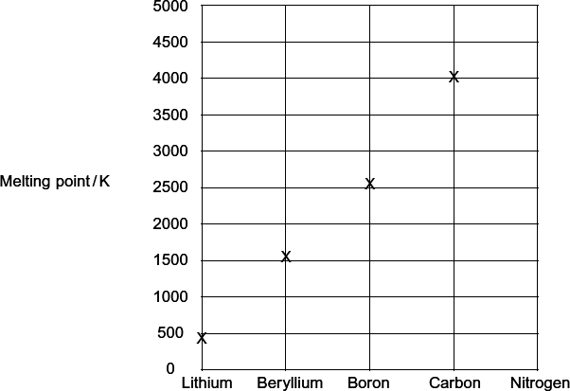
(1)
(e) Explain, in terms of structure and bonding, why the melting point of carbon is high.
........................................................................................................................
........................................................................................................................
........................................................................................................................
........................................................................................................................
........................................................................................................................
(3)
(Total 10 marks)

5. Compound A is an oxide of sulphur. At 415 K, a gaseous sample of A, of mass 0.304 g, occupied a volume of 127 cm³ at a pressure of 103 kPa.
State the ideal gas equation and use it to calculate the number of moles of A in the sample, and hence calculate the relative molecular mass of A.
(The gas constant R = 8.31 J K^{–1} mol^{–1})
Ideal gas equation ................................................................................................
Calculation ............................................................................................................
...............................................................................................................................
...............................................................................................................................
...............................................................................................................................
...............................................................................................................................
(Total 5 marks)

6. This question concerns the chemistry of the Group II metals Mg to Ba.
An aqueous solution of a Group II metal chloride, XCl₂, forms a white precipitate when dilute aqueous sodium hydroxide is added. A separate sample of the solution of XCl₂ does not form a precipitate when dilute aqueous sodium sulphate is added.
An aqueous solution of a different Group II metal chloride, YCl₂, does not form a precipitate when dilute aqueous sodium hydroxide is added. A separate sample of the solution of YCl₂ forms a white precipitate when dilute aqueous sodium sulphate is added.
Suggest identities for the Group II metals X and Y. Write equations, including state symbols, for the reactions which occur.
...............................................................................................................................
...............................................................................................................................
...............................................................................................................................
...............................................................................................................................
...............................................................................................................................
...............................................................................................................................
(Total 6 marks)

7. Concentrated sulfuric acid reacts with solid potassium iodide as shown in the equation.
8KI + 9H₂SO₄ 4l₂ + 8KHSO₄ + H₂S + 4H₂O
Give two observations that you would make when this reaction occurs.
In terms of electrons, state what happens to the iodide ions in this reaction.
State the change in oxidation state of sulfur that occurs during this formation of H₂S and deduce the half-equation for the conversion of H₂SO₄ into H₂S
...............................................................................................................................
...............................................................................................................................
...............................................................................................................................
...............................................................................................................................
...............................................................................................................................
(Total 5 marks)

8. When heated above 100 °C, nitrosyl chloride (NOCl) partly decomposes to form nitrogen monoxide and chlorine as shown in the equation.
2NOCl(g) 2NO(g) + Cl₂(g)
(a) A 2.50 mol sample of NOCl was heated in a sealed container and equilibrium was established at a given temperature. The equilibrium mixture formed contained 0.80 mol of NO.
Calculate the amount, in moles, of Cl₂ and of NOCl in this equilibrium mixture.
Moles of Cl₂ ...................................................................................................
Moles of NOCl ................................................................................................
(2)

(b) A different mixture of NOCl, NO and Cl₂ reached equilibrium in a sealed container of volume 15.0 dm³. The equilibrium mixture formed contained 1.90 mol of NOCl and 0.86 mol of NO at temperature T.
The value of K_{c} for the equilibrium at temperature T was 7.4 × 10⁻³ mol dm⁻³.
(i) Write an expression for the equilibrium constant K_{c}
...............................................................................................................
...............................................................................................................
(1)
(ii) Calculate the amount, in moles, of Cl₂ in this equilibrium mixture.
...............................................................................................................
...............................................................................................................
...............................................................................................................
...............................................................................................................
...............................................................................................................
...............................................................................................................
...............................................................................................................
...............................................................................................................
...............................................................................................................
(4)
(iii) Consider this alternative equation for the equilibrium at temperature T.
NOCl(g) NO(g) + Cl₂(g)
Calculate a value for the different equilibrium constant K_{c} for the equilibrium as shown in this alternative equation. Deduce the units of this K_{c}
Calculation ............................................................................................
...............................................................................................................
...............................................................................................................
...............................................................................................................
Units .....................................................................................................
...............................................................................................................
(2)
(Total 9 marks)

9.
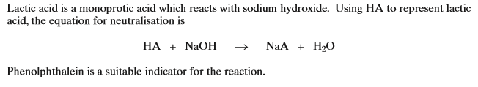
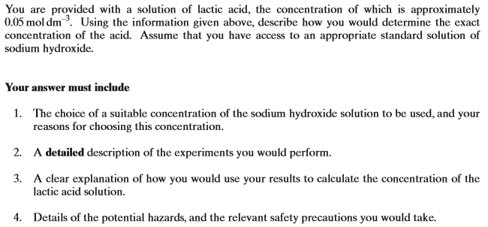
..............................................................................................................................................................
..............................................................................................................................................................
..............................................................................................................................................................
..............................................................................................................................................................
..............................................................................................................................................................
..............................................................................................................................................................
..............................................................................................................................................................
..............................................................................................................................................................
..............................................................................................................................................................
..............................................................................................................................................................
..............................................................................................................................................................
..............................................................................................................................................................
..............................................................................................................................................................
..............................................................................................................................................................
..............................................................................................................................................................
..............................................................................................................................................................
..............................................................................................................................................................
..............................................................................................................................................................
..............................................................................................................................................................
..............................................................................................................................................................
..............................................................................................................................................................
..............................................................................................................................................................
..............................................................................................................................................................
..............................................................................................................................................................
..............................................................................................................................................................
..............................................................................................................................................................
..............................................................................................................................................................
..............................................................................................................................................................
..............................................................................................................................................................
..............................................................................................................................................................
..............................................................................................................................................................
..............................................................................................................................................................
..............................................................................................................................................................
..............................................................................................................................................................
..............................................................................................................................................................
..............................................................................................................................................................
..............................................................................................................................................................
..............................................................................................................................................................
..............................................................................................................................................................
..............................................................................................................................................................
..............................................................................................................................................................
..............................................................................................................................................................
..............................................................................................................................................................
..............................................................................................................................................................
[8]
10. | 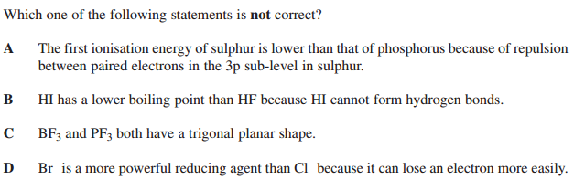
11. | 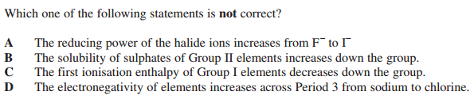
12. | 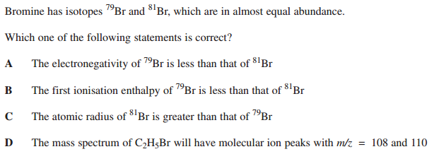
13. | 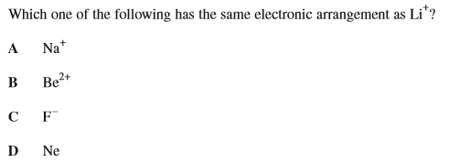

14. | 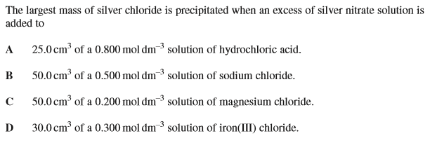
15. | 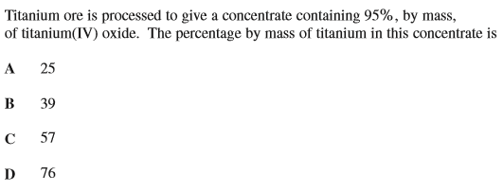
16. | 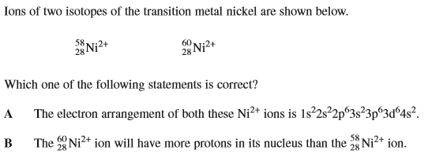  C In a mass spectrometer, the ion will drift more quickly than the

17 - 19
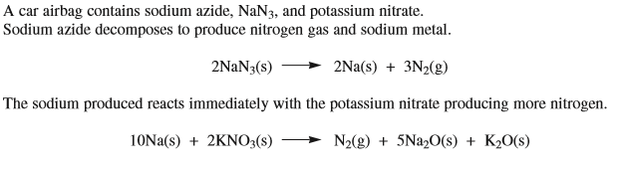
17. | 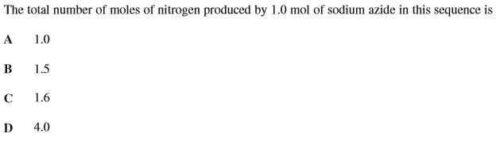
18. | 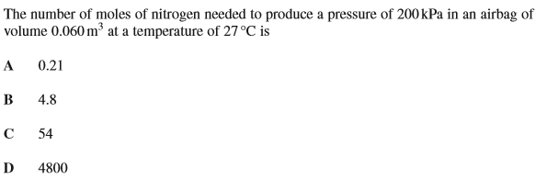
19. | 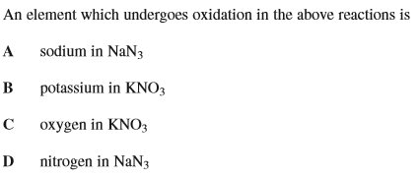

20. | Which of the following statements is correct?  A  B  C  D
21. | Which of the following statements is incorrect?  A is an example of a redox reaction  B is an example of a redox reaction  C is an example of a redox reaction  D is not an example of a redox reaction
22. | Which of the following has a maximum oxidation state of +4?  A Ti  B Co  C Ga  D Se

