AS-LEVEL PAPER 1 PP20 MS

**1.**

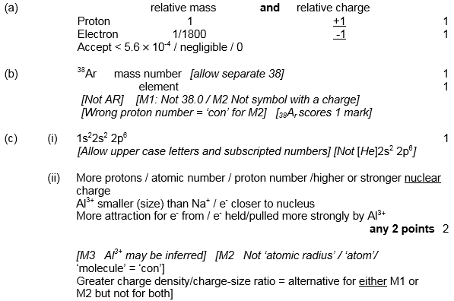

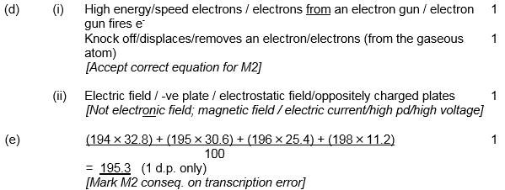**[12]**

**2.**

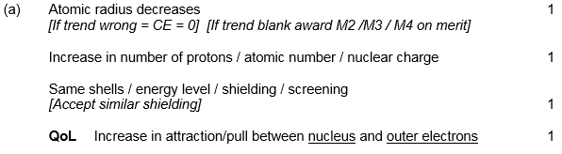

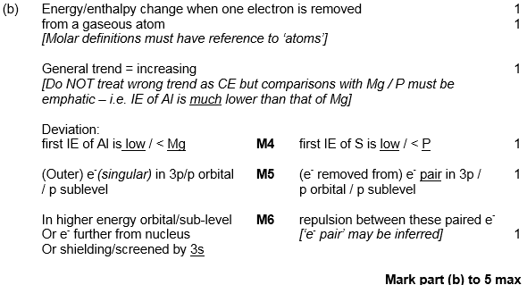**[9]**

|  |  |  |
| --- | --- | --- |
| **3.** | (a) |  |
|  | (b) |  |
|  | (c) |  |
|  | (d) |  |
|  | (e) |  |
|  | (f) |  |
|  | (g) |  |
|  | (h) |  |
|  | (i) |  |
|  | (j) |  |
|  | (k) |  |
|  | (l) |  |
|  | (m) |  |
|  | (n) |  |
|  | (o) |  |
|  | (p) | **(Total 22 marks)** |

**4.**

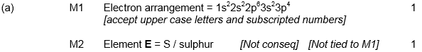

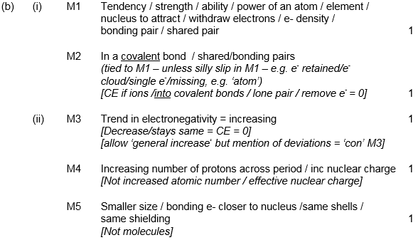

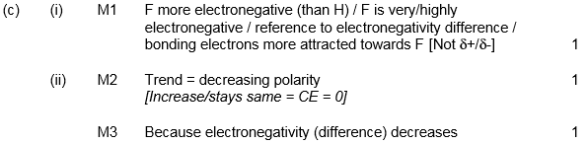

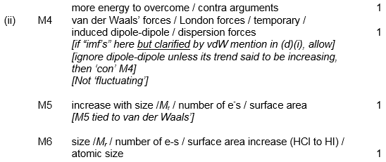

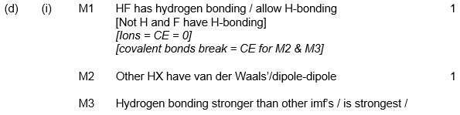

**[16]**

**5.**

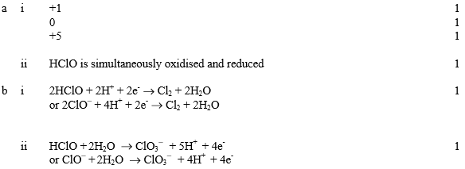**[6]**

**6.**

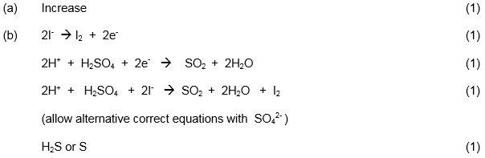

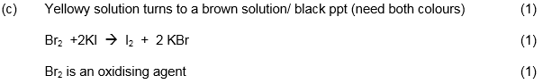

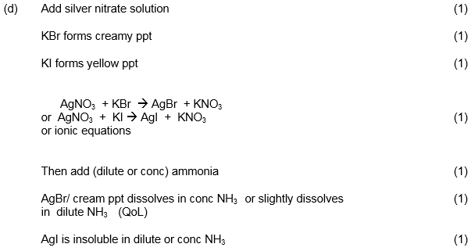

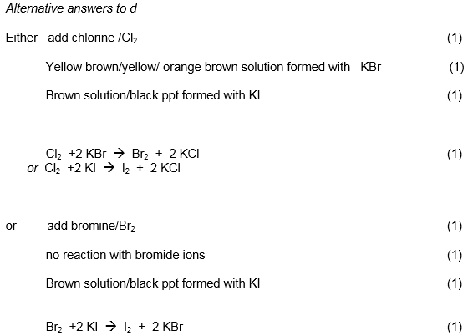

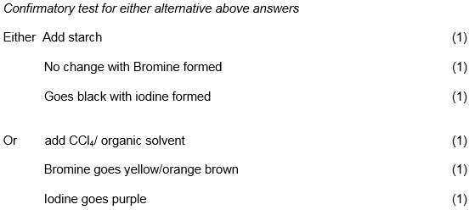**[15]**