AS LEVEL CHEMISTRY

PAPER 1
PRACTICE PAPER 3
Answer all questions
Max 80 marks

Name ……………………………………………………………..

Mark ……../80 ……....% Grade ………

- The mass spectrum of the isotopes of element X is shown in the diagram.
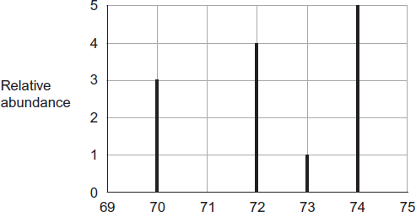
m / z
(a) Define the term relative atomic mass.
........................................................................................................................
........................................................................................................................
........................................................................................................................
........................................................................................................................
(2)
(b) Use data from the diagram to calculate the relative atomic mass of X.
Give your answer to one decimal place.
........................................................................................................................
........................................................................................................................
........................................................................................................................
........................................................................................................................
........................................................................................................................
........................................................................................................................
(3)
(c) Identify the ion responsible for the peak at 72
........................................................................................................................
(1)

(d) Identify which one of the isotopes of X will reach the detector first in a mass spectrometer. Give a reason for your answer.
Isotope ..........................................................................................................
Reason ..........................................................................................................
(2)
(e) In a mass spectrometer, the relative abundance of each isotope is proportional to the current generated by that isotope at the detector.
Explain how this current is generated.
........................................................................................................................
........................................................................................................................
........................................................................................................................
........................................................................................................................
(2)

(f) X and Zn are different elements. Explain why the chemical properties of ⁷⁰X and ⁷⁰Zn are different.
........................................................................................................................
........................................................................................................................
(1)
(Total 11 marks)

2. This question is about the elements in Period 3 of the Periodic Table.
(a) State the element in Period 3 that has the highest melting point.
Explain your answer.
Element ..........................................................................................................
Explanation ....................................................................................................
........................................................................................................................
........................................................................................................................
........................................................................................................................
........................................................................................................................
(3)

(b) State the element in Period 3 that has the highest first ionisation energy.
Explain your answer.
Element ..........................................................................................................
Explanation ....................................................................................................
........................................................................................................................
........................................................................................................................
........................................................................................................................
........................................................................................................................
(3)
(c) Suggest the element in Period 3 that has the highest electronegativity value.
........................................................................................................................
(1)
(d) Chlorine is a Period 3 element.
Chlorine forms the molecules ClF₃ and CCl₂
(i) Use your understanding of electron pair repulsion to draw the shape of ClF₃ and the shape of CCl₂
Include any lone pairs of electrons that influence the shape.
Shape of ClF₃ Shape of CCl₂
(2)

(ii) Name the shape of CCl₂
...............................................................................................................
(1)
(iii) Write an equation to show the formation of one mole of ClF₃ from its elements.
...............................................................................................................
(1)
(Total 11 marks)

3. A sample of nitrogen dioxide gas (NO₂) was prepared by the reaction of copper with concentrated nitric acid.
(a) (i) Balance the equation for the reaction of copper with concentrated nitric acid.
Cu + ........ HNO₃ → Cu(NO₃)₂ + ........ NO₂ + ........ H₂O
(1)
(ii) Give the oxidation state of nitrogen in each of the following compounds.
HNO₃ ........................................................
NO₂ ..........................................................
(2)
(iii) Deduce the half-equation for the conversion of HNO₃ into NO2 in this reaction.
.............................................................................................................
(1)

(b) The following equilibrium is established between colourless dinitrogen tetraoxide gas (N₂O₄) and dark brown nitrogen dioxide gas.
N₂O₄(g) 2NO₂(g) ΔH = 58 kJ mol^{–1}
(i) Give two features of a reaction at equilibrium.
Feature 1 ............................................................................................
.............................................................................................................
.............................................................................................................
.............................................................................................................
Feature 2 ............................................................................................
.............................................................................................................
.............................................................................................................
.............................................................................................................
(2)
(ii) Use Le Chatelier’s principle to explain why the mixture of gases becomes darker in colour when the mixture is heated at constant pressure.
.............................................................................................................
.............................................................................................................
.............................................................................................................
.............................................................................................................
.............................................................................................................
(2)
(iii) Use Le Chatelier’s principle to explain why the amount of NO₂ decreases when the pressure is increased at constant temperature.
.............................................................................................................
.............................................................................................................
.............................................................................................................
.............................................................................................................
.............................................................................................................
.............................................................................................................
(2)
(Total 10 marks)

4. Sulfuric acid is made from SO₃ which can be manufactured in a series of stages from iron(II) disulfide (FeS₂), found in the mineral iron pyrites.
(a) In the first stage, FeS₂ is roasted in air to form iron(III) oxide and sulfur dioxide.
(i) Balance the following equation for this reaction.
..........FeS₂ + ..........O₂ → ..........Fe₂O₃ + ..........SO₂
(1)
(ii) Deduce the oxidation state of sulfur in each of the following compounds.
SO₂ .....................................................................................................
FeS₂.....................................................................................................
(2)
(b) In the second stage of the manufacture of sulfuric acid, sulfur dioxide reacts with oxygen. The equation for the equilibrium that is established is shown below.
SO₂(g) + O₂(g) SO₃(g) ΔH = –98 kJ mol^{–1}
State and explain the effect of an increase in temperature on the equilibrium yield of SO₃
Effect of increase in temperature on yield ..................................................
Explanation …..............................................................................................
......................................................................................................................
......................................................................................................................
(3)
(c) In the extraction of iron, carbon monoxide reacts with iron(III) oxide. Write an equation for this reaction and state the role of the carbon monoxide.
Equation ......................................................................................................
Role of the carbon monoxide .......................................................................
(2)
(Total 8 marks)

5. (a) Chlorine displaces iodine from aqueous potassium iodide.
(i) Write the simplest ionic equation for this reaction.
...............................................................................................................
(1)
(ii) Give one observation that you would make when this reaction occurs.
...............................................................................................................
...............................................................................................................
(1)
(b) In bright sunlight, chlorine reacts with water to form oxygen as one of the products.
Write an equation for this reaction.
........................................................................................................................
(1)
(c) Explain why chlorine has a lower boiling point than bromine.
........................................................................................................................
........................................................................................................................
........................................................................................................................
........................................................................................................................
........................................................................................................................
........................................................................................................................
(2)
(Total 5 marks)

6. A sample of sodium carbonate was known to be the monhydrate Na₂CO₃.H₂O. A chemist was asked to confirm the identity of the sample by titration of a solution of the sodium carbonate with hydrochloric acid.

The chemist rinsed a weighing bottle with de-ionised water and transferred sodium carbonate to the bottle until 0.25 g had been added. The contents of the weighing bottle were then tipped into a conical flask. About 30 cm³ of de-ionised water were added to the conical flask, and the mixture was shaken until all of the sodium carbonate had dissolved.

The chemist filled a burette with 0.100 moldm⁻³ hydrochloric acid. The sodium carbonate solution was titrated with the acid solution using phenolphthalein as indicator.

The chemist then repeated the above procedure using a further 0.25 g portions of the sodium carbonate sample. The following results were obtained.

Titration number | 1 | 2 | 3 | 4 | 5
Final burette reading/cm³ | 19.60 | 19.20 | 19.35 | 19.15 | 25.85
Initial burette reading/cm³ | 0.05 | 0.05 | 0.05 | 0.10 | 6.75
Titre/cm³

- Using the conditions of the titration, sodium carbonate and hydrochloric acid react in a 1:1 mole ratio to form sodium hydrogencarbonate, NaHCO₃, write an equation for the reaction, representing sodium carbonate as NaHCO₃.

………………………………………………………………………………………………………………………..

………………………………………………………………………………………………………………………..

………………………………………………………………………………………………………………………..

- Use all the concordant results in the table to determine an average titre.

………………………………………………………………………………………………………………………..

………………………………………………………………………………………………………………………..

- Use the average titre to calculate the number of moles of sodium carbonate present in 0.25 g of the sample.

………………………………………………………………………………………………………………………..

……………………………………………………………………………………………………………………….

- Using your results from part 3, determine the relative molecular mass M_{r} of the hydrated sodium carbonate

………………………………………………………………………………………………………………………..

……………………………………………………………………………………………………………………….

- Using your results from part 4, calculate the number of moles of water of crystallisation in one mole of hydrated sodium carbonate.

………………………………………………………………………………………………………………………..

……………………………………………………………………………………………………………………….

- Assume that the maximum errors for the apparatus used in the experiment were:
balance total error = ± 0.01 g
burette total error = ± 0.15 cm³
Calculate the maximum percentage error in using the balance and burette in this experiment and hence the overall maximum percentage error.

………………………………………………………………………………………………………………………..

……………………………………………………………………………………………………………………….

………………………………………………………………………………………………………………………..

- Comment on the consistency of the titrations.

………………………………………………………………………………………………………………………..

……………………………………………………………………………………………………………………….

………………………………………………………………………………………………………………………..

………………………………………………………………………………………………………………………..

- Calculate the difference between the experimental M_{r} value determined by the chemist and the actual M_{r} value of Na₂CO₃.H₂O. Express this as a percentage of the actual M_{r} value of Na₂CO₃.H₂O. (If you could not complete the calculation in part 4 of the analysis, you should assume that the experimental M_{r} value is 133. This is not the correct answer).

………………………………………………………………………………………………………………………..

……………………………………………………………………………………………………………………….

- Comment on the significance of the difference between the actual M_{r} of the hydrated sodium carbonate and your calculated value. Assume that this difference is not due to impurities.

………………………………………………………………………………………………………………………..

……………………………………………………………………………………………………………………….

- State two ways of improving the chemist’s method of weighing out the sodium carbonate and explain why the accuracy of the experiment would be improved.
……………………………………………………………………………………………………………………..

……………………………………………………………………………………………………………………….

……………………………………………………………………………………………………………………..

……………………………………………………………………………………………………………………….
(Total 14 marks)

7.
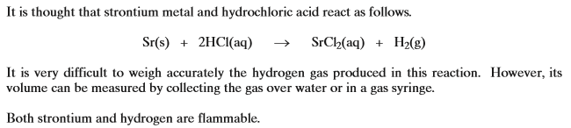
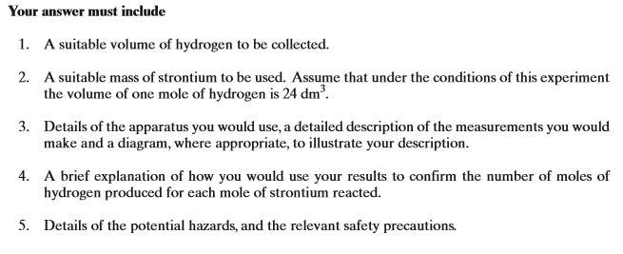
……………………………………………………………………………………………………………………..

……………………………………………………………………………………………………………………….

……………………………………………………………………………………………………………………..

……………………………………………………………………………………………………………………….

……………………………………………………………………………………………………………………..

……………………………………………………………………………………………………………………….

……………………………………………………………………………………………………………………..

……………………………………………………………………………………………………………………….

……………………………………………………………………………………………………………………..

……………………………………………………………………………………………………………………….

……………………………………………………………………………………………………………………..

……………………………………………………………………………………………………………………….

……………………………………………………………………………………………………………………..

……………………………………………………………………………………………………………………….

……………………………………………………………………………………………………………………..

……………………………………………………………………………………………………………………….

……………………………………………………………………………………………………………………..

……………………………………………………………………………………………………………………….

……………………………………………………………………………………………………………………..

……………………………………………………………………………………………………………………….

……………………………………………………………………………………………………………………..

……………………………………………………………………………………………………………………….

……………………………………………………………………………………………………………………..

……………………………………………………………………………………………………………………….

……………………………………………………………………………………………………………………..

……………………………………………………………………………………………………………………….

……………………………………………………………………………………………………………………..

……………………………………………………………………………………………………………………….

……………………………………………………………………………………………………………………..

……………………………………………………………………………………………………………………….

……………………………………………………………………………………………………………………..

……………………………………………………………………………………………………………………….

……………………………………………………………………………………………………………………..

……………………………………………………………………………………………………………………….

……………………………………………………………………………………………………………………..

……………………………………………………………………………………………………………………….

……………………………………………………………………………………………………………………..

……………………………………………………………………………………………………………………….

……………………………………………………………………………………………………………………..
(Total 8 marks)

8. | Which of the following statements is incorrect?
 | A
 | B
 | C | is a redox reaction
 | D | is a redox reaction
9. | Which of the following statements is incorrect?
 | A | Concentrated sulphuric acid is reduced to hydrogen sulphide by solid sodium iodide.
 | B | Concentrated sulphuric acid can react with sodium chloride to produce chlorine gas.
 | C | is a redox reaction
 | D | is a redox reaction
10. | Which of the following statements is incorrect?
 | A | is a redox reaction
 | B | The first ionisation energy of sulphur is lower than that of phosphorus because there is repulsion between paired electrons in the 3p sub-level
 | C
 | D
11. | Which of the following statements is incorrect?
 | A | contains an element with an oxidation state of +5
 | B
 | C | If an aqueous solution of chlorine is added to aqueous potassium iodide, iodine is formed.
 | D | contains an element with an oxidation state of +5
12. | Which of the following statements is incorrect?
 | A
 | B
 | C
 | D | contains an element with an oxidation state of +4

13. | Which of the following statements is correct?
 | A
 | B | the reactioncan take place.
 | C | is a redox reaction
 | D | is a redox reaction
14. | 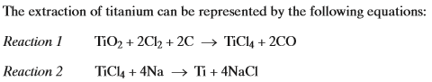  Which of the following statements is incorrect?
 | A | Reaction 1 is a redox reaction.
 | B | Reaction 2 is a redox reaction.
 | C | 0.52 tonne of titanium can be produced by using 1.0 tonne of sodium.
 | D | 0.48 tonne of sodium is needed to produce 1.0 tonne of titanium.
15. | Which of the following statements is incorrect?
 | A | Na atoms are larger than Mg atoms.
 | B | Mg²⁺ ions are smaller than Na⁺ ions.
 | C | S atoms are larger than Cl atoms.
 | D | Cl⁻ ions are larger than S²⁻ ions.
16. | Consider the Period 3 elements Na, Mg, Al, Si, P, S and Cl  Which of the following statements is correct?
 | A | Na(g) has the smallest atomic radius.
 | B | Na(s) has the highest electrical conductivity.
 | C | Cl(g) has the highest first ionisation enthalpy.
 | D | Cl⁻(g) and S²⁻(g) have the same ionic radius.
17. | 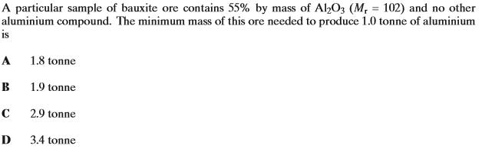
18. | Which of the following is not a redox reaction?
 | A
 | B
 | C
 | D
19. | Which of the following statements is incorrect?
 | A | is a redox reaction
 | B
 | C | vanadium increases its oxidation state from left to right in the series
 | D | chlorine increases its oxidation state from left to right in the series
20. | 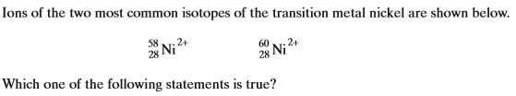
 | A
 | B
 | C | Both of these Ni²⁺ ions have the same number of electrons but a different number of neutrons.
 | D | In a mass spectrometer, the ion will reach the detector in less time than the ion.

