AS-LEVEL PAPER 1 PP4 MS

- (a) (i) Average/mean mass of 1 atom (of an element);
Average mass of 1 atom × 12.
1
Mass 1/12 atom of ¹²C;
Mass 1 atom of ¹²C.
QWC.
1
(ii) Other isotope = 46.0%;
1
107.9 = 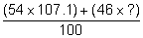;
M2 whole expression.
1
108.8;
Answer 108.8 (3 marks).
Answer min 1 d.p..
1
Same electronic configuration/ same number of electrons (in
outer shell)/ both have 47 electrons;
Ignore protons and neutrons unless incorrect.
Not just electrons determine chemical properties.
1
(b) Ionisation;
1
high energy electrons fired at sample;
Allow electron gun /blasted with electrons.
1
Acceleration;
1
With electric field/accelerating potential/potential difference;
Allow by negative plate.
1
Deflection;
1
With electromagnet/ magnet/ magnetic field;
M2 dependent on M1.
M4 dependent on M3.
M6 dependent on M5.
1
(c) (Silver) metallic (bonding);
Vdw/molecules CE=0.
1
Regular arrangement of same sized particles;
1
+ charge in each ion;
Ignore multiple positive charges.
Candidates do not need to show delocalised electrons.
1

(d) Ionic (bonds);
1
Minimum 4 ions shown in 2D square arrangement placed Correctly;
Do not allow multiple charges on ions.
1
Further 3 ions shown correctly in a cubic lattice;
1
Strong (electrostatic) forces/bonds;
If vdw/molecules/covalent mentioned CE = 0 for M4 and M5.
1
Between + and – ions;
Accept between oppositely charged ions.
1
[20]

2. (a) (i) mol H₂ = 0.47
1
mol I₂ = 0.17
If answers reversed, ie
mol H₂ = 0.17
mol I₂ = 0.47
then allow one mark (for second answer).
1
(ii) 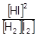
Penalise expression containing V
But mark on in (a)(iv)
Penalise missing square brackets in this part(and not elsewhere in paper) but mark on in (a)(iv)
1
(iii) equal number of moles (on each side of equation)
OR
equal moles (top and bottom of Kc expression)
1
(iv) 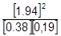
Ignore V
If Kc wrong in (a)(ii) (wrong powers or upside down etc) no marks here
1
= 52(.1)
1
(b) (i) D
1
(ii) B
1
(iii) A
1
(iv) C
1
[10]

3. (a) M1 Increases / gets bigger
If M1 is incorrect CE = 0 for the clip
If M1 is blank, mark on and seek to credit the correct information in the text
M2 requires a correct M1
M2 requires correct M1
More shells or sub-shells or (main) levels or sub-levels or orbitals (of electrons)
If “molecules” penalise M2
Not simply “more electrons”
Not “more outer shells”
Ignore reference to nuclear charge and shielding
2
(b) (i) Increases / gets more reactive / reacts more vigorously / violently (down the Group)
1
(ii) Sr + 2H₂O Sr(OH)₂ + H₂
Credit multiples and correct ionic equations
Ignore state symbols
1
(c) Ba(OH)₂
This MUST be a formula so ignore the name
Credit Ba²⁺ 2OH⁻
Ignore state symbols
1
[5]

4. (a) (i) –2 OR 2–
(ii) NaI or NaAt or I– or iodide or At–or Astatide (1)
Not atoms or molecules
(iii) Smell of bad eggs (1)
Allow PbAc₂ goes black and K₂Cr₂O₇/H⁺ goes
cloudy green
(iv) 8 e– + 8 H⁺ + H₂SO₄ → H₂S + 4H₂O (1)
OR 10 H⁺ +SO₄^{2–}
4
(b) (i) HF or HCl (1)
CE = 0 if redox answer given
If wrong halide given allow max one in b(iii)
If NaF or NaCl, or F– or Cl– given lose mark in (i)
Mark on if X is e.g. HF₂ or H₂F
(ii) NaF or NaCl or F– or Cl– (1)
(iii) A proton donor or an acid (1)
(iv) H⁺ +F– → HF
OR H₂SO₄ + NaF → NaHSO₄ + HF
OR H₂SO₄ + 2 NaF → Na₂SO₄ + 2 HF
OR for chloride
4
[8]

5. (a) HA + NAOH NaA + H₂O (1)

(b) 27.95 + 28.05 + 28.00
3
= 28 .00 cm³ (1)
(c) 1:1 reaction so moles of acid = 2.5 x 10⁻³
conc = 2.5 x 10⁻³ /(28/1000)
= 0.0893 mol dm⁻³ (1)
(d) conc. original solution = 0.0893 x 10 = 0.893 mol dm⁻³
conc. in gdm⁻³ = 0.893 x 60 = 53.6 gdm⁻³ (1)
(e) (i) measuring cylinder (0.5/ 25) x 100 = 2.00%
(ii) Volumetric flask (0.5/ 250) x 100 = 0.20%
(iii) pipette (0.05 / 25) x 100 = 0.20%
(iv) burette (0.15 / 28) x 100 = 0.54% (all 4 = 1)
TOTAL = 2.94% (1)

Precision: average titre to 2dp
Both concentrations to 3 sf (1)
Working: clear working
Accurate use of terminology
Correct units (1)
(f) First titration poor / probably rough (1)
Three good results/ concordant results
Titration technique good/ results consistent (both = 1)
(g) difference = 2.5
= 4.5 % error (both = 1)
(h) appreciates discrepancy (4.5%) is greater than total apparatus error (1)
(i) Uses pipette/ burette for measuring supplier’s solution (1)
As apparatus error is smaller (1)

6.
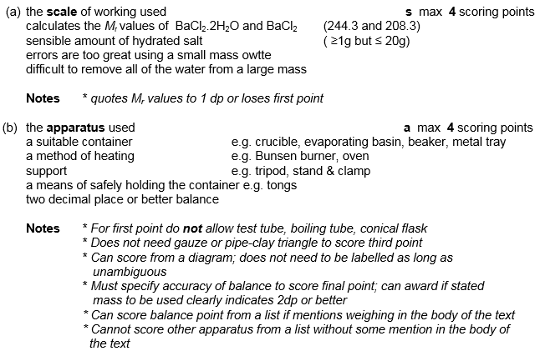
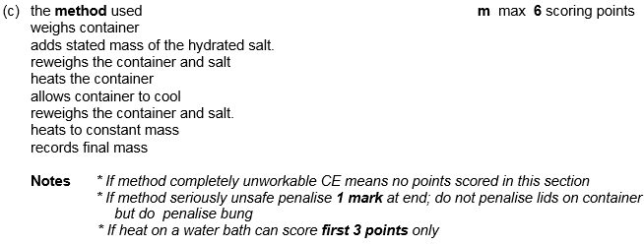
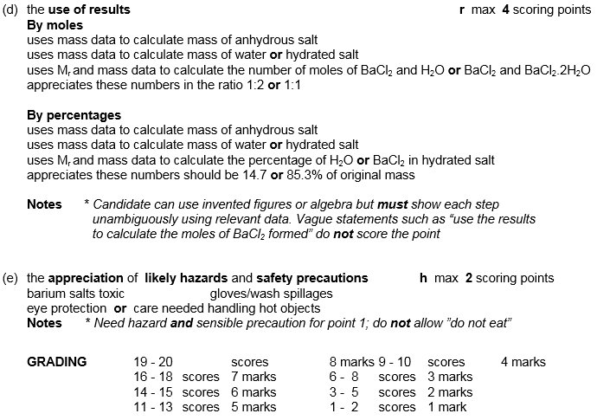
7. A
[1]
8. B
[1]
9. D
[1]
10. A
[1]
11. B
[1]
12. B
[1]
13. D
[1]
14. A
[1]
15. C
[1]
16. A
[1]
17. B
[1]
18. A
[1]
19. C
[1]
20. D
[1]
21. D
[1]

