AS LEVEL CHEMISTRY

PAPER 1
PRACTICE PAPER 5
Answer all questions
Max 80 marks

Name ……………………………………………………………..

Mark ……../80 ……....% Grade ………

Note – the multiple choice questions used in this paper are recycled from the assessed homeworks, tests and assessment points for the AS-level/1st Year course

1. In 1913 Niels Bohr proposed a model of the atom with a central nucleus, made up of protons and neutrons, around which electrons moved in orbits. After further research, the model was refined when the existence of energy levels and sub-levels was recognised.
(a) Complete the following table for the particles in the nucleus.

Particle | Relative charge | Relative mass
proton
neutron

(2)
(b) State the block in the Periodic Table to which the element tungsten, W, belongs.
......................................................................................................................
(1)
(c) Isotopes of tungsten include ¹⁸²W and ¹⁸⁶W
(i) Deduce the number of protons in ¹⁸²W
.............................................................................................................
(1)
(ii) Deduce the number of neutrons in ¹⁸⁶W
.............................................................................................................
(1)
(d) In order to detect the isotopes of tungsten using a mass spectrometer, a sample containing the isotopes must be vaporised and then ionised.
(i) Give two reasons why the sample must be ionised.
1 ..........................................................................................................
2 ..........................................................................................................
(2)
(ii) State why the different isotopes reach the detector at different times.
.............................................................................................................
(1)
(e) State and explain the difference, if any, between the chemical properties of the isotopes ¹⁸²W and ¹⁸⁶W
Difference ....................................................................................................
Explanation ..................................................................................................
......................................................................................................................
(2)

(f) The table below gives the relative abundance of each isotope in the mass spectrum of a sample of tungsten.

m/z | 182 | 183 | 184 | 186
Relative abundance /% | 26.4 | 14.3 | 30.7 | 28.6

Use the data above to calculate a value for the relative atomic mass of this sample of tungsten. Give your answer to 2 decimal places.
......................................................................................................................
......................................................................................................................
......................................................................................................................
(2)
(Total 12 marks)

2. (a) When aluminium is added to an aqueous solution of copper(II) chloride, CuCl₂, copper metal and aluminium chloride, AlCl₃, are formed. Write an equation to represent this reaction.
......................................................................................................................
(1)
(b) (i) State the general trend in the first ionisation energy of the Period 3 elements from
Na to Ar.
.............................................................................................................
(ii) State how, and explain why, the first ionisation energy of aluminium does not follow this general trend.
.............................................................................................................
.............................................................................................................
.............................................................................................................
.............................................................................................................
(4)
(c) Give the equation, including state symbols, for the process which represents the second ionisation energy of aluminium.
......................................................................................................................
(1)

(d) State and explain the trend in the melting points of the Period 3 metals Na, Mg and Al.
Trend ..........................................................................................................
Explanation ..................................................................................................
......................................................................................................................
......................................................................................................................
(3)
(Total 9 marks)

3. (a) Ammonia gas readily condenses to form a liquid when cooled.
(i) Name the strongest attractive force between two ammonia molecules.
...............................................................................................................
(1)
(ii) Draw a diagram to show how two ammonia molecules interact with each other in the liquid phase.
Include all partial charges and all lone pairs of electrons in your diagram.

(3)
(b) Ammonia reacts with boron trichloride to form a molecule with the following structure.
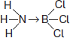
State how the bond between ammonia and boron trichloride is formed.
........................................................................................................................
........................................................................................................................
........................................................................................................................
(1)

(c) The following table shows the electronegativity values of some elements.

 |  | H | Li | B | C | O | F
 | Electronegativity | 2.1 | 1.0 | 2.0 | 2.5 | 3.5 | 4.0

(i) Give the meaning of the term electronegativity.
...............................................................................................................
...............................................................................................................
...............................................................................................................
...............................................................................................................
(2)
(ii) Suggest the formula of an ionic compound that is formed by the chemical combination of two different elements from the table.
...............................................................................................................
(1)
(iii) Suggest the formula of the compound that has the least polar bond and is formed by chemical combination of two of the elements from the table.
...............................................................................................................
(1)
(Total 9 marks)

4. Thallium is in Group 3 of the Periodic Table.
Thallium reacts with halogens to form many compounds and ions.
(a) Draw the shape of the TlBr₃^{2–} ion and the shape of the TlCl₄^{3–} ion.
Include any lone pairs of electrons that influence the shapes.
Name the shape made by the atoms in TlBr₃^{2–} and suggest a value for the bond angle.

........................................................................................................................
(4)

(b) Thallium(I) bromide (TlBr) is a crystalline solid with a melting point of 480 °C.
Suggest the type of bonding present in thallium(I) bromide and state why the melting point is high.
........................................................................................................................
........................................................................................................................
........................................................................................................................
........................................................................................................................
........................................................................................................................
........................................................................................................................
(3)
(c) Write an equation to show the formation of thallium(I) bromide from its elements.
........................................................................................................................
(1)
(Total 8 marks)

5. The elements in Group 2 can be used to show the trends in properties down a group in the Periodic Table.
(a) State the trend in atomic radius down Group 2 from Mg to Ba and give a reason for this trend.
Trend ..........................................................................................................
Reason ........................................................................................................
(2)
(b) State and explain the trend in melting points of the elements down Group 2 from Mg to Ba.
Trend ...........................................................................................................
Explanation …..............................................................................................
......................................................................................................................
......................................................................................................................
......................................................................................................................
(3)
(c) State the trend in reactivity with water of the elements down Group 2 from Mg to Ba.
Write an equation for the reaction of magnesium with steam and an equation for the reaction of strontium with water.
Trend ..........................................................................................................
Equation for magnesium .............................................................................
Equation for strontium .................................................................................
(3)
(d) Sulfates of the Group 2 elements from Mg to Ba have different solubilities. Give the formula of the least soluble of these sulfates and state one use that depends upon the insolubility of this sulfate.
Formula ........................................................................................................
Use ...............................................................................................................
(2)
(Total 10 marks)

6. For each of the following reactions, select from the list below, the formula of a sodium halide that would react as described.
NaF NaCl NaBr NaI
Each formula may be selected once, more than once or not at all.
(a) This sodium halide is a white solid that reacts with concentrated sulfuric acid to give a brown gas.
Formula of sodium halide ............................................................................
(1)
(b) When a solution of this sodium halide is mixed with silver nitrate solution, no precipitate is formed.
Formula of sodium halide ............................................................................
(1)
(c) When this solid sodium halide reacts with concentrated sulfuric acid, the reaction mixture remains white and steamy fumes are given off.
Formula of sodium halide ............................................................................
(1)
(d) A colourless aqueous solution of this sodium halide reacts with orange bromine water to give a dark brown solution.
Formula of sodium halide ............................................................................
(1)
(Total 4 marks)

7. |  | 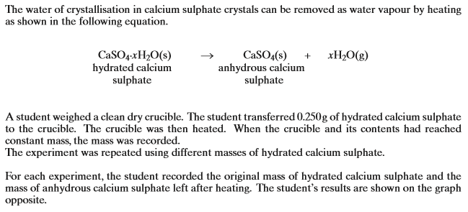  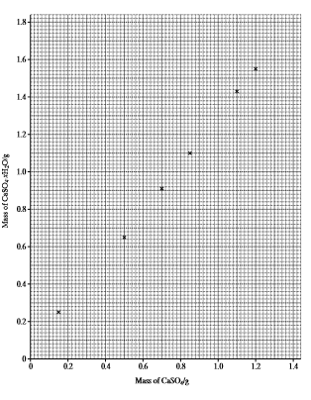
 | (a)
 | (b)

(c)
(d)
(e)
(f)
(g)
(h)
(i)

 | (j)
 |  | (i)
 |  | (ii) | (Total 14 marks)

8. In which one of the following pairs is the first ionisation energy of element Y greater than that of element X?

 |  | electronic configuration  of element X | electronic configuration  of element Y
 | A | 1s¹ | ls²
 | B | 1s² 2s² | ls²2s² 2p¹
 | C | 1s² 2s²2p³ | ls²2s²2p⁴
 | D | 1s² 2s²2p⁶ | ls²2s²2p⁶ 3s¹

(Total 1 mark)

9. When vanadium reacts with chlorine at 400°C, a brown compound is obtained. When an aqueous solution containing 0.193 g of this compound was treated with aqueous silver nitrate all the chlorine in the compound was precipitated as silver chloride. The mass of silver chloride (AgCl) produced was 0.574 g. Which one of the following could be the formula of the brown compound?
A VCl
B VCl₂
C VCl₃
D VCl₄
(Total 1 mark)

10. Which one of the following lists the first ionisation energies (in kJ mol⁻¹) of the elements Mg, Al, Si, P and S in this order?

A | 577 | 786 | 1060 | 1000 | 1260
B | 736 | 577 | 786 | 1060 | 1000
C | 786 | 1060 | 1000 | 1260 | 1520
D | 1060 | 1000 | 1260 | 1520 | 418

(Total 1 mark)

11. The reaction between sodium iodide and concentrated phosphoric acid produces hydrogen iodide but no iodine. The reaction of sodium iodide with concentrated sulphuric acid produces mainly iodine. The difference in product occurs because, in comparison with sulphuric acid, phosphoric acid is
A the weaker acid.
B the stronger oxidising agent.
C the weaker oxidising agent.
D the stronger reducing agent.
(Total 1 mark)

12. Which one of the following ionisations requires less energy than the first ionisation energy of oxygen?
A S(g) → S⁺(g) + e⁻
B O⁺(g) → O²⁺(g) + e⁻
C N(g) → N⁺(g) + e⁻
D F(g) → F⁺(g) + e⁻
(Total 1 mark)

13. Which one of the following is the most likely value for the bond angle α shown in the diagram of SF₄ below?
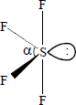
A 118°
B 101°
C 90°
D 88°
(Total 1 mark)

14. Which one of the following has the most covalent character?
A MgF₂
B MgBr₂
C AlF₃
D AlBr₃
(Total 1 mark)

15. The graph shows the equilibrium percentage of ammonia present during the formation of ammonia by the Haber process:
N₂ + 3H₂ ⇌ 2NH₃ ∆H = −92 kJ mol⁻¹
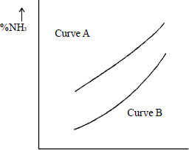
x axis
Which one of the following are correct labels for the graph?

 |  | x axis | Curve A | Curve B
 | A | temperature | high pressure | low pressure
 | B | temperature | low pressure | high pressure
 | C | pressure | high temperature | low temperature
 | D | pressure | low temperature | high temperature

(Total 1 mark)

16. A white salt dissolves in water to give a solution which gives a cream coloured precipitate when aqueous silver nitrate is added. This precipitate is insoluble in dilute aqueous ammonia but is soluble in concentrated aqueous ammonia. The original white salt could be
A AgI
B NaI
C AgBr
D NaBr
(Total 1 mark)

17. Which one of the following does not have a pair of s electrons in its highest filled electron energy sub-level?
A H⁻
B Mg
C P³⁺
D Ar
(Total 1 mark)

18. Which one of the following ions has three lone pairs of electrons around the central atom?
A BF
B NH
C ClF
D PF
(Total 1 mark)

19. Which one of the following explains why boron has a lower first ionisation energy than beryllium?
A A boron atom is smaller than a beryllium atom.
B In beryllium all the electrons are paired in full sub-shells.
C A beryllium atom has fewer protons than a boron atom.
D In boron the 2p electron occupies a higher energy level than a 2s electron.
(Total 1 mark)

20. The equilibrium constant, K_{c}, for a reaction which leads to ozone (O₃) formation is
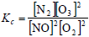
More ozone is formed as the temperature rises. Which one of the following is true at equilibrium?
A When ozone molecules collide with nitrogen they may form nitrogen monoxide.
B The enthalpy change for the reaction has a negative sign.
C Less ozone is formed at high pressure.
D At a fixed temperature, the magnitude of K_{c} increases as the concentration of NO decreases.
(Total 1 mark)
21. The removal of silicon dioxide with limestone in the Blast Furnace can be represented by the following equation.
CaCO₃(s) + SiO₂(s) → CaSiO₃(l) + CO₂(g)
The minimum mass of calcium carbonate needed to remove 1.00 tonne (1000 kg) of silicon dioxide is
A 0.46 tonne
B 0.60 tonne
C 1.67 tonne
D 2.18 tonne
(Total 1 mark)

