AS LEVEL CHEMISTRY

PAPER 1
PRACTICE PAPER 6
Answer all questions
Max 80 marks

Name ……………………………………………………………..

Mark ……../80 ……....% Grade ………

Note – the multiple choice questions used in this paper are recycled from the assessed homeworks, tests and assessment points for the AS-level/1st Year course

1. At room temperature, both sodium metal and sodium chloride are crystalline solids which contain ions.
Sodium chlorate(V), NaClO₃, contains 21.6% by mass of sodium, 33.3% by mass of chlorine and 45.1% by mass of oxygen.
(a) Use the above data to show that the empirical formula of sodium chlorate(V) is NaClO₃
.............................................................................................................
.............................................................................................................
.............................................................................................................
.............................................................................................................
.............................................................................................................
(b) Sodium chlorate(V) may be prepared by passing chlorine into hot aqueous sodium hydroxide. Balance the equation for this reaction below.
....... Cl₂ + ....... NaOH → ....... NaCl + NaClO₃ + 3H₂O
(3)
(Total 3 marks)

2. Zinc forms many different salts including zinc sulfate, zinc chloride and zinc fluoride.

Predict the type of crystal structure in solid zinc fluoride and explain why its melting point is high.
........................................................................................................................
........................................................................................................................
........................................................................................................................
........................................................................................................................
........................................................................................................................
........................................................................................................................
(3)
(Total 3 marks)

3. (a) State the meaning of the term first ionisation energy of an atom.
......................................................................................................................
......................................................................................................................
(2)
(b) Write an equation to illustrate the process occurring when the second ionisation energy of magnesium is measured.
......................................................................................................................
(1)
(c) The Ne atom and the Mg²⁺ ion have the same number of electrons. Give two reasons why the first ionisation energy of neon is lower than the third ionisation energy of magnesium.
Reason 1 .....................................................................................................
Reason 2 .....................................................................................................
(2)
(d) There is a general trend in the first ionisation energies of the Period 3 elements, Na – Ar
(i) State and explain this general trend.
Trend ……….......................................................................................
Explanation .........................................................................................
.............................................................................................................
.............................................................................................................
(ii) Explain why the first ionisation energy of sulphur is lower than would be predicted from the general trend.
.............................................................................................................
.............................................................................................................
.............................................................................................................
(5)
(Total 10 marks)

4. At high temperatures, nitrogen is oxidised by oxygen to form nitrogen monoxide in a reversible reaction as shown in the equation below.
N₂(g) + O₂(g) 2NO(g) ∆H^{ο} = +180 kJ mol^{–1}
(a) In terms of electrons, give the meaning of the term oxidation.
......................................................................................................................
(1)
(b) Nitrogen monoxide, NO, is formed when silver metal reduces nitrate ions, NO₃⁻ in acid solution.
(i) Deduce the oxidation state of nitrogen in NO and in NO₃⁻
NO.......................................................................................................
NO ....................................................................................................
(ii) Write a half-equation for the reduction of NO ions in acid solution to form nitrogen monoxide and water.
.............................................................................................................
(iii) Write a half-equation for the oxidation of silver metal to Ag⁺(aq) ions.
.............................................................................................................
(iv) Hence, deduce an overall equation for the reaction between silver metal and nitrate ions in acid solution.
.............................................................................................................
(5)
(Total 6 marks)

5. Chlorine can form molecules and ions that contain only chlorine, or that contain chlorine combined with another element.
(a) Use your understanding of the electron pair repulsion theory to draw the shape of the AsCl₃ molecule and the shape of the Cl₃⁺ ion.
Include any lone pairs of electrons that influence the shape.
Name the shape made by the atoms in the AsCl₃ molecule and in the Cl₃⁺ ion.

........................................................................................................................
........................................................................................................................
(4)

(b) Explain why the AsCl₄⁺ ion has a bond angle of 109.5°.
........................................................................................................................
........................................................................................................................
........................................................................................................................
........................................................................................................................
(2)
(Total 6 marks)

6. (a) For the elements Mg–Ba, state how the solubilities of the hydroxides and the solubilities of the sulphates change down Group II.
........................................................................................................................
........................................................................................................................
........................................................................................................................
........................................................................................................................
(b) Describe a test to show the presence of sulphate ions in an aqueous solution. Give the results of this test when performed on separate aqueous solutions of magnesium chloride and magnesium sulphate. Write equations for any reactions occurring.
........................................................................................................................
........................................................................................................................
........................................................................................................................
........................................................................................................................
........................................................................................................................
........................................................................................................................
........................................................................................................................
.......................................................................................................................
(c) State the trend in the reactivity of the Group II elements Mg–Ba with water.
Write an equation for the reaction of barium with water.
........................................................................................................................
........................................................................................................................
........................................................................................................................
.......................................................................................................................

(Total 11 marks)
7. (a) State the trend in the boiling points of the halogens from fluorine to iodine and explain this trend.
Trend ............................................................................................................
Explanation ...................................................................................................
......................................................................................................................
......................................................................................................................
(4)
(b) Each of the following reactions may be used to identify bromide ions. For each reaction, state what you would observe and, where indicated, write an appropriate equation.
(i) The reaction of aqueous bromide ions with chlorine gas
Observation ........................................................................................
Equation ..............................................................................................
(ii) The reaction of aqueous bromide ions with aqueous silver nitrate followed by the addition of concentrated aqueous ammonia
Observation with aqueous silver nitrate ...............................................
Equation ..............................................................................................
Observation with concentrated aqueous ammonia ..............................
.............................................................................................................
(iii) The reaction of solid potassium bromide with concentrated sulphuric acid
Observation 1 .....................................................................................
Observation 2 .....................................................................................
(7)
(c) Write an equation for the redox reaction that occurs when potassium bromide reacts with concentrated sulphuric acid.
......................................................................................................................
(2)
(Total 13 marks)

8. | 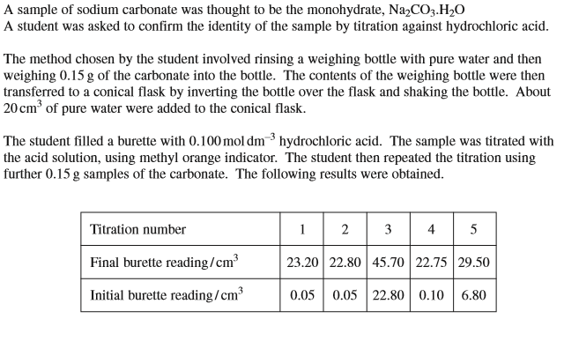
 | (a)  (b) | 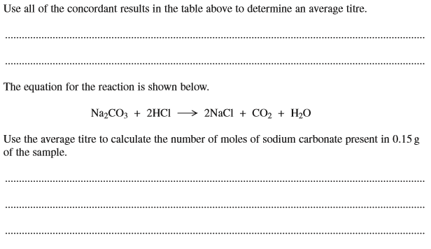

 | (c)  (d) | 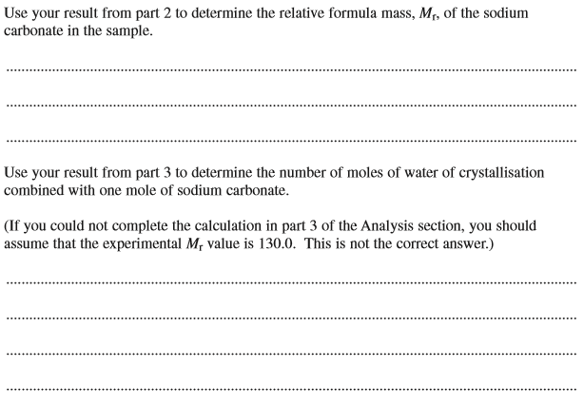
 | (e) | 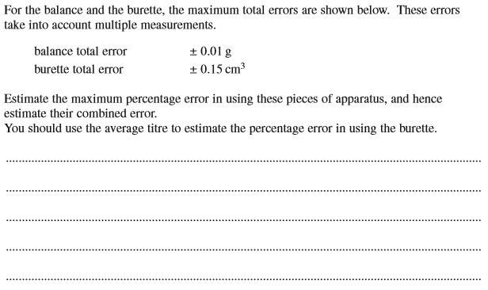

 | (f) | 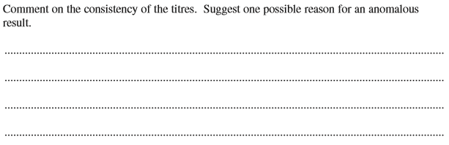
 | (g) | 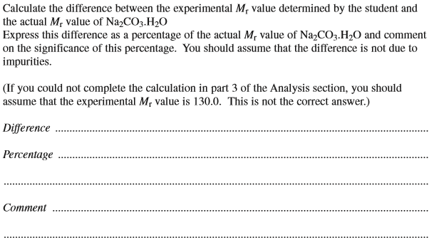
 | (h) | 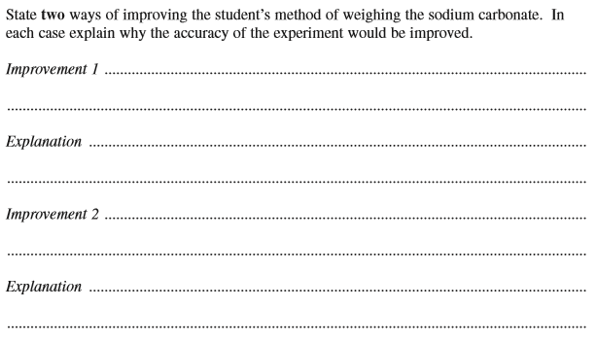

9. Which of the following has does not have only two unpaired electrons in an uncombined atom?
A Ca
B Ti
C C
D Se

10. In which of the following reaction does the oxidation state of an element decrease by more than four units?
A
B
C
D

11. Which of the following statements is incorrect?
A manganese increases its oxidation state from left to right in the series.
B the reaction between iodide ions and concentrated sulphuric acid can result in the oxidation state of sulphur being decreased from +6 to -2.
C the strength of the metallic bonding in a group in the Periodic Table increases as the size of the atoms increases.
D magnesium iodide solution is colourless.

12. Which of the following statements is correct?
A A redox reaction occurs between.
B A redox reaction occurs between .
C a method used to produce titanium is to heat titanium (IV) oxide with magnesium.
D The strength of the halide ion as a reducing agent increases down Group VII.

13. Phosphorus(V) chloride decomposes at high temperatures into phosphorus(III) chloride and chlorine according to the equation.
PCl₅(g) ⇌ PCl₃(g) + Cl₂(g)
Which one of the graphs best represents the variation with pressure of the yield of chlorine at equilibrium?
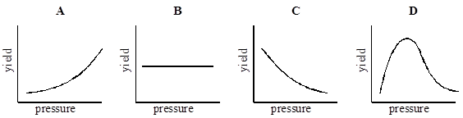
(Total 1 mark)

14. What will you see when a solution of silver nitrate is added to a solution containing bromide ions, and concentrated aqueous ammonia is added to the resulting mixture?
A a white precipitate soluble in concentrated aqueous ammonia
B a white precipitate insoluble in concentrated aqueous ammonia
C a cream precipitate soluble in concentrated aqueous ammonia
D a yellow precipitate insoluble in concentrated aqueous ammonia
(Total 1 mark)

15. Which one of the following atoms has only two unpaired electrons in its ground (lowest energy) state?
A helium
B beryllium
C nitrogen
D oxygen
(Total 1 mark)

16. In which one of the following reactions is the standard enthalpy change equal to the standard enthalpy of formation of lithium fluoride?
A Li(g) + F(g) → LiF(s)
B Li⁺(g) + F⁻(g) → LiF(s)
C Li⁺(aq) + F⁻(g) → LiF(s)
D Li(s) + F₂(g) → LiF(s)
(Total 1 mark)

17. An aqueous solution of a white solid gives a yellow precipitate with aqueous silver nitrate. The formula of the white solid could be
A AgBr
B AgI
C NaBr
D NaI
(Total 1 mark)

18. An atom in which the number of protons is greater than the number of neutrons is
A ²³⁴U
B ⁶Li
C ³He
D ²H
(Total 1 mark)

19. Which one of the following contains the smallest number of moles of carbon dioxide gas?
A 2.65 g
B 0.0150 m³ at 1000 K and 33.0 kPa
C 1.50 dm³ at 327 °C and 200 kPa
D 1500 cm³ at 300 K and 100 kPa
(Total 1 mark)

20. Using the data below, which is the correct value for the standard enthalpy of formation for TiCl₄(l)?
C(s) + TiO₂(s) + 2Cl₂(g) → TiCl₄(l) + CO₂(g) ∆H = −232 kJ mol⁻¹
Ti(s) + O₂(g) → TiO₂(s) = −912 kJ mol⁻¹
C(s) + O₂(g) → CO₂(g) = −394 kJ mol⁻¹
A −1538 kJ mol⁻¹
B −1094 kJ mol⁻¹
C −750 kJ mol⁻¹
D +286 kJ mol⁻¹
(Total 1 mark)

21. When one mole of ammonia is heated to a high temperature, 50% dissociates according to the following equilibrium.
2NH₃(g) ⇌ N₂(g) + 3H₂(g)
What is the total number of moles of gas present in the equilibrium mixture?
A 1.5
B 2.0
C 2.5
D 3.0
(Total 1 mark)

22. The removal of silicon dioxide with limestone in the Blast Furnace can be represented by the following equation.
CaCO₃(s) + SiO₂(s) → CaSiO₃(l) + CO₂(g)
The volume of carbon dioxide, measured at 298 K and 1.01 × 10⁵ Pa, formed in this reaction during the removal of 1.00 tonne (1000 kg) of silicon dioxide is
A 24.5 dm³
B 408 dm³
C 24.5 m³
D 408 m³
(Total 1 mark)

