AS-LEVEL PAPER 2 PP20 MS
1.
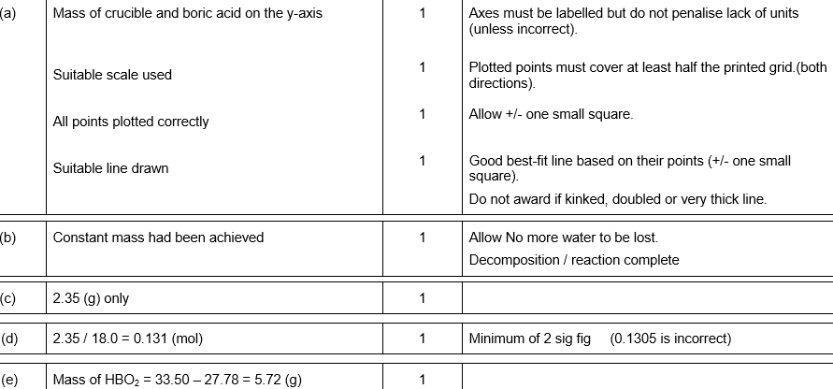
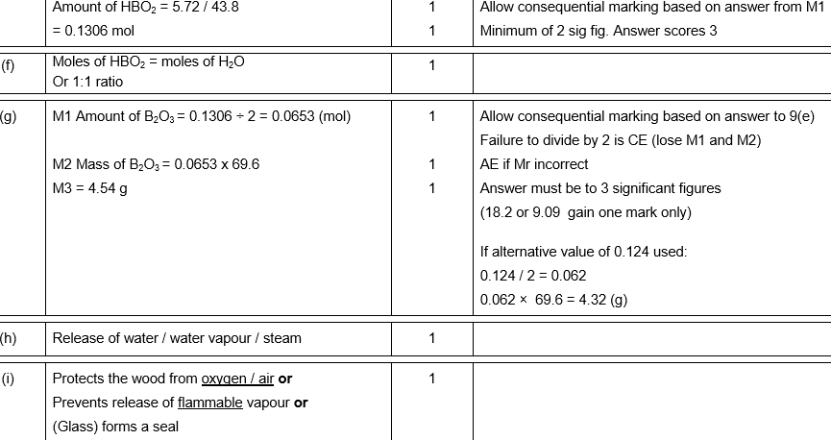[16]
2.
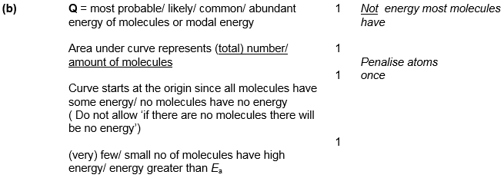
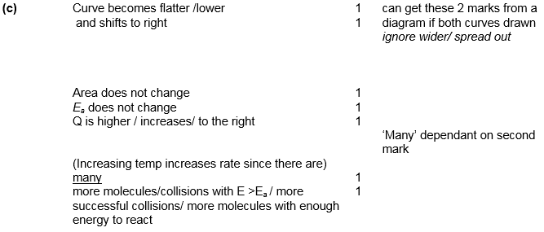
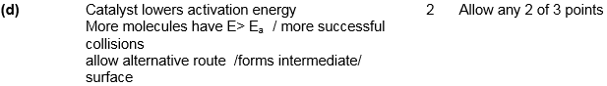
[15]

3. (a) (Different) boiling points
Ignore mp’s, references to imf, different volatilities
1
(b) (i) Compound which have the same molecular formula
Accept same no and type of atom for M1
But If same (chemical) formula M1 = 0 but allow M2
If empirical formula CE = 0/2
1
but different structures/different structural
formulae/different displayed formulae
M2 dependent on M1
1
(ii) 3-methylbut-1-ene
only
ignore commas and hyphens
1
(iii)
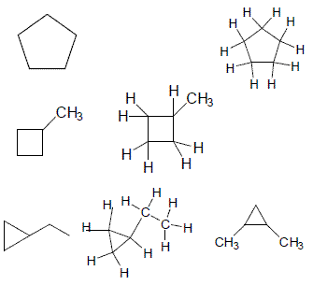
Allow any correct structure with a cyclic alkane
1
Do not allow
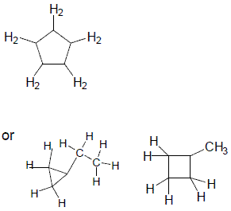
i.e with an H missing on one C

(c) C₁₃H₂₈
only
1
Making plastics/used to make polymers or polythene/used
to make antifreeze/make ethanol/ripening fruit/any named
additional polymer
not used as a plastic/polymer/antifreeze
not just ‘polymers’ – we need to see that they are being made
1
[7]

4. (a) C₁₆H₃₄ + 24.5O₂ → 16CO₂ + 17H₂O
Allow multiples
Ignore state symbols in equation
1
(b) Solidifies/freezes/goes viscous/waxing occurs
Allow does not vapourise/less volatile
Lack of Oxygen = 0
Apply list principle
1
(c) (i) N₂ + O₂ → 2NO
Allow multiples/Ignore state symbols in equation
1
Spark/(very) high temp/2500 °C – 4000 °C
Ignore pressure/catalyst/low % of oxygen
Not just heat/hot
Apply list principle eg if high temp 150 °C = 0
1
(ii) 2CO + 2NO → 2CO₂ + N₂
Allow multiples/Ignore state symbols in equation
OR
C₈H₁₈ + 25NO → 8CO₂ + 12.5 N₂ + 9H₂O
Allow other alkane reacting with NO in correctly balanced equation
OR
C + 2NO → CO₂ + N₂
OR
2NO → N₂ + O₂
1
Pt/Pd/Rh/Ir
Penalise contradiction of name and symbol
1
(iii) 4NO₂ + 2H₂O + O₂ → 4HNO₃
Allow multiples/Ignore state symbols in equation
1

(d) (i) High temp/
anywhere in range 400 °C – 900 °C/
anywhere in range 670-1200K/high pressure/anywhere
in range 5000 kPa up to 8000 kPa/
Not catalyst/heat
1
(ii) C₁₆H₃₄ → C₆H₁₄ + 2C₄H₈ + C₂H₄
Or C₁₆H₃₄ → C₆H₁₄ + C₄H₈ + 3C₂H₄
Do not allow multiples
Ignore state symbols in equation
1
(iii) Polymers/plastics/named polymer
Allow polyesters or polyamides
Ignore object made from polymer
1
[10]

5. (i) C₁₅H₃₂ + 23 O₂ → 15 CO₂ +16 H₂O
Products (1)
Balance (1)
If wrong reactant C.E
(ii) Identity of product: CO or carbon monoxide (1)
Equation: CH₄ + O₂ → CO +2 H₂O (1)
Any balanced equation using CH₄, producing CO
could also make C + CO₂
[4]

6.
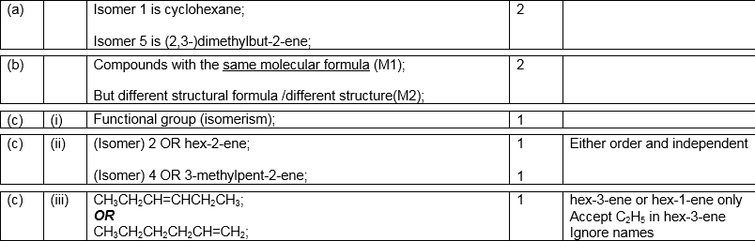
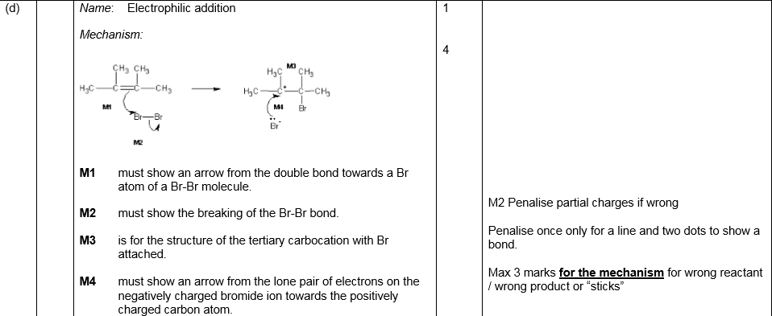
(Total 13 marks)

7.
