AS-LEVEL PAPER 2 PP21 MS
1.
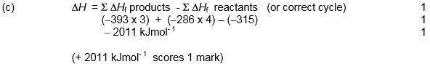
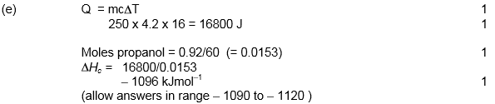
[13]
2.
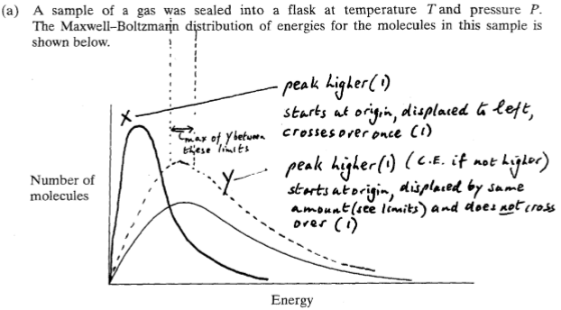
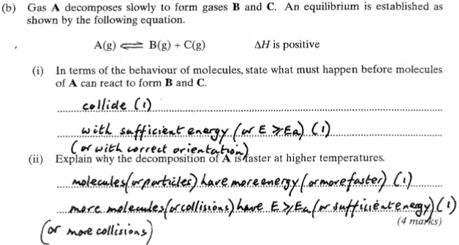
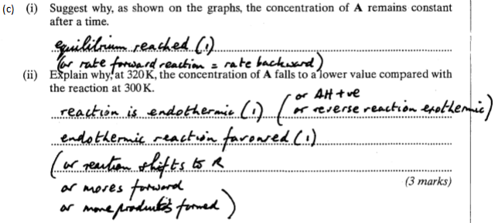[11]
3. (a) (i) C₈H₁₈ + 8 O₂ → 8CO + 9H₂O
Accept multiples
1
(ii) Not enough oxygen or air (available for complete combustion) /lack of oxygen or air / too much octane
Ignore poor ventilation, low temp, poor mixing, incomplete combustion
1

(b) (i) 2CO + 2NO → 2CO₂ + N₂
Allow multiples
1
(ii) Pt / Pd / Rh / Ir or names
Apply list principle
1
Big(ger) surface area / increased reaction rate / removes more of the gases /ensures complete reaction
Allow (ceramic) withstands high temperatures
1
(c) (i) Acid rain
Allow consequence of acid rain
Ignore greenhouse gas / global warming / ozone
1
(ii) CaO/ lime / CaCO₃ /limestone
Allow chemical names
1
Neutralises the gas or words to that effect/it is basic/ SO₂ is acidic
Allow ‘reacts with it’ or ‘it is alkaline’
Ignore ‘absorb’
1
[8]
4.
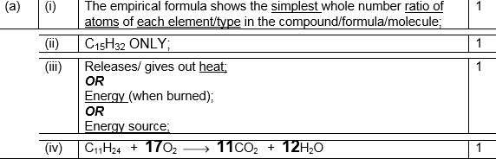
[5]
5.
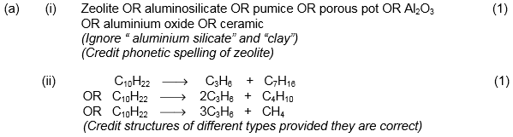
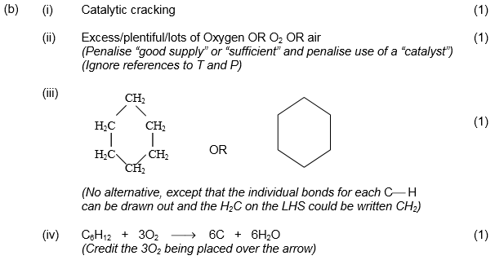
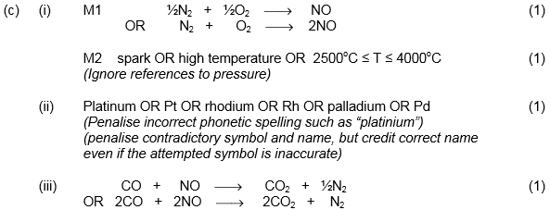 [10]
6.
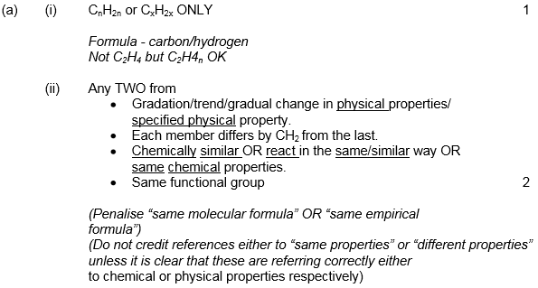

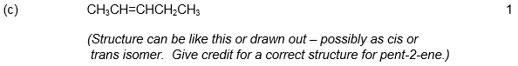
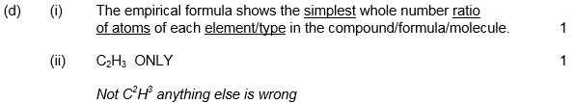
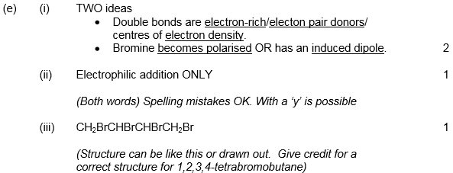 [11]
7.
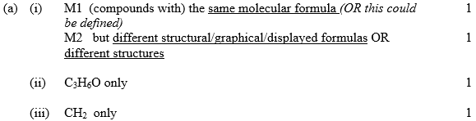
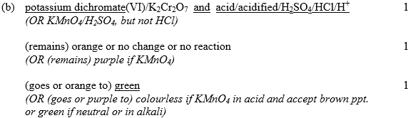
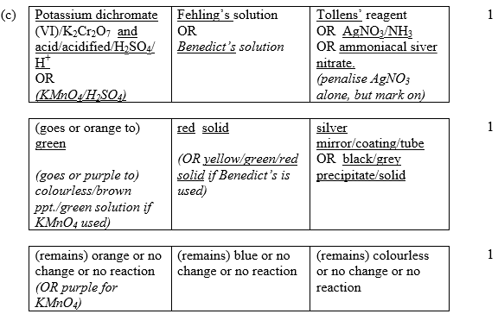
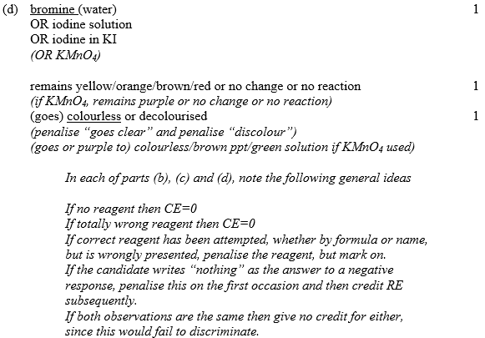 [13]

8.
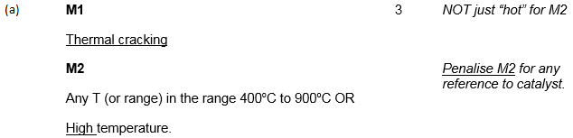
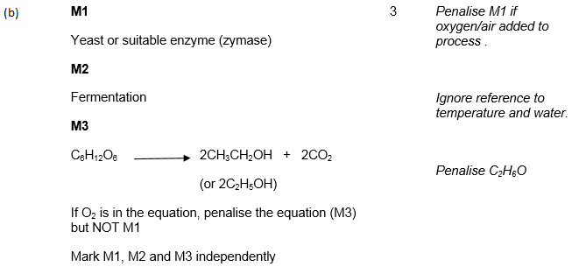
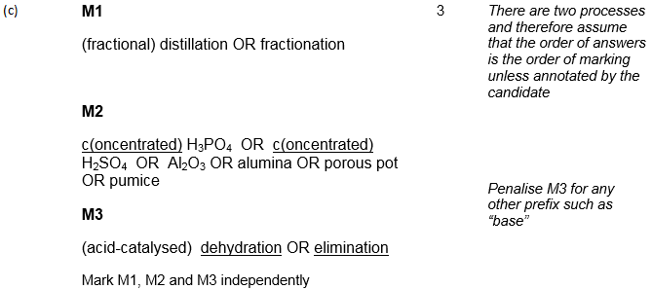
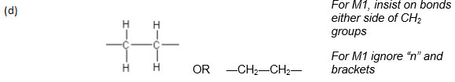 [9]

