AS LEVEL CHEMISTRY

PAPER 2
PRACTICE PAPER 3
Answer all questions
Max 80 marks

Name ……………………………………………………………..

Mark ……../80 ……....% Grade ………

1. The manufacturer supplying concentrated ethanoic acid for the production of vinegar also supplied other acids. The label had come off a batch of one of these other acids.
A sample of this unknown acid was analysed and found to contain 54.5% of carbon and 9.10% of hydrogen by mass, the remainder being oxygen.
(a) Use these data to calculate the empirical formula of the unknown acid.
Show your working.
........................................................................................................................
........................................................................................................................
........................................................................................................................
........................................................................................................................
........................................................................................................................
(3)
(b) A sample of the unknown acid was analysed in a mass spectrometer. The mass spectrum obtained is shown below.
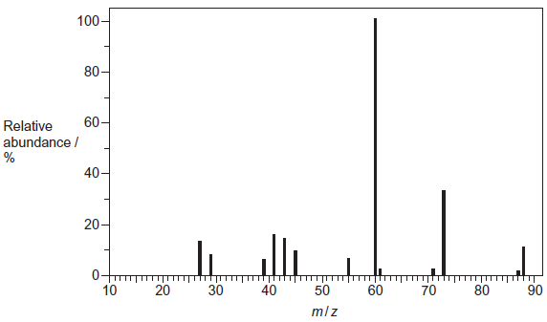
Use the mass spectrum to determine the M_{r} of the unknown acid.
........................................................................................................................
(1)

(c) Use your answers from parts (a) and (b) to determine the molecular formula of the unknown acid.
(If you could not answer part (b), you should assume that the M_{r} of the acid is 132.0 but this is not the correct value.)
Show your working.
........................................................................................................................
........................................................................................................................
(2)
(Total 6 marks)

2. The combustion of hydrocarbons is an important source of energy.
(a) Define the term standard enthalpy of combustion.
......................................................................................................................
......................................................................................................................
......................................................................................................................
(3)
(b) (i) Write an equation for the complete combustion of ethane, C₂H₆.
.............................................................................................................
(ii) Use the standard enthalpies of formation given below to calculate the standard enthalpy of combustion of ethane.

Formula and state of compound | C₂H₆(g) | CO₂(g) | H₂O(l)
Standard enthalpy of formation  (at 298 K)/kJ mol^{–1} | –85 | –394 | –286

.............................................................................................................
.............................................................................................................
.............................................................................................................
(4)
(c) A container and its contents of total heat capacity 120 J K^{–1} were heated using a methane burner. Calculate the maximum theoretical temperature rise when 0.10 g of methane was completely burned. The standard enthalpy of combustion of methane is –890 kJ mol^{–1}.
......................................................................................................................
......................................................................................................................
......................................................................................................................
......................................................................................................................
(4)
(Total 11 marks)
3. The triiodomethane reaction is often used as a test for aldehydes and ketones that contain the CH₃CO group shown.
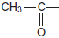
The aldehyde or ketone is reacted with an alkaline solution of iodine. Triiodomethane (CHl₃) is formed as a precipitate. Compounds that contain a group that can be oxidised to the CH₃CO group will also give a positive result in this test.
(a) State, with a reason, whether or not ethanol will give a positive result in the triiodomethane reaction.
........................................................................................................................
........................................................................................................................
........................................................................................................................
(1)
(b) The equation for the reaction of ethanal with an alkaline solution of iodine is
CH₃CHO + 3l₂ + 4NaOH CHl₃ + HCOONa + 3Nal + 3H₂O
In an experiment using this reaction, the yield of triiodomethane (CHl₃) obtained by a student was 83.2%.
Calculate the minimum mass of iodine that this student would have used to form 10.0 g of triiodomethane.
Give your answer to the appropriate precision.
Show your working.
........................................................................................................................
........................................................................................................................
........................................................................................................................
........................................................................................................................
........................................................................................................................
........................................................................................................................
........................................................................................................................
........................................................................................................................
........................................................................................................................
........................................................................................................................
(5)

(c) Triiodomethane can be separated from the reaction mixture by filtration.
State one reason why the solid residue is then washed with water after the filtration.
........................................................................................................................
........................................................................................................................
(1)
(d) State one reason, other than cost or availability, why water is suitable for washing this solid residue after the filtration.
........................................................................................................................
(1)
(Total 8 marks)

4. (a) The reaction of bromine with propane is similar to that of chlorine with methane.
Three steps in the mechanism for the bromination of propane to form 1-bromopropane are shown below.
Step 1 Br₂ 2Br•
Step 2 Br• + CH₃CH₂CH₃ CH₃CH₂CH₂• + HBr
Step 3 CH₃CH₂CH₂• + Br₂ CH₃CH₂CH₂Br + Br•

(i) Name the type of mechanism in this reaction.
.............................................................................................................
(1)
(ii) Give an essential condition for Step 1 to occur.
.............................................................................................................
(1)
(iii) Name the type of step illustrated by Steps 2 and 3.
.............................................................................................................
(1)
(iv) In this mechanism, a different type of step occurs in which free radicals combine. Name this type of step.
Write an equation to show how hexane could be formed from two free radicals in the mechanism of this reaction.
Type of step .......................................................................................
Equation .............................................................................................
(2)
(v) Write an overall equation for the reaction between bromine and propane by the same mechanism to produce octabromopropane (C₃Br₈).
.............................................................................................................
(1)

(b) Bromine reacts with alkenes, even though bromine is a non-polar molecule.
(i) Explain why bromine molecules react with the double bonds in alkenes.
.............................................................................................................
.............................................................................................................
.............................................................................................................
.............................................................................................................
.............................................................................................................
.............................................................................................................
(2)
(ii) Name the type of mechanism involved in this reaction.
.............................................................................................................
(1)
(iii) Draw the structure of the compound with M_{r} = 387.6 formed when penta-1,4-diene (H₂CCHCH₂CHCH₂) reacts with an excess of bromine.

(1)
(c) Two products are formed when propene reacts with hydrogen bromide.
Draw the structure of the intermediate that leads to the formation of the major product in the reaction of propene with hydrogen bromide.
Give the name of this type of intermediate.
Structure of intermediate

Type of intermediate ....................................................................................
(2)
(Total 12 marks)

5. Haloalkanes are used in the synthesis of other organic compounds.
(a) Hot concentrated ethanolic potassium hydroxide reacts with 2-bromo-3-methylbutane to form two alkenes that are structural isomers of each other. The major product is 2-methylbut-2-ene.
(i) Name and outline a mechanism for the conversion of 2-bromo-3-methylbutane into 2-methylbut-2-ene according to the equation.
(CH₃)₂CHCHBrCH₃ + KOH (CH₃)₂C=CHCH₃ + KBr + H₂O
Name of mechanism ...........................................................................
Mechanism

(4)
(ii) Draw the displayed formula for the other isomer that is formed.

(1)
(iii) State the type of structural isomerism shown by these two alkenes.
...............................................................................................................
(1)

(b) A small amount of another organic compound, X, can be detected in the reaction mixture formed when hot concentrated ethanolic potassium hydroxide reacts with 2-bromo-3-methylbutane.
Compound X has the molecular formula C₅H₁₂O and is a secondary alcohol.
(i) Draw the displayed formula for X.
(1)
(ii) Suggest one change to the reaction conditions that would increase the yield of X.
...............................................................................................................
...............................................................................................................
(1)
(iii) State the type of mechanism for the conversion of 2-bromo-3-methylbutane into X.
...............................................................................................................
(1)
(iv) Identify one feature of this infrared spectrum of a pure sample of X that may be used to confirm that X is an alcohol.
You may find it helpful to refer to Table 1 on the Data Sheet.
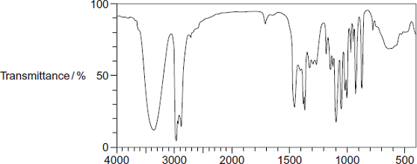
Wavenumber / cm⁻¹
Feature .................................................................................................
...............................................................................................................
(1)
(Total 10 marks)

6.  (a) | 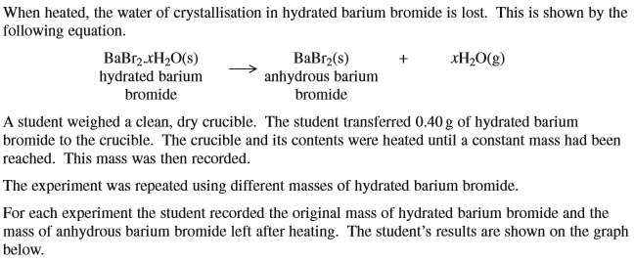  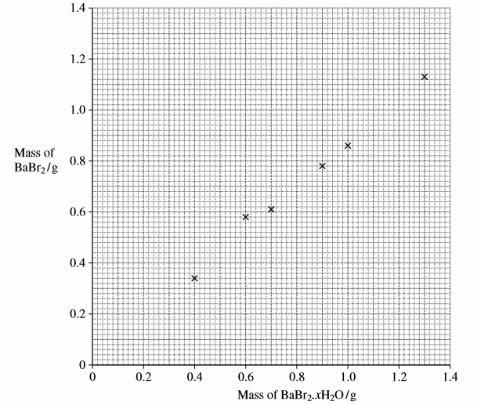  .

(b)  (c)  (d)  (e)  (f) | 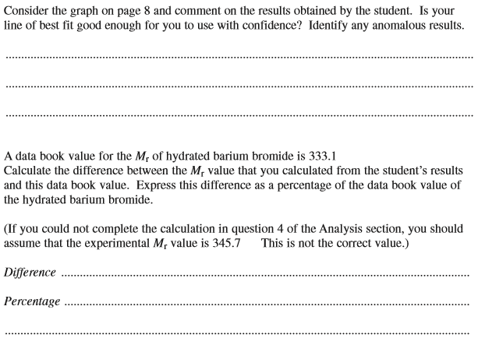

(g)  (h)  (i) | 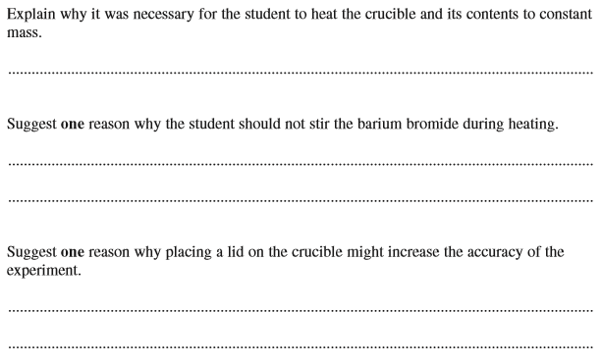  (Total 12 marks)

7. | 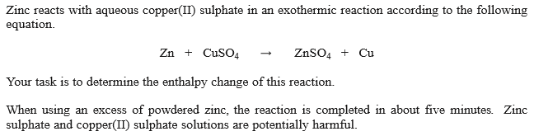

……………………………………………………………………………………………………………………………………………………………………………………………
……………………………………………………………………………………………………………………………………………………………………………………………
……………………………………………………………………………………………………………………………………………………………………………………………
……………………………………………………………………………………………………………………………………………………………………………………………
……………………………………………………………………………………………………………………………………………………………………………………………
……………………………………………………………………………………………………………………………………………………………………………………………
……………………………………………………………………………………………………………………………………………………………………………………………
……………………………………………………………………………………………………………………………………………………………………………………………
……………………………………………………………………………………………………………………………………………………………………………………………
……………………………………………………………………………………………………………………………………………………………………………………………
……………………………………………………………………………………………………………………………………………………………………………………………
……………………………………………………………………………………………………………………………………………………………………………………………
……………………………………………………………………………………………………………………………………………………………………………………………
……………………………………………………………………………………………………………………………………………………………………………………………
……………………………………………………………………………………………………………………………………………………………………………………………
……………………………………………………………………………………………………………………………………………………………………………………………
……………………………………………………………………………………………………………………………………………………………………………………………
……………………………………………………………………………………………………………………………………………………………………………………………
……………………………………………………………………………………………………………………………………………………………………………………………
……………………………………………………………………………………………………………………………………………………………………………………………
……………………………………………………………………………………………………………………………………………………………………………………………
……………………………………………………………………………………………………………………………………………………………………………………………
……………………………………………………………………………………………………………………………………………………………………………………………
……………………………………………………………………………………………………………………………………………………………………………………………
……………………………………………………………………………………………………………………………………………………………………………………………
……………………………………………………………………………………………………………………………………………………………………………………………
……………………………………………………………………………………………………………………………………………………………………………………………
……………………………………………………………………………………………………………………………………………………………………………………………
……………………………………………………………………………………………………………………………………………………………………………………………
……………………………………………………………………………………………………………………………………………………………………………………………
……………………………………………………………………………………………………………………………………………………………………………………………
(Total 8 marks)
8. |  | 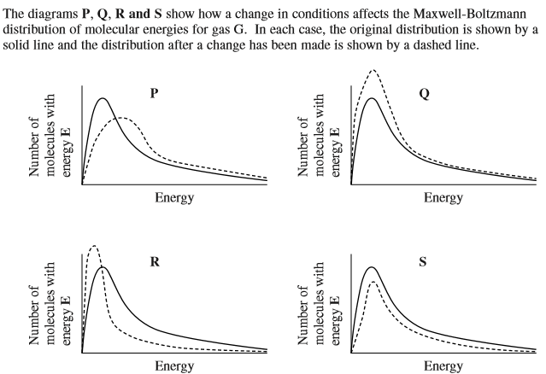  Which of the following statements is correct at constant volume?
 | A | the change shown in diagram P occurs when the temperature is decreased.
 | B | the change shown in diagram Q occurs when a catalyst is used.
 | C | the change shown in diagram R occurs when the temperature is increased.
 | D | the change shown in diagram S occurs in when the pressure of G is decreased at constant temperature.
9. | Which of the following statements is incorrect?
 | A | Carbon monoxide is formed during the incomplete combustion of alkanes.
 | B | A substitution reaction occurs when ammonia reacts with BF₃.
 | C | A substitution reaction occurs when ammonia reacts with CH₃Br.
 | D | 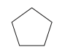is a hydrocarbon which contains 85.7% by mass of carbon.

10. | Which of the following statements is incorrect?
 | A | PCl₅ has at least one bond angle of 90º.
 | B | 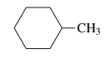is a hydrocarbon which contains 85.7% by mass of carbon.
 | C | 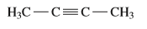 is a hydrocarbon which contains 85.7% by mass of carbon.
 | D | XeF₄ has at least one bond angle of 90º.
11. | Which of the following statements is incorrect?
 | A | a substitution reaction occurs when ammonia reacts with HBr.
 | B | Based on the following equation: ,
 | C | Concentrated sulphuric acid can react with butan-2-ol to produce but-1-ene.
 | D | and are functional group isomers.
12. | 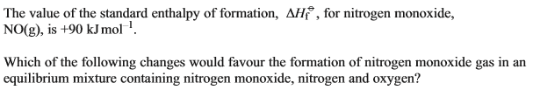
 | A | increasing the temperature
 | B | increasing the pressure
 | C | removing nitrogen gas from the mixture
 | D | adding a catalyst
13. |  | Which of the following statements is correct?
 | A | and are functional group isomers
 | B | The fermentation of glucose is carried out for environmental reasons only
 | C | The catalytic reduction of nitrogen monoxide is carried out for environmental reasons only
 | D | The combustion of methane is carried out for environmental reasons only

14. | 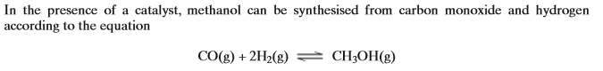  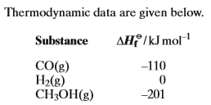  Which of the following changes will not increase the yield of this reaction?
 | A | an increase in pressure.
 | B | liquefying the product.
 | C | the addition of a catalyst
 | D | a decrease in temperature.
15.
 | A | 0.21 mol of magnesium
 | B | 0.19 mol of aluminium
 | C | 0.15 mol of carbon
 | D | 0.075 mol of methane
16. | Which of the statements about the following compound is incorrect?  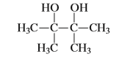
 | A | it does not exhibit geometrical isomerism.
 | B | it has an absorption in the infrared at about 3350 cm⁻¹.
 | C | it can be oxidised with acidified potassium dichromate (VI).
 | D | it can form hydrogen bonds.
17. | 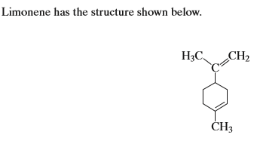  Which of the following statements about limonene is incorrect?
 | A | it has an empirical formula of C₅H₈.
 | B | it has van der Waal’s forces between its molecules.
 | C | one mole of limonene reacts with two moles of hydrogen bromide.
 | D | one mole of limonene requires four moles of hydrogen gas to become completely saturated.
18. | Which one of these molecules does not have a permanent dipole?
 | A | NH₃
 | B | PCl₃
 | C | SCl₂
 | D | SiCl₄
19. | Which of the following statements is incorrect?
 | A | nitriles
 | B
 | C | BCl₃ has one or more lone pairs of electrons on the central atom.
 | D | XeF₄ has one or more lone pairs of electrons on the central atom.
20. | Which of the following statements is correct?
 | A | PF₅ has one or more lone pairs of electrons on the central atom.
 | B | PCl₃ has one or more lone pairs of electrons on the central atom.
 | C | ethane-1,2-diol could be obtained from oxidation of ethanedial by acidified potassium dichromate (VI).
 | D | ethane-1,2-diol could be obtained from acid-catalysed addition of water to ethene.

