AS LEVEL CHEMISTRY

PAPER 2
PRACTICE PAPER 4
Answer all questions
Max 80 marks

Name ……………………………………………………………..

Mark ……../80 ……....% Grade ………

Note – the multiple choice questions used in this paper are recycled from the assessed homeworks, tests and assessment points for the AS-level/1st Year course

1. A scientist used mass spectrometry to analyse a sample of the air near a fertiliser factory. The sample of air included traces of a gas which was shown by its molecular ion to have a precise M_{r} = 44.00105
(a) State the meaning of the term molecular ion.
......................................................................................................................
......................................................................................................................
(1)
(b) (i) Use the following data to show that the trace gas was dinitrogen oxide (N₂O).
Show your working.

Atom | Precise relative atomic mass
¹²C | 12.00000
¹⁴N | 14.00307
¹⁶O | 15.99491

.............................................................................................................
.............................................................................................................
(1)
(ii) Propane is used as a fuel in the fertiliser factory. State why both propane and its combustion product, carbon dioxide, might have been identified as the trace gas if the scientist had used relative molecular masses calculated to one decimal place.
.............................................................................................................
.............................................................................................................
(1)
(iii) State why the precise relative atomic mass for the ¹²C isotope is exactly 12.00000
.............................................................................................................
(1)

(c) Dinitrogen oxide is formed when ammonia is oxidised according to the following equation.
2NH₃(g) + 2O₂(g) → N₂O(g) + 3H₂O(l)
(i) Use the standard enthalpies of formation in the table below to calculate a value for the standard enthalpy change of this reaction.

 | NH₃(g) | O₂(g) | N₂O(g) | H₂O(l)
ΔH_{f}^{ο}/ kJ mol^{–1} | –46 | 0 | +82 | –286
.............................................................................................................
.............................................................................................................
.............................................................................................................
.............................................................................................................
(3)
(ii) State one condition necessary for enthalpies of formation to be quoted as standard values at a specified temperature of 298 K.
.............................................................................................................
(1)
(Total 8 marks)

2. The rate of a chemical reaction is influenced by the size of the activation energy. Catalysts are used to increase the rates of chemical reactions but are not used up in the reactions.
(a) Give the meaning of the term activation energy.
.....................................................................................................................
.....................................................................................................................
.....................................................................................................................
.....................................................................................................................
(2)
(b) Explain how a catalyst increases the rate of a reaction.
.....................................................................................................................
.....................................................................................................................
.....................................................................................................................
.....................................................................................................................
(2)

(c) The diagram below shows the Maxwell–Boltzmann distribution of molecular energies, at a constant temperature, in a gas at the start of a reaction.
On this diagram the most probable molecular energy at this temperature is shown by the symbol E_{mp}
The activation energy is shown by the symbol E_{a}
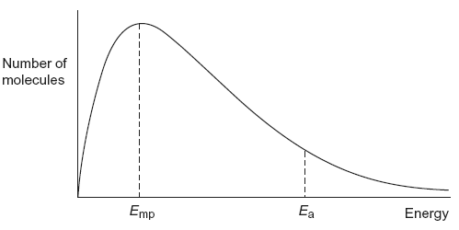
To answer the questions (c)(i) to (c)(iv), you should use the words increases, decreases or stays the same. You may use each of these answers once, more than once or not at all.
(i) State how, if at all, the value of the most probable energy (E_{mp}) changes
as the total number of molecules is increased at constant temperature.
.............................................................................................................
(1)
(ii) State how, if at all, the number of molecules with the most probable energy (E_{mp}) changes as the temperature is decreased without changing the total number of molecules.
.............................................................................................................
(1)
(iii) State how, if at all, the number of molecules with energy greater than the activation energy (E_{a}) changes as the temperature is increased without c hanging the total number of molecules.
.............................................................................................................
(1)
(iv) State how, if at all, the area under the molecular energy distribution curve changes as a catalyst is introduced without changing the temperature or the total number of molecules.
.............................................................................................................
(1)

(d) For each of the following reactions, identify a catalyst and name the organic product of the reaction.
(i) The fermentation of an aqueous solution of glucose.
Catalyst ..............................................................................................
Name of organic product ....................................................................
.............................................................................................................
(2)
(ii) The hydration of but-2-ene.
Catalyst ..............................................................................................
Name of organic product ....................................................................
.............................................................................................................
(2)
(Total 12 marks)

3. Pentane is a member of the alkane homologous series.
(a) Give the general formula for the homologous series of alkanes.
.....................................................................................................................
(1)
(b) One of the structural isomers of pentane is 2,2-dimethylpropane.
Draw the displayed formula of 2,2-dimethylpropane.
State the type of structural isomerism shown.

.....................................................................................................................
(2)

(c) A molecule of hydrocarbon Y can be thermally cracked to form one molecule of pentane and two molecules of ethene only.
Deduce the molecular formula of Y.
State why high temperatures are necessary for cracking reactions to occur.
Give one reason why thermal cracking reactions are carried out in industry.
.....................................................................................................................
.....................................................................................................................
.....................................................................................................................
.....................................................................................................................
.....................................................................................................................
.....................................................................................................................
(3)
(d) Write an equation for the incomplete combustion of pentane to form a solid pollutant.
Suggest why this solid pollutant is an environmental problem.
.....................................................................................................................
.....................................................................................................................
.....................................................................................................................
.....................................................................................................................
(2)
(e) Pentane can react with chlorine as shown in the following equation.
C₅H₁₂ + Cl₂ → C₅H₁₁Cl + HCl
Calculate the percentage atom economy for the formation of C₅H₁₁Cl
Deduce how many straight-chain isomers of C₅H₁₁Cl could be formed.
.....................................................................................................................
.....................................................................................................................
.....................................................................................................................
.....................................................................................................................
.....................................................................................................................
(3)

(f) Consider the following compound.
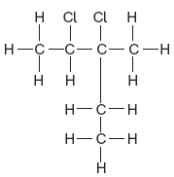
Name this compound.
Deduce the empirical formula of this compound.
.....................................................................................................................
.....................................................................................................................
.....................................................................................................................
.....................................................................................................................
(2)
(Total 13 marks)

4. Consider the following reaction schemes involving two alcohols, A and B, which are position isomers of each other.
CH₃CH₂CH₂CH₂OH → CH₃CH₂CH₂CHO → CH₃CH₂CH₂COOH
A butanal butanoic acid
CH₃CH₂CH(OH)CH₃ → CH₃CH₂COCH₃
B C
(a) State what is meant by the term position isomers.
......................................................................................................................
......................................................................................................................
......................................................................................................................
(2)
(b) Name compound A and compound C.
Compound A ...............................................................................................
Compound C ................................................................................................
(2)

(c) Each of the reactions shown in the schemes above is of the same type and uses the same combination of reagents.
(i) State the type of reaction.
.............................................................................................................
(ii) Identify a suitable combination of reagents.
.............................................................................................................
(iii) State how you would ensure that compound A is converted into butanoic acid rather than into butanal.
.............................................................................................................
.............................................................................................................
(iv) Draw the structure of an isomer of compound A which does not react with this combination of reagents.

(v) Draw the structure of the carboxylic acid formed by the reaction of methanol with this combination of reagents.

(6)
(d) (i) State a reagent which could be used to distinguish between butanal and
compound C.
.............................................................................................................
(ii) Draw the structure of another aldehyde which is an isomer of butanal.

(2)
(Total 12 marks)

5. Zinc reacts with aqueous copper (II) sulphate as shown by the following equation
Zn + CuSO₄ ZnSO₄ + Cu
A student weighed out 1.25 g of zinc dust. Using a pipette, the student then measured out 50.0 cm³ of a 0.400 moldm⁻³ solution of copper (II) sulphate and transferred it to a plastic cup, which was placed in a beaker to provide insulation. A thermometer was mounted in the cup using a clamp and stand. The bulb of the thermometer was fully immersed in the liquid.

The student recorded the temperature of the liquid in the cup every minute, stirring the liquid before reading the temperature. At the fourth minute the student added zinc, but did not record the temperature. The student stirred the mixture thoroughly, then recorded the temperature at the fifth minute. The student then continued stirring and recording the temperature at minute intervals for seven more minutes.
The student’s results are shown on the graph.

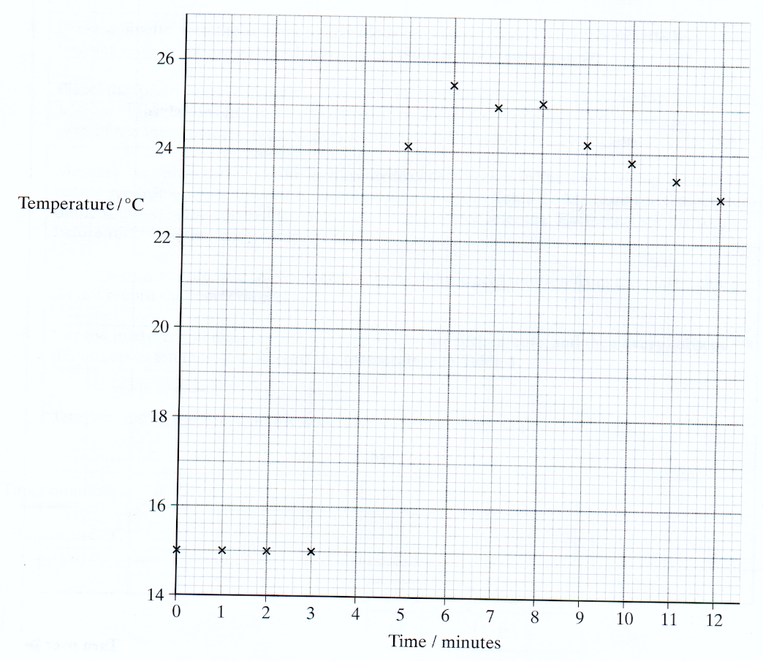
(a) Draw a line of best fit for the points before the fourth minute and a second line for the points after the forth minute. Extrapolate both lines to the fourth minute, and hence determine the temperature rise which would have occurred at the fourth minute.
Temperature rise from graph after extrapolation………………. ºC
(b) Use the temperature rise form your graph to calculate the heat given out during this experiment. Assume that the solution has a density of 1.00 gcm⁻³ and has a specific heat capacity of 4.18 JK⁻¹g⁻¹.
………………………………………………………………………………………………………………
………………………………………………………………………………………………………………

(c) Calculate the number of moles of zinc present in 1.25 g

……………………………………………………………………………………………………………….
(d) Calculate the number of moles of copper (II) sulphate present in 50.0 cm³ of 0.400 moldm⁻³ solution.

……………………………………………………………………………………………………………….
(e) Calculate the molar enthalpy change for the reaction between zinc and copper (II) sulphate.

……………………………………………………………………………………………………………….
(f) Assume that the maximum errors for the apparatus used in the experiment were
balance +- 0.01 g
50 cm³ pipette +- 0.1 cm³
thermometer +- 0.1ºC

Calculate the maximum percentage error in using each piece of apparatus and hence the overall apparatus error. Use the temperature rise from the graph to calculate the error in using the thermometer.
……………………………………………………………………………………………………………….
……………………………………………………………………………………………………………….
……………………………………………………………………………………………………………….
……………………………………………………………………………………………………………….
(g) Comment on the quality of the student’s results
……………………………………………………………………………………………………………….
……………………………………………………………………………………………………………….

(h) The data value for the molar enthalpy change –219 KJmol⁻¹. Calculate the difference between the student’s value and this data book value. Express this difference as a percentage of the data book value. (If you could not complete the calculation you should assume that the student’s enthalpy change is –135 KJmol⁻¹. This is not the correct value).

Difference………………………………………………………………………

Percentage………………………………………………………………………

(i) Identify the main source of error in this experiment. Suggest one improvement to minimise this main source of error.

……………………………………………………………………………………………………………….
……………………………………………………………………………………………………………….
……………………………………………………………………………………………………………….
……………………………………………………………………………………………………………….

(j) Identify one other source of error in this experiment. Suggest one improvement to minimise this other source of error.

……………………………………………………………………………………………………………….
……………………………………………………………………………………………………………….
……………………………………………………………………………………………………………….
……………………………………………………………………………………………………………….
(Total 12 marks)
6.
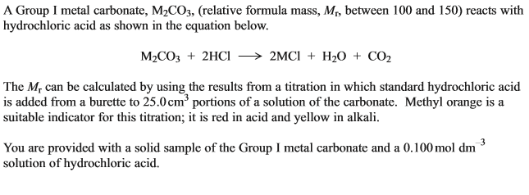
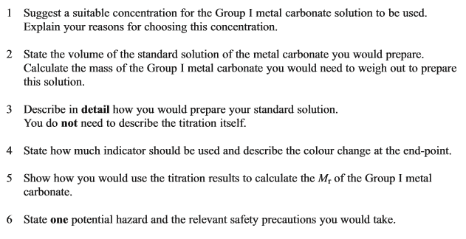
……………………………………………………………………………………………………………….
……………………………………………………………………………………………………………….
……………………………………………………………………………………………………………….
……………………………………………………………………………………………………………….
……………………………………………………………………………………………………………….
……………………………………………………………………………………………………………….
……………………………………………………………………………………………………………….
……………………………………………………………………………………………………………….
……………………………………………………………………………………………………………….
……………………………………………………………………………………………………………….
……………………………………………………………………………………………………………….
……………………………………………………………………………………………………………….
……………………………………………………………………………………………………………….
……………………………………………………………………………………………………………….
……………………………………………………………………………………………………………….
……………………………………………………………………………………………………………….
……………………………………………………………………………………………………………….
……………………………………………………………………………………………………………….
……………………………………………………………………………………………………………….
……………………………………………………………………………………………………………….
……………………………………………………………………………………………………………….
……………………………………………………………………………………………………………….
……………………………………………………………………………………………………………….
……………………………………………………………………………………………………………….
……………………………………………………………………………………………………………….
……………………………………………………………………………………………………………….
……………………………………………………………………………………………………………….
……………………………………………………………………………………………………………….
……………………………………………………………………………………………………………….
……………………………………………………………………………………………………………….
……………………………………………………………………………………………………………….
……………………………………………………………………………………………………………….
……………………………………………………………………………………………………………….
……………………………………………………………………………………………………………….
……………………………………………………………………………………………………………….
……………………………………………………………………………………………………………….
……………………………………………………………………………………………………………….
……………………………………………………………………………………………………………….
(Total 8 marks)

7. Which of the following statements is incorrect?
A ethane-1,2-diol could be obtained from reaction of bromine with ethene followed by alkaline hydrolysis.
B
C water and ethane-1,2-diol cannot be distinguished in their infra-red spectra above 1600 cm⁻¹.
D the reaction of chlorine with hexane to make a chlorohexane involves free radicals.
8.
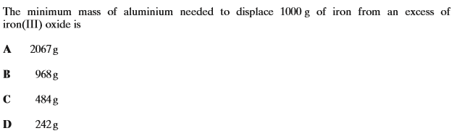

9.
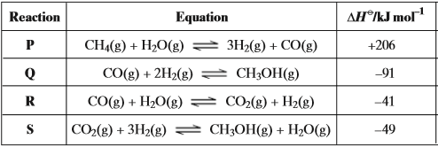
A Reaction P and Reaction R
B Reaction Q and Reaction S
C Reaction P and Reaction S
D Reaction Q and Reaction R

10. Which of the following is not a hazard associated with the process in Question 9?
A methanol is a corrosive acid.
B methane gas can form an explosive mixture with air.
C carbon monoxide is a poisonous gas.
D hydrogen is a flammable gas.

11. An ester is hydrolysed as shown by the following equation.
RCOOR/ + H₂O RCOOH + R/OH
What is the percentage yield of RCOOH when 0.50 g of RCOOH (M_{r} = 100) is obtained from 1.0 g of RCOOR/ (M_{r} = 150)?
A 33%
B 50%
C 67%
D 75%
(Total 1 mark)

12. How many isomers have the molecular formula C₅H₁₂?
A 2
B 3
C 4
D 5
(Total 1 mark)

13. Which molecule is not produced when ethane reacts with bromine in the presence of ultraviolet light?

 | A | C₂H₄Br₂
 | B | HBr
 | C | H₂
 | D | C₄H₁₀

(Total 1 mark)

14. How many structural isomers have the molecular formula C₄H₉Br?
A 2
B 3
C 4
D 5
(Total 1 mark)

15. What is the major product of the reaction between but-1-ene and DBr?
(D is deuterium and represents ²H)
A CH₂DCH₂CH₂CH₂Br
B CH₂DCH₂CHBrCH₃
C CH₃CH₂CHBrCH₂D
C CH₃CH₂CHDCH₂Br
(Total 1 mark)

16. Why are fluoroalkanes unreactive?
A Fluorine is highly electronegative.
B The F– ion is very stable.
C They are polar molecules.
D The C–F bond is very strong.
(Total 1 mark)

17. Which one of the following has a shape which is not influenced by a lone pair of electrons?
A CH₃OH
B H₂F⁺
C BF₃
D NF₃
(Total 1 mark)

18. Which one of the following bond polarities is not correct?
A in ethane
B in bromoethane
C in ethanol
D in ethanal
(Total 1 mark)

19.
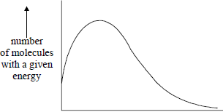
energy
The total area under the distribution curve represents
A total energy.
B activation energy.
C total number of reacting molecules.
D total number of molecules present.
(Total 1 mark)

20. The structure of the molecule of methyl 2-methylpropenoate is shown below.
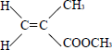
Which one of the following statements concerning this compound is not true?
A It displays geometrical isomerism.
B It forms an addition polymer.
C It undergoes reduction.
D It decolourises bromine.
(Total 1 mark)

21. The number of structural isomers of molecular formula C₄H₉Br is
A 5
B 4
C 3
D 2
(Total 1 mark)

