CHEMISTRY HONORS HOMEWORK 5.1 – ACIDS, BASES, SALTS AND NEUTRALIZATION

1. | Complete the following table:  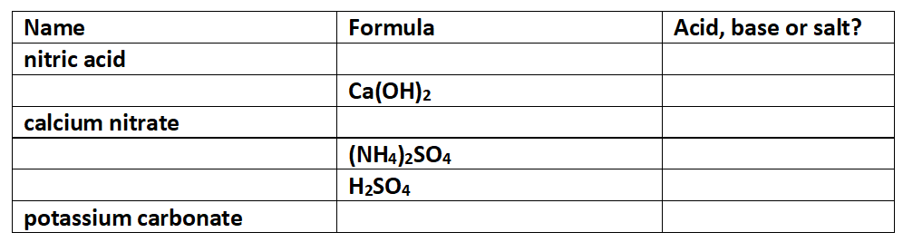 |  | /6
2. | Write balanced equations, with state symbols, for the following reactions:
 | (a) | magnesium hydroxide powder with dilute hydrochloric acid | /3
 | (b) | dilute sulfuric acid with sodium carbonate solution | /3
 | (c) | Ammonia solution with dilute nitric acid | /3
3. | (a) | Describe what you would see as reaction 2 (a) was taking place. | /2
 | (b) | State a useful application of reaction 2 (a). | /1
 | (c) | Explain how you would prepare a pure sample of the salt produced in reaction 2 (a). | /3
 | (d) | Explain why it is much easier to produce a pure sample of salt from reaction 2 (a) than from reactions 2 (b) or 2 (c) | /2

4. | In terms of the concentration of H⁺ and OH⁻ ions, explain what it meant by the terms:  acidic solution …………………………………………………………………………………………………………………………….  alkaline solution ………………………………………………………………………………………………………………………….  neutral solution …………………………………….……………………………………………………………………………………. |  | /3
5. | (a) | What is the concentration of H⁺ ions in a solution with a pH of 5? | /1
 | (b) | What is the pH of a solution containing an OH⁻ concentration of 1 x 10⁻⁴ mol/L? | /2
 | (c) | What is the hydrogen ion concentration and the hydroxide ion concentration in a solution with a pH of 12?  H⁺ concentration: …………..…….. mol/L OH⁻ concentration: ……………..…….. mol/L | /2
TOTAL |  |  | /30

