DEPARTMENT OF CHEMISTRY
FOURAH BAY COLLEGE
UNIVERSITY OF SIERRA LEONE

CHEM 213

INORGANIC CHEMISTRY III

(Unit 1 only)

CREDIT HOURS | 2.0
MINIMUM REQUIREMENTS | Pass in CHEM 122
REQUIRED FOR | CHEM 221

UNIT 1 – FURTHER ATOMIC STRUCTURE AND BONDING
Course Outline: | Wave-particle duality: what are the typical properties of particles? What are the typical properties of waves? How do waves show particle properties? How do particles show wave properties? What is the Heisenberg uncertainty principle and what is the de Broglie wavelength?  Atomic Structure: What are atomic emission spectra? How can the wavelengths of the radiation in the emission spectrum of hydrogen be calculated? What was Bohr’s quantisation postulate and how can we use it to derive the Rydberg constant? What are the limitations of the Bohr model? How did de Broglie and Sommerfeld develop the Bohr model? What is the Schrodinger equation, how is it derived and what are its solutions?  Bonding: What factors determine bond energies and bond lengths? What is valence bond theory? What is hybridisation? How can we predict the electronic structure of simple molecules? What is the link between bond energy and bond length? What is molecular orbital theory? What are bonding and antibonding orbitals? What are molecular orbital diagrams and how are they constructed? How can molecular orbital diagrams be used to predict bond orders and compare bond lengths and bond energies? How can molecular orbital diagrams be used to predict magnetic properties of molecules? What is resonance and why does it exist?
Lesson 1: | Waves, particles, photons and photoelectric effect
Lesson 2: | Wave-Particle Duality of Matter
Lesson 3: | The Bohr model, the Rydberg constant and emission spectra
Lesson 4: | The development of the atomic model from Bohr to Schrodinger
Lesson 5: | Deriving and Solving the Schrodinger Equation
Lesson 6: | Bond energies, and bond lengths, valence bond theory and hybridisation
Lesson 7: | Molecular orbital theory and diagrams
Lesson 8: | Using molecular orbital diagrams
Lesson 9: | Resonance

Lessons 1 and 2

- Wave-Particle Duality of Matter

- Particles are discrete objects with mass (m) and velocity v; they have kinetic energy (½mv²), momentum (mv) and angular momentum mvr and should obey Newton’s Laws of motion

- Waves are vibrating disturbances by which energy is transmitted; waves have an amplitude (A), a frequency (f), a wavelength (λ) and a speed (v); v = fλ; electromagnetic waves travel at the speed of light, c, so c = fλ; waves undergo diffraction

- Evidence that waves have particle-like properties came from:
- Planck: particles cannot emit arbitrary amounts of energy, but only specific packets called photons; the energy of each photon is given by E = hf; the phenomenon is known as the quantisation of energy
- Einstein: in the photoelectric effect; energy must be above a certain energy per photon to remove an electron from a metal; this energy is needed to overcome each electron’s binding energy; any excess energy is given to the electron as KE (hf = BE + KE)
- Compton: the wavelength of light increased when it interacted with a free electron; the change in wavelength (and loss of energy) was consistent with the conservation of energy and momentum to be expected from a collision between two particles
- Maxwell: photons behave as if they have momentum (p) = $\frac{hf}{c}$ = $\frac{h}{λ}$; the change in momentum expected from the Compton effect is consistent with the observed change in wavelength

- Evidence that particles have wave-like properties came from:
- Davisson-Germer (and also Thomson) experiment, which produced a diffraction pattern from a beam of electrons, proving the particles such as electrons had wave-like properties
- Heisenberg: developed the uncertainty principle; the minimum uncertainty in deducing both the position (x) and momentum (p) of a particle: $ΔpΔx≥\frac{h}{4π}$; this means that it is not possible to know the precise position and momentum of a particle at the same time

- de Broglie formalised the wave-particle duality of matter by applying Maxwell’s equation to particles:
momentum p = mv = $\frac{h}{λ}$ so λ = $\frac{h}{mv}$; this is the de Broglie wavelength and is consistent with the wavelength observed by Davisson, Germer and Thomson

Lesson 3

- Development of the atomic model post-Rutherford

- In the Rutherford model of the atom, the electrons cannot be static or they would fall into the nucleus; furthermore, Rutherford’s model contained no consideration of quantisation, but the fact that atoms produce line spectra, rather than continuous spectra, suggests that electrons can only occupy certain fixed energy levels; in other words they are quantised

- When subjected to radiation, electrons may move from their ground state into an excited state; when returning to their ground state or another lower energy state they will emit radiation corresponding to ΔE; the emission spectrum of the hydrogen atom results in various spectral series, the Lyman series is the series of transitions down to n = 1; the Balmer series is the series of transitions down to n = 2; the Paschen, Brackett and Pfund series are the series of transitions down to n = 3, 4 and 5 respectively; the wavelength of these transitions is given by $\frac{1}{λ}= R_{H}\left(\frac{1}{n_{f}^{2}}-\frac{1}{n_{i}^{2}}\right)$, where R_{H} is the Rydberg constant

- Bohr explained his model of the hydrogen atom by postulating that the angular momentum was quantised and had to be a whole number multiple of $\frac{h}{2π}$, so mvr = $\frac{nh}{2π}$
- Firstly, combine the centripetal law (F = $\frac{mv^{2}}{r}$) (1) with the law of electrostatic attraction (F = $\frac{q_{1}q_{2}}{{4πε_{0}r}^{2}}$ = $\frac{ze^{2}}{{4πε_{0}r}^{2}}$) (2) to get two expressions:
- r in terms of v r = $\frac{ze^{2}}{4πε_{0}mv^{2}}$ (3)
- KE = $\frac{mv^{2}}{2}$ (4) in terms of r KE = $\frac{mv^{2}}{2}$ = $\frac{ze^{2}}{8πε_{0}r}$ (5)
- Then take Bohr’s postulate (mvr = $\frac{nh}{2π}$) (6 and 7) to it and rearrange to get a quantised expression for v in terms of r: v = $\frac{nh}{2πmr}$ (8)
- Then substitute (8) into (3) to get a quantised expression for r in terms of fundamental constants:
r = $\frac{n^{2}h^{2}ε_{0}}{e^{2}zπm}$ (9)
- The total energy of an electron E = KE + PE (10); combine (5) (KE = $\frac{ze^{2}}{8πε_{0}r}$) and the expression for PE in an electrostatic field (PE = - $\frac{ze^{2}}{4πε_{0}r}$) (11) to get an expression for the total energy of an orbiting electron in terms of r: E = $\frac{ze^{2}}{8πε_{0}r}$ - $\frac{ze^{2}}{4πε_{0}r}$ = - $\frac{ze^{2}}{8πε_{0}r}$ (12)
- Substitute (9) into (12) to get an expression for E in terms of fundamental constants:
E = - $\frac{z^{2}e^{4}m}{8ε_{0}^{2}h^{2}}$($\frac{1}{n^{2}}$) (13)
- The energy of an emitted photon is the difference in energies of the two states E₂ – E₁ = ΔE (14)
ΔE = - $\frac{z^{2}e^{4}m}{8ε_{0}^{2}h^{2}}$($\frac{1}{n_{f}^{2}}$) + $\frac{z^{2}e^{4}m}{8ε_{0}^{2}h^{2}}$($\frac{1}{n_{i}^{2}}$) = $\frac{z^{2}e^{4}m}{8ε_{0}^{2}h^{2}}\left( \frac{1}{n_{i}^{2}} – \frac{1}{n_{f}^{2}}\right)$ (15)
- The wavelength of an emitted photon is given by the expression ΔE = $\frac{hc}{λ}$, so $\frac{1}{λ}$ = $\frac{ΔE}{hc}$ (16)
- Substituting (15) into (16) gives $\frac{1}{λ}$ = $\frac{z^{2}e^{4}m}{8ε_{0}^{2}h^{3}c}\left( \frac{1}{n_{i}^{2}} – \frac{1}{n_{f}^{2}}\right)$ so R_{H} = $\frac{z^{2}e^{4}m}{8ε_{0}^{2}h^{3}c}$ = 1.1 x 10⁷ m⁻¹

- This value of R_{H}, based on five fundamental constants, can account for the emission spectrum of hydrogen to within 0.5%

- but Bohr couldn’t explain why only certain energy states were permitted, nor the fine structure of spectral lines for atoms with more than one electron (Bohr’s model only had principal quantum numbers)

- Sommerfeld adapted Bohr’s model by suggesting that more than one value of angular momentum was possible for electrons with the same principal quantum number, by introducing the possibility of elliptical orbits; he introduced azimuthal (or angular momentum) quantum numbers

- De Broglie explained quantisation by comparing an electron to a standing wave around a nucleus; the circumference of the orbit must be an integer multiple of the wavelength for the wave to sustain itself

- If an electron has wave properties, it must be described by a wave equation, or wavefunction (ψ), which describes how the amplitude of a wave varies in space; the wavefunction for an electron in an atom was successfully developed by Schrodinger in 1926 and is called the Schrodinger equation; the Schrodinger can accurately predict the energies and shapes of atomic orbitals

Lessons 4 and 5
- The Schrodinger Equation

- Schrodinger considered the electron to be a standing wave; three-dimensional harmonic standing waves satisfy the differential equation: $∇$²ψ = -$\frac{{4π}^{2}}{λ^{2}}$ ψ

- Schrodinger combined this equation with:
- The de Broglie equation: substituting λ with the de Broglie wavelength gives
$∇$²ψ = - $\frac{4π^{2}m^{2}v^{2}}{h^{2}}$ ψ
- a classical particle expression for energy
E = PE + KE, but KE = $\frac{mv^{2}}{2}$ and in a one electron atom, PE = - $\frac{ze^{2}}{4πε_{0}r}$
So E = - $\frac{ze^{2}}{4πε_{0}r}$ + $\frac{mv^{2}}{2}$ so v² = $\frac{2\left(E + \frac{ze^{2}}{4πε_{0}r}\right)}{m}$

Substituting v² into the standing wave equation gives the Schrodinger equation for a single-electron atom:
$∇$²ψ = - $\frac{8π^{2}m}{h^{2}}$ (E + $\frac{ze^{2}}{4πε_{0}r}$)ψ or $∇$²ψ + $\frac{8π^{2}m}{h^{2}}$ (E + $\frac{ze^{2}}{4πε_{0}r}$)ψ = 0

- In summary, a single electron with mass m and charge e around a nucleus of charge z+ will have standing wave associated with it which can be describe by the wavefunction ψ; ψ describes position of the electron in space and has a radial component (which describes the distance from the nucleus) and an angular component (which describes the orientation with respect to the nucleus)

- Solving the Schrodinger equation in three dimensions using polar coordinates (r, θ, φ) results in three types of quantum number, one for each of the variables; this in turn gives a number of permitted wavefunctions for each atom; these permitted functions are called eigenfunctions and they describe the position of the electron in space in terms of r (radial component), θ and φ (angular component); each eigenfunction therefore describes a particular atomic orbital; the energy associated with the electron in each eigenfunction is called the eigenvalue

- The quantum numbers are:

Quantum number | Describes | Possible values | Also known as
Principal (n) | The main energy level | Any integer  n = 1, 2, 3 etc | energy level or shell
Angular momentum (l) | The shape of the orbital | Any integer up to n-1  If n = 1, l = 0 (s)  If n = 2, l = 0 (s) or 1 (p) | s, p and d orbitals
Magnetic quantum number (m_{l}) | The number of each orbital type and their orientation | Any integer between -l and l inclusive  If l = 0, m_{l} = 0  If l = 1, m_{l} = -1, 0 or 1 | p_{x}, p_{y} and p_{z} orbitals

- The magnitude of ψ is the amplitude of the wavefunction, so the value of ψ² is the intensity, or the probability of finding an electron in a particular space and is a more convenient way of representing the wavefunction visually; the integral of ψ² across all three dimensions should be equal to 1

- Solving the Schrodinger equation for single-electron atoms gives the same Eigenvalues as predicted by Bohr

- The potential energy is a more complex function for atoms with two electrons:
U =$\frac{1}{4πε_{0}}$(- $\frac{Ze^{2}}{r_{1}}$ - $\frac{Ze^{2}}{r_{2}}$ + $\frac{e^{2}}{r_{1}r_{2}}$); the Schrodinger equation cannot be solved for polyelectronic atoms as these variables cannot be separated; but approximations can be made to provide approximate solutions

- Orbitals with the same energy are said to be degenerate

- A node is region in space in which Ψ = 0, and so there is zero probability of finding an electron there; s-orbitals do not have nodes other than at infinite distance from the nucleus; all other orbitals have nodes

Lesson 6

- Covalent Bonding

- Bond length and bond energy

- Potential energy decreases as attraction between nuclei and electrons outweighs repulsion between electrons and nuclei; the potential energy reaches a minimum at the most stable internuclear distance; below this distance repulsion dominates, minimum energy is most stable internuclear distance; this distance is the bond length and the potential energy at this distance is the bond energy
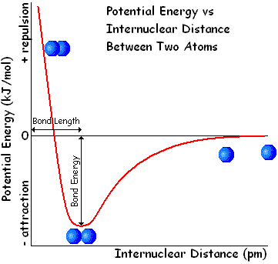

- Valence bond theory

- Valence bond theory considers bonds as molecular orbitals formed by overlapping atomic orbitals; like an atomic orbital, a molecular orbital can only contain two electrons, so is formed either by two singly occupied orbitals overlapping (normal covalent bond) or by a fully occupied orbital overlapping with an empty orbital; in some cases, atoms will promote paired electrons into empty orbitals in order to increase bonding capacity, which in turn should decrease potential energy

- The most stable overlap is direct overlap along the internuclear axis but it is only possible to place one molecular orbital here; this is known as a σ-bond; indirect overlap is also possible; above and below or either side of the internuclear axis (ie in the xy and xz planes if the internuclear axis is x) these are known as π-bonds; up to two π-bonds can form between the same two atoms in addition to a σ-bond

- The bond order is the number of covalent bonds formed between two atoms:

Bond order | Types of bond
1 | 1 x σ
2 | 1 x σ and 1 x π
3 | 1 x σ and 2 x π

- σ-bonds can be formed by the head-on overlap of s, p or d orbitals; the orientation of s, p and d orbitals around an atom is not conducive to arranging the bonds in space according to VSEPR theory, so all occupied atomic orbitals not in core energy levels and not involved in π-bonding undergo hybridisation as follows:
- s-orbital + p-orbital 2 x sp orbitals (linear arrangement; 180º)
- s-orbital + 2 x p-orbital 3 x sp² orbitals (trigonal planar arrangement; 120º)
- s-orbital + 3 x p-orbital 4 x sp³ orbitals (tetrahedral arrangement; 109.5º) 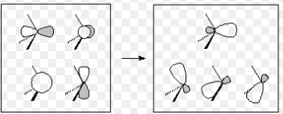
- s-orbital + 3 x p-orbital + d-orbital 5 x sp³d orbitals (trigonal bipyramidal arrangement; 90º and 120º)
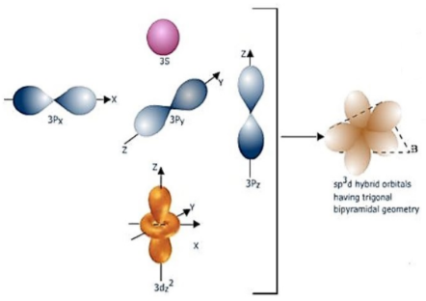
- s-orbital + 3 x p-orbital + 2 x d-orbital 6 x sp³d² orbitals (octahedral arrangement; 90º)
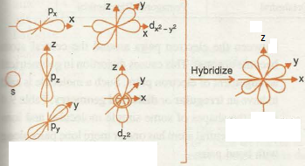

- π-bonds can be formed by the sideways overlap of p or d orbitals; s orbitals and hybridised orbitals do not have the correct geometry for π-bond formation so any p or d orbitals involved in π-bond formation must remain unhybridised

- The angle between hybridised orbitals assumes that all electron pairs are equidistant from the nucleus of the central atom and so repel equally; lone pairs are the closest so repel the most, followed by electron pairs in bonds with less electronegative atoms, followed by electron pairs in bonds with equally electronegative atoms, followed by electron pairs in bonds with more electronegative atoms; these may result in bond angles being slightly more or less than the angle in the regular arrangement
Lessons 7 and 8

- Molecular orbital theory

- Valence bond theory is able to explain some molecular properties but not all; a better theory is molecular orbital theory; consider atomic orbitals as waves – they can overlap constructively or destructively to form molecular orbitals; two atomic orbitals overlap to form a bonding orbital (constructive) and an antibonding orbital (destructive)

- Head on overlap by s or p_{x} orbitals produces a σ-orbital (bonding) and a σ*-orbital (anti-bonding):
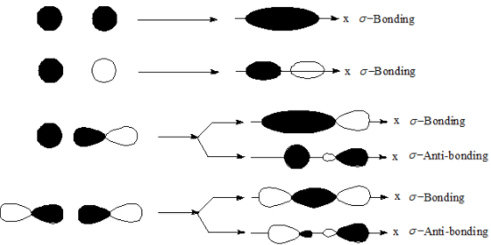

- Sideways overlap by p_{y} and p_{z} orbitals produces a π-orbital (bonding) and a π*-orbital (anti-bonding):
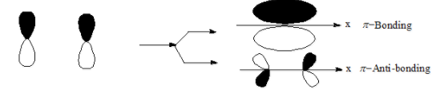

- Electrons fill molecular orbitals according to the Aufbau principle, in the same way as they would fill atomic orbitals

- H₂, He₂, H₂⁺, H₂⁻, He₂⁺ all use σ_{1s} and σ*_{1s} only:
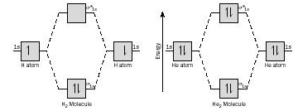

- In homonuclear diatomic molecules of Period 2 atoms, the σ_{1s} and σ*_{1s} molecular orbitals are filled first; the energies of the remaining orbitals might be expected to be: σ_{2s} < σ*_{2s} < σ_{2px} < π_{2py} = π_{2pz} < π*_{2py} = π*_{2pz} < σ*_{2px}
There is some hybridisation of the 2s and 2p_{x} orbitals, which has the effect of lowering the energy of σ_{2s} and σ*_{2s} and increasing the energy of σ_{2px} and σ*_{2px}; if the 2s and 2p orbitals are similar in energy, this happens to a greater extent and the effect can be sufficient to move σ_{2px} above π_{2py} and π_{2pz} in energy; this is the case in Li₂, Be₂, B₂, C₂ and N₂ (because the 2s and 2p orbitals are closer in energy) but not in O₂ or F₂ (because the 2s and 2p orbitals are further apart in energy)
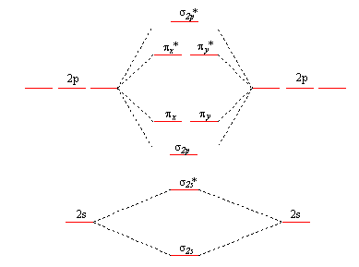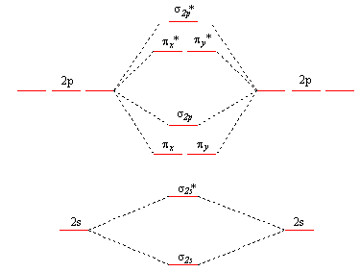
O₂, F₂ and Ne₂ Li₂, Be₂, B₂, C₂ and N₂
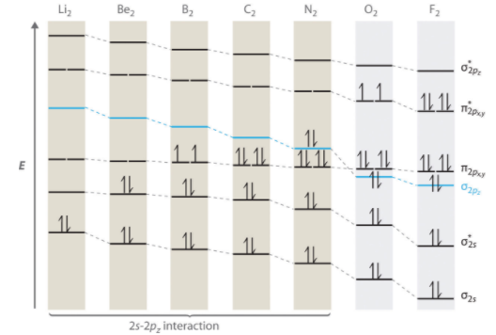

- Similar molecular orbital diagrams can be used to predict the electronic structures of heteronuclear atoms such as CO and NO; the same molecular orbitals are created, although the energies of the atomic orbitals in C and N are higher than the equivalent energies in O
- assuming no hybridisation between 2s and 2p, the molecular orbital diagram would appear as follows:

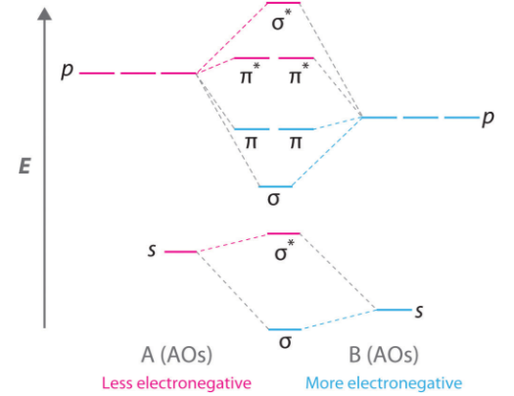
- Mixing of 2s and 2p orbitals is likely, however as the 2s orbitals in A are similar in energy to the 2p_{x} orbitals in B; it is therefore likely that σ_{2s} is higher in energy than π_{2py} and π_{2pz}:
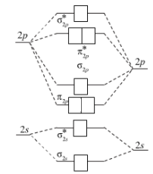

- In diatomic molecules between atoms in which equivalent orbitals have very different energies, such as H with Li, F or Cl, the 1s orbitals in H will mix with whichever orbital on the other atom is closest in energy to it and can overlap; these two atomic orbitals will form a bonding and antibonding molecular orbitals, and the remaining electrons will be non-bonding; eg for HF:

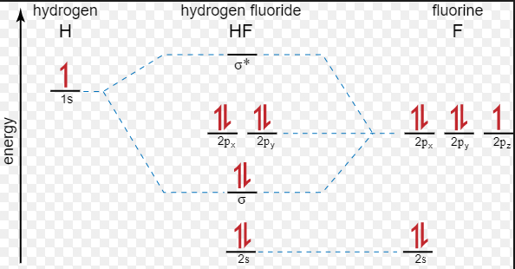

- Molecular orbital theory is very useful in predicting the bond order likely to be found in diatomic species; a bond order of 1 means a single bond; a bond order of 2 means a double bond etc
- the bond order can be calculated using the equation bond order = 0.5 (number in bonding orbitals – number in antibonding orbitals)
- the bond order can be used to make qualitative comparisons of the bond lengths and bond energies in different species; in different diatomic species with the same nuclei, the higher the bond order, the higher the bond dissociation energy and the shorter the bond length
- bond energies and bond lengths also depend on other factors, such as the charge on the nuclei and the number of electrons in lower energy levels

- Molecular orbital theory can also be used to predict the number of unpaired electrons in a molecule, and hence whether it will be paramagnetic or diamagnetic; if a molecule has unpaired electrons, these electrons can align themselves to a magnetic field and will be attracted to the poles of a magnet; this is known as paramagnetism; paired electrons cannot do this and hence the orbitals are distorted by the magnetic field, creating a small repulsion known as diamagnetism

- When subjected to radiation, molecules behave like atoms; electrons may move from their ground state into an excited state; in so doing they absorb and emit radiation and this can be analysed by spectroscopy

Lesson 9

- Resonance

- Some structures exhibit resonance; this happens when there is more than one Lewis structure which describes the bonding in the molecule or ion; the species adopt a resonance hybrid of two or more Lewis structures; in effect the electrons are in molecular orbitals which stretch across more than two atoms; in other words the electrons are delocalised; molecular orbitals across more than two atoms are possible when the are available atomic orbitals of suitable energy and orientation in adjacent atoms

- Evidence for resonance comes in three forms:
- bond lengths, angles and energies identical when individual Lewis structures predict a combination of single and double bonds, or a combination of double and triple bonds
- bond lengths and energies intermediate between known values for single/double/triple bonds
- greater stability than expected if the electrons were localised; this increased stability is known as the “resonance energy”; the greater the number of classical Lewis structures contributing to the resonance structure, the greater the resonance energy

- Most resonance structures consist of two or more equally stable structures which contribute equally to the structure; however there are also less stable structures which can make a smaller contribution to the resonance energy; the greater the number of covalent bonds which are formed, the more stable the structure; the fewer the number of charged atoms and the lower the charge on these atoms, the more stable the structure

Examples of resonance structures include:

- Nitrate ions, carbonate ions and sulphate ions
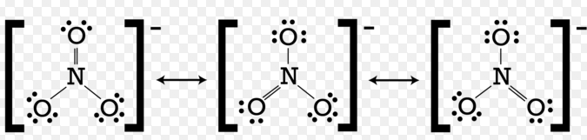

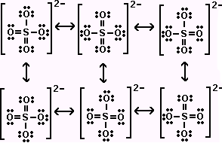
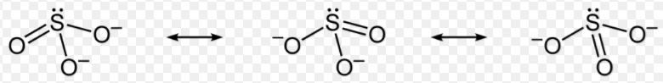
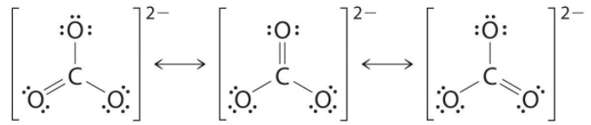

In all the above cases, the structures are all equally stable
- Carboxylic acids
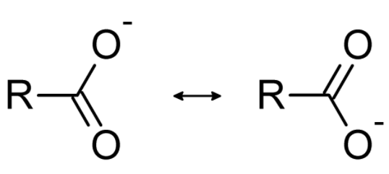both structures equally stable

- Benzene and aromatic compounds
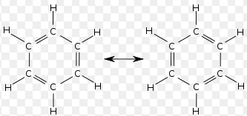both structures equally stable

- Amides and esters
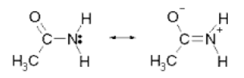; 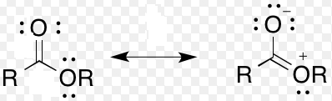
More stable less stable more stable less stable

- Carbon monoxide

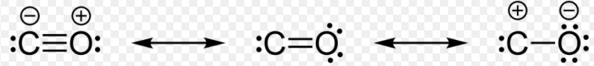
Most stable least stable

- Carbon dioxide

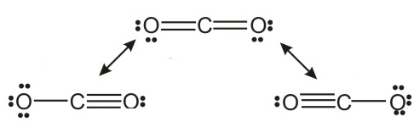
Most stable

- Boron trifluoride

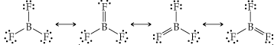

- Oxides of nitrogen

N₂O: NO₂:
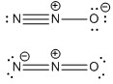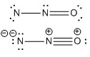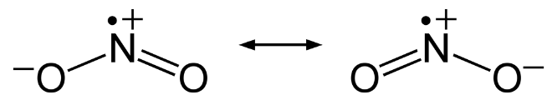
More stable less stable

NO:

More stable less stable

QUESTIONS ON 213 UNIT 1

Lessons 1 – 2

1. | (a) | Calculate the kinetic energy and momentum of a 60 g tennis ball moving at 25 ms⁻¹
 | (b) | Calculate the kinetic energy and momentum of an electron moving at 100 ms⁻¹ (the mass of an electron is 9.1 x 10⁻³¹ kg)
2. | (a) | Calculate the wavelength of Radio Democracy waves, which are emitted with a frequency of 98.1 MHz
 | (b) | Calculate the frequency of a microwave with wavelength 1 cm
3. | (a) | Calculate the energy of a photon of green light of wavelength 522 nm
 | (b) | Calculate the energy of an X-ray photon of wavelength 50 pm
4. |  | The energy required to remove an electron from lithium is 276 kJmol⁻¹
 | (a) | Calculate the minimum frequency of light required to cause photoelectric emission in lithium
 | (b) | Calculate the maximum possible velocity of an electron emitted when light of frequency 7.3 x 10¹⁴ Hz is used for photoelectric emission in lithium
 | (c) | The longest wavelength capable of causing photoelectric emission in aluminium is 3.03 x 10⁻⁷ m; calculate the molar energy required to remove an electron from aluminium
 | (d) | Calculate the momentum of a photon of green light of wavelength 522 nm
 | (e) | Explain briefly how the Compton effect and the Photoelectric effect provide evidence that waves can behave as particles
5. | (a) | Calculate the minimum uncertainty in the position of a 0.40 kg football if the uncertainty in its momentum is 16 kgms⁻¹
 | (b) | Calculate the minimum uncertainty in the position of an electron is the uncertainty in its momentum is 1.6 x 10⁻⁸ kgms⁻¹
 | (c) | Explain the importance of the Davisson-Germer experiment in developing the theory of wave-particle duality of matter
6. | (a) | Calculate the de Broglie wavelength of an electron moving at 100 ms⁻¹
 | (b) | Calculate the de Broglie wavelength of a 60 g tennis ball moving at 5 ms⁻¹

Lessons 3 – 4

1. | (a) | Describe how atoms produce emission spectra
 | (b) | State the postulate used by Bohr to describe how electrons were quantised in an atom
 | (c) | Use this postulate to show that the value of the Rydberg constant in a hydrogen atom should be 1.10 x 10⁷ m⁻¹.
 | (d) | Deduce the value for the Rydberg constant in a He⁺ ion
2. | (a) | Use the value of R_{H} given in 1(c) to calculate the wavelength of light emitted as a result of the following transitions:
 |  | (i) | n = 3 to n = 1
 |  | (ii) | n = 5 to n = 2
 | (b) | Calculate the energy required, in kJmol⁻¹, to remove an electron completely from its ground state in a hydrogen atom
3. | How did de Broglie and Sommerfeld improve on the Bohr model of the atom?

Lesson 5

1. | Three dimensional classical standing waves are known to satisfy the following differential equation: $∇$²ψ = -$\frac{{4π}^{2}}{λ^{2}}$ ψ
 | (a) | Explain the meaning of the terms $∇$²ψ, ψ and λ in this equation.
 | (b) | From this equation, derive the Schrodinger equation for ψ in terms of m, E and U and explain the meaning of these terms.
 | (c) | Hence explain how the Schrodinger equation contains both a wave component and a particle component.
2. | (a) | What is the significance of the term ψ²?
 | (b) | What is the general expression for the value of U in an atom containing only one electron? How must this expression be adapted to allow for multi-electron atoms?
 | (c) | What are polar coordinates? What do the terms “radial component” and “angular component” of a wavefunction mean? What information can be found by finding the real solutions to these components?
3. | (a) | List all the different combinations of l and m_{l} possible if n = 3.
 | (b) | Hence explain how many electrons can be placed in the third energy level of an atom.
 | (c) | Explain the meaning of the terms “degenerate” and “node”.

Lesson 6

1. | Using valence bond theory, draw Lewis-dot structures for, state the type of hybridisation in, draw the shapes for and state the approximate bond angles in the following molecules and ions:
 | (a) | SO₃ | (i) | NO₂⁻
 | (b) | SO₂ | (j) | ClF₃
 | (c) | SO₄²⁻ | (k) | IF₅
 | (d) | SO₃²⁻ | (l) | IO₃⁻
 | (e) | SF₆ | (m) | ClO₂⁻
 | (f) | PCl₃ | (n) | XeF₂
 | (g) | PCl₅ | (o) | XeF₄
 | (h) | NO₃⁻
2. | Sketch a graph to show the relationship between potential energy and internuclear distance. Identify the bond length and the bond energy from this graph.

Lessons 7 – 8

1. | Draw diagrams to show how to p orbitals can overlap to form:
 | (a) | a σ-bonding orbital
 | (b) | A σ*-antibonding orbital
 | (c) | A π-bonding orbital
 | (d) | A π*-antibonding orbital
2. | Draw molecular orbital diagrams to show the bonding in H_{2,} He₂ and He₂⁺; hence deduce the bond order and the number of unpaired electrons in each species
3. | Draw molecular orbital diagrams to show the bonding in N₂, O₂ and CO; deduce the bond order and number of unpaired electrons in each species and explain any differences in the relative energies of σ_{2pz} and π_{2pxy}

Lesson 9

1. | (a) | Explain the meaning of the term resonance.
 | (b) | Draw Lewis-dot structures for the main canonical forms of the following substances; in each case, comment on their relative stability:
 |  | (i) | NO
 |  | (ii) | NO₂
 |  | (iii) | NO₃⁻
 |  | (iv) | N₂O
 |  | (v) | CO
 |  | (vi) | CH₃COOCH₃
 |  | (vii) | C₆H₆

