Section A

A1. | (a) | 2Al + 3H₂SO₄ Al₂(SO₄)₃ + 3H₂  2Tl + H₂SO₄ Tl₂SO₄ + H₂  M1: H₂ produced in both equations  M2: correct salt in either equation  M3: two correct equations
 | (b) | M4: Al +3 and Tl + 1  M5: due to inert pair effect in Tl  [5]
A2. | (a) | M1: SiCl₄ has 3d orbitals  M2: which can accept an electron pair from water  M3: CCl₄ has no empty orbitals of low energy
 | (b) | M4: SiCl₄ + H₂O SiO₂ + 4HCl  M5: White fumes  [5]
A3. | (a) | M1: N≡N  M2: 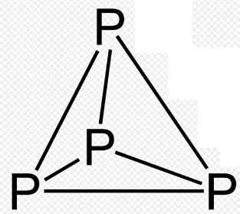 |  | (b) | M3: N favours triple bonds but P favours single bonds  M4: good p-orbital overlap possible with N but not with P  M5: N-N single bond weak due to repulsion between p-orbitals  [5]
A4. | SO₄²⁻ |  | SO₃²⁻ |  |  | S₂O₃²⁻ | S₄O₆²⁻ | S₂O₇²⁻ | S₂O₈²⁻
 | +6 |  | +4 |  |  | +2 | +2.5 | +6 | +6
 |  |  |  |  |  | 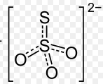 | 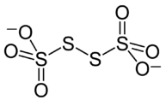
Any three anions with corresponding ON and structure (ignore 3D shape)
M1: any 2 correct, M2: any 4 correct, M3: any 6 correct, M4: any 8 correct, M5: all 9 correct (no errors)
All marks must come from max three oxoanions
[5]

A5. | (a) | M1: It forms a + 1 cation in aqueous solution/ can exist in +1 oxidation state  M2: It has one electron in its outer shell
 | (b) | M3, M4, M5: it is not a metal, it is much less electropositive than the other alkali metals, it cannot form +1 ions in the solid state, it can also exist as a -1 ion/oxidation number (max 3, 1 mark for each)  [5]

Section B

B1. | (a) | M1, M2: saucepans, aircraft, overhead power lines, furniture, food cans (any two sensible suggestions)  M3, M4: low density, strong, resistant to corrosion (any 2)  (4)
 | (b) | (i) | M1: Al₂O₃ + 2NaOH + 3H₂O 2NaAl(OH)₄ or suitable alternative equation  M2: NaAl(OH)₄(aq) Al(OH)₃(s) + NaOH(aq) or suitable seeding equation  M3: 2Al(OH)₃(s) Al₂O₃(s) + 3H₂O(g)  M4: idea that Al₂O₃ dissolves in first equation (can be shown from state symbols)  M5: idea that Al(OH)₃ is crystallised/seeded in second equation (can be shown from state symbols)  M6: heat needed for third equation or cooling needed for second equation
 |  | (ii) | M7: amphoteric
 |  | (iii) | M8: energy or electricity  (8)
 | (c) | M1: B₂O₃ is covalent or not ionic  M2: reference to reduction of BCl₃ or B₂O₃ with hydrogen  M3: 2BCl₃ + 3H₂ 2B + 6HCl or B₂O₃ + 3H₂ 2B + 3H₂O  (3)
 | (d) | (i) | 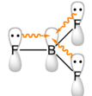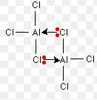 | M1: BF₃ monomer  M2: Al₂Cl₆ dimer  M3: dative π-bond from F to B  M4: evidence of resonance in BF₃  M5: two dative σ-bonds from Cl to Al on adjacent monomer  (M1 – M5) can all be awarded from diagram only)
 |  | (ii) | Good p-orbital overlap possible between B-F (ORA)  Due to small size of atoms (ORA)  (7)
 | (e) | M1: Both contain H⁻ or H in -1 oxidation number  M2: H can be oxidised  M3: lone pair on H⁻ attracted to/can attack nucleophiles  (3)  Total 25 marks

B2. | (a) | (i) | M1: Diamond sp³ or tetrahedral and graphite sp² or planar  M2, M3: both giant covalent or macromolecular, graphite forms layers, graphite layers held together by Van der Waal’s forces, but diamond 3D macromolecular (any 3 = 2, any 2 = 1)  M4, M5: one electron per atom in graphite delocalised, due to p-orbital overlap, but no electrons in diamond delocalised (any 3 = 2, any 2 = 1)  any of above marks available from suitable diagrams
 |  | (ii) | M6: Si atoms larger  M7: so good p-orbital overlap not possible  (7)
 | (b) | (i) | M1: CO₂ simple molecular and SiO₂ macromolecular/giant covalent  M2: CO₂ linear (or sp) and SiO₂ tetrahedral (or sp³)  M3: weak Van der Waal’s forces need to be broken to melt CO₂  M4: strong covalent bonds need to be broken to melt SiO₂
 |  | (ii) | M5: Si and O different in size (ORA)  M6: so good p-orbital overlap not possible (ORA)
 |  | (iii) | M7: CO stabilised by extra π-bond between C and O  M8: Si and O different in size (ORA) so good p-orbital overlap not possible (ORA)  (8)
 | (c) | (i) | M1: PbO₂ + 4HCl PbCl₂ + Cl₂ + 2H₂O  M2: SnO₂ + 4HCl SnCl₄ + 2H₂O
 |  | (ii) | M3: redox reaction with PbO₂  M4: acid-base reaction with SnO₂
 |  | (iii) | M5: PbO₂ is an oxidising agent (ORA)  M6: Because Pb (II) is more stable than Pb (IV) (ORA)  M7: Due to inert paid effect  (7)
 | (d) | M1: PbO₂ + H₂SO₄ + 2H⁺ + 2e⁻ PbSO₄ + 2H₂O  M2: Pb + H₂SO₄ PbSO₄ + 2H⁺ + 2e (M4)  M3: both equations form +2, suggesting that +2 is the most stable oxidation state of Pb  (3)  Total 25 marks

B3. | (a) | M1: P can promote an electron from 3p into 3d  M2: to increase its valency to 5  M3: N has no available d-orbitals  (3)
 | (b) | (i) | 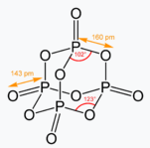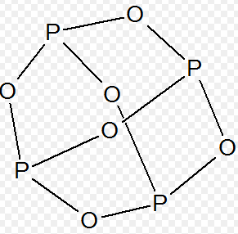 |  |  | M1: P₄O₆  M2: all bonds correct on diagram (ignore shape)  M3: P₄O₁₀  M4: all bonds correct on diagram (ignore shape)
 |  | (ii) | N₂O | NO | NO₂ |  | N₂O₄ | N₂O₅
 |  |  | (either)
M5, M6: two correct molecular formulae (1 mark for each)
M7, M8: two correct structures (1 mark for each, ignore shape)
M5 – M8 must come from two structures only
 |  | (iii) | M9: P and O cannot form good p-orbital overlap (ORA)  M10: due to difference in size (ORA)
 |  | (iv) | M11: N and O cannot easily form their desired valencies  M12: without forming N-O-N single bonds which are very weak  M13: no single oxide significantly more stable than any other  (max 2)  (12)
 | (b) | (i) | M1: correctly identifies anomalous electron affinity and X-X bond enthalpy of F  general decrease in first electron affinity down group:  M2 and M3: due to more shells, more shielding, weaker attraction between electron and nucleus (any 2, 1 mark for each)  Low first electron affinity for F:  M4 and M5: F is small atom, so large repulsion between p-electrons, so easy to add electron (any 2, 1 mark for each)  Decrease in H-X or X-X bond enthalpy down group:  M6 and M7: larger atoms, greater distance/ more shielding between nuclei and bonding electrons, less attraction between nuclei and bonding electrons  Low bond dissociation enthalpy for F-F:  M8: repulsion between p-orbitals on adjacent atoms
 |  | (ii) | M9: H-F bond much stronger than H-Cl bond (ORA)  M10: hetrolytic fission or dissociation into H⁺ and X⁻ less likely (ORA)  (10)  Total 25 marks

