PROTON NMR SPECTRA
Molecule 1:
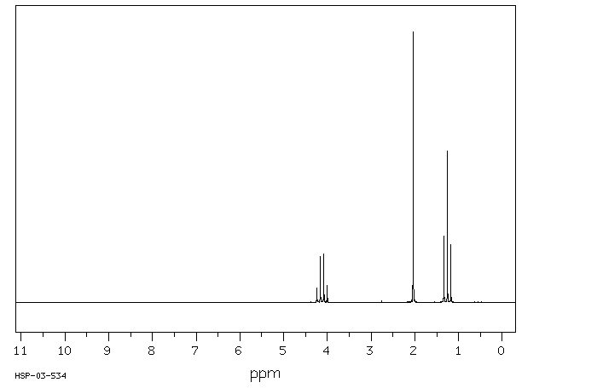

Shift | Relative peak intensity | Splitting
4.1 | 2 | Quartet
2.1 | 3 | Singlet
1.3 | 3 | Triplet

Molecule 2:
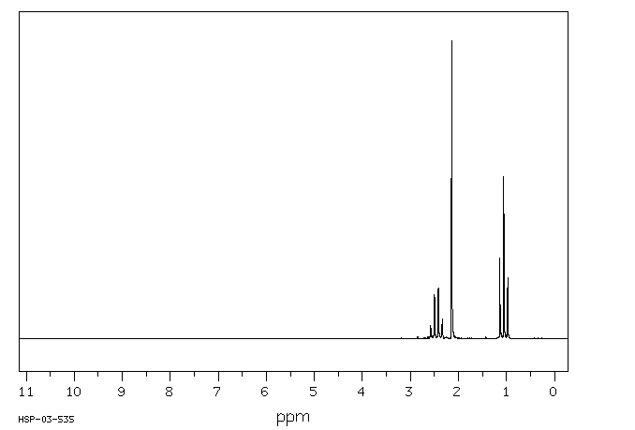

Shift | Relative peak intensity | Splitting
2.4 | 2 | Quartet
2.2 | 3 | Singlet
1.1 | 3 | Triplet

Molecule 3
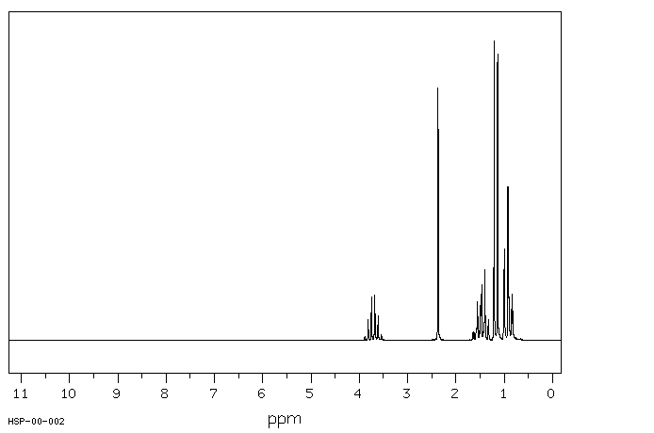

Shift | Relative peak intensity | Splitting
3.6 | 1 | Sextet
2.3 | 1 | Singlet
1.4 | 2 | Pentet
1.2 | 3 | Doublet
0.9 | 3 | Triplet

Molecule 4
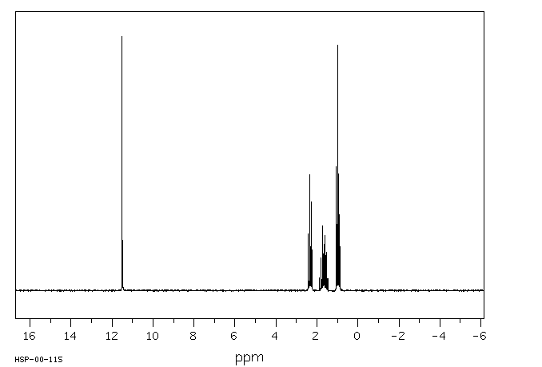
Shift | Relative peak intensity | Splitting
11.6 | 1 | Singlet
2.2 | 2 | Triplet
1.9 | 2 | Sextet
1.0 | 3 | Triplet

Molecule 5
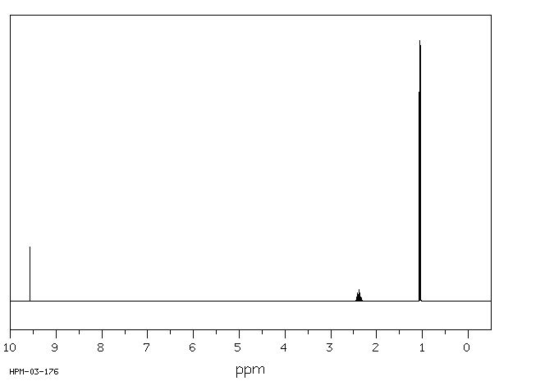
Shift | Relative peak intensity | Splitting
9.6 | 1 | Doublet
2.3 | 1 | Octet
1.1 | 6 | Doublet

