A LEVEL CHEMISTRY
TOPIC 11 – HOW FAR HOW FAST II
TEST
Answer all questions
Max 50 marks

Name ……………………………………………………………..

Mark ……../50 ……....% Grade ………

SECTION A

1. The rate of hydrolysis of an ester X (HCOOCH₂CH₂CH₃) was studied in alkaline conditions at a given temperature. The rate was found to be first order with respect to the ester and first order with respect to hydroxide ions.
(a) (i) Name ester X.
.............................................................................................................
(1)
(ii) Using X to represent the ester, write a rate equation for this hydrolysis reaction.
.............................................................................................................
(1)
(iii) When the initial concentration of X was 0.024 mol dm^{–3} and the initial concentration of hydroxide ions was 0.035 mol dm^{–3}, the initial rate of the reaction was
8.5 × 10^{–5} mol dm^{–3} s^{–1}.
Calculate a value for the rate constant at this temperature and give its units.
Calculation ..........................................................................................
.............................................................................................................
.............................................................................................................
Units ....................................................................................................
(3)
(iv) In a second experiment at the same temperature, water was added to the original reaction mixture so that the total volume was doubled.
Calculate the initial rate of reaction in this second experiment.
.............................................................................................................
.............................................................................................................
(1)
(v) In a third experiment at the same temperature, the concentration of X was half that used in the experiment in part (a) (iii) and the concentration of hydroxide ions was three times the original value.
Calculate the initial rate of reaction in this third experiment.
.............................................................................................................
.............................................................................................................
(1)
(vi) State the effect, if any, on the value of the rate constant k when the temperature is lowered but all other conditions are kept constant. Explain your answer.
Effect …...............................................................................................
Explanation .........................................................................................
(2)

(b) Compound A reacts with compound B as shown by the overall equation
A + 3B → AB₃
The rate equation for the reaction is
rate = k[A][B]²
A suggested mechanism for the reaction is
Step 1 A + B → AB
Step 2 AB + B → AB₂
Step 3 AB₂ + B → AB₃
Deduce which one of the three steps is the rate-determining step.
Explain your answer.
Rate-determining step .................................................................................
Explanation ..................................................................................................
......................................................................................................................
(2)
(Total 11 marks)

2. (a) The initial rate of the reaction between compounds A and B was measured in a
series of experiments at a fixed temperature. The following rate equation was deduced.
rate = k[A][B]²
(i) Complete the table of data below for the reaction between A and B.
Expt | Initial [A]  /mol dm^{–3} | Initial [B]  /mol dm^{–3} | Initial rate  /mol dm^{–3} s^{–1}
1 | 4.80 × 10^{–2} | 6.60 × 10^{–2} | 10.4 × 10^{–3}
2 | 4.80 × 10^{–2} | 3.30 × 10^{–2}
3 |  | 13.2 × 10^{–2} | 5.20 × 10^{–3}
4 | 1.60 × 10^{–2} |  | 10.4 × 10^{–3}

(ii) Using the data for experiment 1, calculate a value for the rate constant, k, and state its units.
Calculation ..........................................................................................
.............................................................................................................
Units ....................................................................................................
(6)
(b) State how the value of the rate constant, k, would change, if at all, if the concentration of A were increased in a series of experiments.
......................................................................................................................
(1)
(Total 7 marks)

3. (a) The following data were obtained in a series of experiments on the rate of the reaction between compounds A and B at a constant temperature.

Experiment | Initial concentration  of A/mol dm^{–3} | Initial concentration  of B/mol dm^{–3} | Initial rate/mol dm^{–3} s^{–1}
1 | 0.12 | 0.15 | 0.32 × 10^{–3}
2 | 0.36 | 0.15 | 2.88 × 10^{–3}
3 | 0.72 | 0.30 | 11.52 × 10^{–3}

(i) Deduce the order of reaction with respect to A.
.............................................................................................................
.............................................................................................................
(ii) Deduce the order of reaction with respect to B.
.............................................................................................................
.............................................................................................................
(2)

(b) The following data were obtained in a series of experiments on the rate of the reaction between NO and O₂ at a constant temperature.

Experiment | Initial concentration  of NO/mol dm^{–3} | Initial concentration  of O₂/mol dm^{–3} | Initial rate/mol dm^{–3} s^{–1}
4 | 5.0 × 10^{–2} | 2.0 × 10^{–2} | 6.5 × 10^{–4}
5 | 6.5 × 10^{–2} | 3.4 × 10^{–2} | To be calculated

The rate equation for this reaction is
rate = k[NO]²[O₂]
(i) Use the data from experiment 4 to calculate a value for the rate constant, k, at this temperature, and state its units.
Value of k ............................................................................................
.............................................................................................................
.............................................................................................................
Units of k .............................................................................................
.............................................................................................................
(ii) Calculate a value for the initial rate in experiment 5.
.............................................................................................................
.............................................................................................................
.............................................................................................................
(4)
(Total 6 marks)

4. Propanone and iodine react in acidic conditions according to the following equation.
CH₃COCH₃ + I₂ → ICH₂COCH₃ + HI
A student studied the kinetics of this reaction using hydrochloric acid and a solution containing propanone and iodine. From the results the following rate equation was deduced.
rate = k[CH₃COCH₃][H⁺]
(a) Give the overall order for this reaction.
......................................................................................................................
(1)
(b) When the initial concentrations of the reactants were as shown in the table below, the initial rate of reaction was found to be 1.24 × 10^{–4} mol dm^{–3} s^{–1}.

 | initial concentration / mol dm^{–3}
CH₃COCH₃ | 4.40
I₂ | 5.00 × 10^{–3}
H⁺ | 0.820

Use these data to calculate a value for the rate constant, k, for the reaction and give its units.
Calculation ...................................................................................................
......................................................................................................................
......................................................................................................................
......................................................................................................................
Units .............................................................................................................
(3)
(c) Deduce how the initial rate of reaction changes when the concentration of iodine is doubled but the concentrations of propanone and of hydrochloric acid are unchanged.
......................................................................................................................
(1)
(d) The following mechanism for the overall reaction has been proposed.
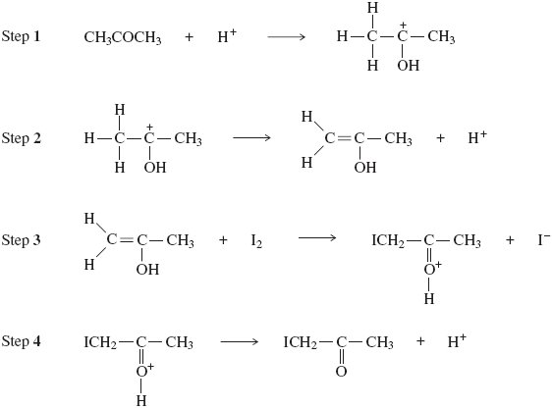
Use the rate equation to suggest which of the four steps could be the rate-determining step. Explain your answer.
Rate-determining step .................................................................................
Explanation ..................................................................................................
......................................................................................................................
(2)
(e) Use your understanding of reaction mechanisms to predict a mechanism for Step 2 by adding one or more curly arrows as necessary to the structure of the carbocation below.
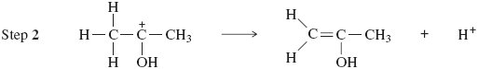
(1)
(Total 8 marks)

5. At high temperatures, SO₂Cl₂ dissociates according to the following equation.
SO₂Cl₂(g) SO₂(g) + Cl₂(g) ΔH = +93 kJ mol^{–1}
When 1.00 mol of SO₂Cl₂ dissociates, the equilibrium mixture contains 0.75 mol of Cl₂ at 673 K and a total pressure of 125 kPa.
(a) Write an expression for the equilibrium constant, K_{p}, for this reaction.
......................................................................................................................
......................................................................................................................
(1)
(b) Calculate the total number of moles of gas present in the equilibrium mixture.
......................................................................................................................
(2)
(c) (i) Write a general expression for the partial pressure of a gas in a mixture of gases in terms of the total pressure.
.............................................................................................................
(ii) Calculate the partial pressure of SO₂Cl₂ and the partial pressure of Cl₂ in the equilibrium mixture.
Partial pressure of SO₂Cl₂ ...................................................................
.............................................................................................................
Partial pressure of Cl₂ ..........................................................................
.............................................................................................................
(5)
(d) Calculate a value for the equilibrium constant, K_{p}, for this reaction and give its units.
......................................................................................................................
......................................................................................................................
(3)
(e) State the effect, if any, of an increase in temperature on the value of K_{p} for this reaction.
Explain your answer.
Effect on K_{p} ..................................................................................................
Explanation ..................................................................................................
......................................................................................................................
(2)
(f) State the effect, if any, of an increase in the total pressure on the value of K_{p} for this reaction.
......................................................................................................................
(1)
(Total 14 marks)
SECTION B
This question relates to the equilibrium gas-phase synthesis of sulphur trioxide:
2SO₂(g) + O₂(g) 2SO₃(g)
Thermodynamic data for the components of this equilibrium are:

This equilibrium, at a temperature of 585 K and a total pressure of 540 kPa, occurs in a vessel of volume 1.80 dm³. At equilibrium, the vessel contains 0.0500 mol of SO₂(g), 0.0800 mol of O₂(g) and 0.0700 mol of SO₃(g).
6. The mole fraction of SO₃ in the equilibrium mixture is
A 0.250
B 0.350
C 0.440
D 0.700
(Total 1 mark)
7. With pressures expressed in MPa units, the value of the equilibrium constant, K_{p}, is
A 4.90
B 6.48
C 9.07
D 16.8
(Total 1 mark)
8. Possible units for the equilibrium constant K_{p} include
A no units
B kPa
C Mpa⁻¹
D kPa⁻²
(Total 1 mark)

9. Normal water and heavy water react together to form isotopicaily mixed water according to the equation
H₂O(l) + D₂O(l) ⇌ 2HDO(l)
The standard enthalpy of formation of H₂O(l) is −286 kJ mol⁻¹, that of D₂O(l) is −294 kJ mol⁻¹, and that of HDO(l) is −290 kJ mol⁻¹. Which one of the following best represents the variation with temperature of the yield of HDO at equilibrium?
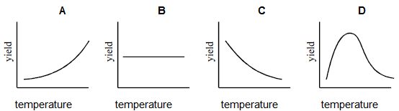
(Total 1 mark)

