Topic 19

AMINO ACIDS, POLYMERS, ORGANIC SYNTHESIS AND BIOCHEMISTRY

Amino Acids
Polymers and Proteins
Biochemistry
Organic Synthesis

STRUCTURE OF AMINO ACIDS

Amino acids are molecules containing an amine group and a carboxylic acid group. Naturally occurring amino acids have the following general formula:

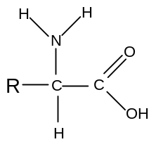
There is a central carbon atom attached to a hydrogen, a carboxylic acid group, an amine group and an alkyl group. Amino acids are thus all chiral except for glycine, in which the R is another H atom.

Amino acids occur widely in nature and have a number of uses in the human body. Some simple examples are:

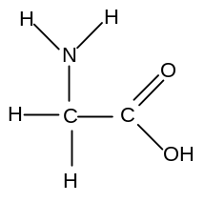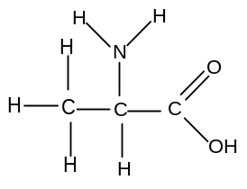
glycine alanine
aminoethanoic acid 2-aminopropanoic acid

ACID-BASE PROPERTIES OF AMINO ACIDS

Carboxylic acids have acidic properties and react with bases.
Amines have basic properties and react with acids.
It therefore follows that amino acids have both acidic and basic properties.

i) reaction with bases

Amino acids react with strong bases such as sodium hydroxide:

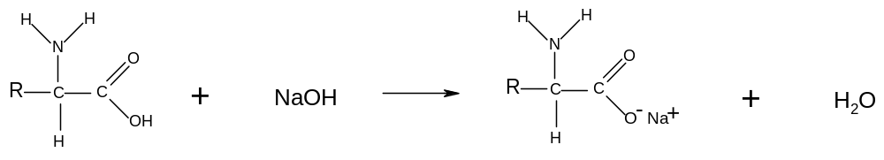In high pH, therefore, amino acids exist in anionic form:
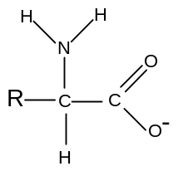

ii) reaction with acids

Amino acids react with strong acids such as hydrochloric acid:

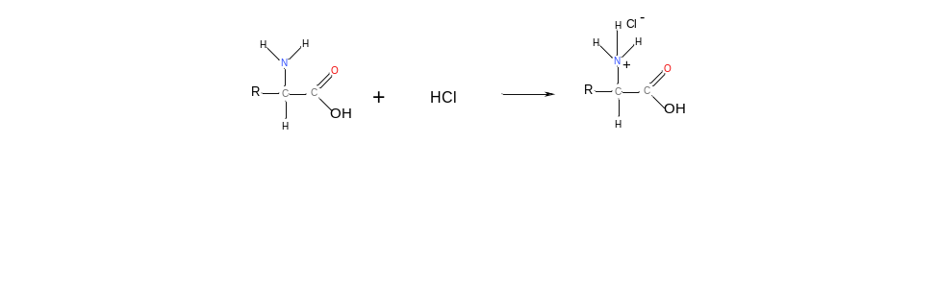
In low pH, therefore, amino acids exist in cationic form:
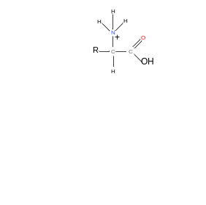
iii) reaction with itself

Since amino acids have a proton donating group and a proton accepting group on the same molecule, it follows that each molecule can undergo an acid-base reaction with itself:
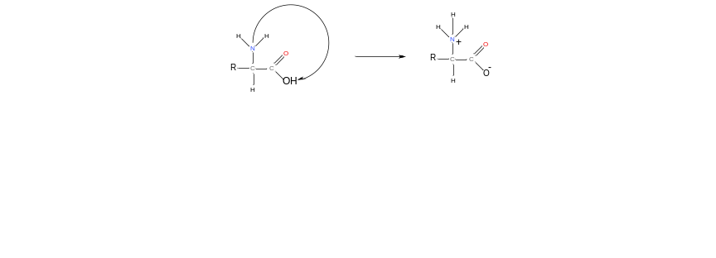
The double ion that is formed as a result of this reaction is called a Zwitterion. This reaction happens in the solid state.

In the solid state, therefore, amino acids are ionic. This explains why they are solids with a high melting point.

iv) summary

Amino acids can exist in molecular form, in cationic form, in anionic form or in Zwitterion form depending on the environment:

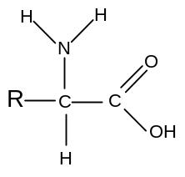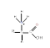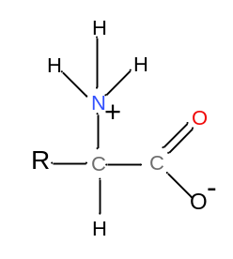
in neutral solution in alkaline solution in acidic solution in the solid state

Since amino acids can react with acids and alkalis, they make very effective buffer solutions.

POLYMERS

1. Making Addition Polymers

Addition polymers are formed from alkenes.

Alkenes can be made to join together in the presence of high pressure and a suitable catalyst. The π-bond breaks and the molecules join together. No other product is formed, and so this is known as addition polymerisation. Since the polymers are made from alkenes they are also known as polyalkenes.

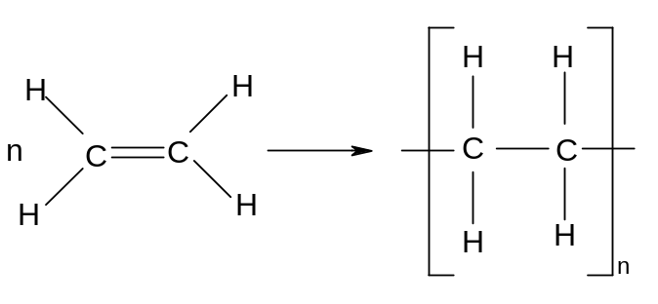
ethene → polyethene

The product of this addition process is a very long hydrocarbon chain.
Addition polymers can be made from any alkene:

Eg propene poly(propene)
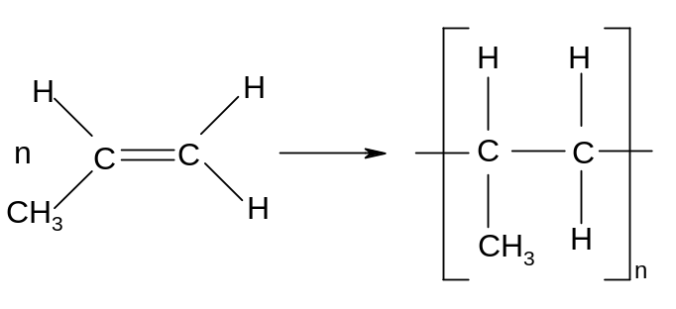

Eg but-2-ene poly(but-2-ene)
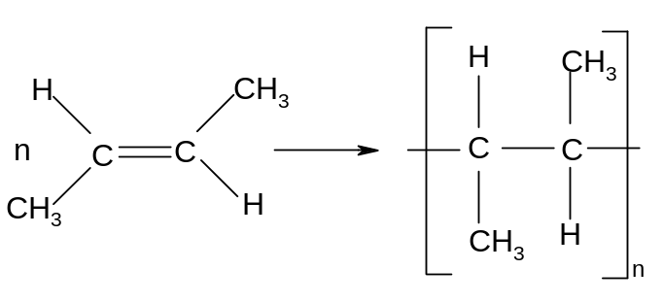
Many useful polymers are addition polymers made by this process:

- polyethene is used in plastic bags and in crates

- polypropene is used in plastic tubing

- polychloroethene (polyvinylchloride) is used in waterproof clothing and records
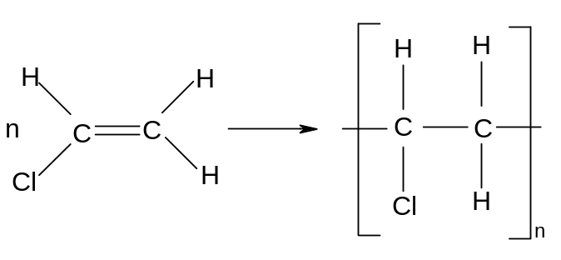
- polyphenylethene (polystyrene) is used in packaging
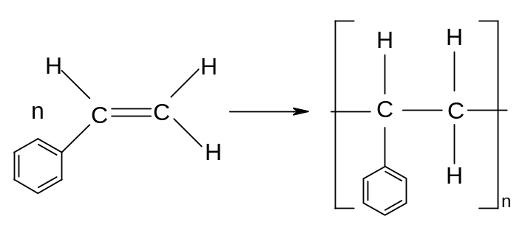

The most favourable conditions for the polymerisation of alkenes can be deduced from Le Chatelier's principle, if two points are noted:
- the reaction involves breaking π-bonds only, and many σ-bonds are made. The reaction is thus exothermic.
- The reaction involves a reduction in the total number of moles:

Since the reaction is exothermic, the best yield is obtained at low temperature. Since the number of gas moles decreases, the best yield is obtained at high pressure.

Addition polymerisation reactions are carried out at high pressure in the presence of a suitable catalyst.
2. Making Condensation Polymers

- Polyesters

It has been shown that if a carboxylic acid is reacted with an alcohol, then an ester is formed and a small molecule is lost.

Eg ethanoic acid + ethanol → ethyl ethanoate + H₂O
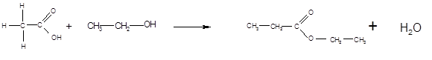

Eg benzoic acid + methanol → methyl benzoate + H₂O
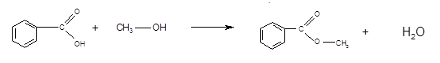

These are examples of condensation reactions – combination of two or more molecules followed by the elimination of a small molecule.

It follows that if a dicarboxylic acid is reacted with a diol, then the -COOH group at each end of the dicarboxylic acid should join to an -OH group, and the -OH group at each end of the diol should join to a -COOH group. It should therefore be possible for all the molecules to link together and form a polymer.

Eg benzene-1,4-dicarboxylic acid and ethan-1,2-diol
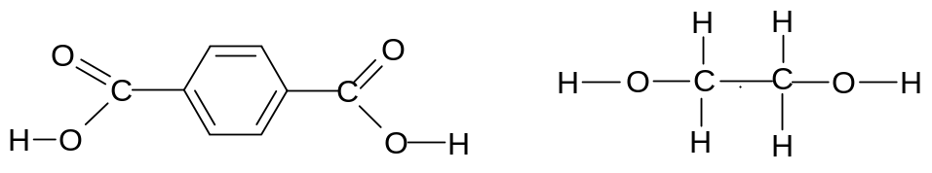
benzene-1,4-dicarboxylic acid ethan-1,2-diol

These two compounds can link together to form a polymer, and water is given off:
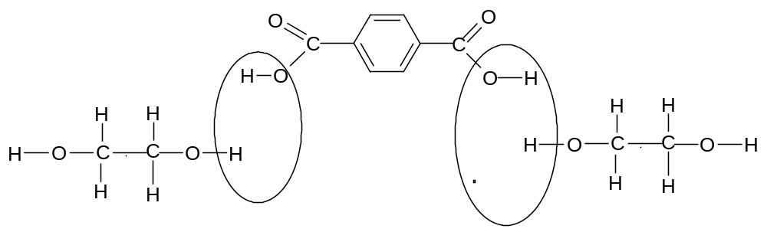
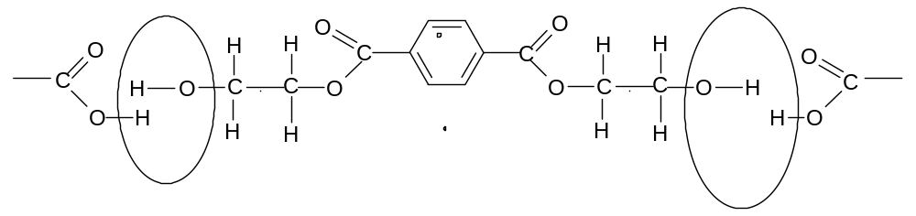

This polymer can be represented by the following repeating unit:
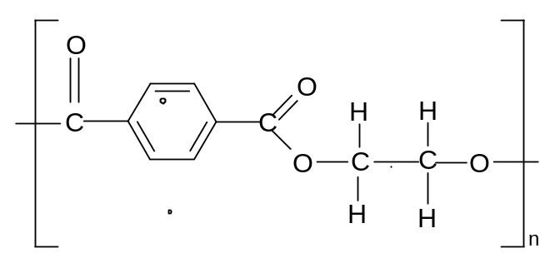

The overall equation can be represented as:
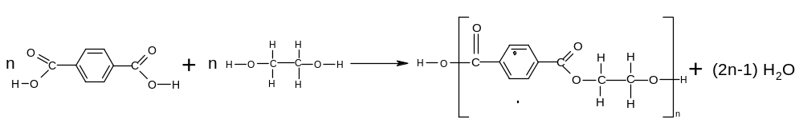

The monomer units are linked together by the ester group:
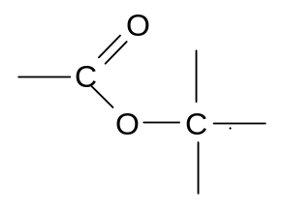
Polymers containing this type of linkage are therefore known as polyesters.

The above polymer is known as terylene. It is used in fire-resistant clothing (eg racing drivers)

Another example of polyester formation is:

Ethanedioic acid and propan-1,2-diol
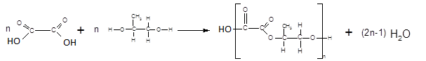

- Polyamides

It has been shown that if a carboxylic acid is reacted with a primary amine, an N-substituted amide is formed:

Eg propanoic acid + ethylamine == N-ethylpropanamide + H₂O

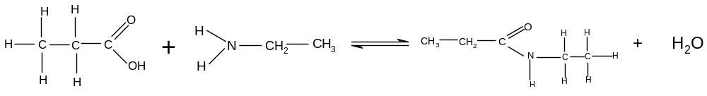

It follows that if a dicarboxylic acid is reacted with a diamine, the -COOH group at each end of the dicarboxylic acid with join to an -NH₂ group, and the -NH₂ group at each end of the diamine will join to a -COOH group. It should therefore be possible for each of the molecules to join together and form a polymer.

Eg hexanedioic acid + 1,6-diaminohexane
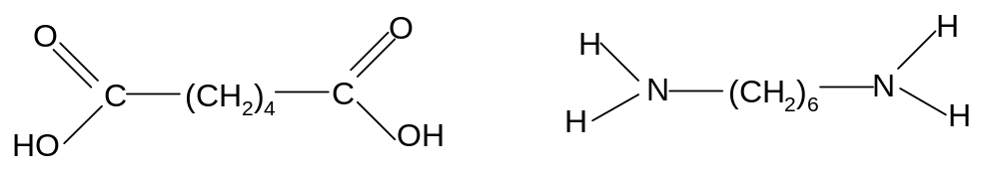
These two compounds can link together to form a polymer, and water is given off.
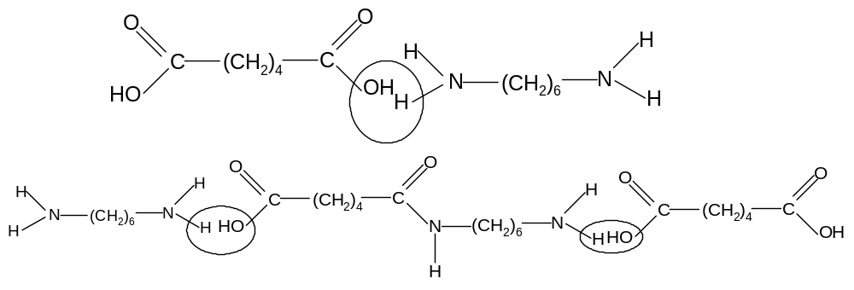

The polymer can be represented by the following repeating unit:
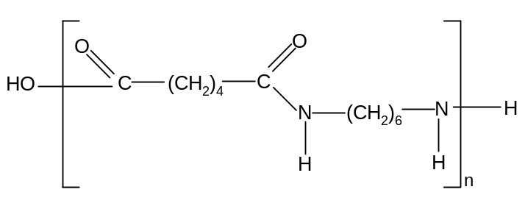

The overall equation can be represented as:
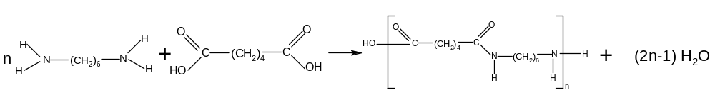
The monomers are linked together by the amide, or peptide link:
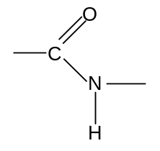
Polymers containing this type of linkage are therefore known as polyamides.

The above polymer is known as nylon 66. It is a man-made fibre used in clothing

Another example of polyamide formation is:

Butanedioic diacid and 1,2 diaminopropane
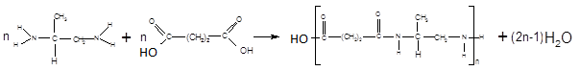

- Proteins

Amines undergo condensation reactions with carboxylic acids.

Since amino acids have both acid and amine groups, two molecules can therefore react with each other to form a molecule containing a peptide or amide link:

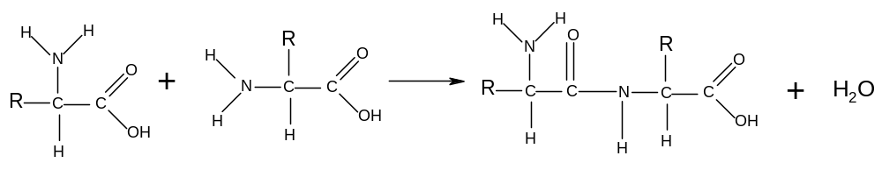
This reaction is a condensation reaction and the resulting molecule is called a dipeptide.

Dipeptides can also be formed by the condensation of two different amino acids. In this case two different molecules can be formed:

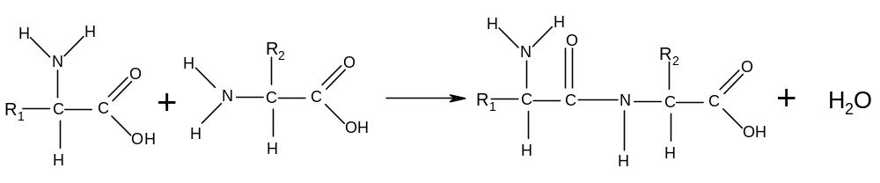
or
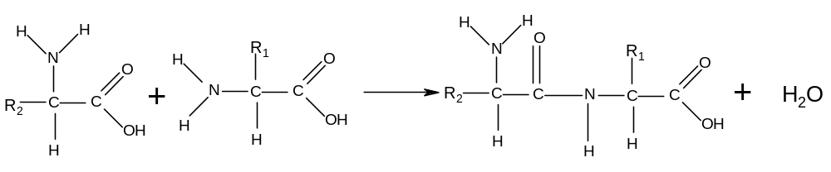

Since the resulting dipeptides also have both amine groups and carboxylic acid groups, they can undergo further condensation reactions, eventually forming polymers:

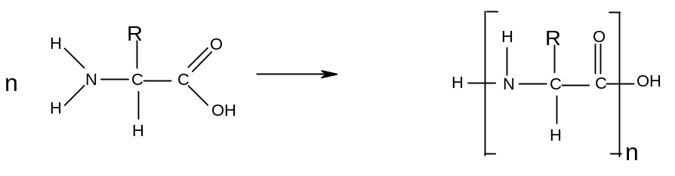
This reaction is carried out alongside DNA molecules in the bodies of living organisms. The DNA lines up the amino acid molecules in the correct order so that the condensation reactions can take place. The resulting polymer is called a protein, and is an essential component of living organisms.

Polyesters, polyamides and proteins are collectively known as condensation polymers because they are the product of condensation reactions.

3. Properties of Polymers

- Addition Polymers

Addition polymers (polyalkenes) are long chain hydrocarbons which are saturated and non-polar. Their structure results in their having a number of characteristic properties:

- Since the hydrocarbon chains are often very long, the Van der Waal's forces between the chains are often very strong and the polymers have relatively high melting and boiling points. Since the chain length is variable, most polymers contain chains of a variety of different lengths. Thus the Van der Waal's forces are of variable strength and these polymers tend to melt gradually over a range of temperatures rather than sharply at a fixed temperature. As the chains are not rigidly held in place by each other, polymers tend to be reasonably soft.

- Since the chains are non-polar, addition polymers are insoluble in water. In fact the long saturated hydrocarbon chains result in polyalkenes being very unreactive generally, as they cannot react with electrophiles, nucleophiles or undergo addition reactions.

This results in their widespread use as inert materials - they are very useful as insulators, as packaging and in making containers.

However their low reactivity means that they are not easily decomposed in nature and as a result have a very long lifetime. Such substances are said to be non-biodegradable, and constitute an environmental hazard as they are very persistent in nature and thus difficult to dispose of.

- Condensation polymers

Condensation polymers (polyesters, polyamides and proteins) consist of long chains which include polar bonds (C-O and C-N). This gives condensation polymers certain characteristic properties

- The strength of the intermolecular forces between the different chains in polyamides and proteins is enhanced by the presence of hydrogen bonding.
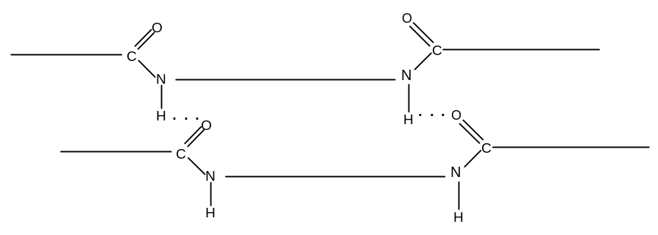

Polyamides are therefore generally very strong. In some natural polyamides, such as proteins, intramolecular hydrogen bonding is possible and the molecule curls up to form a helical structure:
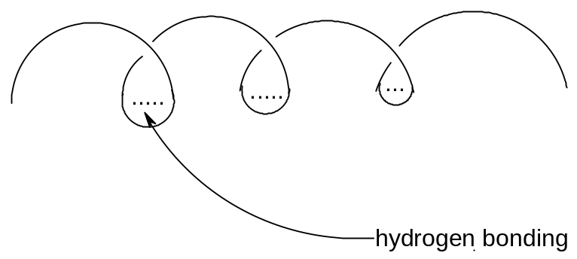

Polyamides and polyesters are both used largely in high-strength synthetic fibres.

Polyesters are used as wool and cotton substitutes in clothing (esp jumpers, T-shirts, shirts etc) and also in carpets and rugs. Bullet-proof vests and some flame-retardant clothing are made from polyesters.

Polyamides are more elastic and used in underwear, fishing nets and other synthetic fibres.

- Because condensation polymers are made up of chains containing polar bonds, the polar carbon atoms can be readily attacked by nucleophiles and as a result the polymers can be broken up and the constituent monomers reformed. Condensation polymers are hence biodegradable, and so clearly constitute a smaller environmental hazard than addition polymers, whose chains are made up entirely of non-polar C-C bonds and which are hence non-biodegradable.

The break-up of these polymers is carried out in aqueous solution and can be classed as hydrolysis reactions:

Polyesters are best hydrolysed in strongly alkaline conditions, in which they undergo saponification to produce the salt of the carboxylic acid:
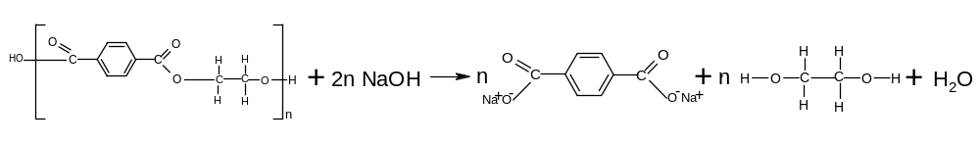

Polyamides and proteins are best hydrolysed in strongly acidic conditions to give the ammonium salt of the amine:
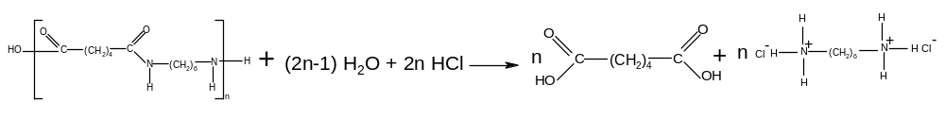
The hydrolysis of proteins breaks them down into their constituent amino acids; 6 moldm⁻³ HCl is generally used.
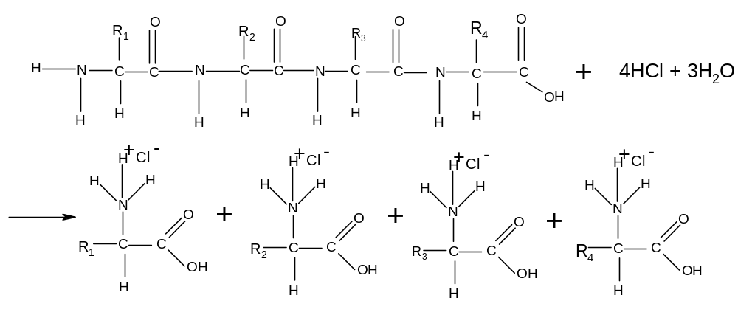
This hydrolysis reaction enables chemists to deduce which amino acids are present in a sample of protein.

The biodegradability of condensation polymers may compromise their effectiveness, since physical and chemical durability is one of the reasons for their widespread use. A balance must be struck between practical durability and long-term biodegradability.

4. Disposal and Recyling of Polymers

The disposal of non-biodegradable polymers is a significant problem. There are three options:
- burying in landfill sites
This is widespread in all developed countries but is a completely unsustainable practice, as each landfill site will eventually fill up. Landfill sites are also unsightly and unhygienic.
- burning
This is also common, but burning polymers releases greenhouses gases such as carbon dioxide and can also release toxic gases, depending on exactly what polymer is being burned
- recycling
This is environmentally preferable to burying or burning, but it is not easy. Different plastics need to be collected, separated and cleaned. They then need to be melted down before being recast into the new item. Often this process can cost more than it costs to manufacture the plastic from crude oil.
Some plastics cannot be melted – they burn or harden instead of melting. It is even more difficult to recycle these plastics as they can only be used in the same shape in which they were originally cast.

The above problems mean that the continued manufacture of non-biodegradable polymers is a cause for environmental concern.

Biodegradable polymers decompose naturally, so burying them is slightly less environmentally unsustainable as they will eventually break down.
They can be recycled, broken down into their original components and reused, but they still need to be collected, separated and cleaned.
BIOCHEMISTRY

- Primary structure of proteins

The sequence of amino acids in a protein is known as the primary structure of the protein. It varies from protein to protein, depending on the function that the protein needs to perform.

Eg: gly – ala – leu – iso – gln
(each of these three–letter symbols is the code for an amino acid)
A protein can have several thousand amino acids, all arranged in a specific order.
The primary structure of a protein is generally stable as the amino acids are held together by strong covalent bonds.

- Secondary structure of proteins

Protein molecules are not straight as hydrogen bonds can form between amino acids on the same chain or adjacent chains. The hydrogen atom on one peptide link can form a hydrogen bond with the nitrogen or oxygen atoms on another peptide link, either on the same molecule or on an adjacent molecule.

This can have one of two effects:

- α-helix

The structure coils up into a helical shape (this is known as an α-helix). Typically, eighteen amino acids make five coils.

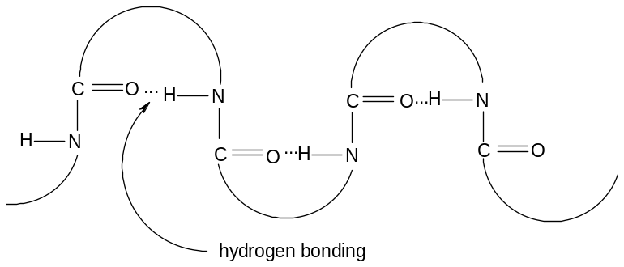
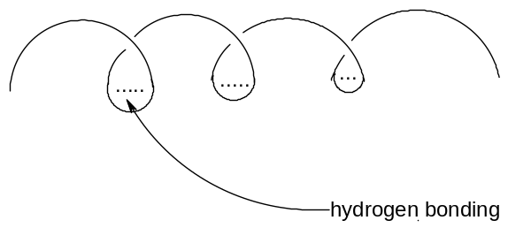
(ii) β-pleated sheet

Alternatively, the hydrogen bonds can form predominantly between adjacent protein molecules, resulting in a pleated sheet structure extending over 3 – 10 amino acids.

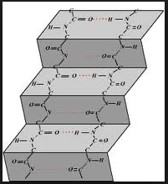

This short-range three-dimensional shape of a protein (covering a small number of adjacent amino acids) is known as the secondary structure of the protein, and it is generally either an α-helix or a β-pleated sheet.

- tertiary structure of proteins

The tertiary structure of proteins describes the interaction between different amino acids which are much further apart on the chain. These interactions control the overall shape of the protein. There are three types of interaction that can take place between amino acid groups and hence determine the tertiary structure of the protein.

- Hydrogen bonding – this is the same type of bonding as that which determines the secondary structure of the protein; an attraction between the hydrogen atom on one peptide link can form a hydrogen bond with the nitrogen or oxygen atoms on another peptide link.

- Ionic bonding – some amino acids contain the -NH₃⁺ group and other amino acids contain the -COO⁻ group; these two groups can form an ionic bond with each other.

- Covalent bonding – cysteine contains a -CH₂SH group; in the presence of oxygen, these two groups can join together to form a S-S bond:
-CH₂SH + -CH₂SH + [O] → -CH₂S-SCH₂- + H₂O

When these bonds form between amino acids which are not close to each other on the chain, the influence the overall shape of the protein and are said to be part of its tertiary structure.
- DNA (deoxyribonucleic acid)

DNA is the material from which chromosomes (and hence genes) are made. It is found in the nucleus of all cells. DNA is a polymer made from monomers called nucleotides.

- Nucleotides

A nucleotide is a molecule consisting of a phosphate group (-H₂PO₄) bonded to a deoxyribose sugar group (-C₅H₈O₂-) which is turn bonded to a base group. There are four different bases which the sugar group can be bonded to: Cytosine (C), Thymine (T), Adenine (A) and Guanine (G). There are thus four different types of nucleotide, and all of the structures are given in the AQA A-level Chemistry data sheet.

This is a nucleotide made from thymine:

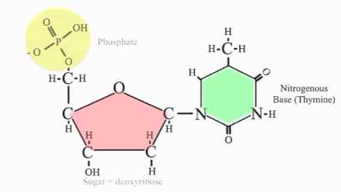

- Polymerisation of nucleotides

A single strand of DNA forms when the nucleotides undergo condensation polymerization; one of the -OH groups on the phosphate reacts with the -OH group on the sugar of a different nucleotide and water is eliminated.

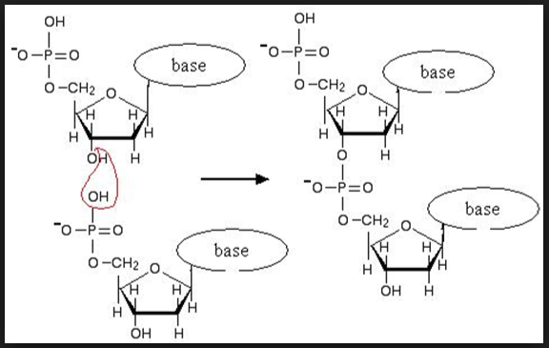

This process can continue indefinitely until a long chain is formed called a sugar-phosphate backbone, with each sugar group also bonded to one of the base groups. This is a single strand of DNA:

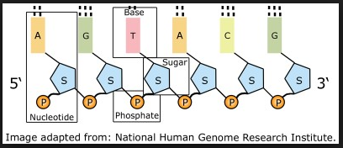

- Formation of double helix

DNA exists as two complementary strands. The bases pairs form hydrogen bonds with base pairs on the complementary strand to form a double helix structure:

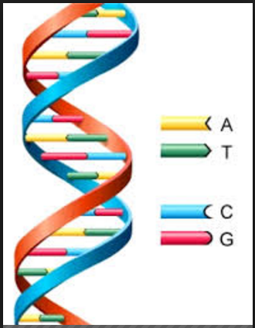

Adenine (A) always bonds with Guanine (G) and Cytosine (C) always bonds with Guanine (G). This happens because each pair of bases has the correct complementary shape to allow hydrogen bonding to take place:

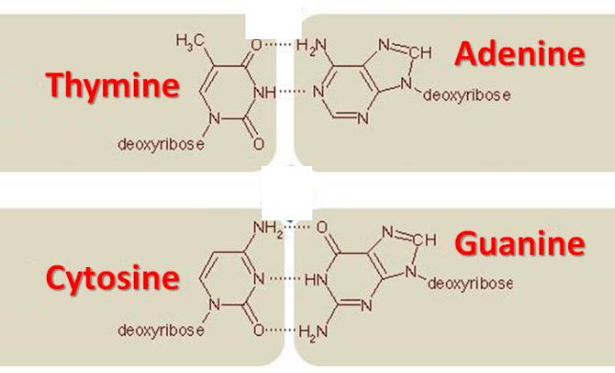
- Anti-cancer drugs

Cisplatin is a drug which is well known for treating cancer. Cancer results from the uncontrolled replication of certain cells in the body, and they replicate much faster than healthy cells. They also have no Hayflick limit.

Cisplatin has the following structure:

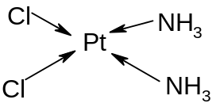
Cisplatin works by binding to two different Guanine (G) base groups on a strand of DNA. The cisplatin undergoes a ligand substitution reaction with each guanine – the N atom on the guanine replaces the Cl atom on the cisplatin and a dative covalent bond is formed between the Pt atom on cisplatin the N atoms on two different guanine groups:

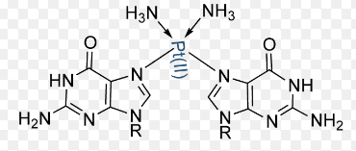

This reaction prevents this section of DNA from replicating itself, as it is now unable to create an RNA copy of itself, which makes transcription, and hence mitosis, impossible. If the DNA is part of a cancerous cell, will prevent the multiplication of that cancerous cell and prevent the spread of the cancer.

The disadvantage of cisplatin, as with many other anti-cancer drugs, is that it also binds to DNA in healthy cells and prevents them from multiplying aswell. These drugs work because cancer cells replicate faster than healthy cells, so the drugs have a greater effect on cancerous cells. The worst side effects are seen in fast-replicating healthy cells such as hair follicles, which is why people often lose their hair during cancer treatment.

When deciding whether or not to use a drug, it is necessary to evaluate the benefits of the drug against its harmful side effects, and use the drug only if society considers that the benefits of the drug significantly outweigh its harmful side-effects.

The best types of anti-cancer drug are those which can discriminate effectively between cancerous cells and healthy cells.
- Enzymes

- How enzymes work

Enzymes are proteins designed to act as catalysts for specific reactions in Biochemistry.

Enzymes usually have globular shapes, with each globule having a crevice in it which is known as the active site. The active site has the precise shape required to accommodate the specific molecule or molecules it is designed to react with, known as the substrate molecules. Because these crevices are three-dimensional spaces, they can usually only catalyse an individual enantiomer of a chiral molecule. These enzymes are said to be stereospecific.

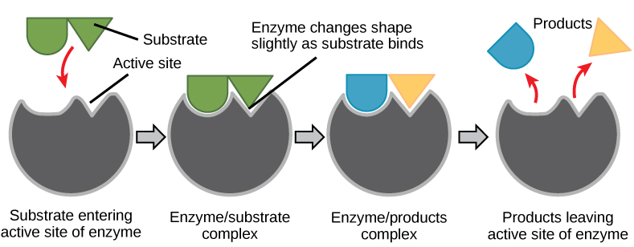

- How enzyme-inhibiting drugs work

Drugs can be designed to prevent a harmful enzyme from catalyzing a harmful reaction.

Molecules can be created which have a similar shape to the substrate which the enzyme is meant to be reacting with. These drugs mimick the substrates and bind to the active sites instead, which prevents the substrate from bonding to the enzyme and prevents the enzyme from catalyzing the reaction. This form of drug action is known as enzyme-inhibition.

It is now possible to use computer modelling techniques to predict the shape of enzymes and other proteins. Once the shape of an enzyme is understood, the shape of the substrate required to react with the enzyme can also be predicted and inhibitors can be designed accordingly.

SUMMARY OF AMINO ACID AND POLYMER REACTIONS

Type of reaction | Mechanism
1. acid-base reactions of amino acids

a) with acids
reagents: HCl
conditions: room temperature
equation: R-CH(NH₂)-COOH + HCl → R-CH(NH₃⁺Cl⁻)-COOH

b) with alkalis
reagents: NaOH
conditions: room temperature
equation: R-CH(NH₂)-COOH + NaOH →R-CH(NH₂)-COO⁻Na⁺ + H₂O

2. Polymerisation Reactions  - Addition polymerisation (alkenes → polyalkenes)  conditions: high temperature, Ziegle-Natte catalyst  equation:  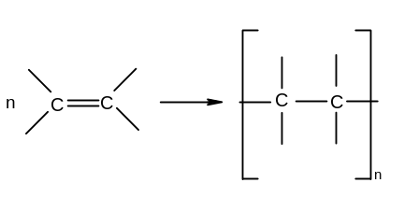  - Condensation polymerization - polyesters  dicarboxylic acid + diol → polyester  conditions: H₂SO₄, heat under reflux  equation:  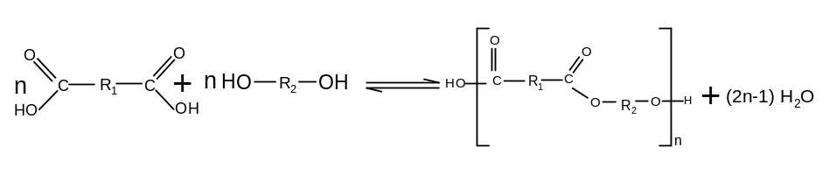  - Condensation polymerization – polyamides  dicarboxylic acid + diamine → polyamide  conditions: warm, reflux  equation:  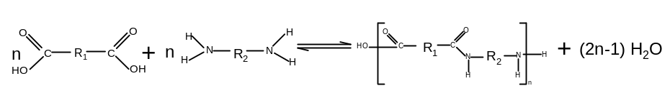  - Condensation polymerization - proteins  conditions: DNA  equation: n R-CH(NH₂)-COOH → H-(NHCRHCO)_{n}-OH + (n-1) H₂O | Free radical addition  (not required)  Nucleophilic addition-elimination  (not required)  Nucleophilic addition-elimination  (not required)  Nucleophilic addition-elimination  (not required)

3. Hydrolysis of condensation polymers

a) polyesters
reagents: NaOH(aq)
conditions: heat, reflux
equation:
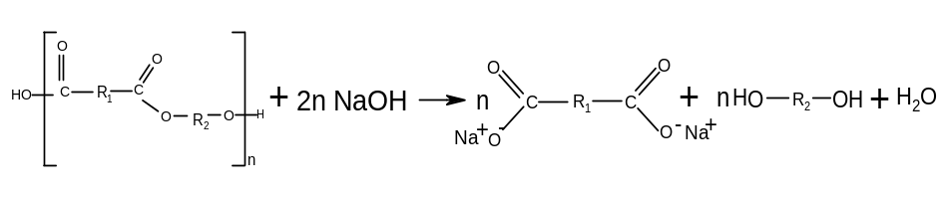
b) polyamides
reagents: HCl(aq)
conditions: heat, reflux
equation:

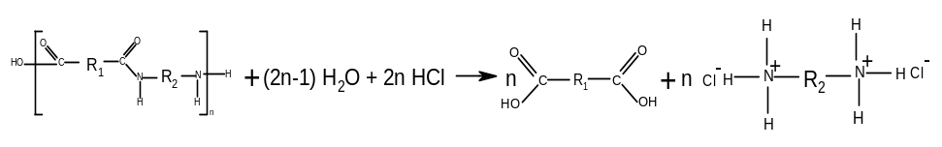

- proteins

reagents: 6 moldm⁻³ HCl
conditions: heat, reflux
equation: H-(NHCRHCO)_{n}-OH + (n-1) H₂O + n HCl → n R-CH(NH₃⁺Cl⁻)-COOH

ORGANIC SYNTHESIS

It is possible to make a large number of organic products from a few starting compounds and the necessary reagents. There are often many ways to make a particular molecule, and when choosing the best pathway, chemists need to try to find:

- processes which do not require a solvent – solvents can be expensive, difficult to dispose of and often cannot be re-used after a reaction has taken place

- processes which use non-hazardous starting materials – so that the reactions are safer to operate and avoid having to dispose of any unreacted starting materials

- Processes which consist of as few steps as possible – this means they are usually faster and more efficient

- Processes which have a high atom economy – in order to avoid waste products

The following organic pathways are required for A-level:

1. alkane → chloroalkane

reagents: chlorine
conditions: UV light
equation: CH₄ + Cl₂ → CH₃Cl + HCl (example)

NB This reaction introduces a new functional group onto the molecule

2. chloroalkane → alcohol

reagents: aqueous NaOH
conditions: warm, reflux
equation: R-Cl + NaOH → R-OH + NaCl

3. chloroalkane → alkene

reagents: alcoholic KOH
conditions: heat, distillation
equation: CH₃CH₂Cl + KOH → CH₂=CH₂ + KCl + H₂O (example)

4. chloroalkane → nitrile

reagents: aqueous KCN
conditions: heat, reflux
equation: R-Cl + KCN → R-CN + KCl

NB This reaction introduces an extra carbon atom onto the molecule

5. chloroalkane → primary amine

reagents: excess ammonia
conditions: heat
equation: R-Cl + 2NH₃ → R-NH₂ + NH₄Cl

6. primary amine → secondary amine

reagents: chloroalkane
conditions: warm
equation: R₁-NH₂ + R₂-Cl → R₁R₂NH + HCl

7. secondary amine → tertiary amine

reagents: chloroalkane
conditions: warm
equation: R₁R₂NH + R₃-Cl → R₁R₂R₃N + HCl

8. tertiary amine → quaternary ammonium salt

reagents: chloroalkane
conditions: warm
equation: R₁R₂R₃N + R₄-Cl → R₁R₂R₃R₄N⁺Cl⁻

9. alkene → dibromoalkane

reagents: bromine
conditions: room temperature
equation: CH₂=CH₂ + Br₂ → CH₂BrCH₂Br (example)

NB This reaction introduces a new functional group onto the molecule

10. alkene → bromoalkane

reagents: hydrogen bromide
conditions: room temperature
equation: CH₂=CH₂ + HBr → CH₃CH₂Br (example)

11. alkene → alkylhydrogensulphate

reagents: concentrated sulphuric acid
conditions: cold
equation: CH₂=CH₂ + H₂SO₄ → CH₃CH₂OSO₃H (example)

12. alkylhydrogensulphate → alcohol

reagents: water
conditions: warm
equation: CH₃CH₂OSO₃H + H₂O → CH₃CH₂OH + H₂SO₄ (example)

13. alkene → alcohol

reagents: steam
conditions: 300 ºC, 600 kPa, phosphoric acid catalyst
equation: CH₂=CH₂ +H₂O → CH₃CH₂OH

14. nitrile → primary amine

reagents: LiAlH₄
conditions: dry ether
equation: R-CN + 4[H] → R-CH₂NH₂ (example)

15. alcohol → alkene

reagents: concentrated sulphuric acid
conditions: heat, reflux
equation: CH₃CH₂OH → CH₂=CH₂ + H₂O (example)

16. primary or secondary alcohol → carbonyl

reagents: potassium dichromate and dilute sulphuric acid
conditions: warm, distillation
equation: R₁R₂CHOH + [O] → R₁-COR₂ + H₂O

17. primary alcohol → carboxylic acid

reagents: potassium dichromate and dilute sulphuric acid
conditions: heat, reflux
equation: R-CH₂OH + 2[O] → R-COOH + H₂O

18. aldehyde → carboxylic acid

reagents: potassium dichromate and dilute sulphuric acid
conditions: heat, reflux
equation: R-CHO + [O] → R-COOH

19. carbonyl → alcohol

reagents: NaBH₄(aq)
conditions: room temperature
equation: R₁-COR₂ + 2[H] → R₁R₂CHOH

20. carboxylic acid → carboxylate salt

reagents: NaOH
conditions: room temperature
equation: R-COOH + NaOH → R-COONa + HO

21. amine → alkylammonium salt

reagents: HCl(aq)
conditions: room temperature
equation: R₁R₂R₃N + HCl → R₁R₂R₃NHCl

22. carbonyl → hydroxynitrile

reagents: HCN
conditions: room temperature
equation: R₁COR₂ + HCN → R₁R₂COHCN

NB This reaction adds an extra carbon atom and introduces an extra functional group onto the molecule

23. acyl chloride → carboxylic acid

reagents: water
conditions: room temperature
equation: R-COCl + H₂O → R-COOH

24. acyl chloride → amide

reagents: ammonia
conditions: room temperature
equation: R-COCl + NH₃ → R-CONH₂

25. acid anhydride → carboxylic acid

reagents: water
conditions: warm
equation: (RCO)₂O + H₂O → 2R-COOH

26. acid anhydride → amide

reagents: ammonia
conditions: warm
equation: (RCO)₂O + NH₃ → R-CONH₂ + RCOOH

27. carboxylic acid + alcohol → ester

reagents: concentrated sulphuric acid
conditions: heat, reflux
equation: R₁COOH + R₂OH → R₁COOR₂ + H₂O

28. acyl chloride + alcohol → ester

conditions: room temperature
equation: R₁COCl + R₂OH → R₁COOR₂ + HCl

29. acid anhydride + alcohol → ester

conditions: warm
equation: (R₁CO)₂O + R₂OH → R₁COOR₂ + R₁COOH

30. ester → carboxylic acid + alcohol

reagents: concentrated sulphuric acid
conditions: heat under reflux
equation: R₁COOR₂ + H₂O → R₁COOH + R₂OH

31. ester → carboxylate salt + alcohol

reagents: NaOH(aq)
conditions: heat under reflux
equation: R₁COOR₂ + NaOH → R₁COONa + R₂OH

32. acyl chloride + primary amine → N-substituted amide

conditions: room temperature
equation: R₁-COCl + 2R₂-NH₂ → R₁-CONHR₂ + R₂-NH₃Cl

33. acid anhydride + primary amine → N-substituted amide

conditions: warm
equation: (R₁CO)₂O+ R₂-NH₂ → R₁-CONHR₂ + R₁-COOH

34. benzene → nitrobenzene

reagents: concentrated sulphuric and nitric acids
conditions: warm, reflux
equation: C₆H₆ + HNO₃ → C₆H₅NO₂ + H₂O

35. benzene → phenylalkanone

reagents: acyl chloride, AlCl₃
conditions: room temperature
equation: C₆H₆ + RCOCl → C₆H₅COR + HCl

36. nitrobenzene → phenylamine

reagents: tin, concentrated HCl
conditions: room temperature
equation: C₆H₆ + 6[H] → C₆H₅NH₂ + 2H₂O

The interconversion of these compounds can be summarised in the following synthesis maps:

a) aliphatic synthesis map – simple conversions

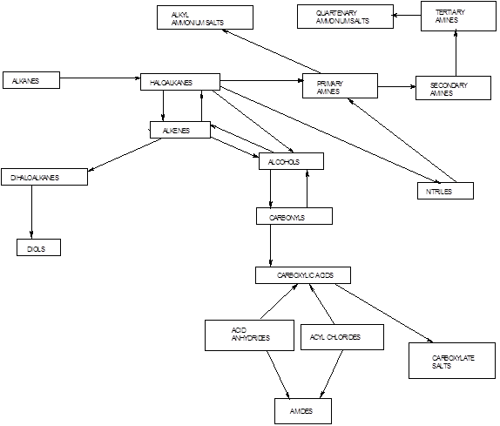
b) condensation reactions

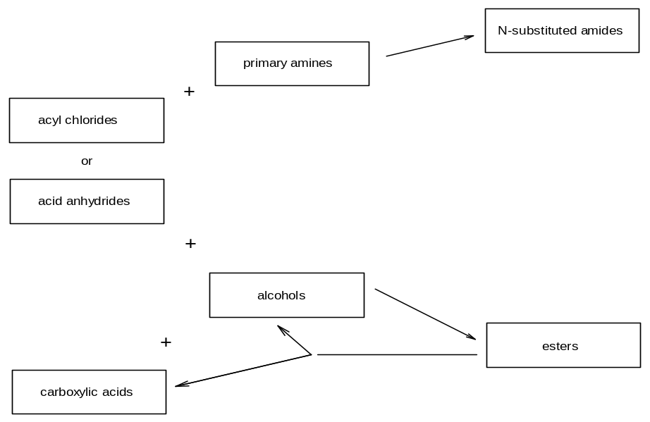

c) aromatic conversions



