Topic 7

INTRODUCTION TO ORGANIC CHEMISTRY

Introduction to Organic Chemistry
Nomenclature
Isomerism
Crude Oil
Combustion of Alkanes

INTRODUCTION TO ORGANIC CHEMISTRY

1. Carbon compounds

Organic chemistry is the chemistry of carbon compounds. Carbon forms a vast number of compounds because it can form strong covalent bonds with itself. This enables it to form long chains (up to 5000 in length) of carbon atoms, and hence an almost infinite variety of carbon compounds are known.
The tendency of identical atoms to form covalent bonds with each other and hence form chains is known as catenation.

All organic compounds contain carbon. Most contain hydrogen.
Carbon always forms four covalent bonds and hydrogen one.

The physical and chemical properties of organic compounds depend on two factors:

- The number and arrangement of carbon atoms in the molecule.

A number of important physical properties are determined by the number of carbon atoms in the molecule. The greater the number of carbon atoms, the larger the Van der Waal’s forces and the higher the melting points, boiling points and viscosity.

In many cases, all the carbon atoms are arranged in a straight chain. Often, however, there are shorter chains of carbon atoms branching off a longer chain. These are known as branched molecules.
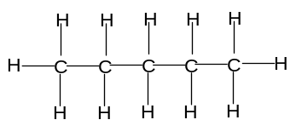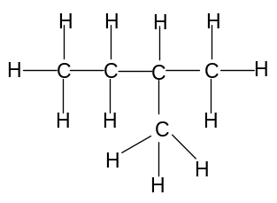

Straight chain molecule Branched molecule

Carbon atoms can also be arranged to form rings. These are known as cyclic molecules. The most common number of carbon atoms in a ring is 6.

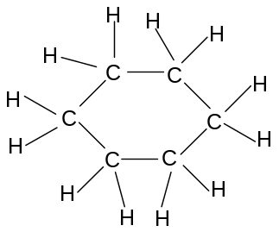
Cyclic molecule

- The functional groups in the molecule

A functional group is a specific atom or group of atoms which confer certain physical and chemical properties onto the molecule. Organic molecules are classified by the dominant functional group on the molecule.

2. Functional groups

These are the some of the most important functional groups found on organic molecules:

Type of compound | Nature of functional group
Alkane | C-C and C-H single bonds only (ie no functional group)  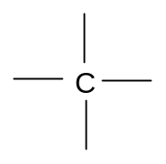
Alkene | C=C double bond  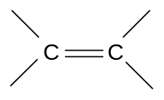
Halogenoalkane  -Chloroalkane  -Bromoalkane  -Iodoalkane | Cl, Br or I atom attached to a carbon atom  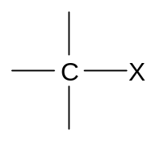
Alcohol | O atom in between a C atom and an H atom  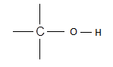

3. Drawing and writing organic compounds

Organic compounds can be represented in a number of ways:

- Displayed formula, showing all covalent bonds

This is also known as the graphical formula. All covalent and ionic bonds between all atoms are shown:
eg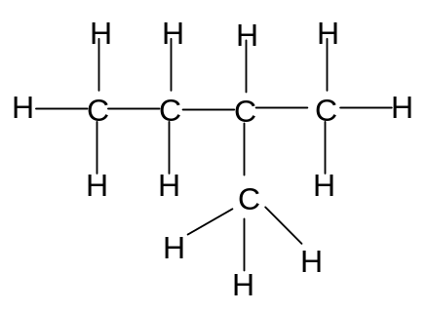

- Structural formula, not showing covalent bonds

Enough information is shown to make the structure clear, but the actual covalent bonds are omitted.

Straight chain alkanes are shown as follows:
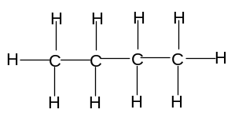is represented as CH₃CH₂CH₂CH₃ or CH₃(CH₂)₂CH₃.

Branched alkanes are shown as follows:
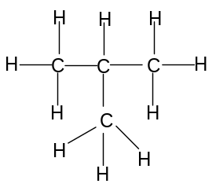is represented as CH₃CH(CH₃)CH₃.

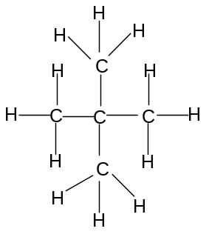is represented as CH₃C(CH₃)₂CH₃.

Alkenes are shown as follows:

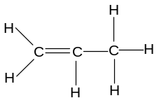is represented as CH₂CHCH₃.

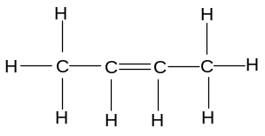is represented as CH₃CHCHCH₃.

Halogenoalkanes are represented as follows:

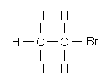 is represented as CH₃CH₂Br

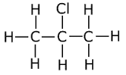is represented as CH₃CHClCH₃

Alcohols are represented as follows:

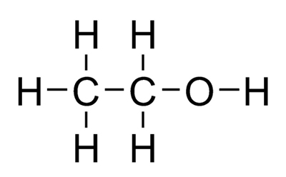is represented as CH₃CH₂OH

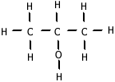is represented as CH₃CH(OH)CH₃

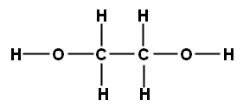 is represented as HOCH₂CH₂OH

- Skeletal Formula, not showing carbon atoms

In skeletal formulae:

carbon atoms are not drawn – they are represented by a dot
hydrogen atoms are not drawn if they are bonded to carbon atoms
covalent bonds are represented by a line if they do not involve hydrogen
covalent bonds involving hydrogen are omitted
the angle between the bonds must be correct

is represented as 

is represented as 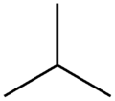

is represented as 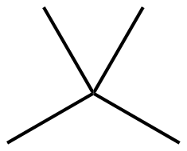
is represented as 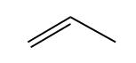

is represented as 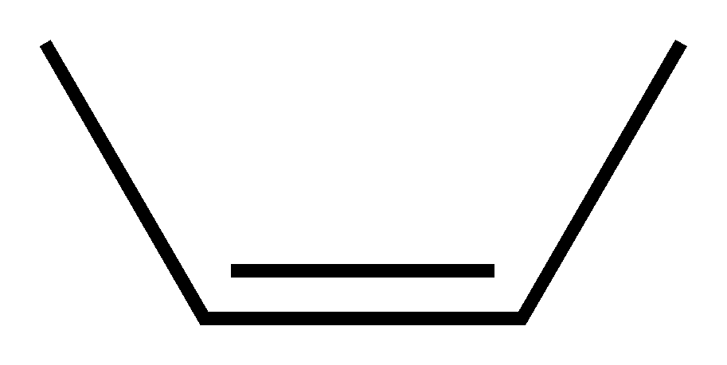

is represented as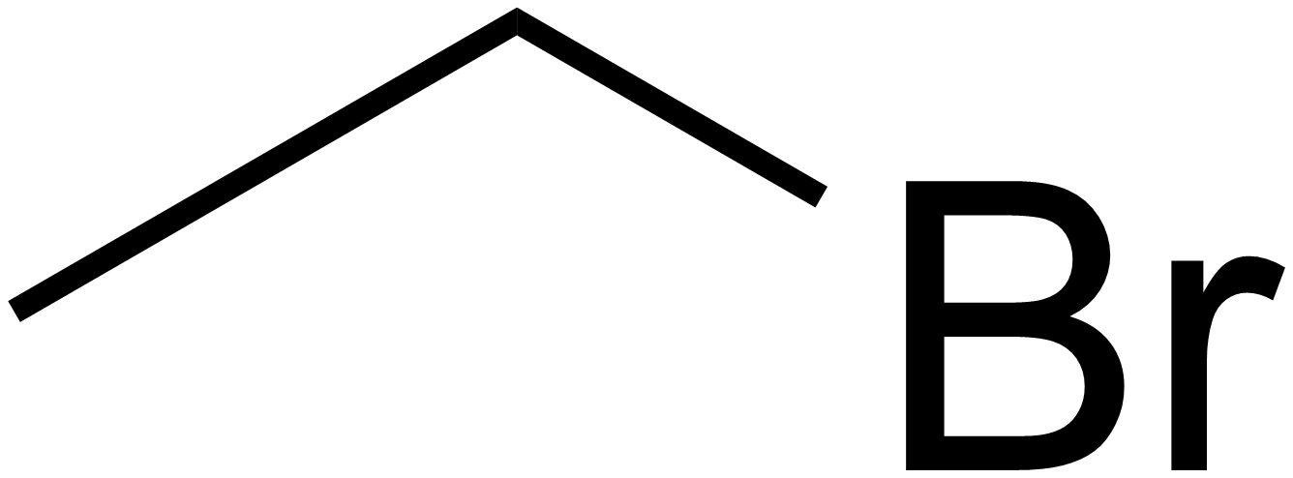

is represented as 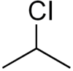

is represented as 

is represented as 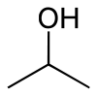

is represented as 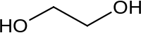

- Molecular formula

The molecular formula shows the number of each atom in one molecule of the compound. It does not show unequivocally the structure of the molecule, so different molecules can have the same molecular formula.

is written C₄H₁₀

is written C₄H₈

Alkanes have the general molecular formula C_{n}H_{2n+2}.

Alkenes have the general molecular formula C_{n}H_{2n}.

Haloalkanes have the general molecular formula C_{n}H_{2n+1}X.

Alcohols have the general molecular formula C_{n}H_{2n+2}O.

- Empirical formula

The empirical formula is the simplest whole number ratio of the number of atoms of each element in a substance.

4. Homologous series

Organic compounds with the same functional group, but a different number of carbon atoms, are said to belong to the same homologous series. Every time a carbon atom is added to the chain, two hydrogen atoms are also added.

A homologous series is a series of organic compounds which have the same functional group, but in which the formula of each successive member increases by -CH₂-.

Eg Homologous series of alkanes:
CH₄, CH₃CH₃, CH₃CH₂CH₃, CH₃CH₂CH₂CH₃, CH₃(CH₂)₃CH₃, CH₃(CH₂)₄CH₃ etc

As a homologous series is ascended, the size of the molecule increases. Therefore the Van der Waal’s forces between the molecules become stronger and the boiling point increases.
NOMENCLATURE OF ORGANIC COMPOUNDS

Most organic compounds can be named systematically by the IUPAC method.

In order to describe completely an organic molecule, three features must be described:

- the longest carbon chain on the molecule.

- the length and position of any branches on the molecule.

- the nature and position of any functional groups on the molecule.

- The longest straight chain on the molecule

The longest carbon chain on the molecule is indicated by one of the following prefixes:

Number of carbon atoms in the chain | Prefix
1 | Meth-
2 | Eth-
3 | Prop-
4 | But-
5 | Pent-
6 | Hex-

- The nature and position of any functional groups on the molecule

a) Alkanes

Alkanes are named using the ending -ane:

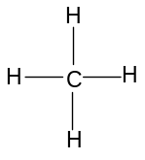 | Methane
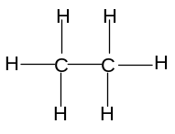 | Ethane
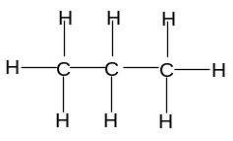 | Propane
 | Butane

b) Alkenes

Alkenes are named using the ending -ene. In molecules with a straight chain of 4 or
more carbon atoms, the position of the C=C double bond must be specified. The
carbon atoms on the straight chain must be numbered, starting with the end closest to
the double bond. The lowest-numbered carbon atom participating in the double bond
is indicated just before the -ene:

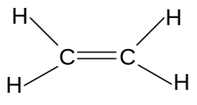 | Ethene
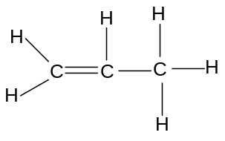 | Propene
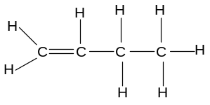 | But-1-ene
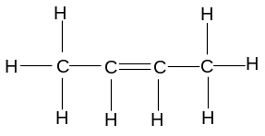 | But-2-ene

c) Halogenoalkanes

Halogenoalkanes are named using the prefix chloro-, bromo- or iodo-, with the ending -ane. In molecules with a straight chain of three or more carbon atoms, the position of the halogen atom must also be specified. The carbon atoms on the straight chain must be numbered, starting with the end closest to the halogen atom. The number of the carbon atom attached to the halogen is indicated before the prefix:

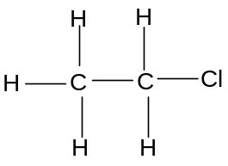 | Chloroethane
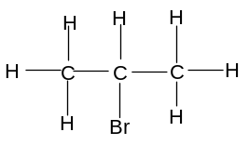 | 2-bromopropane
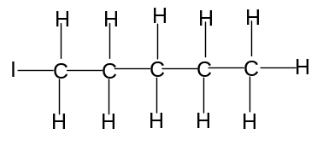 | 1-iodopentane
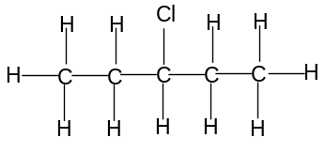 | 3-chloropentane

The position of all halogens in dihaloalkanes except those with one carbon atom must be specified. If there is more than one of the same type of halogen atom on the molecule, the di (two), tri (three) or tetra (four) prefixes must also be used.

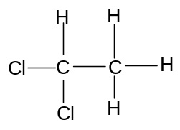 | 1,1-dichloroethane
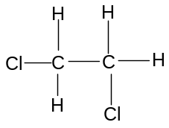 | 1,2-dichloroethane
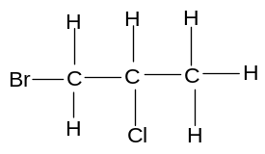 | 1-bromo,2-chloropropane

3. The length and position of any branches on the molecule

Many carbon chains are branched. The presence of a branch is indicated one of the following prefixes:

Branch | Prefix
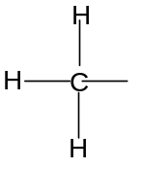 | Methyl
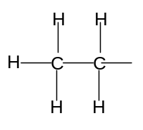 | Ethyl

In some cases, there is more than one place in which the branch can be attached. In such cases, the position of the branch must be specified according to the number of the carbon on the straight chain to which it is attached. The carbons are always numbered from the carbon at the end of the chain closest to the functional group. If there is no functional group, the carbons are numbered from the carbon at the end of the chain closest to the branch.

Eg

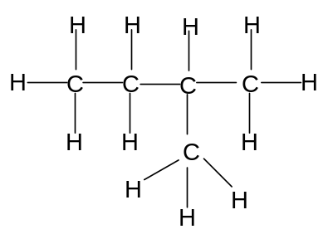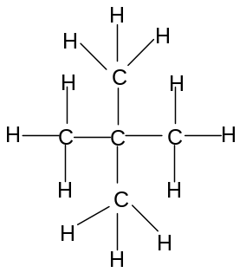

2-methylbutane or methylbutane 2,2-dimethylpropane or dimethylpropane

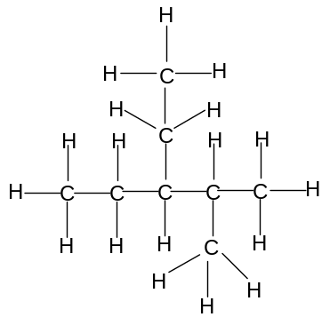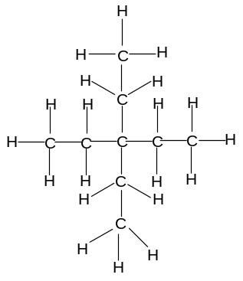

2-methyl,3-ethylpentane diethylpentane

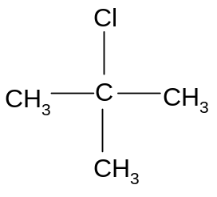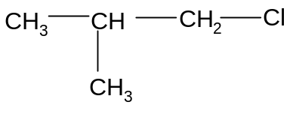

2-methyl,2-chloropropane 2-methyl,1-chloropropane
or methyl, 2-chloropropane or methyl,1-chloropropane

Many organic compounds which appear to be different are in fact the same. They appear to be different because different notations are used, or because some of the bonds are simply rotated.

Eg butane can be represented in a number of ways:

Such as
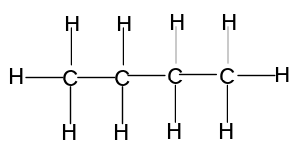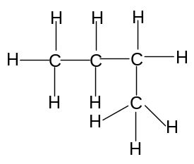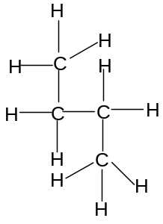

Eg 1-chloropropane can be represented in a number of ways:

Such as
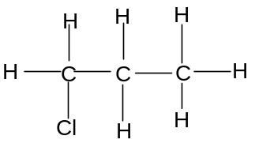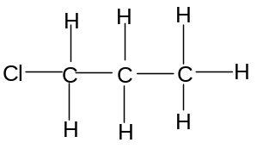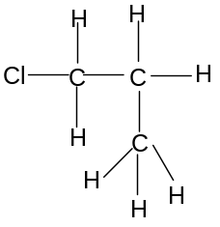
ISOMERISM

Isomers are molecules which have the same molecular formula but different structures.

There are a number of different types of isomerism in organic compounds, which can be classified as structural isomerism or stereoisomerism.

- Structural Isomerism

Structural isomers are molecules which have the same molecular formula but a different arrangement of covalent bonds.

The different arrangement of covalent bonds can result from:
- The functional group being in different positions (positional isomerism)
ii) A different arrangement of the carbon skeleton (chain isomerism)
iii) A different functional group (functional isomerism)

i) Positional isomerism

Positional isomers are molecules with the same molecular formula but which have the functional group on different positions in the molecule.

Alkanes do not show functional isomerism as they have no functional group.

Alkenes with four or more carbon atoms show positional isomerism:

Eg but-1-ene and but-2-ene

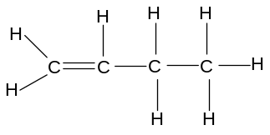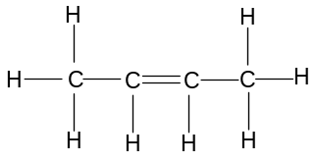
Halogenoalkanes and alcohols with three or more carbon atoms show positional isomerism

Eg 1-chloromethylpropane and 2-chloromethylpropane

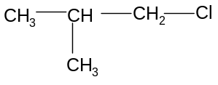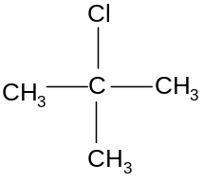
ii) Chain isomerism

Chain isomers are molecules with the same molecular formula but a different arrangement of carbon atoms.

The arrangement of carbon atoms in an organic molecule is known as the carbon skeleton.

Carbon skeletons containing up to three carbon atoms can only be arranged in one way – i.e. a straight chain with no branching:

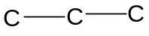

Carbon skeletons containing four carbon atoms can be arranged in two ways:

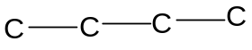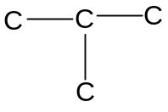

Carbon skeletons containing five carbon atoms can be arranged in three ways:

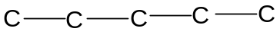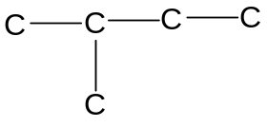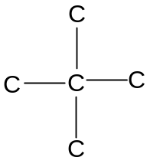
Carbon skeletons containing six carbon atoms can be arranged in five ways:
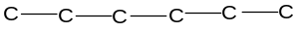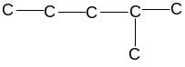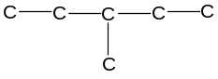
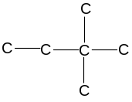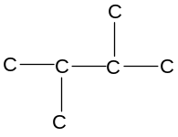
All molecules containing four or more carbon atoms can thus show chain isomerism:

Eg butane and methylpropane
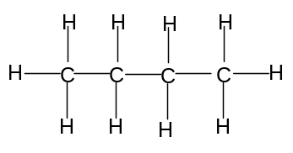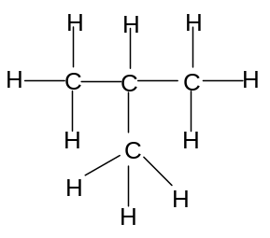

Eg pent-1-ene and 2-methylbut-1-ene
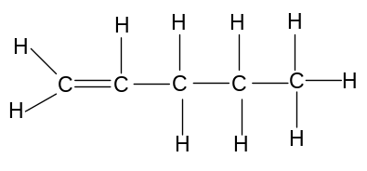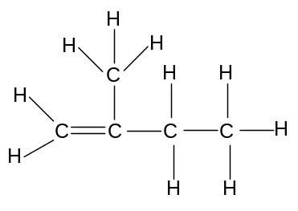

Eg 1-chloropentane and 1-chloro,2,2-dimethylpropane
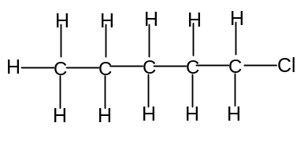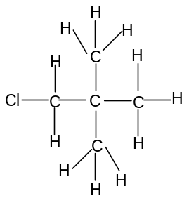

iii) Functional isomerism

Functional isomers are molecules with the same molecular formula but different functional groups.

eg Alkanes which have a ring rather than a straight chain arrangement are known as cycloalkanes. They have the general formula C_{n}H_{2n}, which is the same as alkenes. Cycloalkanes and alkenes can thus show functional isomerism.

Eg cyclohexane and hex-1-ene

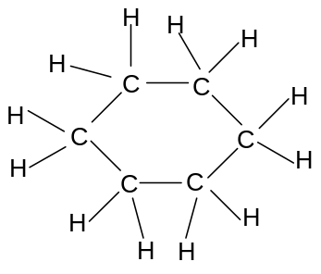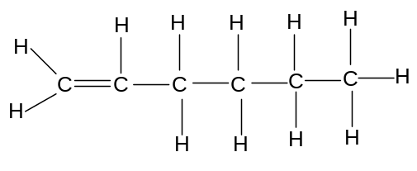

Eg cyclobutane and but-1-ene
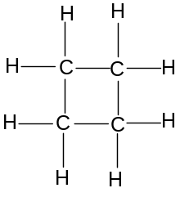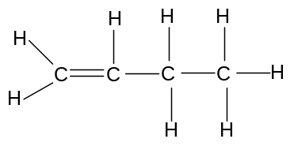

- Stereoisomerism

It is possible for a two molecules to have the same atoms bonded to each other but to be different due to a different spatial arrangement. This is known as stereoisomerism. The only type of stereoisomerism required at AS-level is E-Z isomerism.

Stereoisomers are molecules with the same structural formula but a different spatial arrangement of atoms.

E-Z stereoisomerism

In double bonds, the first bond involves an overlap of atomic orbitals directly in between the nuclei of the two atoms:

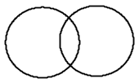
This is known as a σ-bond. All single covalent bonds are σ-bonds.

The second bond, however, cannot bond in the same place. Instead, two p-orbitals overlap above and below the internuclear axis:



This is known as a π-bond. All double covalent bonds consist of one σ-bond and one π-bond.

Since these orbitals overlap in two places, it is not possible to rotate a π-bond about its axis without breaking the bonds. There is thus restricted rotation about the double bond. If both carbon atoms on either side of the bond are attached to different groups, then two different structures arise which cannot be interconverted. This is known as E-Z isomerism.

E-Z stereoisomers (also called geometrical isomers) are stereoisomers with different spatial orientations around the carbon-carbon double bond.

It is caused by the restricted rotation about a carbon-carbon double bond.

It arises when the carbon atoms on both sides of the bond are attached two different groups.

Eg but-2-ene has two geometrical isomers:

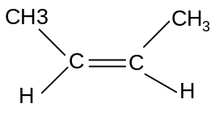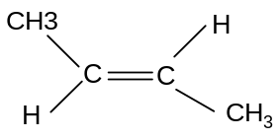

These two isomers cannot be interconverted without breaking the π-bond.

It is possible to distinguish the isomers by a simple prefix, known as CIP (Cahn-Ingold-Prelog) notation.

The carbon atoms on either side of the double bond must both be attached to two different groups for stereoisomerism to exist. These two different groups, for each carbon, must be classified as higher priority or lower priority.

Whichever group has the atom with the higher atomic number attached to the C atom in the C=C bond is the higher priority group. If both groups are attached to the C by the same atom, then the next atom along the chain is considered.

Eg Cl is a higher priority group than CH₃
(because Cl has a higher atomic number than C)
CH₃ is a higher priority group than H
(because C has a higher atomic number than H)
C₂H₅ is a higher priority group than CH₃
(both groups use a C bonded to the C in C=C, but in C₂H₅ that C is bonded to another C, whereas in CH₃ that C is only bonded to H atoms)

If higher priority groups are on the same side of the molecule, the prefix Z is used (Zusammen, which means together in German).
If higher priority groups are on different sides of the molecule, the prefix E is used (Entgegen, which means opposite in German).

Z but-2-ene E but-2-ene

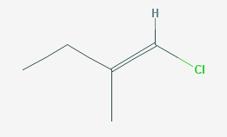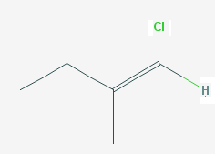
E 1-chloro, 2-methylbut-1-ene Z 1-chloro, 2-methylbut-1-ene

Note that molecules which show geometrical isomerism always have two specific structural features:
- there is a carbon-carbon double bond
- both the carbon atoms are attached to two different groups.

Geometrical isomers should always be drawn using crab notation. Crab notation shows the C=C bond as a planar centre with the 4 groups shown as follows:
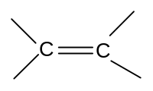
Using crab notation, it is easy to predict whether geometrical isomerism will exist in molecules.

Ethene | 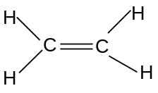 | No geometrical isomerism
Propene | 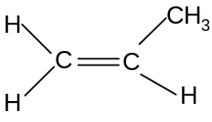 | No geometrical isomerism
But-1-ene | 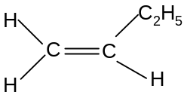 | No geometrical isomerism
But-2-ene | 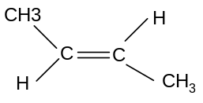 | Geometrical isomerism
2-methylpropene | 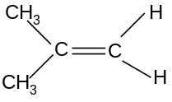 | No geometrical isomerism
Pent-1-ene | 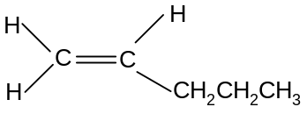 | No geometrical isomerism
Pent-2-ene | 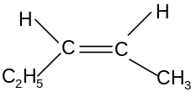 | Geometrical isomerism
2-methylbut-1-ene | 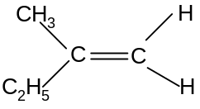 | No geometrical isomerism
2-methylbut-2-ene | 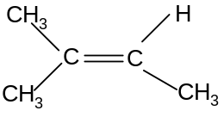 | No geometrical isomerism
3-methylbut-1-ene | 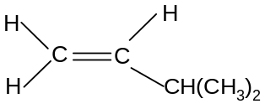 | No geometrical isomerism

- Distinguishing between isomers

Isomers tend to differ slightly in their melting and boiling points. Molecules with no branching tend to have higher boiling points than isomers with more branching. This is because they have a higher surface area, so they pack together better and so the van der Waal’s forces are stronger.

Eg isomers of pentane, C₅H₁₂:

Isomer | Structure | Boiling point/ºC
Pentane | 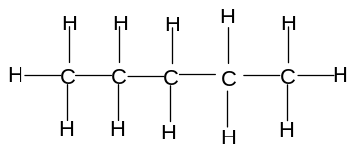 | 36
Methylbutane | 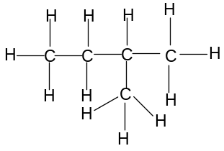 | 28
2,2-dimethylpropane | 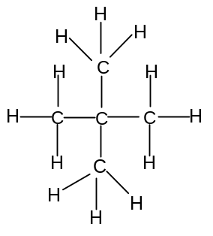 | 10

CRUDE OIL

- Introduction

The vast majority of carbon-containing compounds in widespread use have been made from crude oil. Crude oil is also known as petroleum.

Crude oil is a mixture of hydrocarbons. A hydrocarbon is a substance containing carbon and hydrogen only. Most of the hydrocarbons in crude oil are alkanes. Alkanes are hydrocarbons containing only single bonds between the carbon atoms.

Each of the hydrocarbons present in crude oil has a slightly different use. Mixed together they are of no use at all. It is necessary, therefore, to separate them before they can be used productively. Crude oil is separated into its different components by a process called fractional distillation.

The products of fractional distillation are often converted into other, even more useful hydrocarbons by a process called cracking.

- Fractional distillation

The different hydrocarbons in crude oil have different boiling points. This is because the chain length varies. The greater the number of carbon atoms in the chain, the longer the chain length. This results in more Van der Waal’s forces acting between the molecules and a greater intermolecular attraction. Thus more energy is needed to separate the molecules and the boiling point is higher. It is the difference in boiling points of the different hydrocarbons in crude oil which is used to separate them from each other.

The crude oil is passed into a tall tower called a fractionating column. This is very hot near the base but much cooler near the top. When the crude oil is passed into the tower, near the bottom, most of the mixture boils and starts to rise up the tower. As they rise up the tower, they start to cool down and will gradually condense back into liquid form. They are then tapped off. The larger hydrocarbons, with higher boiling points, will condense first and be tapped off near the base of the column. The smaller hydrocarbons, with smaller boiling points, will condense later and be tapped off near the top of the column. Thus the separation is achieved. Not that the process involves breaking intermolecular forces only; the molecules themselves are unaffected by this process.

This process does not actually separate the crude oil mixture into pure hydrocarbon components, but into mixtures called fractions. Fractions are mixtures of hydrocarbons with similar boiling points. In many cases these fractions can be used directly, but sometimes further separation is required into purer components.

The following page shows a diagram of a typical fractionating column, and a table showing the most important fractions and their main uses:
A fractionating column

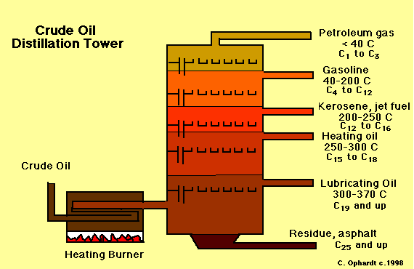

Fractions from crude oil

Name of fraction | Boiling range  / ºC | Number of hydrocarbons | Uses
Liquefied petroleum gas | Less than 25  Above 450 | 1 – 4  More than 50 | Gas for camping/ cooking
Petrol or gasoline | Less than 25  Above 450 | 1 – 4  More than 50 | Fuel for cars etc
Naphtha | Less than 25  Above 450 | 1 – 4  More than 50 | Petrochemicals
Kerosine or paraffin | Less than 25  Above 450 | 1 – 4  More than 50 | Plane fuel, petrochemicals
Diesel or gas oil | Less than 25  Above 450 | 1 – 4  More than 50 | lorry, central heating fuel
Mineral/lubricating oil | Less than 25  Above 450 | 1 – 4  More than 50 | Lubrication, petrochemicals
Fuel oil | Less than 25  Above 450 | 1 – 4  More than 50 | Ship fuel, power stations
Wax and grease | Less than 25  Above 450 | 1 – 4  More than 50 | Candles, grease, polish
Bitumen or tar | Less than 25  Above 450 | 1 – 4  More than 50 | Road surfaces, roofing

The term petrochemical means that the compounds are converted into other chemicals for use as solvents, paints and various other things.
- Cracking

Although all of the fractions produced from crude oil have their uses, some of the fractions are produced in greater quantities than needed, whilst others are not produced in sufficient quantities. The table below gives an example of the difference between the supply and demand of some important fractions:

Supply and demand for fractions

Fraction | Approximate supply/% | Approximate demand/%
Liquefied petroleum gases | 2 | 4
Petrol and naphtha | 16 | 27
Kerosine | 13 | 8
Gas oil | 19 | 23
Fuel oil and bitumen | 50 | 38

This disparity can be corrected by breaking up some larger hydrocarbons in fuel oil into the smaller ones found in gas oil, or by breaking up some hydrocarbons in kerosene into the smaller ones found in petrol, naphtha or the liquefied petroleum gases. In other words the larger fractions (for which supply exceeds demand) can be broken up into smaller fractions (for which demand exceeds supply).

The process by which this is carried out is called cracking.

Cracking has the added advantage of producing other useful hydrocarbons not naturally present in crude oil, such as alkenes (widely used as petrochemicals), cycloalkanes and branched alkanes (widely used in motor fuels) and aromatic hydrocarbons (used as petrochemicals and as motor fuels).

Thus cracking is important for two reasons:
- It converts low-demand fractions into higher demand fractions
- It makes useful hydrocarbons not naturally found in crude oil

There are two types of cracking: thermal cracking and catalytic cracking. Both involve the breaking of C-C bonds to form smaller molecules. C-C bonds are weaker than C-H bonds and so break more easily when heated.

- Thermal cracking

In thermal cracking, the bonds are broken using a high temperature (400 – 900ºC) and a high pressure (70 atmospheres).

The high temperatures mean that the molecule breaks near the end of the chain, giving a high percentage of small alkenes such as ethene.

Most thermal cracking reactions involve the formation of one of more small alkane molecules and one alkene molecule. Naphtha (C₇ – C₁₄) is usually used as the starting material.

Eg C₈H₁₈ → C₆H₁₄ + C₂H₄

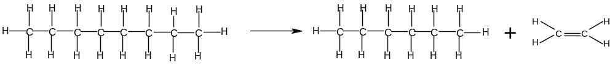

Eg C₆H₁₄ → C₃H₈ + C₃H₆

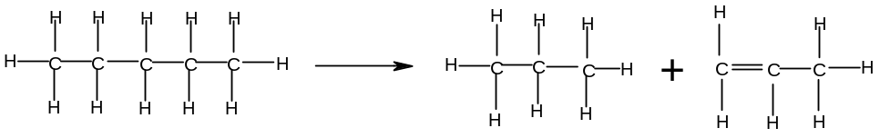

- Catalytic cracking

In catalytic cracking, the bonds are broken using a high temperature (450 ºC, which is generally lower than in thermal cracking), a slight pressure (slightly greater than 1 atmosphere), and a zeolite catalyst.

Catalytic cracking is cheaper and more efficient than thermal cracking as it uses a lower temperature and pressure.

The zeolite catalyst favours the formation of branched alkanes and cycloalkanes, which are widely used in motor fuels. The most important product of catalytic cracking is 2-methylheptane, which is the major component of petrol. It also produces aromatic hydrocarbons such as benzene, which have a variety of uses.

Eg 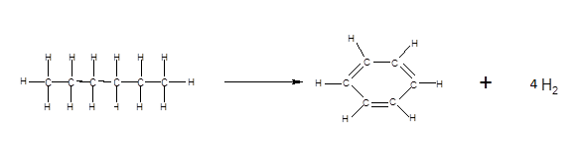

A table summarising the differences between thermal and catalytic cracking can is shown below:

Type of cracking | Thermal | Catalytic
Conditions | High temperature (400 – 900 ºC)  High pressure (70 atm) | High temperature (450 ºC)  Slight pressure ( > 1 atm)  Zeolite catalyst
Main products | High percentage of alkenes | Motor fuels (ie branched alkanes)  Aromatic hydrocarbons

COMBUSTION OF ALKANES

1. Alkanes as fuels

Many of the fractions produced from crude oil are used as fuels. These fractions include:

fraction | uses
Liquefied petroleum gases | Camping gas, cooking gas
Petrol | Fuel for cars, motorbikes and machines
Kerosine | Fuel for aeroplanes, lamps, ovens
Diesel | Fuel for lorries, and central heating systems
Fuel oil | Fuel for ships, power stations
Wax | Fuel for candles

A fuel is a something that can be changed in a reacting vessel to produce useful energy.

Hydrocarbons, and especially alkanes, will react with oxygen in the air to give carbon dioxide and water. A reaction with oxygen is known as combustion. As alkanes are unreactive the reaction needs heat or a spark to get going.

These reactions are very exothermic, which means that heat energy is released. This heat energy can be used for direct heating (eg camping gas, central heating, candles). It can also be converted into mechanical energy (eg cars, lorries, ships), or even electrical energy (eg power stations).

Typical examples of combustion reactions include:

Reaction | Enthalpy change/ kJmol⁻¹
CH₄ + 2O₂ → CO₂ + 2H₂O | -890
C₄H₁₀ + 6½O₂ → 4CO₂ + 5H₂O | -2877
C₈H₁₈+ 12½O₂ → 8CO₂ + 9H₂O | -5470

The release of heat energy during these combustion reactions results in their widespread use as fuels.

2. Pollution problems associated with burning hydrocarbons

- carbon dioxide

Although carbon dioxide is not poisonous and is naturally removed from the atmosphere by plants, the enormous quantities of hydrocarbons burned in recent years has caused carbon dioxide levels to rise significantly.

Carbon dioxide, along with various other compounds, prevents the earth’s heat from escaping into space and is resulting in an increase in the earth’s temperature. This is known as global warming. The result is the melting of the polar ice caps which is likely to cause severe flooding in the future, as well as serious damage to numerous ecosystems.

Gases which contribute towards global warming are known as greenhouse gases.

- Water vapour

Water vapour is also produced in large quantities as a result of combustion of hydrocarbons and is also a greenhouse gas.

- carbon monoxide and carbon

The combustion of hydrocarbons to produce carbon dioxide and water is called complete combustion, and it requires a lot of oxygen. If oxygen is not present in sufficiently large quantities, carbon monoxide or carbon is produced instead of carbon dioxide. This is called incomplete combustion.

Examples of incomplete combustion reactions are:

C₄H₁₀ + 4½O₂ → 4CO + 5H₂O | Incomplete combustion
C₄H₁₀ + 2½O₂ → 4C + 5H₂O | Incomplete combustion
C₈H₁₈+ 10½O₂ → 8CO + 9H₂O | Incomplete combustion
C₈H₁₈+ 8½O₂ → 8C + 9H₂O | Incomplete combustion

The less oxygen that is available, the more likely it is that incomplete combustion will occur. This is a particular problem in internal combustion engines where the air supply is limited. Incomplete combustion is a problem for three reasons:

- Less energy is released by incomplete combustion than by complete combustion.
- Carbon monoxide is a pollutant – it is absorbed by the blood in place of oxygen, and hence reduces the ability of the blood to carry oxygen causing suffocation and eventually death.
- Carbon particles can cause breathing difficulties and cancer.

It is therefore desirable to ensure that the air supply is as good as possible when burning hydrocarbon fuels.

Occasionally incomplete combustion is desirable – such as with a Bunsen burner. Closing the air hole produces a yellow flame (the yellow colour results from hot carbon particles) and this makes the flame more visible and causes a more gentle heat. Usually, however, complete combustion is considered more desirable.

- sulphur dioxide

Most crude oil deposits contain sulphur as an impurity. Oil refineries are increasingly treating the petrol fractions to lower the sulphur content, but some sulphur is still present in most hydrocarbon fuels. When the fuel is burned, the sulphur also burns, producing sulphur dioxide:

S(s) + O₂(g) → SO₂(g)

This gas dissolves in rainwater forming a very acidic solution, known as acid rain. This causes various problems, including erosion of buildings and statues, killing of plants and trees, and killing of fish through contamination of lakes.

- oxides of nitrogen

Most fuels are not burned in pure oxygen but in air, which contains 80% nitrogen. Although nitrogen is not a reactive gas, the high temperatures and the spark in combustion engines cause some of the nitrogen to react with the oxygen to produce nitric oxide and nitrogen dioxide:

N₂(g) + O₂(g) → 2NO(g)
2NO(g) + O₂(g) → 2NO₂(g)

Nitrogen dioxide (NO₂) also dissolves in rainwater to form an acidic solution and contributes to the problem of acid rain.

Nitrogen oxides can also combine with unburned hydrocarbons to produce a photochemical smog.

- unburned hydrocarbons

Some of the hydrocarbon fuel is vaporised in the engine but escapes before it is burned. These unburned hydrocarbons cause various problems. They are toxic and can cause cancer if breathed in.

They also combine with oxides of nitrogen to produce a photochemical smog.

3. Ways of reducing pollution levels

A number of ways have been developed to reduce the polluting effects associated with the burning of fossil fuels. Two examples are given here:

a) Flue gas desulphurisation

Many factory chimneys contain alkaline materials such as lime (calcium oxide). These absorb the acidic gases such as SO₂ and thus prevent them from escaping:
SO₂ + CaO → CaSO₃

Further reactions result in the formation of CaSO₄ (gypsum) which is used to make plaster.

b) Catalytic Converters

Most modern car exhausts are now fitted with catalytic converters. These are designed to convert some of the more harmful gases present in car exhausts into less harmful ones. Unburned hydrocarbons, carbon monoxide and the oxides of nitrogen can all be converted into less harmful gases inside these converters.

There are two main types of reaction taking place in a catalytic converter:

i) removal of carbon monoxide and nitrogen monoxide

2NO(g) + 2CO(g) → N₂(g) + 2CO₂(g)

Hence harmful NO and CO gases are converted into the less harmful nitrogen and carbon dioxide.

ii) removal of unburned hydrocarbons and nitrogen monoxide

eg C₈H₁₈ + 25NO → 8CO₂ + 9H₂O + 12.5N₂

Hence harmful unburned hydrocarbons and oxides of nitrogen are converted into the less harmful carbon dioxide, water and nitrogen.

...........................................................................................................................

The reality is, however, that the burning of hydrocarbon fuels has caused and continues to worsen most of the planet’s most serious environmental problems. Although technological innovations such as catalytic converters can limit some of the damage, the only action which will have any lasting effect is to reduce the reliance of rich Western countries, especially the USA, on fossil fuels. This will only happen if the potential of alternative sources of energy is more fully exploited, the political and economic power of oil barons is curbed and wealthy industrialised countries look at ways to reduce their energy consumption. Achieving these goals, however, has been socially and politically problematic.

