UNIT 1
ATOMS AND THE PERIODIC TABLE
Answers

Lesson 1 – What are atoms?

Test Your Knowledge 1.1: Understanding the basic structure of an atom
Red (+) circles are protons, blue circles are neutrons, small black (-) circles are electrons, larger black circle containing protons and neutrons is the nucleus, large outer circles containing electrons are shells
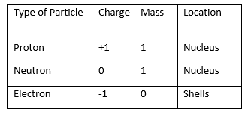

Test Your Knowledge 1.2: Understanding atomic names and symbols
1, 1, hydrogen, H; 3, 3, lithium, Li; 8, 8, oxygen, O; 15, 15, phosphorus, P; 29, 29, copper, Cu; 54, 54, xenon, Xe; 9, 9, fluorine, F; 13, 13, aluminium, Al; 11, 11, sodium, Na

Lesson 2 – How many neutrons do atoms have?

Test your knowledge 2.1: Understanding atomic numbers and mass numbers
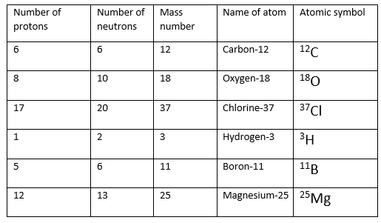

Test Your Knowledge 2.2: Understanding atomic symbols
(a) (i) 1p, 0n, 1e; (i) 8p, 9n, 8e; (iii) 54p, 78n, 54e; (iv) 92p, 143n, 92e; (v) 6p, 8n, 6e
(b) (i) ³⁹K; (ii) ¹⁶O; (iii) ³H; (iv) ²⁰⁸Pb; (v) ¹²⁷I

Summary Activity 2.3: Mass and charge in atoms
- Proton: mass 1, charge +1; neutron: mass 1, charge 0; electron: mass 0, charge -1

Thinkabout 2.4: Why do protons and neutrons not have a fixed mass?
Note: this is intended for discussion only; students are not expected to know the detailed answers to this question at this stage in the course:
Nucleons stick together and the energy needed to force them apart is called the binding energy; the greater the binding energy, the lower the mass of the nucleon (E = mc²); during nuclear reactions, the binding energy changes and the difference in energy is released as heat and kinetic energy (note: this topic will be covered later in the course)

Lesson 3 – What is relative atomic mass?

Test Your Knowledge 3.1: Calculating relative atomic masses
(a) 28.11; (b) 107.96; (c) 63.62; (d) 69.80; (e) 24.32
Note: students should record answers to 2 dp to prevent them from simply copying down the rams from the Periodic Table

Extension 3.2: Understanding relative atomic masses
- They must be approximately equal
- 40% ¹⁹¹Ir and 60% ¹⁹³Ir

Test your knowledge 3.3: Calculating relative atomic mass accurately
- Average mass of ²H nucleon = 2.0141/2 = 1.0071, so the nucleon in ¹H is heavier
- ((1.0078 x 99.985) + (2.0141 x 0.015))/100 = 1.0080

Test Your Knowledge 3.4: Understanding atoms and ions
(a) (i) 2p, 2n, 0e; (ii) 13p, 14n, 10e; (iii) 35p, 44n, 36e; (iv) 1p, 2n, 0e; (v) 9p, 10n, 8e
(b) (i) ¹⁶O²⁻; (ii) ²⁰⁷Pb²⁺; (iii) ¹²⁷I⁻; (iv) ²¹⁰Po²⁺; (v) ⁵⁶Fe³⁺
(c) Cations: 1abde, 2 bde; anions 1c, 2ac

Lesson 4 – How are electrons arranged in atoms?

Test your knowledge 4.1: Understanding energy levels, sub-shells, orbitals and shells
- Line spectra are a series of electromagnetic radiations, each with certain distinct frequencies, which result when electrons in atoms fall from higher energy levels to lower energy levels. Their existence shows that only certain energy levels are possible in atoms
- 3: 3s, 3p and 3d
- 1 x 3s, 3 x 3p, 5 x 3d
- 4 (1 x 3s, 3 x 3p)

Extension 4.2: Understanding energy levels, sub-shells, orbitals and shells
- 1 x 4s, 3 x 4p, 5 x 5d, 7 x 4f
- 1 x 4s, 5 x 3d, 3 x 4p

Lesson 5 – How are electrons arranged in the different orbitals in an atom?

Test your knowledge 5.1: Filling electrons in orbitals, shells and energy levels
- 2
- 2s, 3 x 2p, so 8 electrons
- 18
- 8

Extension 5.2: Filling electrons in orbitals, shells and energy levels
Fourth energy level: 32 (2 in 4s, 6 in 4p, 10 in 4d, 14 in 4f)
Fourth shell: 18 (2 in 4s, 10 in 3d, 6 in 4p)

Test your knowledge 5.3: Understanding electronic configuration of atoms
- S: 1s²2s²2p⁶3s²3p⁴; Ti: 1s²2s²2p⁶3s²3p⁶4s²3d²; Br: 1s²2s²2p⁶3s²3p⁶4s²3d¹⁰4p⁵
- P: [Ne] 3s²3p³; Cu: [Ar] 4s¹3d¹⁰

Extension 5.4: Understanding electronic configuration of atoms
Free choice question so no answers available

Lesson 6 – What is the Periodic Table?

Test your knowledge 6.1: Understanding electronic configuration of Ions
Na⁺: 1s²2s²2p⁶ O⁻: 1s²2s²2p⁵ Fe²⁺: 1s²2s²2p⁶3s²3p⁶3d⁶ Cu²⁺: 1s²2s²2p⁶3s²3p⁶3d⁹
Br: 1s²2s²2p⁶3s²3p⁶4s²3d¹⁰4p⁶

Extension 6.2: Understanding electronic configuration of ions
Free choice question so no answers available

Test your knowledge 6.3: Understanding the structure of the Periodic Table
- (i) 2 shells, 5 electrons in outer shell; (ii) 5 shells, 7 (or 17) electrons in outer shell; 5 shells; 2 electrons in outer shell; 4 shells, 8 (or 18) electrons in outer shell; (v) 5 shells, 4 (or 14) electrons in outer shell
- (i) selenium (Se); (ii) phosphorus (P)
- (i) s-block; (ii) d-block; (iii) f-block; (iv) p-block

Lesson 7 – How do the properties of atoms change with their position in the Periodic Table?

Test your knowledge 7.1: Understanding trends in atomic and ionic size
- Mg has more protons and the same shielding, so a stronger nuclear attraction, so electrons in outer shell pulled in closer to nucleus
- K has more shells, so more shielding, so a weaker nuclear attraction, so outer shell electrons pushed further away from nucleus
- Cl⁻ has an extra electron, so the outer electrons repel more and move further apart
- Na⁺ has one fewer electron and also one less shell, so there is less shielding of the outer electrons (which are now in the second shell)

Test your knowledge 7.2: Understanding trends in first ionisation energy
- Mg has more protons, but the same number shells so the same shielding; so the outer electrons in Mg are more strongly attracted to the nucleus and harder to remove
- Mg has fewer protons, but the outer electron in Al is in a 3p subshell, so experiences extra shielding from the 3s electrons which reduces the nuclear attraction and makes the electron easier to remove
- P has fewer protons, but the outer electron in S is paired; the repulsion between the paired electrons makes it easier to remove one of them
- Na has more shells so the outer electrons are more shielded from the nucleus, reducing the nuclear attraction and make the outer electron easier to remove

Extension 7.3: Understanding trends in first ionisation energy
Free choice question so no answers available

Lesson 8 – What is meant by electron affinity?

Test your knowledge 8.1: Understanding trends in first electron affinity
- Al has more protons, but the same number shells so the same shielding; so the incoming electron is more attracted to the nucleus
- Na has fewer protons, but the incoming electron in Mg must be added to a 3p subshell, so experiences extra shielding from the 3s electrons which reduces the nuclear attraction
- Si has fewer protons, but incoming electron in P would have to be paired; the repulsion between the paired electrons makes it harder to add the second one
- Na has more shells so the incoming electron is more shielded from the nucleus, reducing the nuclear attraction

Extension 8.2: Trends in First Electron Affinity
Free choice question so no answers available

Test your knowledge 8.3: Understanding the chemical properties of atoms
- Cl has an extra proton and the same shielding, so a greater attraction between the nucleus and the joining electron
- F has fewer shells, so there is less shielding from inner shells, and a greater attraction between the nucleus and the joining electrons
- Na has an extra shell, which repels the electron in the outer shell making it easier to remove
- The attraction between nucleus and outer electrons is high so it is hard to remove electrons, but they also cannot accept electrons without creating a new shell

Lesson 9 – How has our understanding of the atom changed over time?

Thinkabout 9.1: How scientific theories change over time
Suggestions: How the solar system works (scientists used to believe the earth was flat, then that the sun went around the earth); how new species are created (scientists used to believe that all creatures were created at the beginning of time); encourage other suggestions
A theory is challenged when evidence is found which contradicts it; scientists have to find new theories consistent with the new evidence

Test your knowledge 9.2: Describing how our understanding of the atom has changed over time
(a), (b), (c) (d) 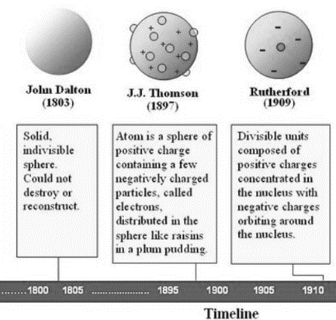

Extension 9.3: Exploring further developments in understanding atomic structure
Bohr: developed idea of fixed energy levels (shells and orbits)
Schrodinger: developed idea of orbitals as regions of electron density
(students do not need to know about these scientists for the WASSCE exam)

Thinkabout 9.4: Mendeleev’s Periodic Table
Most errors were from not having a d-block, so wrongly placing d-block elements in one of the other groups

Lesson 10 – What have you understood about Atoms and the Periodic Table?

10.1 END-OF-TOPIC QUIZ

TOPIC 1 – ATOMS AND THE PERIODIC TABLE
- (a) atoms with the same atomic number (or number of protons) but different mass numbers (or numbers of neutrons); (b) 10.8; (c) same nuclear charge and electronic structure
- 17 protons, 20 neutrons, 18 electrons
- ²³Na⁺
- That only certain energy levels are possible (the energies of the electrons are quantised)
- 1 x 3s, 3 x 3p, 5 x 3d
- 1s²2s²2p³
- 1s²2s²2p⁶3s²3p⁶4s²3d¹⁰4p⁵
- Energy required to remove one electron from each atom in a mole of free gaseous atoms
- Nuclear charge increases, but shielding stays the same, so nuclear attraction increases
- The electron in Al is removed from a 3p orbital, which experiences more shielding, so nuclear attraction is less
- The electron in O is removed from a paired orbital, and the repulsion between the paired electrons makes the first electron easier to remove
- More shells so more shielding and a weaker nuclear attraction
- Energy change when one electron is added to each atom in a mole of free gaseous atoms
- The electron in P is added to a paired orbital, and the repulsion between the paired electrons makes the electron less easy to add
- He discovered the existence of electrons, showing that atoms were not indivisible but made of smaller particles

