UNIT F322: CHAINS, ENERGY AND RESOURCES

REVISION CHECKLIST

Read each point in the specification clearly and answer all the related questions.

If you can answer all of these questions, you will do well!

  - Module 1: Basic Concepts and Hydrocarbons

2.1.1 Basic Concepts

Candidates should be able to:

Representing Formulae of Organic Compounds

- interpret and use the terms:
- empirical formula as the simplest whole number ratio of atoms of each element
present in a compound,
- molecular formula as the actual number of atoms of each element in a molecule,
- general formula as the simplest algebraic formula of a member of a homologous
series, ie for an alkane: C_{n}H_{2n + 2},
- structural formula as the minimal detail that shows the arrangement of atoms in a
molecule, eg for butane: CH₃CH₂CH₂CH₃ or CH₃(CH₂)₂CH₃,
- displayed formula as the relative positioning of atoms and the bonds between them, ie for ethanol:
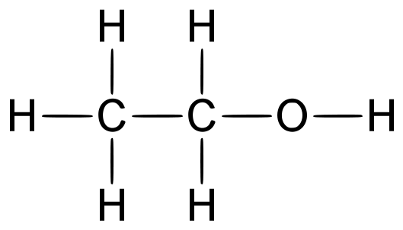
- skeletal formula as the simplified organic formula, shown by removing hydrogen atoms from alkyl chains, leaving just a carbon skeleton and associated functional groups, ie for butan-2-ol:
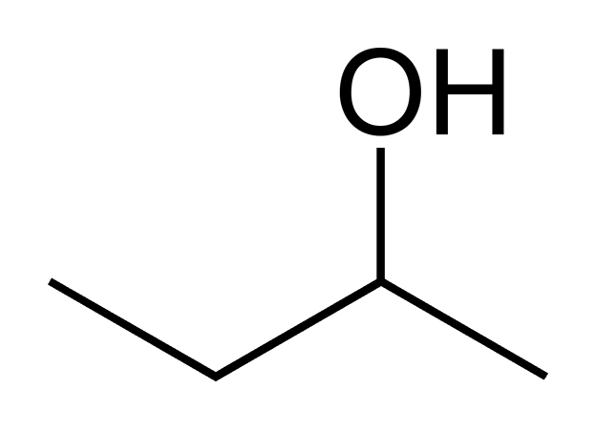

Complete the following table of formulae:

empirical | molecular | structural | displayed | skeletal
 |  | (CH₃)₂C=CHCH₃
 |  |  | 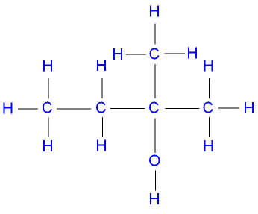
 |  |  |  | 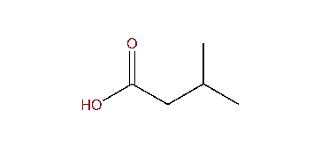
 |  | HOOC(CH₂)₂CHO
 |  |  | 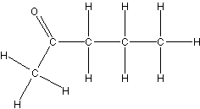
 |  |  |  | 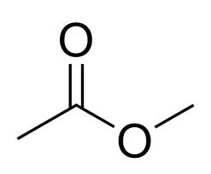
State the general formula of the following molecules:

alkanes:................. alkenes:................. cycloalkanes:................. alcohols:.................

carbonyls:................. alkenols:................. cyclic alcohols:.................

carboxylic acids:................. esters:.................. cycloalkenes:...........................

Suggest what type of compound the following molecules could be:

C₆H₁₄ .............................................................................................

C₆H₁₂ .............................................................................................

C₆H₁₄O .............................................................................................

C₆H₁₂O .............................................................................................

C₆H₁₂O₂ .............................................................................................

C₆H₁₀O₂ .............................................................................................

Functional groups and the naming of organic compounds

- interpret and use the terms:
- homologous series as a series of organic compounds having the same functional group but with each successive member differing by CH₂,
- functional group as a group of atoms responsible for the characteristic reactions of a compound;

Define the terms:

homologous series......................................................................................................................................

....................................................................................................................................................................

functional group.........................................................................................................................................

....................................................................................................................................................................

- use the general formula of a homologous series to predict the formula of any member of the series;

Predict the molecular formula of:

An alkane with 10 carbon atoms ..................................

An alkene with 8 carbon atoms ..................................

An alcohol with 7 carbon atoms ..................................

A bromoalkane with 5 carbon atoms ..................................

A cycloalkane with 8 carbon atoms ..................................

A cycloalkene with 9 carbon atoms ..................................

A cyclic ketone with 6 carbon atoms ..................................

A ketone with 9 carbon atoms ..................................

A carboxylic acid with 9 carbon atoms ..................................

An ester with 9 carbon atoms ..................................

- state the names of the first ten members of the alkanes homologous series;

Name the first 10 members of the alkanes homologous series;

......................... ......................... ......................... .........................

......................... ......................... ......................... .........................

......................... .........................

- use IUPAC rules of nomenclature for systematically naming organic compounds;

Name the following compounds:

(CH₃)₂C=CHCH₃
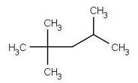 | 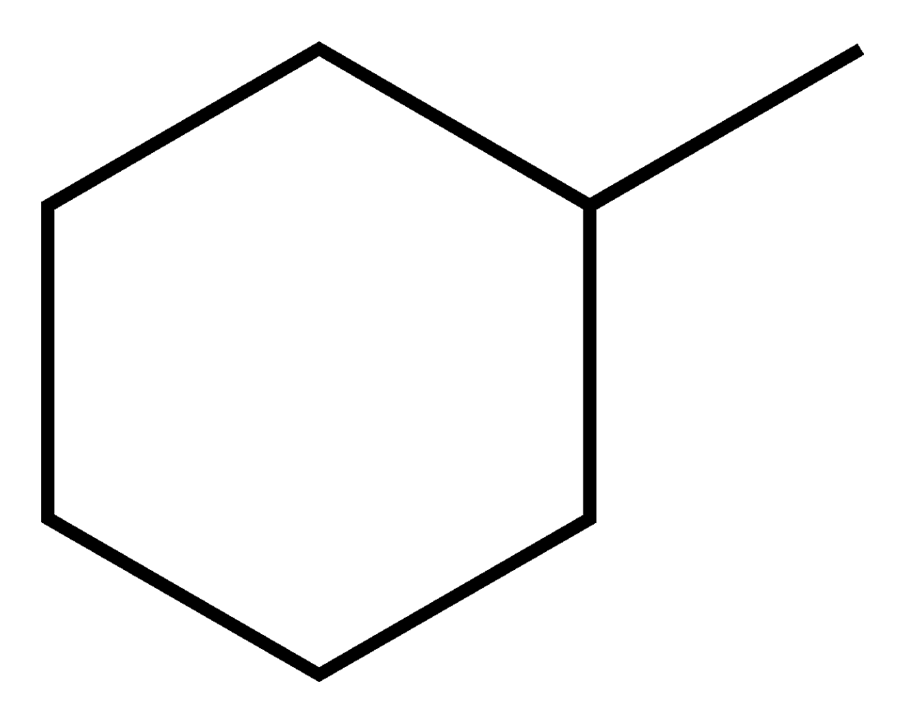 | 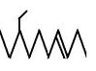 | 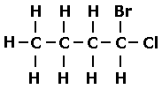
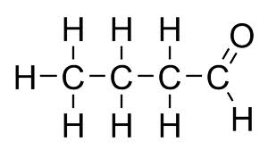 | 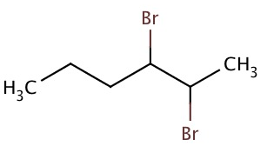 | 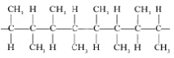 | 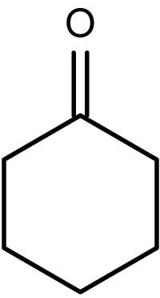
Isomerism
- describe and explain the terms:
- structural isomers as compounds with the same molecular formula but different structural formulae,
- stereoisomers as compounds with the same structural formula but with a different arrangement in space,
- E/Z isomerism as an example of stereoisomerism, in terms of restricted rotation about a double bond and the requirement for two different groups to be attached to each carbon atom of the C=C group,
- cis-trans isomerism as a special case of EIZ isomerism in which two of the substituent groups are the same;

Structural Isomers: ....................................................................................................................................

....................................................................................................................................................................

Draw and name two structural isomers with molecular formula C₄H₈:

Stereoisomers: ..........................................................................................................................................

....................................................................................................................................................................

State which type of stereoisomerism exists in some alkenes:....................................................................

Which alkenes show this type of isomerism?

....................................................................................................................................................................

Why does this type of isomerism exists in these alkenes?

....................................................................................................................................................................

What is cis-trans isomerism?

....................................................................................................................................................................

Draw the two stereoisomers of pent-2-ene, name them and state whether the molecules show cis-trans isomerism:

Draw the two stereoisomers of 1-chloro, 2-methylbut-1-ene and state whether the molecules show cis-trans isomerism.

- determine the possible structural formulae and/or stereoisomers of an organic molecule, given its molecular formula;

Draw the eight different isomers of C₅H₁₁Br and name them:

Draw the eleven different isomers of C₅H₁₀ and name them:

Draw at least seven different isomers of C₅H₁₀O and name them:

Draw at least six different isomers of C₄H₈O₂ and name them:

Reaction mechanisms

- describe the different types of covalent bond fission:
  - homolytic fission forming two radicals,
  - heterolytic fission forming a cation and an anion;

Homolytic fission:......................................................................................................................................

Write an equation to show the homolytic fission of Br₂:...........................................................................

Heterolytic fission:.....................................................................................................................................

Write an equation to show the heterolytic fission of Br₂:..........................................................................

- describe a ‘curly arrow’ as the movement of an electron pair, showing either breaking or formation of a covalent bond;

What does a curly arrow represent? ..........................................................................................................

- outline reaction mechanisms, using diagrams, to show clearly the movement of an electron pair with ‘curly arrows’;

Outline the mechanism of the reaction between propene and bromine:

Outline the mechanism of the reaction between 2-bromopropane and hydroxide ions:

Percentage yields and atom economy
- carry out calculations to determine the percentage yield of a reaction;

10 g of propan-1-ol was oxidised under reflux and 8.5 g of propanoic acid was made. What was the percentage yield in this reaction?

- explain the atom economy of a reaction as:
molecular mass of the desired products x 100;
sum of molecular masses of all products

What is meant by the atom economy of a reaction?

- explain that addition reactions have an atom economy of 100%, whereas substitution reactions are less efficient;

Explain why addition reactions have an atom economy of 100% but substation reactions do not:

...................................................................................................................................................................

....................................................................................................................................................................

- carry out calculations to determine the atom economy of a reaction;

Calculate the atom economy of the following different ways of preparing ethanol:

the hydrolysis of bromoethane: C₂H₅Br + NaOH → C₂H₅OH + NaBr

the fermentation of glucose: C₆H₁₂O₆ → 2C₂H₅OH + 2CO₂

the hydration of ethane: C₂H₄ + H₂O → C₂H₅OH

- describe the benefits of developing chemical processes with a high atom economy in terms of fewer waste materials;

Why is it an advantage for a chemical process to have a high atom economy?

....................................................................................................................................................................

- explain that a reaction may have a high percentage yield but a low atom economy.

Ethene can be produced from bromoethane in the following reaction: C₂H₅Br → C₂H₄ + HBr
In one batch, 200 g of bromoethane produced 45 g of ethene.
Calculate the percentage yield of ethene.

Then calculate the atom economy of the reaction and compare it to the percentage yield.

Is this an efficient process?
2.1.2 Alkanes

Hydrocarbons from crude oil

Candidates should be able to:

- explain that a hydrocarbon is a compound of hydrogen and carbon only;

What is a hydrocarbon?

....................................................................................................................................................................

- explain the use of crude oil as a source of hydrocarbons, separated as fractions with different boiling points by fractional distillation, which can be used as fuels or for processing into petrochemicals;

What does crude oil contain?.....................................................................................................................

What is the purpose of fractional distillation and how does it work?........................................................

....................................................................................................................................................................

What are the products of fractional distillation used for? ............................... and ...............................

- state that alkanes and cycloalkanes are saturated hydrocarbons;

Write the molecular formula of:

An alkane with 8 carbon atoms: ..................... A cycloalkane with 8 carbon atoms: .............

What is meant by the term “saturated”? ....................................................................................................

- state and explain the tetrahedral shape around each carbon atom in alkanes;

Draw a 3-dimensional displayed formula for ethane. State and explain the size of the H-C-H bond angle in ethane and state the shape around each carbon atom in an alkane:

....................................................................................................................................................................

....................................................................................................................................................................

- explain, in terms of van der Waals’ forces, the variations in the boiling points of alkanes with different carbon-chain length and branching;

State and explain the trends in the boiling points of hexane, heptane and octane.

...................................................................................................................................................................

....................................................................................................................................................................

State and explain the trends in the boiling points of heptane, 2-methylhexane and 2,2-dimethylpentane

...................................................................................................................................................................

....................................................................................................................................................................
Hydrocarbons as fuels

- describe the combustion of alkanes, leading to their use as fuels in industry, in the home and in transport;

Write equations to show the complete combustion of:

methane......................................................................................................................................................

octane.........................................................................................................................................................

decane.........................................................................................................................................................

State three different environments in which alkanes are burned and explain why they are burned:

....................................................................................................................................................................

- explain, using equations, the incomplete combustion of alkanes in a limited supply of oxygen and outline the potential dangers arising from production of CO in the home and from car use;

Write equations to show the incomplete combustion of:

methane......................................................................................................................................................

octane.........................................................................................................................................................

decane.........................................................................................................................................................

Explain the potential dangers arising from CO production:

- in the home ...................................................................................................................................

- in car engines ...............................................................................................................................

- describe the use of catalytic cracking to obtain more useful alkanes and alkenes;

Explain what is meant by “catalytic cracking”. .....................................................................................

....................................................................................................................................................................

eg Write an equation to show the cracking of decane to produce butane and propene only.

....................................................................................................................................................................

eg Write an equation to show the cracking of C₁₂H₂₆ to produce hexane and ethene only.

....................................................................................................................................................................

State the two benefits of catalytic cracking:........................................ and .................................

Explain why cracking tends to produce a mixture of several products: ...................................................

....................................................................................................................................................................

- explain that the petroleum industry processes straight-chain hydrocarbons into branched alkanes and cyclic hydrocarbons to promote efficient combustion;

Explain what is meant by “reforming”. ....................................................................................................

....................................................................................................................................................................

Write an equation to show the reforming of octane:

State two benefits of reforming: .................................... and ...........................................

Explain what is meant by “isomerisation”. ...............................................................................................

....................................................................................................................................................................

Write an equation to show the isomerisation of octane:

State one benefit of isomerisation: ................................................................................

- contrast the value of fossil fuels for providing energy and raw materials with:
- the problem of an over-reliance on non-renewable fossil fuel reserves and the importance of developing renewable plantbased fuels, ie alcohols and biodiesel
- increased CO₂ levels from combustion of fossil fuels leading to global warming and climate change;

State the two main applications of fossil fuels:............................................ and ....................................

State two significant disadvantages of being over-reliant on fossil fuels:

................................................................... and .........................................................................................

State which types of fuels are being developed to replace fossil fuels:........................ and ....................

Explain why these alternative fuels have neither of the disadvantages of associated with fossil fuels.
....................................................................................................................................................................

....................................................................................................................................................................
Substitution reactions of alkanes

- describe the substitution of alkanes using ultraviolet radiation, by Cl₂ and by Br₂, to form halogenoalkanes;

What is a substitution reaction? ................................................................................................................

Write an equation for the reaction of ethane with chlorine to make chloroethane:

....................................................................................................................................................................

What type of reaction is this? ....................................................................................................................

- define the term radical as a species with an unpaired electron;

What is a radical? ......................................................................................................................................

- describe how homolytic fission leads to the mechanism of radical substitution in alkanes in terms of initiation, propagation and termination reactions

Write a four-step mechanism to show the mechanism of the reaction of ethane with chlorine to make chloroethane:

Step | Type of reaction | Equation
1
2
3
4

What is required for step 1? ...............................................................................

What type of bond-breaking is taking place in step 1? .............................................................

What is the name of this mechanism? ...........................................................................

- explain the limitations of radical substitution in synthesis, arising from further substitution with formation of a mixture of products.

Hexane can react with bromine to make 1-bromohexane. However a variety of other products are also formed. State three ways in which organic products other than 1-bromohexane can be formed. In each case, give an example of an organic compound that can be formed in this way.

reason for organic product other than 1-bromohexane | example of alternative product

Explain why radical substitution is not an efficient way of making a specific halogenoalkane.

....................................................................................................................................................................

2.1.3 Alkenes

Properties of alkenes

Candidates should be able to:

- state that alkenes and cycloalkenes are unsaturated hydrocarbons;

Write the molecular formula of:

An alkene with 8 carbon atoms: ..................... A cycloalkene with 8 carbon atoms: .............

What is meant by the term “unsaturated”? ................................................................................................

- describe the overlap of adjacent p-orbitals to form a π-bond;

What is a π-bond? ...................................................................................................................

Explain, with the aid of a diagram, how a π –bond is formed between two carbon atoms in an alkene.

....................................................................................................................................................................

- state and explain the trigonal planar shape around each carbon in the C=C of alkenes

Draw a 3-dimensional displayed formula of ethene and state, with a reason, the H-C-H bond angle in ethene. State the shape around the each double-bonded C atom in an alkene.

....................................................................................................................................................................

....................................................................................................................................................................

Addition reactions of alkenes

- describe addition reactions of alkenes, ie by ethene and propene, with:
- hydrogen in the presence of a suitable catalyst, ie Ni, to form alkanes,
- halogens to form dihalogenoalkanes, including the use of bromine to detect the presence of a double C=C bond as a test for unsaturation,
- hydrogen halides to form halogenoalkanes,
- steam in the presence of an acid catalyst to form alcohols;

What is an addition reaction? ....................................................................................................................

Write equations using structural, displayed, skeletal and molecular formulae to show:

- the reaction of but-1-ene with hydrogen (hydrogenation)

- the reaction of but-1-ene with bromine (bromination)

- the reaction of but-1-ene with HCl (hydrogen-halogenation)

- the reaction of but-1-ene with steam (hydration)

- the reaction of but-2-ene with hydrogen (hydrogenation)

- the reaction of but-2-ene with chlorine (chlorination)

- the reaction of but-2-ene with HBr (hydrogen-halogenation)

- the reaction of but-2-ene with steam (hydration)

If two different organic products are formed, write equations to show the formation of both products.

What type of reaction is this? .................................................................

Reaction | Reagents | Conditions
the hydrogenation of alkenes
the bromination of alkenes
the hydrogen-halogenation of alkenes
the hydration of alkenes

How is the bromination of alkenes used in qualitative analysis?

....................................................................................................................................................................
- define an electrophile as an electron pair acceptor;

What is an electrophile? .......................................................................................................

- describe how heterolytic fission leads to the mechanism of electrophilic addition in alkenes

Outline the mechanism for the reaction between but-1-ene and bromine:

Outline the mechanism for the reaction between but-1-ene and hydrogen bromide:

State the type of mechanism in both reactions: .......................................................................................

Polymers from alkenes

- describe the addition polymerisation of alkenes;

State how ethene can be converted into polyethene: ................................................................................

....................................................................................................................................................................

What type of reaction is taking place? ......................................................................................................

- deduce the repeat unit of an addition polymer obtained from a given monomer;

Draw two repeating units of:

polypropene: polybut-1-ene:

polychloroethene: poly(methylpent-2-ene):

- identify the monomer that would produce a given section of an addition polymer;

Name the following addition polymers:

 | 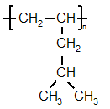 | 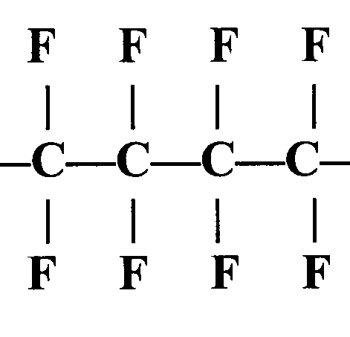
Name:

Industrial importance of alkenes

- outline the use of alkenes in the industrial production of organic compounds:
- the manufacture of margarine by catalytic hydrogenation of unsaturated vegetable oils using hydrogen and a nickel catalyst,
- the formation of a range of polymers using unsaturated monomer units based on the ethene molecule, ie H₂C=CHCl, F₂C=CF₂;

Describe how unsaturated vegetable oils are hydrogenated and state a use for this reaction:

....................................................................................................................................................................

....................................................................................................................................................................

Draw the structures of poly(chloroethene) and poly(tetrafluoroethene) and state why these polymers are useful:

(k) outline the processing of waste polymers by:
(i) separation into types (ie PTFE, etc.) and recycling,
(ii) combustion for energy production
(iii) use as a feedstock for cracking in the production of plastics and other chemicals;

Why are most polymers difficult to dispose of? ...................................................................................

Outline three ways in which waste polymers can be usefully processed.

.............................................................. ...........................................................

..............................................................
(l) outline the role of chemists in minimising environmental damage by:
(i) removal of toxic waste products, ie removal of HCl formed during disposal by
combustion of halogenated plastics (ie PVC),
(ii) development of biodegradable and compostable polymers, ie from isoprene (2-methyl-1,3-butadiene), maize and starch.

Explain why halogenated plastics (eg PVC) are particularly hazardous to dispose of.

....................................................................................................................................................................

Explain how chemists minimise environmental damage when disposing of halogenated polymers.

....................................................................................................................................................................

State, giving examples, two other ways in which scientists have minimised the environmental damage caused by polymers.

....................................................................................................................................................................

....................................................................................................................................................................
  - Module 2: Alcohols, Halogenoalkanes and Analysis

2.2.1 Alcohols

Properties and preparation of ethanol

Candidates should be able to:

- explain, in terms of hydrogen bonding, the water solubility and the relatively low volatility of alcohols;

Explain, with the aid of a diagram, why alcohols are soluble in water:

....................................................................................................................................................................

....................................................................................................................................................................

Explain, with the aid of a diagram, why alcohols are not volatile:

....................................................................................................................................................................

....................................................................................................................................................................

- describe the industrial production of ethanol by:
- fermentation from sugars, ie from glucose,
- the reaction of ethene with steam in the presence of an acid catalyst;

Write an equation for the fermentation of glucose to form ethanol:

....................................................................................................................................................................

State the conditions needed for this reaction:

....................................................................................................................................................................

Write an equation for the reaction of ethene with steam to form ethanol:

....................................................................................................................................................................

State the reagents and conditions needed for this reaction:

....................................................................................................................................................................

- outline, for alcohols:
- the use of ethanol in alcoholic drinks and as a solvent in the form of methylated spirits,
- the use of methanol as a petrol additive to improve combustion and its increasing importance as a feedstock in the production of organic chemicals;

State two uses of ethanol: ............................................ ...................................................

State two uses of methanol: ........................................ ....................................................
Reactions of alcohols

- classify alcohols into primary, secondary and tertiary alcohols;

Name and classify the following alcohols:

 | Name | Type of alcohol
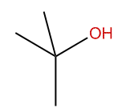
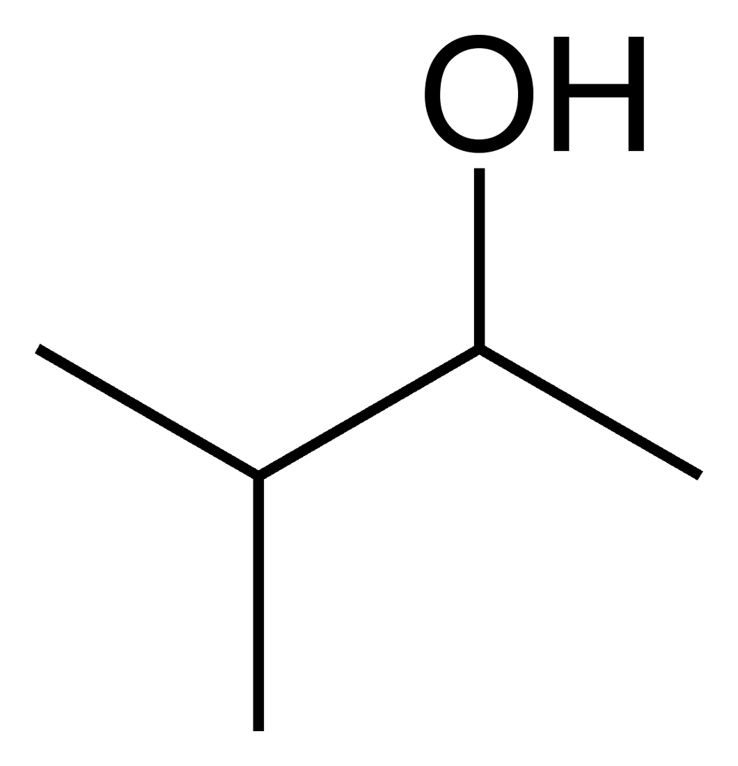
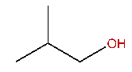

- describe the combustion of alcohols;

Write an equation to show the complete combustion of:

methanol: .........................................................................................................................................

ethanol: .........................................................................................................................................

- describe the oxidation of alcohols using Cr₂O₇^{2–}/H⁺ (ie K₂Cr₂O₇/H₂SO₄), including:
- the oxidation of primary alcohols to form aldehydes and carboxylic acids; the control of the oxidation product using different reaction conditions,
- the oxidation of secondary alcohols to form ketones,
- the resistance to oxidation of tertiary alcohols;

Write equations, using molecular, structural, displayed and skeletal formulae, to show the:

- partial oxidation of propan-1-ol
- complete oxidation of propan-1-ol
- oxidation of butan-2-ol
- oxidation of butanal

In each case, state the reagents and conditions, and name the product.

Draw and name the possible products if the following molecules are oxidised:

Molecule | Structure and name of oxidation product(s), if any
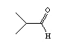
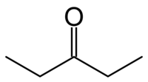

- describe the esterification of alcohols with carboxylic acids in the presence of an acid catalyst;

Write equations for the following esterification reactions:

ethanol + ethanoic acid → ........................................... + .............................................

molecular formulae:

structural formulae:

displayed formulae:

skeletal formulae:

propan-1-ol + methanoic acid →................................. + ..........................................

molecular formulae:

structural formulae:

displayed formulae:

skeletal formulae:

Complete the following reactions:

butan-1-ol + propanoic acid →

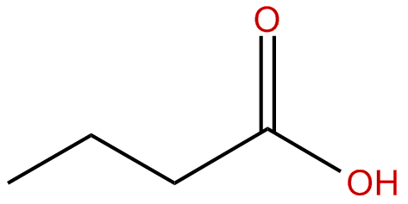 + →

Draw the carboxylic acids and alcohols which need to be reacted together to make the following esters:

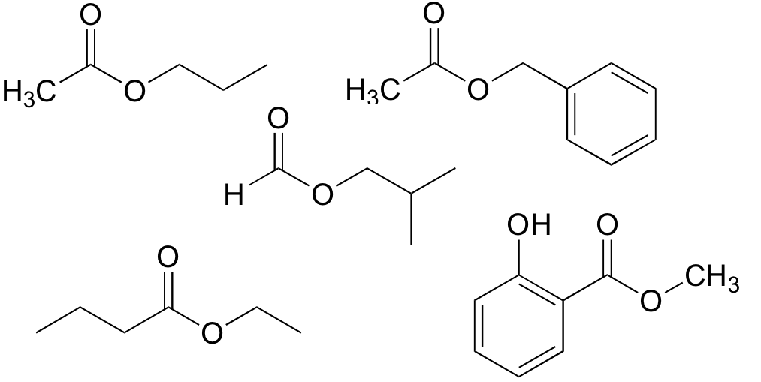

State the conditions required for esterification reactions:

....................................................................................................................................................................
- describe elimination of H₂O from alcohols in the presence of an acid catalyst and heat to form alkenes.

Write equations, using molecular, structural, displayed and skeletal formulae, to show the:

dehydration of butan-1-ol

dehydration of butan-2-ol

dehydration of methylpropan-1-ol

dehydration of methylpropan-2-ol

dehydration of cyclohexanol

dehydration of dimethylpropan-1-ol

State the reagents and conditions required for the elimination of water from alcohols:

....................................................................................................................................................................
2.2.2 Halogenoalkanes

Substitution reactions of halogenoalkanes

Candidates should be able to:

- describe the hydrolysis of halogenoalkanes as a substitution reaction;

Write an equation for the reaction of 1-bromopropane with sodium hydroxide:

....................................................................................................................................................................

What type of reaction is this? ..............................................................................................................

State the reagents and conditions required: .............................................................................................

- define the term nucleophile as an electron pair donor;

What is a nucleophile? ..................................................................................................

- describe the mechanism of nucleophilic substitution in the hydrolysis of primary halogenoalkanes with hot aqueous alkali

Outline the mechanism for the reaction of 2-chlorobutane with hydroxide ions:

What type of mechanism is this? .......................................................................

- explain the rates of hydrolysis of primary halogenoalkanes in terms of the relative bond enthalpies of carbon–halogen bonds (C–F, C–Cl, C–Br and C–I);

Describe a simple test you could carry out to confirm that an organic substance was a halogenoalkane:

....................................................................................................................................................................

....................................................................................................................................................................

Explain what you would see if the organic compound was

a chloroalkane ........................................ a bromoalkane ..........................................

an iodoalkane ...............................................................

State the trend in the rates of hydrolysis of halogenoalkanes:

....................................................................................................................................................................

Explain this trend:

....................................................................................................................................................................

....................................................................................................................................................................

....................................................................................................................................................................

....................................................................................................................................................................

- outline the uses of chloroethene and tetrafluoroethene to produce the plastics PVC and PTFE;

Draw the structures of poly(chloroethene) and poly(tetrafluoroethene) and state why these polymers are useful:

- explain that CFCs:
- were developed as aerosols, refrigerants, and in air-conditioning because of their low reactivity, volatility and non-toxicity,
- have caused environmental damage to the ozone layer;

State three uses of CFCs and state the three properties of CFCs which made them useful for this purpose:

....................................................................................................................................................................

....................................................................................................................................................................

....................................................................................................................................................................

Explain how CFCs have caused environmental damage to the ozone layer

....................................................................................................................................................................

....................................................................................................................................................................

- outline the role of green chemistry in minimising damage to the environment by promoting biodegradable alternatives to CFCs, such as hydrocarbons and HCFCs; CO2 as a blowing agent for expanded polymers.

State three chemicals which are now widely used instead of CFCs:

...................................... ...................................... ......................................

Explain two advantages of using CO₂ instead of CFCs as a blowing agent for expanded polymers:

....................................................................................................................................................................

....................................................................................................................................................................
2.2.3 Modern Analytical Techniques

Infrared spectroscopy

Candidates should be able to:

- state that absorption of infrared radiation causes covalent bonds to vibrate;

What happens when covalent bonds absorb infra-red radiation? ................................................

- identify, using an infrared spectrum of an organic compound:
(i) an alcohol from an absorption peak of the O–H bond,
(ii) an aldehyde or ketone from an absorption peak of the C=O bond,
(iii) a carboxylic acid from an absorption peak of the C=O bond and a broad absorption peak of the O-H bond;

Why do most organic molecules contain a peak at 3000 cm⁻¹? ..................................................
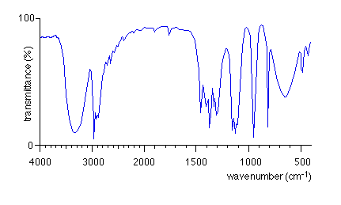
Identify the bonds responsible for the peaks in the non-fingerprint section of this infrared spectrum:

What type of molecule is this? ...................................
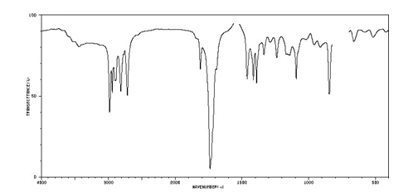
Identify the bonds responsible for the peaks in the non-fingerprint section of this infrared spectrum:

What type of molecule is this? ...................................
Identify the bonds responsible for the peaks in the non-fingerprint section of this infrared spectrum:

What types of molecule could this be? ......................
....................................................................................

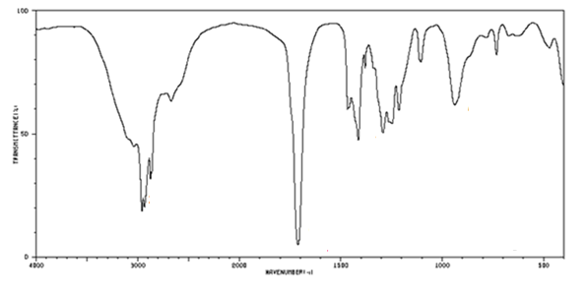
Identify the bonds responsible for the peaks in the non-fingerprint section of this infrared spectrum:

What type of molecule is this? ...................................

Explain why infrared spectroscopy cannot readily distinguish between different alcohols:

......................................................................................................................................................

- state that modern breathalysers measure ethanol in the breath by analysis using infrared spectroscopy;

State a use for infrared spectroscopy: ..........................................................................................

......................................................................................................................................................

Mass spectrometry

- outline the use of mass spectrometry:
(i) in the determination of relative isotopic masses,
(ii) as a method for identifying elements, ie use in the Mars space probe and in monitoring levels of environmental pollution, such as lead;

State which three pieces of information can be established from the mass spectrum of an element:
.........................................................................

.........................................................................

.........................................................................

State two important uses of the mass spectrometry of elements:

.................................................................................................................................

.................................................................................................................................

- interpret mass spectra of elements in terms of isotopic abundances;
State the mass number of the five most abundant isotopes in this mass spectrum and estimate their percentage abundance.

Hence estimate the relative atomic mass of the element and deduce its identity.

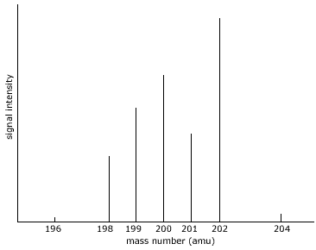

- use the molecular ion peak in a mass spectrum of an organic molecule to determine its molecular mass;

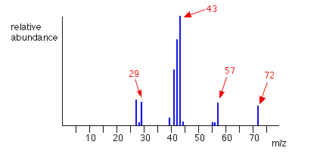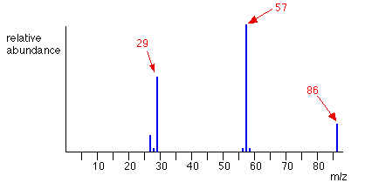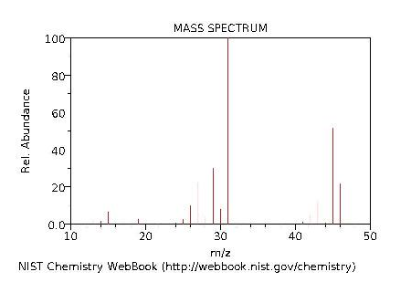
A B C
State the molecular mass of the molecules responsible for the mass spectra above:

............... ................ .................

- suggest the identity of the major fragment ions, ie m/z = 29 as CH₃CH₂⁺, in a given mass spectrum (limited to alkanes, alkenes and alcohols);

Suggest one possible structure for the fragment ions responsible for the peaks at:

m/z = 15 ................................. m/z = 43 .................................

m/z = 31 ................................ m/z = 27 .................................

- use molecular ion peaks and fragmentation peaks to identify structures (limited to unipositive ions);

The mass spectrum of hydrocarbon A is found to give peaks at:
m/z = 15, m/z = 29, m/z = 43, m/z = 57, m/z = 72

The mass spectrum of hydrocarbon B is found to give peaks at:
m/z = 15, m/z = 57, m/z = 72

The mass spectrum of hydrocarbon C is found to give peaks at:
m/z = 15, m/z = 27, m/z = 29, m/z = 41, m/z = 56

The mass spectrum of hydrocarbon D is found to give peaks at:
m/z = 15, m/z = 41, m/z = 56

The mass spectrum of alcohol E is found to give peaks at;
m/z = 15, m/z = 29, m/z = 45, m/z = 59, m/z = 74

The mass spectrum of alcohol F is found to give peaks at;
m/z = 15, m/z = 59, m/z = 74

The mass spectrum of alcohol G is found to give peaks at;
m/z = 15, m/z = 29, m/z = 31, m/z = 43, m/z = 45, m/z = 59, m/z = 74

The mass spectrum of alcohol H is found to give peaks at;
m/z = 15, m/z = 31, m/z = 43, m/z = 59, m/z = 74

Identify B, C, E, F, G and H. Deduce two possible structures of A and D.
Identify at least one of the fragment ions responsible for a peak in each spectrum.

- explain that a mass spectrum is essentially a fingerprint for the molecule that can be identified by computer using a spectral database.

Explain how you could use a complete mass spectrum to identify a molecule without identifying any of the fragment ions:

......................................................................................................................................................

......................................................................................................................................................
Module 3: Energy

2.3.1 Enthalpy Changes

Enthalpy changes: ΔH of reaction, formation and combustion

Candidates should be able to:

- explain that some chemical reactions are accompanied by enthalpy changes that can be exothermic (ΔH, negative) or endothermic(ΔH, positive);

In exothermic reactions, heat energy is ................. This causes the temperature of

the surroundings to ....................... . . The internal chemical energy (enthalpy, H) of

the chemicals .......................... The enthalpy change (ΔH) of the reaction is therefore

................................ In endothermic reactions, heat energy is .............. This causes the

temperature of the surroundings to ....................... . . The internal chemical energy

(enthalpy, H) of the chemicals .......................... The enthalpy change (ΔH) of the

reaction is therefore ................................

- describe the importance of oxidation as an exothermic process in the combustion of fuels and the oxidation of carbohydrates such as glucose in respiration;

Equation for one important exothermic reaction:.................................................................

Reason for importance of reaction: ..........................

Equation for another important exothermic reaction:...........................................................

Reason for importance of reaction: ......................................................................................

Type of reaction: First reaction: ............................... Second reaction: .........................

- describe that endothermic processes require an input of heat energy, eg the thermal decomposition of calcium carbonate;

Explain why most endothermic reactions need to be heated before the reaction can take place:

.....................................................................................................................................

Equation for one endothermic reaction: ...................................................................................

Type of reaction: .........................................................

- construct a simple enthalpy profile diagram for a reaction to show the difference in the enthalpy of the reactants compared with that of the products;

Construct an enthalpy profile diagram, with the activation energy and enthalpy change clearly labelled, for:

- the combustion of methane
- the thermal decomposition of calcium carbonate

- explain qualitatively, using enthalpy profile diagrams, the term activation energy;

Explain the meaning of the term “activation energy”............................................................

................................................................................................................................................

- define and use the terms:
(i) standard conditions,
(ii) enthalpy change of reaction,
- enthalpy change of formation,
- enthalpy change of combustion;

Define “standard conditions”: ..........................................................................................

................................................................................................................................................

Define “enthalpy change of reaction”: ..............................................................................

................................................................................................................................................

Define “enthalpy change of formation”: .............................................................................

................................................................................................................................................

Define “enthalpy change of combustion”: ..................................................................

................................................................................................................................................

- calculate enthalpy changes from appropriate experimental results directly, including use of the relationship: energy change = mcΔT;

25 cm³ of 1.0 moldm⁻³ HCl and 25 cm³ of 1.0 moldm⁻³ NaOH were mixed together in a polystyrene cup. The temperature increased by 6.8 ºC.
Calculate the molar enthalpy change for the following reaction:
HCl(aq) + NaOH(aq) → NaCl(aq) + H₂O(l)

50 cm³ of 1.0 moldm⁻³ HCl was added to an excess of magnesium powder in a polystyrene cup. The temperature increased by 41.2 ºC.
Calculate the molar enthalpy change for the following reaction:
2HCl(aq) + Mg(s) → MgCl₂(aq) + H₂(l)

A spirit burner containing ethanol was lit and used to heat 100 cm³ of water in a copper can by 30 ºC. After the reaction, the mass of the spirit burner had decreased by 1.5 g.
Calculate the enthalpy of combustion of ethanol.

Bond enthalpies

- explain exothermic and endothermic reactions in terms of enthalpy changes associated with the breaking and making of chemical bonds;

All chemical reactions involve first .......................... and then ..................................

The process of breaking bonds is ....................................., and so ........................ heat.

The process of making bonds is ......................................, and so ...................... heat.

During exothermic reactions, more energy is ............................. when bonds are

................ than is ....................... when bonds are .................................

During endothermic reactions, more energy is ............................. when bonds are

................ than is ....................... when bonds are .................................

- define and use the term average bond enthalpy (ΔH positive; bond breaking of one mole of bonds);

Define the term “average bond enthalpy”: ..................................................................

................................................................................................................................................

- calculate an enthalpy change of reaction from average bond enthalpies;

Here are some common bond enthalpies:
C-H: +413 kJmol⁻¹ C-C: +347 kJmol⁻¹ C-O: +352 kJmol⁻¹ O-H: +463 kJmol⁻¹
C=O: +805 kJmol⁻¹ N-H: +391 kJmol⁻¹ H-H: +436 kJmol⁻¹ O=O: +498 kJmol⁻¹
N≡N: +945 kJmol⁻¹

Use them to calculate the following enthalpy changes:

C₃H₈ + 5O₂ → 3CO₂ + 4H₂O

N₂ + 3H₂ → 2NH₃

CH₃OH + 1.5O₂ → CO₂ + 2H₂O

Hydrogen peroxide decomposes according to the following equation:
2H₂O₂ → 2H₂O + O₂ ∆H = -72 kJmol⁻¹
Use this enthalpy change and the average bond enthalpies given above to calculate the bond enthalpy of an O-O bond.

Hess’ law and enthalpy cycles

(k) use Hess’ law to construct enthalpy cycles and carry out calculations to determine:

(i) an enthalpy change of reaction from enthalpy changes of combustion,
(ii) an enthalpy change of reaction from enthalpy changes of formation,
- an enthalpy change of reaction from an unfamiliar enthalpy cycle.

Calculate the enthalpy change of the following reaction:
C₆H₆ + 3H₂ → C₆H₁₂
Given the following enthalpies of combustion:
substance | ∆H_{c}/kJmol⁻¹
C₆H₆ | -3273
H₂ | -286
C₆H₁₂ | -3930

Calculate the enthalpy change of the following reaction:
CO+ 2H₂ → CH₃OH
Given the following enthalpies of combustion:
substance | ∆H_{c}/kJmol⁻¹
CO | -283
H₂ | -286
CH₃OH | -715

Calculate the enthalpy of formation of butane, given the following enthalpies of combustion:
substance | ∆H_{c}/kJmol⁻¹
C | -394
H₂ | -286
C₄H₁₀ | -2878

Calculate the enthalpy change of the following reaction:
C₆H₆ + 3H₂ → C₆H₁₂
Given the following enthalpies of formation:
substance | ∆H_{f}/kJmol⁻¹
C₆H₆ | +49
C₆H₁₂ | -156

Calculate the enthalpy change of the following reaction:
CO+ 2H₂ → CH₃OH
Given the following enthalpies of formation:
substance | ∆H_{f}/kJmol⁻¹
CO | -110
CH₃OH | -238

Calculate the enthalpy of combustion of methanol, given the following enthalpies of formation:
substance | ∆H_{f}/kJmol⁻¹
CH₃OH | -238
CO₂ | -394
H₂O | -286

Calculate the enthalpy change of the following reaction:
3NO₂(g) + H₂O(l) ---> 2HNO₃(aq) + NO(g)
Using the following data:
2NO(g) + O₂(g) ---> 2NO₂(g) | ΔH = -116 kJ
2N₂(g) + 5O₂(g) + 2H₂O(l) ---> 4HNO₃(aq) | ΔH = -256 kJ
N₂(g) + O₂(g) ---> 2NO(g) | ΔH = +183 kJ

Use the following cycle to help you:

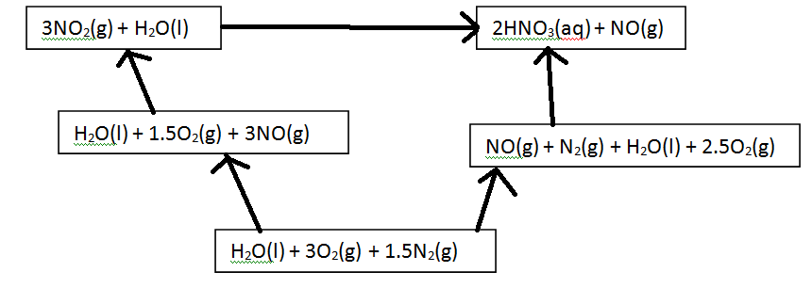
2.3.2 Rates and Equilibrium

Simple collision theory

Candidates should be able to:

- describe qualitatively, in terms of collision theory, the effect of concentration changes on the rate of a reaction;

State and explain the effect of increasing the concentration of one of the reactants on the rate of

reaction: .....................................................................................................................................................

....................................................................................................................................................................

State and explain the effect of decreasing the concentration of one of the reactants on the rate of

reaction: .....................................................................................................................................................

....................................................................................................................................................................

- explain why an increase in the pressure of a gas, increasing its concentration, may increase the rate of a reaction involving gases;

State and explain the effect of increasing the gas pressure on the rate of reaction:

....................................................................................................................................................................

....................................................................................................................................................................

State and explain the effect of decreasing the gas pressure on the rate of reaction:

....................................................................................................................................................................

....................................................................................................................................................................

Catalysts

- state that a catalyst speeds up a reaction without being consumed by the overall reaction;

What is a catalyst? .....................................................................................................................................

....................................................................................................................................................................

- explain that catalysts:
(i) affect the conditions that are needed, often requiring lower temperatures and reducing energy demand and CO₂ emissions from burning of fossil fuels,
(ii) enable different reactions to be used, with better atom economy and with reduced waste,
- are often enzymes, generating very specific products, and operating effectively close to room temperatures and pressures,
- have great economic importance, eg iron in ammonia production, Ziegler–Natta catalyst in poly(ethene) production, platinum/palladium/rhodium in catalytic converters;

Describe two environmental benefits of catalysts:

....................................................................................................................................................................

....................................................................................................................................................................

....................................................................................................................................................................

....................................................................................................................................................................

What is an enzyme?

....................................................................................................................................................................

State two advantages of using enzymes in chemical reactions:

....................................................................................................................................................................

....................................................................................................................................................................

Name three important industrial catalysts and state what reaction they catalyse:

Catalyst | Process

- explain, using enthalpy profile diagrams, how the presence of a catalyst allows a reaction to proceed via a different route with a lower activation energy, giving rise to an increased reaction rate;

Draw a labelled enthalpy profile diagram for an exothermic reaction. On the same diagram, draw the enthalpy profile diagram for the reaction after adding a catalyst:

Hence explain how a catalyst increases the rate of reaction:

....................................................................................................................................................................

....................................................................................................................................................................
The Boltzmann distribution

- explain qualitatively the Boltzmann distribution and its relationship with activation energy;

Sketch and label a graph to show the distribution of molecular energies at a given temperature T₁:

Describe the key features of the graph:

....................................................................................................................................................................

....................................................................................................................................................................

....................................................................................................................................................................

....................................................................................................................................................................

- describe qualitatively, using the Boltzmann distribution, the effect of temperature changes on the proportion of molecules exceeding the activation energy and hence the reaction rate;

On the same axes, sketch and label a graph to show the distribution of molecular energies at a higher temperature T₂. Use the graph to explain why an increase in temperature increases the reaction rate:

....................................................................................................................................................................

....................................................................................................................................................................

....................................................................................................................................................................

On the same axes, sketch and label a graph to show the distribution of molecular energies at a lower temperature T₃. Use the graph to explain why a decrease in temperature decreases the reaction rate:

....................................................................................................................................................................

....................................................................................................................................................................

....................................................................................................................................................................

- interpret the catalytic behaviour in (e), in terms of the Boltzmann distribution;

Sketch and label a graph to show the distribution of molecular energies at a given temperature T₁:

Use the graph to explain why the addition of a catalyst increases the reaction rate:

....................................................................................................................................................................

....................................................................................................................................................................
Dynamic equilibrium and le Chatelier’s principle

- explain that a dynamic equilibrium exists when the rate of the forward reaction is equal to the rate of the reverse reaction;

What is a dynamic equilibrium?

....................................................................................................................................................................

....................................................................................................................................................................

....................................................................................................................................................................

- state le Chatelier’s principle;

State le Chatelier’s principle: ....................................................................................................................

....................................................................................................................................................................

....................................................................................................................................................................

- apply le Chatelier’s principle to deduce qualitatively (from appropriate information) the effect of a change in temperature, concentration or pressure, on a homogeneous system in equilibrium;

In the following exothermic reaction: N₂ + 3H₂ == 2NH₃
State and explain how the following changes to the equilibrium mixture will affect the yield of ammonia:

Increasing the concentration of nitrogen: ..................................................................................................

....................................................................................................................................................................

Decreasing the concentration of hydrogen: ..............................................................................................

....................................................................................................................................................................

Removing ammonia from the mixture as soon as it is made: ...................................................................

....................................................................................................................................................................

Increasing the total pressure: .....................................................................................................................

....................................................................................................................................................................

Decreasing the total pressure: ...................................................................................................................

....................................................................................................................................................................

Increasing the temperature: .......................................................................................................................

....................................................................................................................................................................

Decreasing the temprature: .......................................................................................................................

....................................................................................................................................................................

Adding a catalyst: ......................................................................................................................................

....................................................................................................................................................................

In the following endothermic reaction: CH₄ + H₂O == CO + 3H₂
State and explain how the following changes to the equilibrium mixture will affect the yield of hydrogen:

Increasing the concentration of methane: .................................................................................................

....................................................................................................................................................................

Decreasing the concentration of steam: ....................................................................................................

....................................................................................................................................................................

Removing hydrogen from the mixture as soon as it is made: ...................................................................

....................................................................................................................................................................

Increasing the total pressure: .....................................................................................................................

....................................................................................................................................................................

Decreasing the total pressure: ...................................................................................................................

....................................................................................................................................................................

Increasing the temperature: .......................................................................................................................

....................................................................................................................................................................

Decreasing the temprature: .......................................................................................................................

....................................................................................................................................................................

Adding a catalyst: ......................................................................................................................................

....................................................................................................................................................................

- explain, from given data, the importance in the chemical industry of a compromise between chemical equilibrium and reaction rate.

The Haber process involves the large-scale production of ammonia by the following exothermic reaction: N₂ + 3H₂ == 2NH₃
The conditions used are 450 ºC, 250 atm and an iron catalyst.

Give two reasons why a higher temperature is not used: ..........................................................................

....................................................................................................................................................................

....................................................................................................................................................................

Give one reason why a lower temperature is not used: .............................................................................

....................................................................................................................................................................

....................................................................................................................................................................

Give one reason why a higher pressure is not used: .................................................................................

....................................................................................................................................................................

....................................................................................................................................................................

Give two reasons why a lower pressure is not used: .................................................................................

....................................................................................................................................................................

....................................................................................................................................................................

Explain why the temperature of 450 ºC can be regarded as a compromise temperature:

....................................................................................................................................................................

....................................................................................................................................................................

....................................................................................................................................................................

Module 4: Resources

2.4.1 Chemistry of the Air

The ‘Greenhouse Effect’

- explain that infrared radiation is absorbed by C=O, O–H and C–H bonds in H₂O, CO₂ and CH₄, and that these absorptions contribute to global warming;

What is the greenhouse effect?..................................................................................................................

....................................................................................................................................................................

Which gases are responsible for the greenhouse effect? ...........................................................................

How do these gases cause the greenhouse effect? ....................................................................................

....................................................................................................................................................................

- explain that the ‘Greenhouse Effect’ of a given gas is dependent both on its atmospheric concentration and its ability to absorb infrared radiation;

Which two factors determine the contribution of a given gas to the greenhouse effect?

....................................................................................................................................................................

- outline the importance of controlling global warming resulting from atmospheric increases in greenhouse gases;

What is global warming? ..........................................................................................................................

....................................................................................................................................................................

What is climate change? ...........................................................................................................................

....................................................................................................................................................................

Why is it important to control global warming? ......................................................................................

...................................................................................................................................................................

How can global warming be controlled? .................................................................................................

...................................................................................................................................................................

- outline the role of chemists in minimising climate change resulting from global warming by:
- providing scientific evidence to governments to verify that global warming is taking place,
- investigating solutions to environmental problems, such as carbon capture and storage, CCS, ie the removal of waste carbon dioxide as a liquid injected deep in the oceans, storage in deep geological formations, by reaction with metal oxides to form stable carbonate minerals,
- monitoring progress against initiatives such as the Kyoto protocol;

Suggest two ways in which scientists can work with governments to minimise climate change

resulting from global warming: .................................................................................................................

...................................................................................................................................................................

...................................................................................................................................................................

State three solutions which scientists are currently developing to minimise climate change:

...................................................................................................................................................................

...................................................................................................................................................................

...................................................................................................................................................................

...................................................................................................................................................................
The ozone layer

- explain that ozone is continuously being formed and broken down in the stratosphere by the action of ultraviolet radiation;

Write two equations to show how ozone is created in the stratosphere:

...................................................................................................................................................................

...................................................................................................................................................................

Write one equation to show how ozone is destroyed in the stratosphere:

...................................................................................................................................................................

- using the chemical equilibrium O₂ + O ⇌ O₃
- describe and explain how the concentration of ozone is maintained in the ozone layer, including the role of ultraviolet radiation,
- outline the role of ozone in the absorption of harmful ultraviolet radiation and the essential benefit of this process for life on Earth;

Explain why it is important to maintain ozone levels in the stratosphere:

...................................................................................................................................................................

...................................................................................................................................................................

Explain the role of UV radiation in maintaining ozone levels in the atmosphere:

...................................................................................................................................................................

...................................................................................................................................................................

- understand that radicals, eg from CFCs, and NO_{x} from thunderstorms or aircraft, may
catalyse the breakdown of ozone by the following simple representation:
R + O₃ → RO + O₂
RO + O → R + O₂
where R represents Cl• from a CFC or NO from nitrogen oxides;

Write two equations to show how Cl radicals catalyse the destruction of ozone:

...................................................................................................................................................................

...................................................................................................................................................................

Write two equations to show how NO catalyses the destruction of ozone:
...................................................................................................................................................................

...................................................................................................................................................................
Controlling air pollution

- for carbon monoxide, oxides of nitrogen and unburnt hydrocarbons:

  - explain their formation from the internal combustion engine,
  - state environmental concerns from their toxicity and contribution to low-level ozone and photochemical smog;

Explain how carbon monoxide is formed in an internal combustion engine and why it is an

environmental concern:..............................................................................................................................

...................................................................................................................................................................
Explain how nitrogen monoxide and nitrogen dioxide are formed in an internal combustion engine

and why they are an environmental concern: ……………………………………………………………

...................................................................................................................................................................

Explain why unburned hydrocarbons are an environmental concern:

- outline how a catalytic converter decreases carbon monoxide and nitrogen monoxide emissions from internal combustion engines by:
  - adsorption of CO and NO to the catalyst surface,
  - chemical reaction,
  - desorption of CO2 and N2 from the catalyst surface;

Write an equation for the reaction which takes place in catalytic converter:

...................................................................................................................................................................

Describe how a catalytic converter works in three stages:

...................................................................................................................................................................

...................................................................................................................................................................

...................................................................................................................................................................

- outline the use of infrared spectroscopy in monitoring air pollution.

Describe how infra-red spectroscopy is used to monitor air pollution:
...................................................................................................................................................................

...................................................................................................................................................................
2.4.2 Green Chemistry

Sustainability

(a) describe principles of chemical sustainability:

(i) using industrial processes that reduce or eliminate hazardous chemicals and which involve the use of fewer chemicals,

(ii) designing processes with a high atom economy that minimise the production of waste materials,

(iii) using renewable resources such as plant-based substances,

(iv) seeking alternative energy sources such as solar energy, rather than consuming finite resources such as fossil fuels that will eventually be exhausted,

(v) ensuring that any waste products produced are non-toxic, and can be recycled or biodegraded by being broken down into harmless substances in the environment;

State the five principles of chemical sustainability.

...................................................................................................................................................................

...................................................................................................................................................................

...................................................................................................................................................................

(b) explain that the apparent benefits may be offset by unexpected and detrimental side-effects;

Give one example of an apparent benefit of a chemical process being offset by unexpected and detrimental side-effects:

...................................................................................................................................................................

...................................................................................................................................................................

(c) explain the importance of establishing international cooperation to promote the reduction of pollution levels;

Explain the importance of establishing international cooperation to promote the reduction of pollution levels.

...................................................................................................................................................................

...................................................................................................................................................................

(d) discuss issues of sustainability in contexts based on the principles in a–c;

