WASHINGTON LATIN PUBLIC CHARTER SCHOOL
CHEMISTRY 2019-20

UNIT 5A – CHEMICAL REACTIONS I – ACIDS AND BASES
PRACTICE TEST

Answer all questions
Recommended time = 50 minutes
BAHATI NJEMA!

 | Name:
 | Score for Q1 - 3 (open response) | /21
 | Score for Q4 - 10  (multiple choice) | /8
 | Bonus  (Submits quiz on time and in correct format) | /11

SECTION A – OPEN RESPONSE

1. | Neutralization reactions are reactions between acids and bases to produce salts. They have a variety of uses, including making different salts.  Complete the following table to show the names and formulas of different acids, bases and salts.
 | name |  | formula | acid, base or salt? | 5
 |  |  | KOH | base
 | potassium nitrate
 |  |  | HNO₃
 | magnesium carbonate |  | MgCO₃
 | magnesium chloride
 |  |  | HCl
 | (a) | Complete the following symbol equations for neutralization reactions:
 |  | (i) | KOH + HNO₃ → ……………. + H₂O |  | 3
 |  | (ii) | MgCO₃ + 2HCl → …………… + …………….. + H₂O
 | (b) | State what you would see as reaction (a) (ii) was taking place |  |  | 2
 | TOTAL |  |  |  | 10

2. | The acidity or alkalinity of a solution can be captured in a single number, called the pH.  A sample of lemon juice was analysed and found to have a pH of 3  A sample of blood was analysed and found to have a pH of 7  A sample of 0.1 mol/L sodium hydroxide was also analysed  Complete the following table:
 | Sample | pH | acidic, neutral or alkaline?
 | lemon juice | 3
 | blood | 7
 | sodium hydroxide
 | TOTAL |  |  | 5

3. | Gabi had a solution of lactic acid of unknown molarity.  She determined the molarity of the lactic acid solution by carrying out a titration with 0.10 mol/L sodium hydroxide solution using phenolphthalein indicator.  She found that 21.5 mL of the lactic acid solution were required to react with 25 mL of the sodium hydroxide solution.
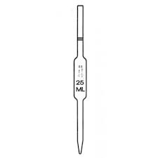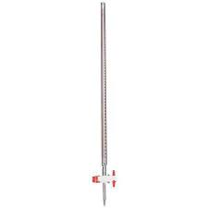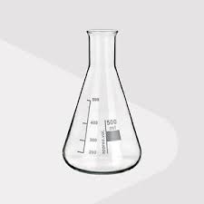
A B C
 | (a) | Name the three pieces of glassware Gabi used in the experiment: | 3
A:
B:
C:
 | (b) | Calculate the molarity of the lactic acid solution.  Use the formula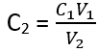. | 3
 | TOTAL |  | 6

SECTION B – MULTIPLE CHOICE

Do not answer these questions on this document. Click on the answer sheet provided at the end of the questions.

4. | When copper oxide reacts with sulfuric acid, the name of the salt produced is
 | A | copper acid
 | B | copper sulfate
 | C | sulfuric oxide
2

5. | A solution of wood bleach has a pH of 2. It could be described as:
 | A | strongly acidic
 | B | weakly acidic
 | C | strongly alkaline
2

6. | Which of the following solutions has the highest pH?
 | A | 1 mol/L ammonia
 | B | vinegar
 | C | pure water
2

7. | What would happen if MgO powder was added separately to 50 mL of 0.5 mol/L HCl and 0.5 mol/L lactic acid (a weak acid)?
 | A | The lactic acid would dissolve more MgO but more slowly
 | B | The lactic acid would dissolve less MgO and more slowly
 | C | The lactic acid would dissolve the same amount of MgO but more slowly
2

Now proceed to the answer sheet

