YEAR 12 PRACTICAL

HOMEWORK EXERCISE 4

DETERMINATION OF THE ENTHALPY CHANGE OF A DISPLACEMENT REACTION

/14

Introduction
Zinc reacts with aqueous copper (II) sulphate as shown by the following equation
Zn + CuSO₄ → ZnSO₄ + Cu

A student weighed out 1.25 g of zinc dust. Using a pipette, the student then measured out 50.0 cm³ of a 0.400 moldm⁻³ solution of copper (II) sulphate and transferred it to a plastic cup, which was placed in a beaker to provide insulation. A thermometer was mounted in the cup using a clamp and stand. The bulb of the thermometer was fully immersed in the liquid.
The student recorded the temperature of the liquid in the cup every minute, stirring the liquid before reading the temperature. At the fourth minute the student added zinc, but did not record the temperature. The student stirred the mixture thoroughly, then recorded the temperature at the fifth minute. The student then continued stirring and recording the temperature at minute intervals for seven more minutes.
The student’s results are shown on the graph.
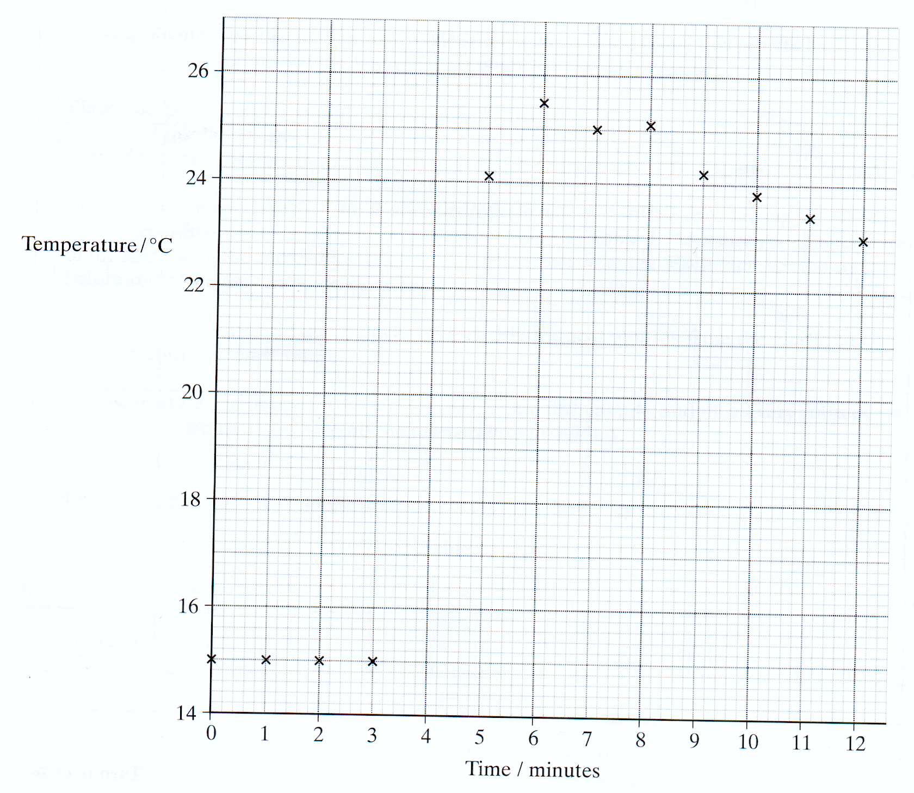

Analysis
1. Draw a line of best fit for the points before the fourth minute and a second line for the points after the forth minute. Extrapolate both lines to the fourth minute, and hence determine the temperature rise which would have occurred at the fourth minute.

Temperature rise from graph after extrapolation ………………. ºC

2. Use the temperature rise form your graph to calculate the heat given out during this experiment. Assume that the solution has a density of 1.00 gcm⁻³ and has a specific heat capacity of 4.18JK⁻¹g⁻¹.
……………………………………………………………………………………………………………………………………………………………………..

3. (a) Calculate the number of moles of zinc present in 1.25 g (Zn A_{r}=65.4)
…………………………………………………………………………..
(b) Calculate the number of moles of copper (II) sulphate present in 50.0 cm³ of 0.400 moldm⁻³ solution.

…………………………………………………………………………..

4. Calculate the molar enthalpy change for the reaction between zinc and copper (II) sulphate.
……………………………………………………………………………………………………………………………………………………………………..

5. Assume that the maximum errors for the apparatus used in the experiment were
balance +- 0.01 g
50 cm³ pipette +- 0.1 cm³
thermometer +- 0.1ºC

Calculate the maximum percentage error in using each piece of apparatus and hence the overall apparatus error. Use the temperature rise from the graph to calculate the error in using the thermometer.

…………………………………………………………………………………………………………………………………………………………………………………………………………………………………………………………………………………………………………………………………………
Evaluation

1. Comment on the quality of the student’s results
…………………………………………………………………………………………………………………………………………………………………….

2. The data value for the molar enthalpy change –219 KJmol⁻¹. calculate the difference between the student’s value and this data book value. Express this difference as a percentage of the data book value. (If you could not complete the calculation in part 4 of the analysis section you should assume that the student’s enthalpy change is –135 KJmol⁻¹. This is not the correct value).

Difference………………………………………………………………………
Percentage………………………………………………………………………

3. Identify the main source of error in this experiment. Suggest one improvement to minimise this main source of error.
………………………………………………………………………………………………………………………………………………………………………………………………………………………………………………………

4. Identify one other source of error in this experiment. Suggest one improvement to minimise this other source of error.
……………………………………………………………………………………………………………………………………………………………………………………………………………………………………………………….

